Angela's Tools · Chapter 20: Resources in Living Systems · Worksheet 4 of 10

Reading an S-Curve: Two Tubs of Duckweed
Learning target: I can read a population growth curve, identify the phases of growth and the carrying capacity, connect the shape of the curve to a limiting resource, and draw a predicted curve for a new situation.
Diagrams and models · about 35 minutes · individual · Standards: MS-LS2-1 (practice)
Name: ____________________________ Date: ____________ Period: ______

Directions
Duckweed is a floating plant smaller than a grain of rice that makes copies of itself every few days. A class floated ten duckweed plants (called fronds) in each of two identical tubs under the same lamp at the same temperature. Tub A was filled with water plus a dilute plant-nutrient solution; Tub B was filled with plain tap water. The fronds were counted every three days for a month. Study the graph in Part A and answer the questions. In Part B you will draw your own predicted curve. Use a ruler for straight parts and label everything you draw.

Part A: Read the graph
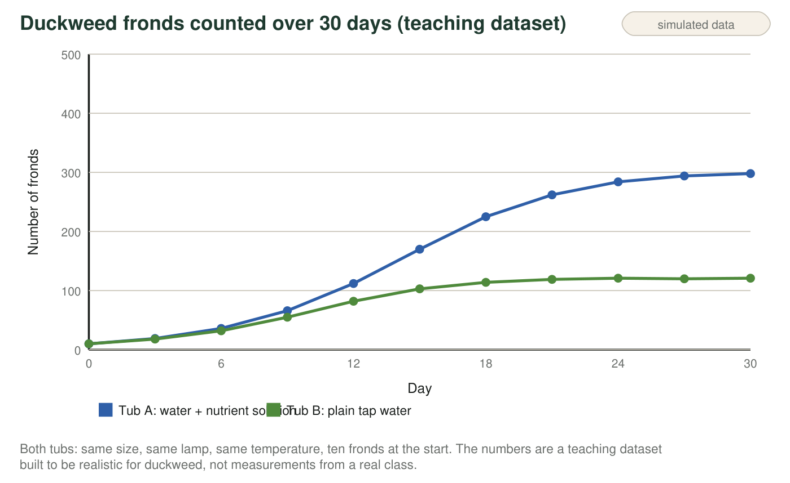
Reading tip
A curve that starts slow, speeds up, then flattens is called an S-curve. Scientists describe it in three phases: a slow start (few plants, so few new plants each day), rapid growth (many plants, each making more, and resources still plentiful), and leveling off (resources per plant are now scarce, so births barely outnumber deaths). The flat height the curve approaches is the carrying capacity for that tub.
1. For the first six days the two curves are almost on top of each other. Explain why the nutrient solution made little difference at first, even though it makes a big difference later.
______________________________________________________________________________________
______________________________________________________________________________________
______________________________________________________________________________________
2. Calculate the average number of new fronds per day in Tub A between day 9 and day 15. Show the subtraction and the division.
______________________________________________________________________________________
______________________________________________________________________________________
______________________________________________________________________________________
3. Now calculate the average number of new fronds per day in Tub A between day 24 and day 30. Compare it with your answer to q2 in one sentence.
______________________________________________________________________________________
______________________________________________________________________________________
______________________________________________________________________________________
4. Complete the table for Tub A by reading the graph: give the day range for each phase and one piece of evidence from the curve.
Day range (about) | Evidence from the curve
Slow start
Rapid growth
Leveling off

5. Estimate the carrying capacity of each tub. Write both numbers with the word 'fronds.'
______________________________________________________________________________________
______________________________________________________________________________________
6. Why did growth in Tub A slow down after day 18, even though the lamp and the temperature never changed?
○ A. The duckweed plants became old and stopped reproducing.
○ B. With hundreds of plants crowded together, the nutrients, light and surface space available to each plant fell, so new fronds were produced about as fast as old ones died.
○ C. The water in the tub became too cold for growth.
○ D. The students started counting less carefully in the last week.
7. Tub B leveled off at a much lower number. Name the resource that was most likely limiting in Tub B, and give two pieces of evidence from the graph or the setup that point to it rather than to light or temperature.
______________________________________________________________________________________
______________________________________________________________________________________
______________________________________________________________________________________
______________________________________________________________________________________

Part B: Build a model for a third tub
The class sets up Tub C: identical to the others, ten fronds at the start, nutrient solution for the first 15 days. On day 15 they pour out the nutrient water and refill the tub with plain tap water, keeping the same plants. They keep counting until day 45.
Draw a graph for Tub C from day 0 to day 45. Label the axes (Day; Number of fronds) with the same scale as the figure (0 to 300 fronds). Lightly copy the Tub A curve up to day 15 so your starting point is right, then draw your predicted curve for days 15 to 45 as a solid line. Mark and label: the day the nutrients were removed, the highest point your curve reaches, and the level it ends up near. Add one sentence under the graph that says what the new carrying capacity is and why.

8. Explain the shape you drew after day 15. Why might the count keep rising for a few days before it falls, and why does it not fall all the way to zero?
______________________________________________________________________________________
______________________________________________________________________________________
______________________________________________________________________________________
______________________________________________________________________________________
9. On day 30, a student scoops half the fronds out of Tub A (leaving about 150) and keeps the nutrient solution the same. Predict what the curve does over the next two weeks and explain why, using the phrase 'resources per plant.'
______________________________________________________________________________________
______________________________________________________________________________________
______________________________________________________________________________________

Finding the phases with a straightedge
Lay a ruler along the steepest part of the Tub A curve (roughly days 9 to 18). Everywhere the curve is flatter than the ruler before that stretch is the slow start; everywhere it is flatter after is the leveling off. For the calculations, 'per day' means divide the change in fronds by the number of days between the two counts, which is 6 days in both q2 and q3. For the drawing, start by placing dots at day 15 (about 170 fronds) and day 45 (near Tub B's level), then decide how to connect them.

A doubling test
In the rapid-growth phase, a population that doubles in a fixed time is growing exponentially. Use Tub A's numbers to find how many days it took to go from 19 to 36 fronds, from 36 to 66, and from 66 to 112 (count each as roughly a doubling). Then test whether the doubling time stays the same later: how long does it take to go from 170 to 262 fronds, and does that count as a doubling? Write two sentences explaining what the change in doubling time tells you about resources per plant.

