Angela's Tools · Chapter 21: Interactions Among Organisms · Lab 3 of 3 · Student recording sheet

Shield the Frog Listener: A Noise Barrier for a Pond Sensor
Investigation question: Can your team build a shield that cuts the highway noise reaching a frog-call sensor by at least 5 decibels, while keeping the pond side open and staying within the kit budget, and which of your two designs best meets the criteria when they are compared systematically?
Name: ____________________________ Group: ________ Date: ____________

Your role
☐ Project lead: Keeps the 20-minute build clock and the 10-credit budget, runs the constraint check, and makes sure the team's two designs use different ideas.
☐ Builder: Cuts, folds and tapes the shields with scissors and masking tape, and seals every loose piece.
☐ Tester: At the test station, checks the phone positions against the marks, starts and stops the clips at the posted volume, and keeps hands and bodies out of the sound path during readings.
☐ Recorder: Reads the sound-level app aloud, writes every reading, computes averages and changes, and fills in the decision matrix with the team.

Safety
• Hearing: keep the playback at the posted setting, which gives about 65 to 75 dB at the sensor, a little louder than conversation. No one puts an ear against a speaker or turns the volume up. NIOSH sets its recommended limit at an average of 85 dB over an 8-hour day; these short tests stay well below that.
• Cutting: students use scissors only. The teacher cuts thick cardboard with a box cutter before class. Fold the edges of foil, which can cut skin.
• Heavy items: stack books or magazines no higher than 15 cm, tape them so they cannot slide, and keep them clear of the phones so nothing falls on a device or a hand.
• Devices: phones lie flat on the table, not near its edge; no drinks at the stations. Only the tester handles the station phones.
• No hot glue, staples or sprays. Cotton balls and other fibers stay sealed in bags or taped down, both for tidy cleanup and because that is a design constraint.
• Students who are sensitive to sound can take the project-lead or recorder role away from the station or wear ear defenders. This activity has not been physically tested by the authors; pilot one station before class.

Procedure
1. Session 1. Read the design brief and the science notes on the recording sheet. As a team, complete q1: for each plain-language need, decide whether it is a criterion or a constraint and write a measurable version with a number, a unit and a test.
2. Compare your q1 table with the class test rules your teacher posts (also on the sheet). Use the class rules for testing so every team's numbers can be compared; keep any extra criteria you wrote as bonus goals.
3. Plan two designs that rely on different ideas about stopping sound (for example, one heavy, gap-free wall versus a three-sided hood lined with soft material). Sketch both from above and from the side in the drawing box, showing the H, S and P marks and the pond line, and label every material and size.
4. Price each design with the kit price list (10 credits or fewer each) and write your predicted highway drop and pond change in the design-plan table.
5. Build Design A within 20 minutes, then Design B within 20 minutes. Tape every loose piece. Label both with your team name and store them flat.
6. Session 2. At your station, the tester checks that the playback phone is at the posted volume and the sensor phone is flat on the pond half with its microphone end at S. With nothing playing, record one background reading.
7. No-shield highway test: place the playback phone on H with its speaker toward S and start the highway clip. Wait 5 seconds, then take three readings (the app's 10-second average, or three readings 5 seconds apart). Everyone stays still and quiet and out of the line between the phones.
8. Place Design A on the highway half of the square without touching the sensor or crossing the pond line, and take three readings. Swap in Design B and take three more.
9. Pond test: move the playback phone to P with its speaker toward S, switch to the pond clip, and take three readings with no shield, three with Design A and three with Design B.
10. Bump test: with each design in place, tap the table firmly twice 20 cm away and fan it three times with a sheet of cardboard from 50 cm. Record whether it stayed standing and in place, then return the station exactly as you found it.
11. Back at your table, compute each average and each change from no shield, complete the constraint check, and score both designs in the decision matrix with the scoring guide. Write your recommendation (q2 and q3).
12. If time allows, build one improved design that combines the best features of A and B, and test it once from H and once from P. Then post your best design's highway drop and pond change on the class chart, clean up, and answer q4 to q11.

Record your observations

Lab 3 recording sheet: Shield the frog listener
The problem. Biologists track the Pacific chorus frogs at Willow Pond, an invented pond, by recording their calls. Each spring night an automatic sensor on a post at the pond's edge records the calling males, and the counts show whether the population is growing or shrinking. Last year the highway along the pond's north side was widened. On busy nights the recordings are mostly traffic, calls are missed, and the counts are too low to trust. Your team will design a shield that sits beside the sensor and cuts the highway noise reaching it, without blocking calls coming from the pond to the south, without touching the sensor, and without harming the pond. In class, a phone on the H mark is the highway, a phone with a sound-level app at the S mark is the sensor, and the P mark is the pond.
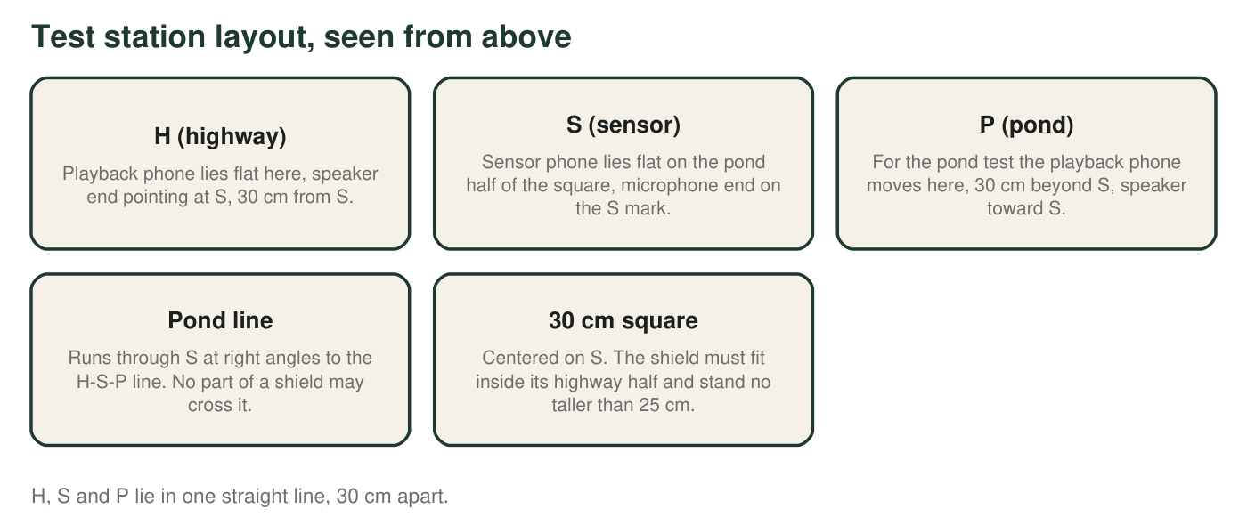
What the science says about stopping sound
Sound is a vibration passed through the air. When it meets a material, some of it is reflected (bounced back), some is absorbed (a little of its energy becomes heat in the material), and some is transmitted (passes through). Heavy, dense materials transmit less sound than light ones. Any gap or crack leaks sound, so a wall should meet the table. A barrier works best when it blocks the straight line between the source and the sensor with room to spare, because sound bends around edges, and low, rumbling pitches bend around more easily than high ones. Soft, porous materials such as towels and felt absorb sound that would otherwise bounce around inside a hood.
1. Turn each need into something you can test. Mark it as a criterion (what success requires) or a constraint (a limit on what is allowed), then write a measurable version with a number and a unit, and how you will check it.
Need | Criterion or constraint? | Our measurable version (number and unit) | How we will test or check it
Cut the highway noise reaching the sensor
Keep the frog calls from the pond reaching the sensor
Stay standing at the pond's edge
Fit at the site
Cost
Let biologists service the sensor
Do no harm to the pond

Class test rules (your teacher confirms these after you draft q1)
Criteria. C1: the average highway reading at S drops by at least 5 dB compared with no shield. C2: the average pond reading at S drops by no more than 2 dB compared with no shield. C3: the shield stays standing and in place through the bump test. Constraints. K1: kit materials only, 10 credits or fewer per design. K2: nothing touches the sensor phone, and the phone can be lifted out without moving the shield. K3: no part of the shield crosses the pond line. K4: the shield fits inside the highway half of the 30 cm square and is no taller than 25 cm. K5: nothing loose; every cotton ball, fiber or scrap is sealed in a bag or taped down, because loose material would end up in a real pond. K6: each design is built in 20 minutes or less.
Kit price list (invented credits for budgeting practice)
Cardboard sheet, 1 credit. Shoebox or carton, 2. Hand towel, 2. Felt or fleece square, 2. Egg carton, 1. Foil, 30 cm, 1. Bubble wrap sheet, 1. Bag of 10 cotton balls, 1. Paperback book or magazine stack, 3 each. Masking tape, free (up to 2 m per design). Scissors and ruler, free.
Sketch Design A and Design B. For each, draw a top view showing H, S, P, the pond line and the square, and a side view showing heights. Label every material and its size, and mark where you expect sound to be reflected or absorbed.

Design plans
Design | Big idea: what should stop the sound? | Materials and credits | Total credits | Predicted highway drop (dB) | Predicted pond change (dB)
A
B
Improved (optional)

Sound readings at the sensor (dB)
Test | Reading 1 | Reading 2 | Reading 3 | Average | Change from no shield
Background, nothing playing |  | — | — | — | —
Highway clip at H, no shield |  |  |  |  | 0
Highway clip at H, Design A
Highway clip at H, Design B
Pond clip at P, no shield |  |  |  |  | 0
Pond clip at P, Design A
Pond clip at P, Design B
Highway clip at H, improved design
Pond clip at P, improved design

Constraint check (write yes or no; one 'no' disqualifies a design)
Design | K1: 10 credits or fewer | K2: sensor untouched and removable | K3: pond line clear | K4: fits the half-square, 25 cm or lower | K5: nothing loose | K6: built in 20 min | C3: passed the bump test
A
B

Scoring guide for the decision matrix
Highway drop (C1): 3 = 8 dB or more; 2 = 5 to 7.9 dB; 1 = 3 to 4.9 dB; 0 = less than 3 dB. Pond change (C2): 3 = no drop, or a rise; 2 = a drop of up to 1 dB; 1 = a drop of 1.1 to 2 dB; 0 = a drop of more than 2 dB. Stability (C3): 3 = did not move; 2 = shifted but stayed standing; 1 = needed one fix; 0 = fell. Cost: 3 = 6 credits or fewer; 2 = 7 or 8; 1 = 9 or 10. Give each criterion a weight from 1 to 3 and explain why; multiply each score by its weight and add.
Decision matrix
Criterion | Weight (1 to 3) | Why this weight | Design A score (0 to 3) | A: weight × score | Design B score (0 to 3) | B: weight × score
C1 highway drop
C2 pond change
C3 stability
Cost
Total | — | — | — |  | —

2. Winning design: ___. Matrix totals: A ___, B ___. Winner's highway drop: ___ dB (C1 needs at least 5). Winner's pond change: ___ dB (C2 allows a drop of no more than 2). Constraints broken by the winner: ___.
______________________________________________________________________________________
______________________________________________________________________________________
______________________________________________________________________________________
3. Write a recommendation to the Willow Pond biologists. Which design should go to the pond, and why? Use your matrix totals and at least two measured numbers, explain the result with the science of reflection, absorption and transmission, and name one constraint your design keeps that protects the frogs or the pond.
______________________________________________________________________________________
______________________________________________________________________________________
______________________________________________________________________________________
______________________________________________________________________________________
______________________________________________________________________________________
______________________________________________________________________________________
______________________________________________________________________________________

Analysis questions
4. One team's highway readings with no shield were 71, 72 and 70 dB. With its shield they were 65, 64 and 65 dB. Find both averages and the drop. Does the shield meet C1?
______________________________________________________________________________________
______________________________________________________________________________________
______________________________________________________________________________________
______________________________________________________________________________________
5. A rule of thumb: every 3 dB drop cuts the sound energy reaching the sensor roughly in half. About what fraction of the original highway sound energy gets through a shield with a 6 dB drop? With a 9 dB drop?
______________________________________________________________________________________
______________________________________________________________________________________
______________________________________________________________________________________
6. Why must the clip, the volume and every phone position stay the same for every test, and why does each team measure its own no-shield readings at its own station instead of using another team's?
______________________________________________________________________________________
______________________________________________________________________________________
______________________________________________________________________________________
7. One team's shield cut the highway reading by 11 dB but also cut the pond reading by 8 dB. Using the purpose of the sensor, explain why this design fails even though it was the quietest in the class.
______________________________________________________________________________________
______________________________________________________________________________________
______________________________________________________________________________________
______________________________________________________________________________________
______________________________________________________________________________________
8. During one test the background reading, with nothing playing, was 60 dB because another team was testing nearby, and the shielded highway reading was 61 dB. Why can this test not show how well the shield works, and what should the team do?
______________________________________________________________________________________
______________________________________________________________________________________
______________________________________________________________________________________
9. Name two ways the classroom test differs from a real highway beside a real pond. For each, say whether a real shield would probably do better or worse than your test showed, and why.
______________________________________________________________________________________
______________________________________________________________________________________
______________________________________________________________________________________
______________________________________________________________________________________
______________________________________________________________________________________
10. Why do managers need trustworthy frog counts? Name two interactions that Willow Pond's chorus frogs take part in, rate each partner with +, − or 0, and predict one ripple effect on another population if the frogs declined and nobody noticed.
______________________________________________________________________________________
______________________________________________________________________________________
______________________________________________________________________________________
______________________________________________________________________________________
______________________________________________________________________________________
11. A real shield must stand outdoors through a whole spring breeding season. Write one new criterion and one new constraint you would add, each with a number.
______________________________________________________________________________________
______________________________________________________________________________________
______________________________________________________________________________________

