Angela's Tools · Chapter 21: Interactions Among Organisms · Worksheet 1 of 10

The Tree That Hires Bodyguards: Ants, Thorns and Nectar (Teacher answer key)
Learning target: I can observe an interaction between two species, describe what each partner gives and gets, and write a first explanation that I could test.
Phenomenon exploration · about 30 minutes · pairs · Standards: MS-LS2-2 (practice)

Standards connections
MS-LS2-2 (practice): Students meet one interaction up close, rate its effect on each partner and ask whether the same kind of partnership could exist elsewhere. That is the first step toward explaining and predicting patterns of interaction across ecosystems; no prediction across ecosystems is assessed yet.

Answers with reasoning

What you are looking at
In the dry forests of Central America grows a small tree called the bullhorn acacia. Its thorns are swollen and hollow, about the size of your thumb. Inside the thorns live colonies of small, fast, bad-tempered ants. The tree does two strange things for a plant. It leaks sugary nectar from tiny glands on its leaf stalks, and it grows little orange food packets, rich in protein and fat, on the tips of its leaflets. The ants eat both. The ants also do strange things for ants. They patrol the branches day and night. Any caterpillar, beetle or browsing mammal that touches the tree is stung within seconds. Any vine that starts to climb the trunk is chewed through. Seedlings that sprout near the base of the tree are clipped off. The ants almost never leave the tree, and they do not hunt anywhere else.
Scientists who study these trees have run a simple test: remove the ant colony from some trees and leave it on others, then come back a year later. The comparison below shows the kind of difference they describe. The numbers are a teaching version, invented to be realistic, not measurements copied from a real study.
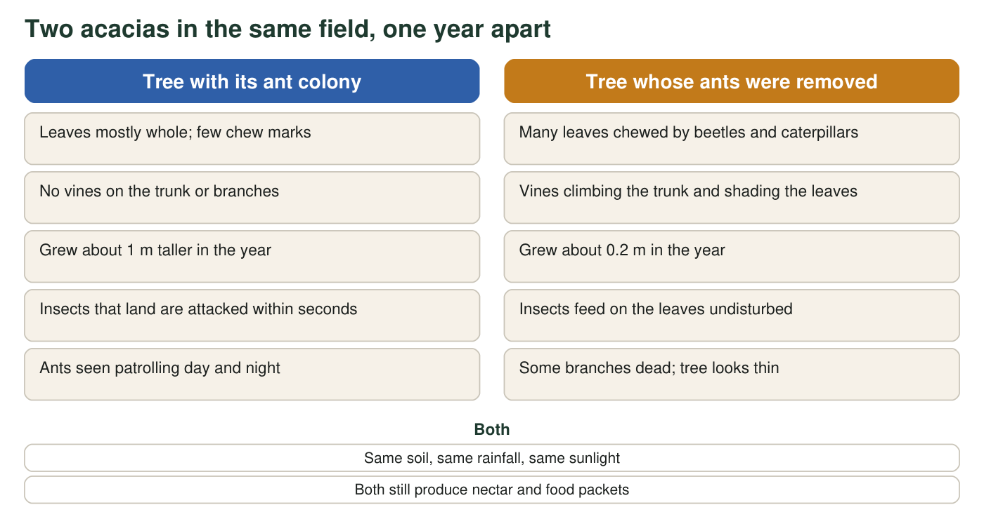
Teaching comparison modeled on field studies of acacia trees with and without their ants. The growth numbers are invented to be realistic, not measured.

Part A: Notice and wonder
1. Write three things you notice in the description or the comparison. Noticings are things you can see or read directly, not explanations.
Answer: Any three direct observations, for example: the thorns are hollow and ants live inside; the tree makes nectar and orange food packets; ants sting anything that touches the tree; ants chew through vines; the tree without ants grew only 0.2 m while the tree with ants grew about 1 m; the tree without ants has chewed leaves and vines on its trunk.
Reasoning: Noticings must be observations, not explanations. 'The ants protect the tree' is an inference; 'ants sting insects that land on the tree' is a noticing.
Also acceptable: Accept observations about the 'both' list, such as 'both trees still make nectar'.
Full credit must include:
• Three distinct observations
• Each is stated as something seen or read, not as a reason
2. Write two things you wonder. Start each with 'Why', 'How' or 'What would happen if'.
Answer: Any two genuine questions, for example: Why does the tree make food for ants instead of using the energy itself? How do the ants know the tree is being attacked? What would happen if the ants left? Do other trees have ant bodyguards? Would the ants survive if the tree died?
Reasoning: The question format is required so that students practice turning curiosity into something testable.
Also acceptable: Accept 'Do...' questions if they can be investigated.
Full credit must include:
• Two questions
• Each begins with Why, How or What would happen if
3. Complete the table using only facts from the description and the comparison.
Answer: Acacia gives: nectar, protein-and-fat food packets, hollow thorns to live in. Acacia gets: protection from leaf-eating insects and browsing mammals, vines removed, competing seedlings cleared. Ants give: stinging defense, vine and seedling clipping, constant patrolling. Ants get: food (nectar and packets) and a home (thorns).
Reasoning: Each cell can be filled from the description alone; the comparison supplies evidence that the protection is real.
Also acceptable: Accept 'a safe place to live' for the thorns.
Full credit must include:
• Both 'gives' cells name food or shelter from the tree and defense from the ants
• Both 'gets' cells are the mirror of the other partner's 'gives'
4. Rate the interaction for each partner: helped (+), harmed (−) or no effect (0). Give one piece of evidence for each rating.
Answer: Tree: + (the tree with ants grew about five times as much and kept its leaves whole). Ants: + (they get all their food and housing from the tree and do not need to hunt elsewhere).
Reasoning: Both partners gain; this is the pattern the lesson will later name mutualism. The growth difference (1 m versus 0.2 m) is the clearest evidence for the tree.
Also acceptable: A student who rates the ants 0 because 'they could live somewhere else' should be asked where the ants would get food; the description says they do not hunt off the tree.
Full credit must include:
• Both partners rated +
• A specific piece of evidence for each rating

Part B: Connect and explain
5. Think of another pair of living things you know about, from any place on Earth, that seem to help each other. Name them and say what each one gets.
Answer: Any accurate pairing, for example: bees and flowering plants (bees get nectar and pollen; plants get pollen carried between flowers); clownfish and sea anemones (fish get shelter among the stinging tentacles; the anemone gets a defender that chases away animals that would nibble it); people and dogs; cleaner fish and larger fish.
Reasoning: This activates prior knowledge of helpful interactions; accuracy matters more than the choice of pair.
Also acceptable: If a student names a pair in which only one partner benefits, note it and say the lesson will give that pattern its own name.
Full credit must include:
• Two named partners
• A benefit for each partner
6. First explanation. Making nectar and protein packets costs the tree sugar and energy it could have used to grow. Explain why a tree that 'pays' ants this way can end up taller and healthier than a tree that keeps the energy for itself. Use evidence from the comparison.
Answer: Model response: The tree spends sugar and protein on the ants, but in return it gets guards that stop insects and mammals from eating its leaves and that remove vines and seedlings. The comparison shows the cost of not having guards: the tree without ants had chewed leaves, vines shading it and dead branches, and it grew only 0.2 m, while the tree with ants grew about 1 m. Leaves are where the tree makes its food, so losing leaves to insects and shade costs the tree far more energy than the nectar and packets cost. Paying the ants is a good trade: the tree gives up a little energy to keep a lot.
Reasoning: A first explanation should reach the idea of a trade: a small cost that prevents a larger loss. Students need not use the word mutualism.
Also acceptable: A student who argues the tree does not 'choose' to pay but that trees which happened to feed ants survived better is giving a more advanced, correct explanation.
Full credit must include:
• States what the tree gives up
• States what the tree gains, with at least two facts from the comparison
• Reaches the idea that the gain is larger than the cost
7. The comparison shows one year. Describe one more test you would run, or one more measurement you would take, to be more certain that the ants are the reason for the difference.
Answer: Examples: repeat the test on many trees, not just two; follow the trees for several years; remove ants from some trees but also keep insects off those trees with a net, to check whether insects (not ants) explain the difference; count how many insects land on each tree per hour; measure leaf area lost to chewing; put ants back on a stripped tree and see whether it recovers.
Reasoning: The aim is to see that one comparison is suggestive, not conclusive, and that a fair test changes one thing at a time with enough repeats.
Also acceptable: Accept 'do it with more trees' with a reason.
Full credit must include:
• A test or measurement that would separate the ants' effect from other causes, or increase the number of trees or years
8. Predict: a disease sweeps through the forest and kills most of the ant colonies. What happens to the acacia population over the next few years, and why?
Answer: The acacia population would probably shrink. Without ants, trees would be chewed by insects, browsed by mammals and overgrown by vines, so they would grow slowly, produce fewer seeds and some would die. Young trees would be hit hardest. Because the partners depend on each other, a drop in one population pulls the other down.
Reasoning: The prediction follows from the comparison: the ant-free tree is the model for every tree after the disease.
Also acceptable: A student who adds that the ants would also be in trouble if trees died is making a correct two-way connection.
Full credit must include:
• Predicts a decline
• Links the decline to the loss of defense, using the comparison
Keep this sheet
At the end of the lesson you will read your answer to question 6 again. Scientists call a partnership like this one a mutualism. You will learn that the same kind of partnership, and four other kinds of interaction, turn up in ecosystems all over the world, which is what lets scientists predict what will happen when one partner's numbers change.

Teacher notes
The bullhorn acacia and its ants are a real, well-studied mutualism from Central America; the ant-removal pattern (heavy insect damage, vines, poor growth) is documented, but the growth figures on this sheet are invented for teaching and are labeled as such. Do not name the interaction before students have rated it in q4; the point of the sheet is to let them discover the plus-plus pattern. In the extension, the Kenyan study (large herbivores fenced out, trees reduced rewards, defending ants replaced) is a real result; keep the wording 'scientists reported' and do not add numbers. Collect q6 answers or have students keep them; W10's synthesis asks them to revise this first explanation.

