Angela's Tools · Chapter 21: Interactions Among Organisms · Worksheet 1 of 10

The Tree That Hires Bodyguards: Ants, Thorns and Nectar
Learning target: I can observe an interaction between two species, describe what each partner gives and gets, and write a first explanation that I could test.
Phenomenon exploration · about 30 minutes · pairs · Standards: MS-LS2-2 (practice)
Name: ____________________________ Date: ____________ Period: ______

Directions
Read the description of the acacia tree and its ants, then study the two-tree comparison. Work through the questions in order with a partner, but write your own answers. There are no wrong noticings. Your explanation in question 6 is a first draft; you will come back to it at the end of the lesson and see what you would change.

What you are looking at
In the dry forests of Central America grows a small tree called the bullhorn acacia. Its thorns are swollen and hollow, about the size of your thumb. Inside the thorns live colonies of small, fast, bad-tempered ants. The tree does two strange things for a plant. It leaks sugary nectar from tiny glands on its leaf stalks, and it grows little orange food packets, rich in protein and fat, on the tips of its leaflets. The ants eat both. The ants also do strange things for ants. They patrol the branches day and night. Any caterpillar, beetle or browsing mammal that touches the tree is stung within seconds. Any vine that starts to climb the trunk is chewed through. Seedlings that sprout near the base of the tree are clipped off. The ants almost never leave the tree, and they do not hunt anywhere else.
Scientists who study these trees have run a simple test: remove the ant colony from some trees and leave it on others, then come back a year later. The comparison below shows the kind of difference they describe. The numbers are a teaching version, invented to be realistic, not measurements copied from a real study.
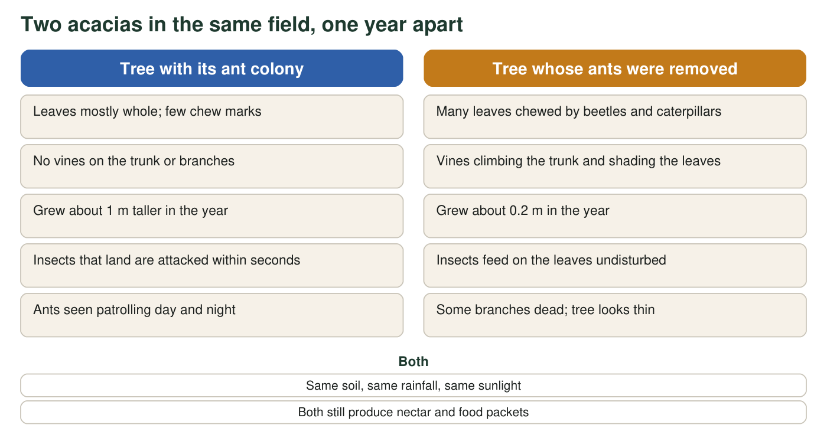
Teaching comparison modeled on field studies of acacia trees with and without their ants. The growth numbers are invented to be realistic, not measured.

Part A: Notice and wonder
1. Write three things you notice in the description or the comparison. Noticings are things you can see or read directly, not explanations.
______________________________________________________________________________________
______________________________________________________________________________________
______________________________________________________________________________________
2. Write two things you wonder. Start each with 'Why', 'How' or 'What would happen if'.
______________________________________________________________________________________
______________________________________________________________________________________
______________________________________________________________________________________
3. Complete the table using only facts from the description and the comparison.
What this partner GIVES | What this partner GETS
The acacia tree
The ants

4. Rate the interaction for each partner: helped (+), harmed (−) or no effect (0). Give one piece of evidence for each rating.
______________________________________________________________________________________
______________________________________________________________________________________
______________________________________________________________________________________

Part B: Connect and explain
5. Think of another pair of living things you know about, from any place on Earth, that seem to help each other. Name them and say what each one gets.
______________________________________________________________________________________
______________________________________________________________________________________
______________________________________________________________________________________
6. First explanation. Making nectar and protein packets costs the tree sugar and energy it could have used to grow. Explain why a tree that 'pays' ants this way can end up taller and healthier than a tree that keeps the energy for itself. Use evidence from the comparison.
______________________________________________________________________________________
______________________________________________________________________________________
______________________________________________________________________________________
______________________________________________________________________________________
______________________________________________________________________________________
______________________________________________________________________________________
______________________________________________________________________________________
7. The comparison shows one year. Describe one more test you would run, or one more measurement you would take, to be more certain that the ants are the reason for the difference.
______________________________________________________________________________________
______________________________________________________________________________________
______________________________________________________________________________________
8. Predict: a disease sweeps through the forest and kills most of the ant colonies. What happens to the acacia population over the next few years, and why?
______________________________________________________________________________________
______________________________________________________________________________________
______________________________________________________________________________________
Keep this sheet
At the end of the lesson you will read your answer to question 6 again. Scientists call a partnership like this one a mutualism. You will learn that the same kind of partnership, and four other kinds of interaction, turn up in ecosystems all over the world, which is what lets scientists predict what will happen when one partner's numbers change.

Sentence frames for the explanation
If question 6 feels hard, build it from these frames: 'The tree spends energy on ___ and ___.' 'In return the ants ___ and ___.' 'The comparison shows that the tree without ants ___, so it lost more than it saved.' 'Therefore paying the ants is worth it because ___.' Use at least two facts from the comparison, such as the growth numbers or the chewed leaves.

When the bodyguards are no longer needed
On the savannas of Kenya, a related acacia feeds and houses ants that defend it against elephants and giraffes. Scientists reported that when large animals were fenced out of some plots for about ten years, the trees inside the fences made fewer swollen thorns and less nectar, their defending ants declined, and other, less helpful ants moved in. Write a paragraph explaining why a tree might 'stop paying' when there is nothing to defend against, and why that could end up hurting the tree anyway. Then write one question you would want to ask the scientists.

