Angela's Tools · Chapter 21: Interactions Among Organisms · Worksheet 4 of 10

Reading the Waves: Rabbits, Foxes and the Lag Between Them (Teacher answer key)
Learning target: I can read a predator-prey graph to find peaks, lows and the lag between them, explain each stage of the cycle as cause and effect, and build a model that predicts the same pattern for a new pair of species.
Diagrams and models · about 40 minutes · individual · Standards: MS-LS2-2 (practice)

Standards connections
MS-LS2-2 (practice): Interpreting the lagged predator-prey pattern and then sketching it for a different pair of species in a different ecosystem is the model-building half of predicting consistent patterns of interaction across ecosystems.

Answers with reasoning

Part A: Read the graph
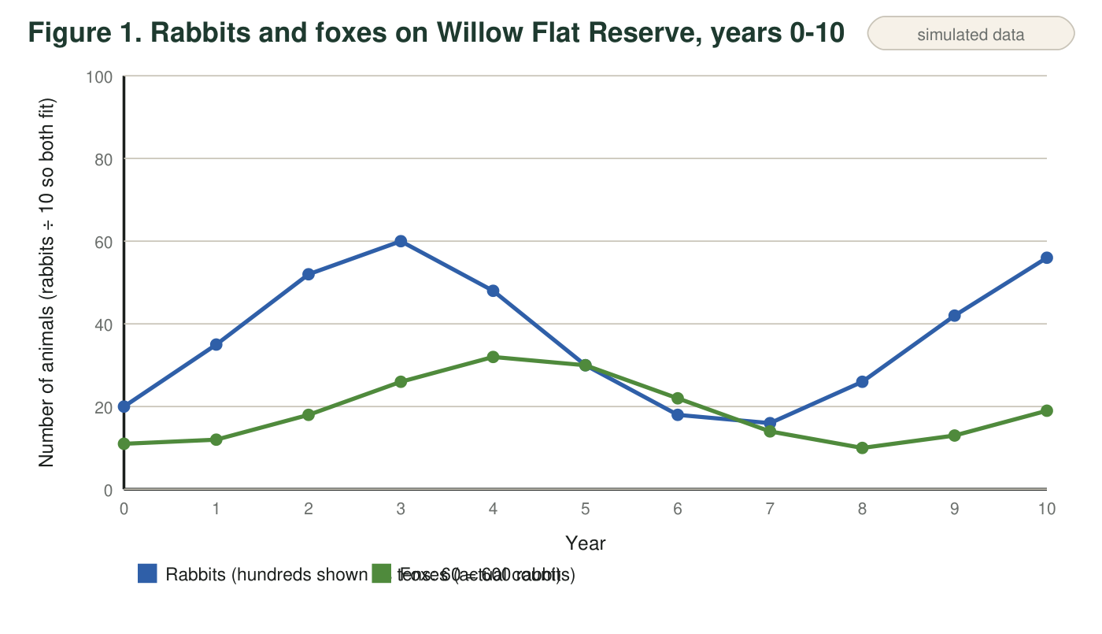
Teaching data: rabbit and fox counts on a fenced 400-hectare reserve, invented to be realistic. Rabbits are counted in hundreds of animals; foxes are counted as individual adults. Read both lines against the same year axis.
Reading the rabbit line
To keep both lines on one graph, the rabbit line is drawn at one-tenth of the real count. A rabbit value of 60 on the graph means 600 rabbits; 16 means 160 rabbits. The fox line shows the real number of foxes. Multiply rabbit readings by 10 before you calculate.
1. In which year were rabbits most numerous, and how many rabbits were there? In which year were foxes most numerous, and how many?
Answer: Rabbits: year 3, 60 on the graph = 600 rabbits. Foxes: year 4, 32 foxes.
Reasoning: The highest rabbit point is at year 3 (60 × 10 = 600). The highest fox point is at year 4 (32).
Also acceptable: Accept 'about 600' and '32'.
2. Find the lag: how many years after the rabbit peak does the fox peak come? Do the same for the lowest points of each line. Show the subtraction.
Answer: Peaks: fox peak year 4 − rabbit peak year 3 = 1 year lag. Lows: rabbits lowest in year 7 (160); foxes lowest in year 8 (10); 8 − 7 = 1 year lag.
Reasoning: Both the peaks and the lows show the fox line trailing the rabbit line by one year, which is the pattern the sheet is built on.
Also acceptable: Accept 'about one year' for both.
3. Calculate the number of rabbits per fox in year 3 and in year 7. Show your work and round to one decimal place. What does the change tell you about how easy it was for a fox to find food?
Answer: Year 3: 600 rabbits ÷ 26 foxes = 23.1 rabbits per fox. Year 7: 160 rabbits ÷ 14 foxes = 11.4 rabbits per fox. The number of rabbits per fox fell by about half, so each fox had far fewer prey to find in year 7 than in year 3; food was scarce for foxes.
Reasoning: Students must convert the rabbit reading (×10) before dividing. 600/26 = 23.08; 160/14 = 11.43.
Also acceptable: Accept 23 and 11 if rounded to whole numbers with the work shown. A student who forgets the ×10 gets 2.3 and 1.1; the ratio of the two is still correct, so give partial credit and point to the callout.
4. Describe what happens to each population between year 4 and year 7. For each change, name the cause from the other population.
Answer: Rabbits fall from 480 (year 4) to 160 (year 7) because there are many foxes (32 at the peak) eating them faster than they can breed. Foxes rise to 32 in year 4 and then fall to 14 by year 7 because rabbits, their food, have become scarce, so fewer fox cubs survive and some adults starve or leave.
Reasoning: Each change must be tied to the other population: prey fall is caused by many predators; predator fall is caused by scarce prey.
Also acceptable: Accept 'foxes ate too many rabbits, then ran out of food.'
Full credit must include:
• Rabbit decline with values and the fox cause
• Fox decline with values and the rabbit cause
5. On the graph the fox line touches the rabbit line in year 5 and rises above it in year 6, but only because the rabbit line is drawn at one-tenth size. In real numbers, every year has at least 8 rabbits for every fox. Explain why a predator population is usually much smaller than the population of its main prey.
Answer: Each fox must eat many rabbits over its life to survive, grow and raise cubs; only a small part of the energy in the rabbits it eats becomes fox. So a prey population can only support a predator population that is much smaller than itself. If there were as many foxes as rabbits, the rabbits would be gone in days.
Reasoning: The idea is that predators need many prey each, so predators are fewer. Energy loss between feeding levels is a fuller explanation but is not required.
Also acceptable: Accept an answer based on energy: 'only some of the rabbit's energy becomes fox.'
Full credit must include:
• States that each predator needs many prey
• Concludes predators must be fewer than prey
6. In year 10 the rabbits are at 560 and rising. Predict the direction of each line in years 11 and 12, and explain the prediction using the lag.
Answer: Rabbits will probably keep rising in year 11 and then level off or start to fall by year 12 as foxes catch up. Foxes will keep rising in years 11 and 12, trailing the rabbit rise by about a year, because the rabbit increase in years 9-10 gives foxes more food and more surviving cubs, which show up in later counts.
Reasoning: The prediction should apply the one-year lag: fox rise follows rabbit rise, and the rabbit peak comes before the fox peak.
Also acceptable: Accept a rabbit peak in year 11 or 12 as long as the fox peak is placed later.
Full credit must include:
• Foxes rising in 11 and 12
• Rabbits rising then peaking or starting to fall
• Mentions the lag as the reason

Part B: The cycle as cause and effect
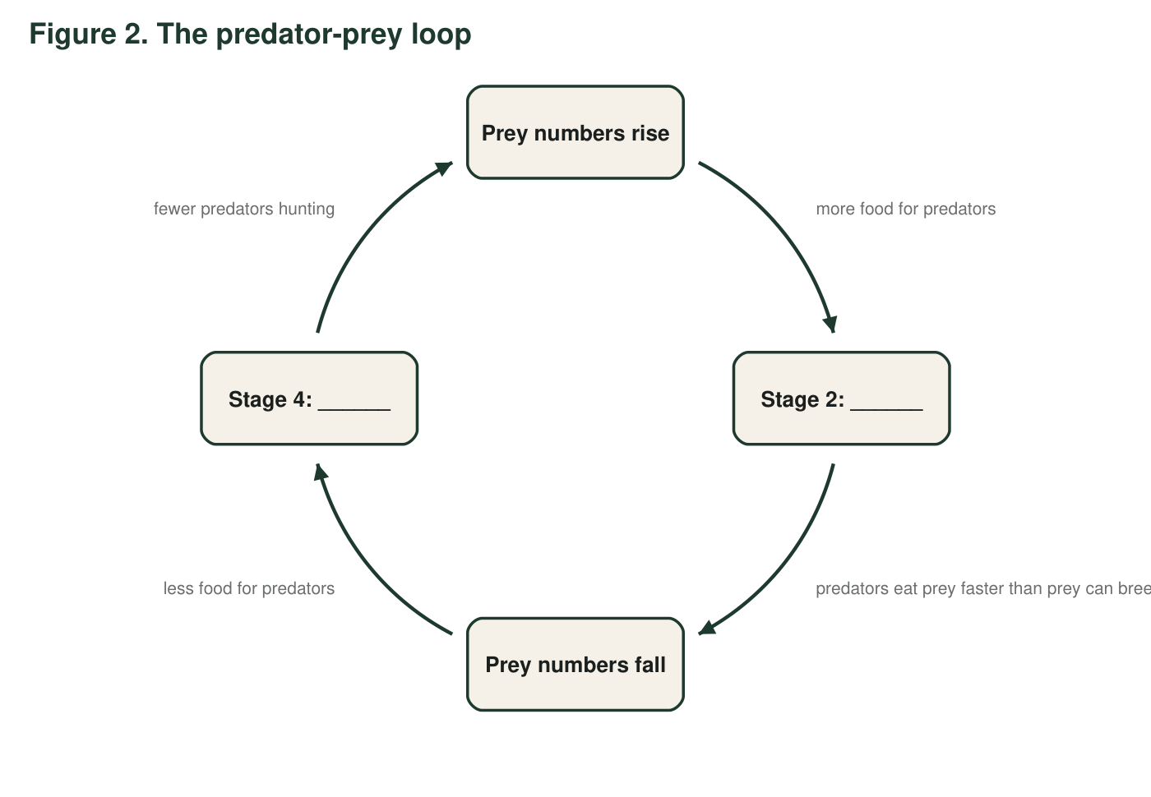
Figure 2 shows the same pattern as a loop. Each arrow means 'this causes the next.' Two of the stages have been left blank for you.
7. Complete the loop. Stage 2: ______________________. Stage 4: ______________________.
Answer: Stage 2: Predator numbers rise. Stage 4: Predator numbers fall.
Reasoning: The loop alternates prey change, predator change, prey change, predator change; the edge labels ('more food for predators', 'fewer predators hunting') confirm the missing stages.
Also acceptable: Accept 'more foxes' and 'fewer foxes' or 'predators increase' and 'predators decrease'.
8. Figure 2 is a loop that could run forever. Name two real-world factors that could change the size or timing of a wave, and say which stage each one would affect.
Answer: Examples: a hard winter or drought that kills prey or their food (affects the 'prey numbers fall' stage, making the fall deeper or earlier); disease in the predator (deepens 'predator numbers fall'); a second prey species the predator can switch to (softens 'predator numbers fall'); a second predator arriving (steepens 'prey numbers fall'); people hunting either species.
Reasoning: Any two sensible outside factors tied to a stage of the loop earn credit; the point is that the loop is an idealized model and real waves vary.
Also acceptable: Accept 'food shortage for the prey' as a factor affecting the prey-fall stage.
Full credit must include:
• Two outside factors
• Each tied to a stage of the loop

Part C: Build the model for a new ecosystem
On an Arctic island, lemmings (small rodents) are the main prey of snowy owls. A field team reports: lemmings were very abundant in year 1, crashed in year 2, stayed low in years 3 and 4, and were very abundant again in year 5. No owl counts were made. Use the pattern from Figures 1 and 2 to predict the owl line.
Draw a graph with 'Year' (1 to 6) on the horizontal axis and 'Number of animals' on the vertical axis. Draw the lemming line from the report as a solid line. Then draw the predicted snowy owl line as a dashed line, keeping it below the lemming line. Mark each lemming peak with a P and each owl peak with an O. Draw a bracket showing the lag and write how long it is. Add a title and a key.
Expected drawing: A titled, keyed graph with years 1-6 on the x-axis. Lemming line (solid): high at year 1, low at year 2, low at years 3-4, high at year 5, and a reasonable continuation at year 6 (starting to fall). Owl line (dashed, below the lemming line throughout): peak about year 2 (one year after the year-1 lemming peak), falling through years 3-4 to a low about year 3-4, rising again to a peak about year 6 (one year after the year-5 lemming peak). P marks on years 1 and 5; O marks on years 2 and 6; a bracket labeled 'lag ≈ 1 year'.
Reasoning: The drawing applies the one-year lag from Figure 1 to a new pair of species. Because the lemming crash is sudden, a strong answer shows the owl peak as brief. Exact heights are not assessed; order and lag are.
9. Explain two choices you made in your drawing: where you put the owl peaks, and why you kept the owl line below the lemming line.
Answer: Owl peaks were placed about one year after each lemming peak because owls need a season of plentiful food to raise more chicks before their numbers rise, as in Figure 1 and Figure 2. The owl line stays below the lemming line because each owl eats many lemmings, so the island can only support far fewer owls than lemmings.
Reasoning: Both choices should be justified with the pattern from Part A and B, not just 'that is what the figure looked like.'
Also acceptable: Accept 'owls follow lemmings' for the first if the time-to-raise-young idea appears anywhere in the answer.
Full credit must include:
• Lag explained by reproduction taking time
• Lower line explained by predators needing many prey each
10. Your drawing is a prediction, not a measurement. Name one thing about the real island that could make the real owl line look different from yours.
Answer: Any one: snowy owls can fly away from the island when lemmings crash instead of starving, so the owl 'crash' might be a departure; owls might eat seabirds or other prey, softening their fall; a severe winter could kill owls regardless of lemmings; owls might arrive from elsewhere when lemmings are abundant, making their rise faster than breeding alone would allow.
Reasoning: The point is that the pattern predicts the general shape, not the exact line; real factors bend it.
Also acceptable: Accept 'the lemming crash might have been caused by weather, not owls' as a factor affecting the match.
Full credit must include:
• One realistic factor that would change the predicted owl line

Teacher notes
Figure 1 is fully simulated; the counts were chosen so that both peaks (year 3 rabbits, year 4 foxes) and both lows (year 7 rabbits, year 8 foxes) show a clean one-year lag. The rabbit line is scaled by one-tenth so both species fit one axis; the callout explains this, and q3 is the item most likely to expose a student who skipped it. Real predator-prey data are far messier than Figure 1 and the lag varies from months to years depending on how fast the predator breeds; say so when debriefing q8 and q10. Snowy owls really do move long distances and switch prey, which is why the Part C prediction is framed as a model to be checked. The textbook's Figure 2 draws smooth regular waves; this sheet's Figure 2 loop makes the same simplification on purpose, and q8 asks students to break it.

