Angela's Tools · Chapter 21: Interactions Among Organisms · Worksheet 4 of 10

Reading the Waves: Rabbits, Foxes and the Lag Between Them
Learning target: I can read a predator-prey graph to find peaks, lows and the lag between them, explain each stage of the cycle as cause and effect, and build a model that predicts the same pattern for a new pair of species.
Diagrams and models · about 40 minutes · individual · Standards: MS-LS2-2 (practice)
Name: ____________________________ Date: ____________ Period: ______

Directions
Figure 1 is a teaching graph: the counts were invented to be realistic for a fenced reserve, not measured in the field. Use a ruler to read values off the lines. Answer Part A from Figure 1, Part B from Figure 2, then build your own model in Part C. Label every drawing; an unlabeled line earns no credit.

Part A: Read the graph
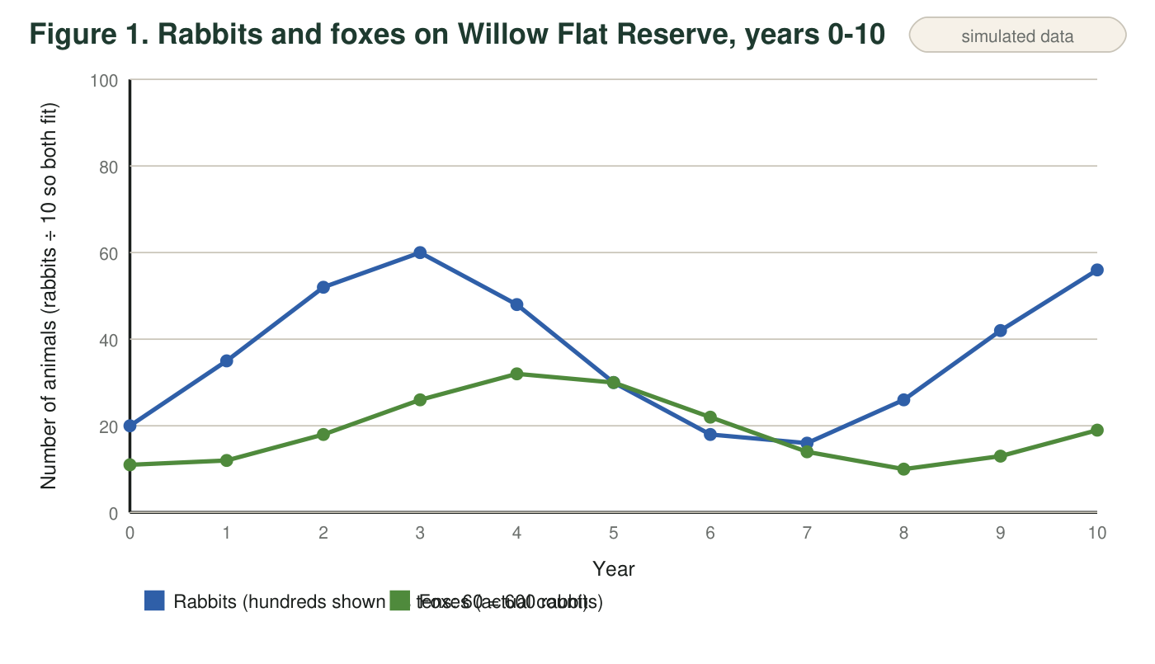
Teaching data: rabbit and fox counts on a fenced 400-hectare reserve, invented to be realistic. Rabbits are counted in hundreds of animals; foxes are counted as individual adults. Read both lines against the same year axis.
Reading the rabbit line
To keep both lines on one graph, the rabbit line is drawn at one-tenth of the real count. A rabbit value of 60 on the graph means 600 rabbits; 16 means 160 rabbits. The fox line shows the real number of foxes. Multiply rabbit readings by 10 before you calculate.
1. In which year were rabbits most numerous, and how many rabbits were there? In which year were foxes most numerous, and how many?
______________________________________________________________________________________
______________________________________________________________________________________
2. Find the lag: how many years after the rabbit peak does the fox peak come? Do the same for the lowest points of each line. Show the subtraction.
______________________________________________________________________________________
______________________________________________________________________________________
3. Calculate the number of rabbits per fox in year 3 and in year 7. Show your work and round to one decimal place. What does the change tell you about how easy it was for a fox to find food?
______________________________________________________________________________________
______________________________________________________________________________________
______________________________________________________________________________________
4. Describe what happens to each population between year 4 and year 7. For each change, name the cause from the other population.
______________________________________________________________________________________
______________________________________________________________________________________
______________________________________________________________________________________
______________________________________________________________________________________
5. On the graph the fox line touches the rabbit line in year 5 and rises above it in year 6, but only because the rabbit line is drawn at one-tenth size. In real numbers, every year has at least 8 rabbits for every fox. Explain why a predator population is usually much smaller than the population of its main prey.
______________________________________________________________________________________
______________________________________________________________________________________
______________________________________________________________________________________
6. In year 10 the rabbits are at 560 and rising. Predict the direction of each line in years 11 and 12, and explain the prediction using the lag.
______________________________________________________________________________________
______________________________________________________________________________________
______________________________________________________________________________________

Part B: The cycle as cause and effect
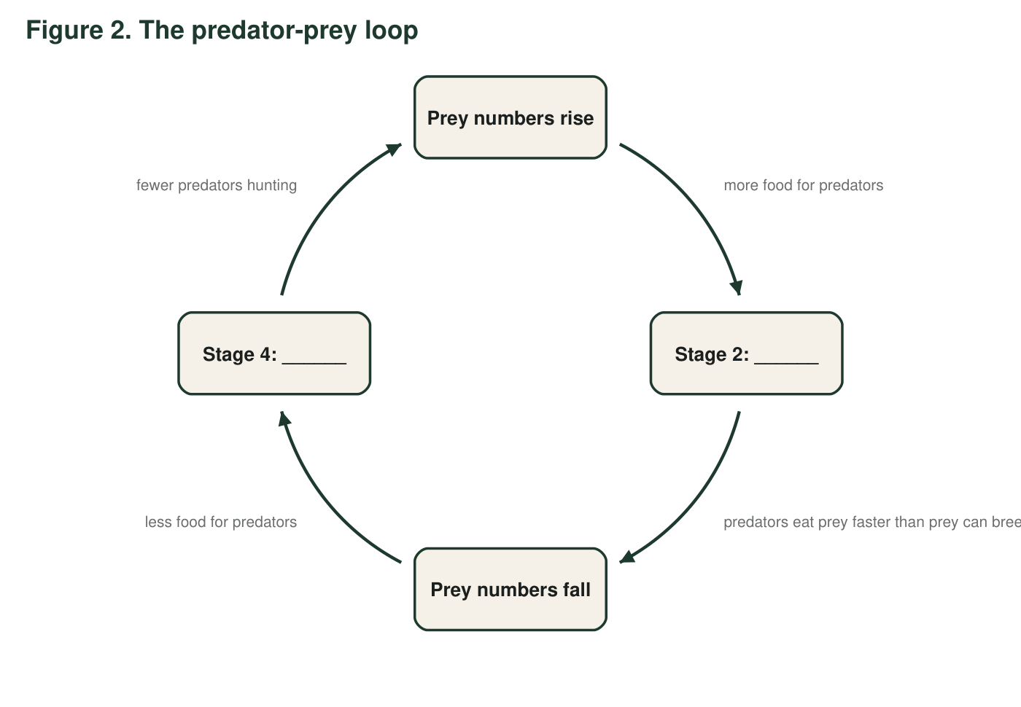
Figure 2 shows the same pattern as a loop. Each arrow means 'this causes the next.' Two of the stages have been left blank for you.
7. Complete the loop. Stage 2: ______________________. Stage 4: ______________________.
______________________________________________________________________________________
______________________________________________________________________________________
______________________________________________________________________________________
8. Figure 2 is a loop that could run forever. Name two real-world factors that could change the size or timing of a wave, and say which stage each one would affect.
______________________________________________________________________________________
______________________________________________________________________________________
______________________________________________________________________________________

Part C: Build the model for a new ecosystem
On an Arctic island, lemmings (small rodents) are the main prey of snowy owls. A field team reports: lemmings were very abundant in year 1, crashed in year 2, stayed low in years 3 and 4, and were very abundant again in year 5. No owl counts were made. Use the pattern from Figures 1 and 2 to predict the owl line.
Draw a graph with 'Year' (1 to 6) on the horizontal axis and 'Number of animals' on the vertical axis. Draw the lemming line from the report as a solid line. Then draw the predicted snowy owl line as a dashed line, keeping it below the lemming line. Mark each lemming peak with a P and each owl peak with an O. Draw a bracket showing the lag and write how long it is. Add a title and a key.

9. Explain two choices you made in your drawing: where you put the owl peaks, and why you kept the owl line below the lemming line.
______________________________________________________________________________________
______________________________________________________________________________________
______________________________________________________________________________________
10. Your drawing is a prediction, not a measurement. Name one thing about the real island that could make the real owl line look different from yours.
______________________________________________________________________________________
______________________________________________________________________________________
______________________________________________________________________________________

Peaks and valleys first
Before you answer anything, put a small triangle on the highest point of each line in Figure 1 and a small circle on the lowest point of each line. Write the year under each mark. Every question in Part A can be answered by comparing those four marks. For Part C, start with the lemming line only, then ask at each lemming peak: 'What will the owls be doing one year later?' and place the owl peak there.

What if the predator has a backup meal?
Snowy owls on some islands also eat seabirds. Redraw your Part C graph on scrap paper for an island where owls switch to seabirds whenever lemmings are scarce. Explain in a paragraph how the owl line would differ from your first drawing, what that does to the lag and the size of the owl crash, and why a predator with several prey species makes the prediction less reliable.

