Angela's Tools · Chapter 22: Changing Ecosystems · Worksheet 1 of 10

Gray to Green: What Happened at Mount St. Helens After 1980? (Teacher answer key)
Learning target: I can observe a described recovery, record what I notice and wonder, and write a first explanation of how an ecosystem can return after a sudden change.
Phenomenon exploration · about 30 minutes · individual · Standards: MS-LS2-4 (practice), MS-LS2-1 (supports)

Standards connections
MS-LS2-4 (practice): Students begin noticing that a physical change (an eruption that buried the land) reshaped which populations lived there, and start asking what evidence would show how populations came back. This is the opening move toward building an argument from evidence.
MS-LS2-1 (supports): The initial explanation draws on the earlier idea that populations depend on resources such as soil, water and shelter, which the eruption removed and recovery slowly rebuilt.

Answers with reasoning

Scene one: the morning of May 18, 1980
Mount St. Helens is a volcano in the Cascade Range of Washington State. At 8:32 in the morning on May 18, 1980, an earthquake shook the mountain and its bulging north side collapsed. The collapse was the largest landslide in recorded history. It uncorked the volcano, and a sideways blast of hot gas, rock and ash raced across the land north of the mountain faster than a car on a highway. Within minutes, forests on the slopes were knocked flat or stripped bare across roughly 600 square kilometers. Hot flows of pumice piled up north of the crater, and the summit was about 400 meters shorter than it had been the day before. Fifty-seven people died. Ash drifted east and fell on towns hundreds of kilometers away.
Imagine standing on the plain of pumice north of the crater a few weeks later. The ground is gray, hot in places, and silent. There are no trees, no grass, no insects buzzing. Nearby, in the zone where the blast knocked the forest down, enormous trees lie on their sides, all pointing the same direction, under a blanket of ash. A lake that had been ringed with forest is now covered with a floating mat of thousands of dead trees.

Scene two: the same places, decades later
Scientists kept visiting the same spots year after year, counting plants and animals. Within about two years of the eruption, one of them found a single purple-flowered plant, a prairie lupine, growing on the bare pumice far from any other plant. Lupines have bacteria in their roots that turn nitrogen gas from the air into a form plants can use, so each lupine patch left the ground a little richer when it died. Insects, then seeds of other plants, collected in the lupine patches. In the knocked-down forest zone, small burrowing animals called pocket gophers had survived underground; their digging mixed buried soil up into the ash. Elk walked back in, trampling the ash and carrying seeds in their droppings. Willows and alders took root along streams. Frogs and salamanders returned to ponds within a few years. Today the blast zone has meadows, shrubs and young trees, though the pumice plain is still patchy and open, and nowhere does the land look exactly as it did before the eruption.
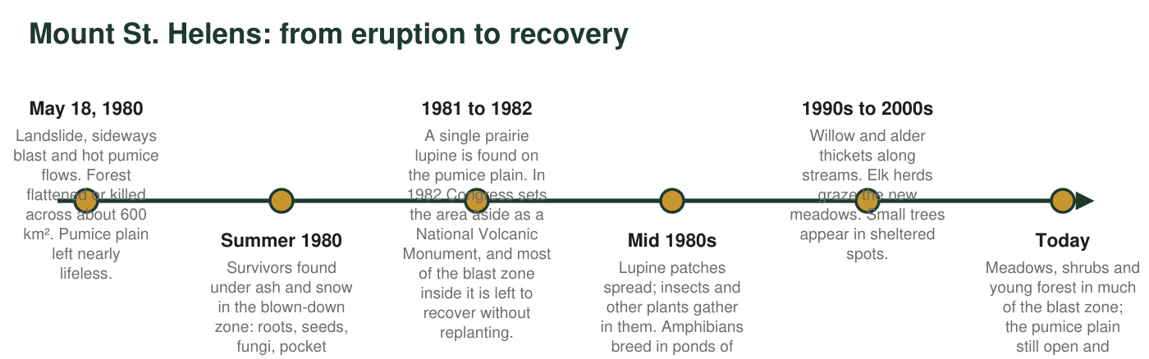
Figure 1. A timeline of the first decades of recovery north of Mount St. Helens. The dates of the eruption and the creation of the monument are exact; accounts date the first lupine to 1981 or 1982. The later entries describe general trends scientists have reported, not a fixed schedule.

Part A: Notice and wonder
1. Write at least three things you notice in the scenes and the timeline. A notice is something you can point to in the text, not a guess about why.
Answer: Any three accurate notices, for example: the blast flattened or stripped forest across about 600 km²; the summit lost about 400 m; the pumice plain had no plants or insects at first; a single lupine was found on the pumice plain within about two years of the eruption; some animals (pocket gophers) survived underground; lupines have root bacteria that add usable nitrogen; elk carried seeds; the pumice plain is still patchy today while other zones have young forest.
Reasoning: A notice must be traceable to the text or the timeline. Statements of cause ('the lupine made the soil better so trees grew') are inferences and belong in Part C; accept them here only if the student also records what the text literally says.
Also acceptable: Noticing the floating log mat on the lake or the direction of the fallen trees is a fine observation.
Full credit must include:
• At least three notices
• Each notice can be found in the scenes or timeline
• Notices are observations, not explanations
2. Write at least three things you wonder. Write each one as a question that a scientist could try to answer by collecting evidence.
Answer: Any three testable questions, for example: How many years did it take for the number of plant species on the pumice plain to match the blown-down zone? Did lupine patches have more insects than bare pumice nearby? Did areas with gophers recover faster than areas without? How did the lake's oxygen levels change as the logs decayed? Will the pumice plain ever become forest?
Reasoning: Full credit requires questions that could be answered with counts, measurements or comparisons. 'Was it scary?' is a real question but not a scientific one; ask the student to rewrite it.
Also acceptable: Accept questions about engineering or people (for example, 'Should people have replanted trees?') if the student can say what evidence would help decide.
Full credit must include:
• At least three questions
• Each could be answered by collecting evidence

Part B: Connect to what you know
3. In earlier lessons you learned that populations need resources such as food, water, shelter and space. List three resources the pumice plain was missing in the summer of 1980.
Answer: Any three of: soil (the pumice had no soil and little usable nitrogen), plants as food, shelter or shade, living space that was not hot or loose, water that stayed on the surface, seeds or any living things to start from.
Reasoning: This connects the eruption to the resource idea from MS-LS2-1: populations were absent because the resources they depend on were gone.
Also acceptable: Accept 'nitrogen' as a resource since the text explains the lupine's role.
Full credit must include:
• Three resources named
• Each is something the pumice plain lacked
4. The lupine, the pocket gopher and the elk each changed the land in a way that helped other living things. Pick one and describe, in your own words, what it changed and who benefited.
Answer: Lupine: its root bacteria turned nitrogen gas into a usable form, and dead lupines enriched the pumice, so other plants and insects could live in the patches. Pocket gopher: tunneling mixed buried soil into the ash, giving plant seeds a better place to grow. Elk: trampling broke up the ash surface and their droppings carried seeds in, so new plants started where elk walked.
Reasoning: The point is that living things are themselves a cause of change in an ecosystem; each organism altered a physical component (soil, nitrogen, seed supply) and other populations benefited.
Also acceptable: A student who says the lupine 'made soil' is close enough at this stage; the lesson will sharpen it to 'enriched the pumice with nitrogen and organic matter'.
Full credit must include:
• Names one of the three organisms
• Describes the change it made to the land
• Names who benefited
5. The pumice plain and the blown-down forest zone recovered at different speeds. Which one do you predict recovered faster? Give one reason from the text.
Answer: The blown-down forest zone. Reasons from the text: survivors (roots, seeds, fungi, gophers, insects) were already there under the ash and snow; there was old soil beneath the ash; amphibians returned to its ponds within a few years, while the pumice plain is still open and patchy today.
Reasoning: The prediction is correct and the text supports it. The key idea for later worksheets is the difference between starting from survivors (secondary succession) and starting from nothing (primary succession).
Also acceptable: A student who predicts the pumice plain but gives a reasoned argument earns partial credit; redirect them to the 'survivors' sentence.
Full credit must include:
• Predicts the blown-down zone
• Gives one reason from the text

Part C: Your first explanation
6. Write a first explanation of this question: How can an ecosystem come back after almost everything in it is destroyed? Use at least two pieces of information from this sheet. It is fine to say what you are unsure about.
Answer: A strong first explanation: Recovery starts from two sources, living things that survived (underground gophers, roots and seeds, fungi) and living things that arrive from outside (lupine seeds, elk, insects on the wind). The first arrivals change the land itself: lupines add usable nitrogen, gophers mix soil, elk carry seeds. Those changes restore resources (soil, food, shelter), so more populations can live there, and each new population changes the place a little more. Recovery is faster where survivors remained and slower where nothing was left, and the result does not have to match the original ecosystem.
Reasoning: This is a first explanation, so credit the use of evidence and the chain of cause and effect rather than vocabulary. The terms succession, pioneer species and primary versus secondary succession come later in the chapter.
Also acceptable: A student who explains recovery only by 'seeds blew in' has part of the story; ask what the seeds needed in order to grow.
Full credit must include:
• Uses at least two pieces of information from the sheet
• Describes a sequence or chain (first..., then...)
• Connects living things to changes in resources or the land
7. What evidence would you want scientists to collect to test your explanation? Name one kind of measurement and say how often it should be repeated.
Answer: Examples: count the number of plant species (or percent of ground covered by plants) in fixed study squares on the pumice plain and in the blown-down zone every summer; count insects in lupine patches and on bare pumice each year; measure soil nitrogen each year. Repeating yearly at the same spots lets scientists see a trend instead of a single snapshot.
Reasoning: The answer should describe a repeatable measurement at fixed locations, because the chapter's evidence comes from exactly this kind of long-term comparison.
Also acceptable: Accept photographs from the same spot each year as a measurement if the student says what would be compared in them.
Full credit must include:
• Names a measurable quantity
• States a repeat interval (yearly, every few years)

Teacher notes
All historical statements on this sheet are established: the eruption began at 8:32 a.m. on May 18, 1980, after a magnitude 5.1 earthquake triggered the largest landslide in recorded history; the lateral blast damaged forest across roughly 600 square kilometers; 57 people died; the summit lost about 400 meters; Congress created the Mount St. Helens National Volcanic Monument in 1982. The first prairie lupine on the pumice plain is dated 1981 in Washington State University accounts and about 1982 in others, so the scene says 'within about two years' and the timeline gives both years; do not assess the exact year. The timeline's later entries describe trends reported by monument scientists rather than exact years, and the caption says so. Keep this sheet; students revisit q6 in Worksheet 10. The textbook says an eruption can kill all living things in an area; this sheet deliberately includes the survivors (gophers, roots, seeds, fungi) because they mattered to recovery, which is the accurate account. Hold off on naming primary and secondary succession until Worksheet 2.

