Angela's Tools · Chapter 22: Changing Ecosystems · Worksheet 1 of 10

Gray to Green: What Happened at Mount St. Helens After 1980?
Learning target: I can observe a described recovery, record what I notice and wonder, and write a first explanation of how an ecosystem can return after a sudden change.
Phenomenon exploration · about 30 minutes · individual · Standards: MS-LS2-4 (practice), MS-LS2-1 (supports)
Name: ____________________________ Date: ____________ Period: ______

Directions
Read the two scene descriptions and study the timeline. Do not try to be right yet; this sheet is for noticing and asking. Write at least three notices and three wonders. Then use what you already know about resources and populations to write a first explanation. You will come back to this sheet at the end of the chapter to see how your thinking changed.

Scene one: the morning of May 18, 1980
Mount St. Helens is a volcano in the Cascade Range of Washington State. At 8:32 in the morning on May 18, 1980, an earthquake shook the mountain and its bulging north side collapsed. The collapse was the largest landslide in recorded history. It uncorked the volcano, and a sideways blast of hot gas, rock and ash raced across the land north of the mountain faster than a car on a highway. Within minutes, forests on the slopes were knocked flat or stripped bare across roughly 600 square kilometers. Hot flows of pumice piled up north of the crater, and the summit was about 400 meters shorter than it had been the day before. Fifty-seven people died. Ash drifted east and fell on towns hundreds of kilometers away.
Imagine standing on the plain of pumice north of the crater a few weeks later. The ground is gray, hot in places, and silent. There are no trees, no grass, no insects buzzing. Nearby, in the zone where the blast knocked the forest down, enormous trees lie on their sides, all pointing the same direction, under a blanket of ash. A lake that had been ringed with forest is now covered with a floating mat of thousands of dead trees.

Scene two: the same places, decades later
Scientists kept visiting the same spots year after year, counting plants and animals. Within about two years of the eruption, one of them found a single purple-flowered plant, a prairie lupine, growing on the bare pumice far from any other plant. Lupines have bacteria in their roots that turn nitrogen gas from the air into a form plants can use, so each lupine patch left the ground a little richer when it died. Insects, then seeds of other plants, collected in the lupine patches. In the knocked-down forest zone, small burrowing animals called pocket gophers had survived underground; their digging mixed buried soil up into the ash. Elk walked back in, trampling the ash and carrying seeds in their droppings. Willows and alders took root along streams. Frogs and salamanders returned to ponds within a few years. Today the blast zone has meadows, shrubs and young trees, though the pumice plain is still patchy and open, and nowhere does the land look exactly as it did before the eruption.
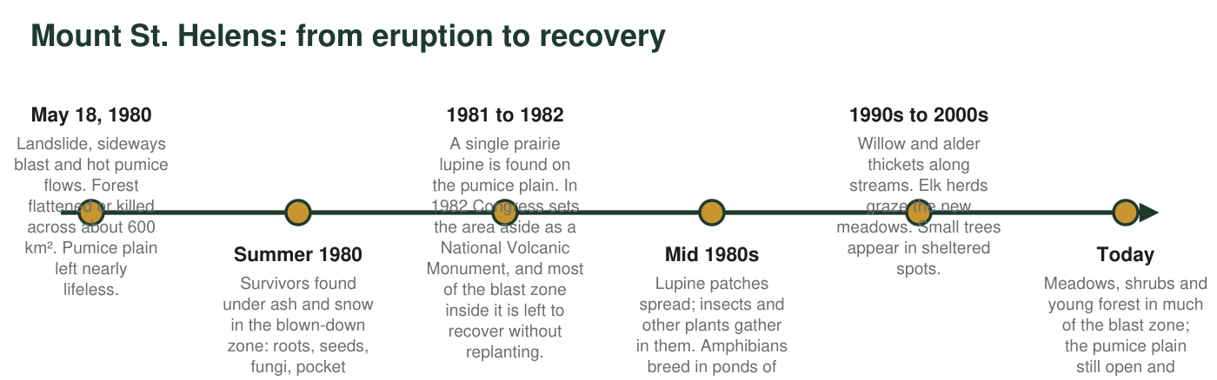
Figure 1. A timeline of the first decades of recovery north of Mount St. Helens. The dates of the eruption and the creation of the monument are exact; accounts date the first lupine to 1981 or 1982. The later entries describe general trends scientists have reported, not a fixed schedule.

Part A: Notice and wonder
1. Write at least three things you notice in the scenes and the timeline. A notice is something you can point to in the text, not a guess about why.
______________________________________________________________________________________
______________________________________________________________________________________
______________________________________________________________________________________
______________________________________________________________________________________
______________________________________________________________________________________
2. Write at least three things you wonder. Write each one as a question that a scientist could try to answer by collecting evidence.
______________________________________________________________________________________
______________________________________________________________________________________
______________________________________________________________________________________
______________________________________________________________________________________
______________________________________________________________________________________

Part B: Connect to what you know
3. In earlier lessons you learned that populations need resources such as food, water, shelter and space. List three resources the pumice plain was missing in the summer of 1980.
______________________________________________________________________________________
______________________________________________________________________________________
______________________________________________________________________________________
4. The lupine, the pocket gopher and the elk each changed the land in a way that helped other living things. Pick one and describe, in your own words, what it changed and who benefited.
______________________________________________________________________________________
______________________________________________________________________________________
______________________________________________________________________________________
5. The pumice plain and the blown-down forest zone recovered at different speeds. Which one do you predict recovered faster? Give one reason from the text.
______________________________________________________________________________________
______________________________________________________________________________________
______________________________________________________________________________________

Part C: Your first explanation
6. Write a first explanation of this question: How can an ecosystem come back after almost everything in it is destroyed? Use at least two pieces of information from this sheet. It is fine to say what you are unsure about.
______________________________________________________________________________________
______________________________________________________________________________________
______________________________________________________________________________________
______________________________________________________________________________________
______________________________________________________________________________________
______________________________________________________________________________________
______________________________________________________________________________________
7. What evidence would you want scientists to collect to test your explanation? Name one kind of measurement and say how often it should be repeated.
______________________________________________________________________________________
______________________________________________________________________________________
______________________________________________________________________________________

Sentence starters for noticing and wondering
Notice starters: 'The text says that...', 'On the timeline, the first ... appeared in...', 'Both scenes mention...'. Wonder starters: 'How long did it take for...?', 'Why did ... come back before ...?', 'What would have happened if ... had not survived?'. For Part C, try this shape: 'First, ... survived or arrived. That changed the land by... Then ... could live there because...'.

A different kind of blank slate
Volcanoes are not the only way an ecosystem gets wiped nearly clean. Glaciers that melt back leave bare rock and gravel, and new islands rise from the sea. Choose one of these cases and write a short prediction of how recovery there would be similar to Mount St. Helens and how it would differ. Think about where the first living things would come from, and whether anything could have survived underneath.

