Angela's Tools · Chapter 22: Changing Ecosystems · Worksheet 2 of 10

Words for a Changing Place: Succession, Disturbance and Resilience (Teacher answer key)
Learning target: I can use the vocabulary of changing ecosystems to sort real situations, complete a concept map and explain how the terms connect to one another.
Vocabulary in action · about 35 minutes · individual · Standards: MS-LS2-4 (supports)

Standards connections
MS-LS2-4 (supports): Students need precise words (physical component, biological component, disturbance, succession, evidence) before they can build an argument that changes to those components affect populations. This sheet builds that vocabulary through sorting and application rather than memorizing definitions.

Answers with reasoning
dynamic system: A system in which something is always changing, even when the overall picture looks steady. Every ecosystem is one.
physical component: A nonliving part of an ecosystem that organisms depend on: water, soil, light, temperature, wind, the shape of the land.
biological component: A living part of an ecosystem: a population of plants, animals, fungi or microbes, and the interactions among them.
disturbance: An event that damages or removes living things from an area, such as a fire, flood, eruption, storm, clear-cut or plowing. It can be natural or caused by people, sudden or slow.
ecological succession: The gradual replacement of one community of organisms by another after a disturbance or on new ground. It follows common patterns but not a fixed timetable, and it does not always rebuild the same ecosystem.
primary succession: Succession that starts on ground with no soil and no survivors, such as cooled lava, fresh pumice or rock left by a melting glacier. Soil must be built before most plants can grow.
secondary succession: Succession that starts where soil, seeds, roots or other survivors remain, such as a burned forest or an abandoned field. It is usually much faster than primary succession.
biological legacy: Living things or their remains that survive a disturbance in place, such as buried seeds, resprouting roots, fungi, logs or animals in burrows. They give recovery a head start.
pioneer species: The first organisms to live on bare or newly disturbed ground, such as lichens, mosses or nitrogen-fixing plants. They change the ground in ways that let other species follow.
resilience: How well an ecosystem recovers its populations and functions after a disturbance. A resilient ecosystem bounces back; a less resilient one shifts to something different.
cascading change: A chain of changes in which a change in one population or resource changes another, which changes another, spreading through the ecosystem's interactions.
keystone species: A species that many others depend on, so that its loss changes the ecosystem far more than its numbers would suggest. Prairie dogs and beavers are examples.
invasive species: A species moved by people into an area where it did not live before, that then spreads and harms native populations, usually by competing for resources or eating them.
evidence: Information gathered by observation or measurement, such as counts of a population over several years or comparisons of places with and without a species.

Part A: Primary or secondary?
Each situation below describes a place where succession begins. Decide whether it is primary or secondary succession, and name the single clue in the situation that decided it for you (the clue is always about soil or survivors).
1. Complete the table for all six situations.
Answer: 1. Primary; clue: cooled lava rock with no soil. 2. Secondary; clue: roots and buried seeds survived. 3. Primary; clue: bare rock and gravel with no soil. 4. Secondary; clue: the field has soil (and a seed bank) even though it was plowed. 5. Secondary; clue: seedlings growing in the existing soil among the trunks. 6. Primary; clue: new volcanic rock with no soil, so seeds must arrive from elsewhere.
Reasoning: The decision rests on soil and survivors in every case. Situation 4 is the one students most often call primary because the field looks empty; soil with a seed bank makes it secondary.
Also acceptable: For situation 5, accept 'soil was not removed' as the clue. In situations 2, 4 and 5, accept 'biological legacies (roots, seeds) survived' as the clue. For 6, accept 'birds had to bring the seeds' as evidence that nothing was there to start with.
Full credit must include:
• All six classified correctly
• Each clue refers to soil or survivors

Part B: Complete the concept map
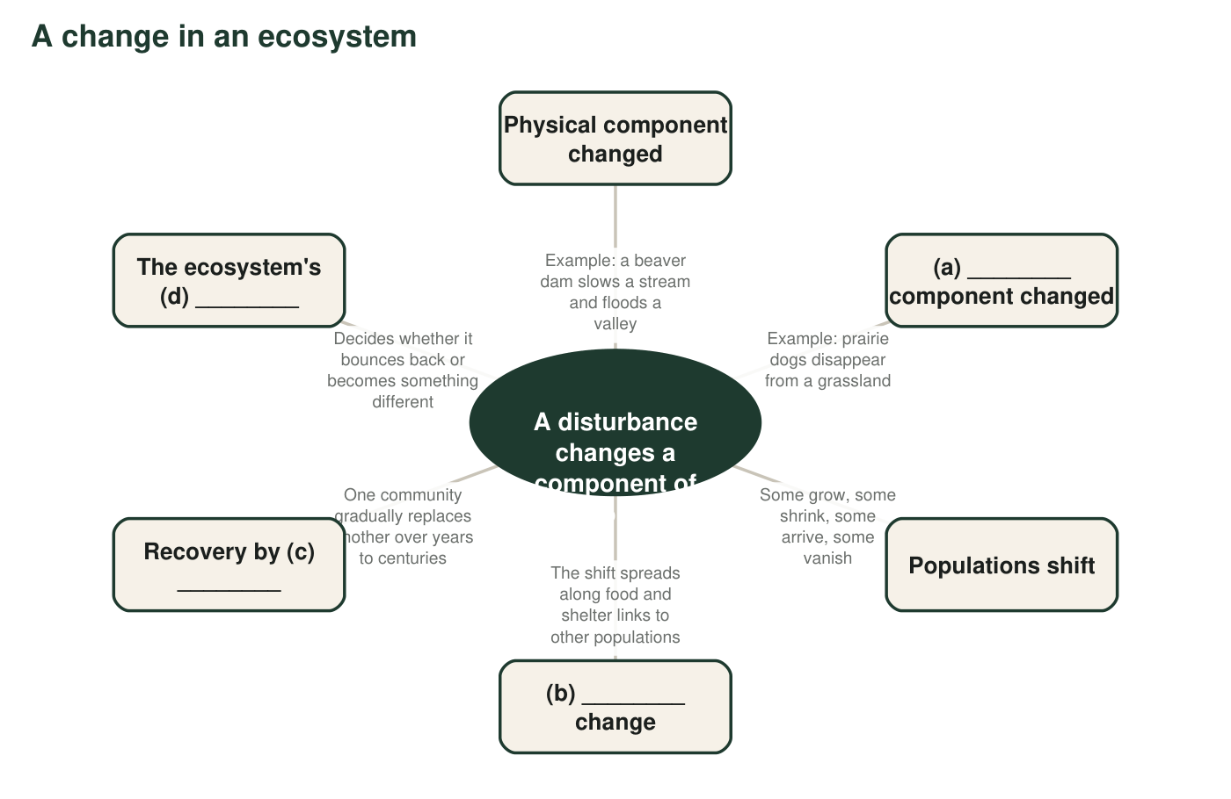
Figure 1. A concept map with the hub filled in and some branches blank. The blank branches are labeled with a letter; write the missing term or phrase for each letter in q2.
2. Write the term that belongs at (a), (b), (c) and (d) in Figure 1.
Answer: (a) biological; (b) cascading; (c) ecological succession (accept 'succession'); (d) resilience.
Reasoning: The map's structure is the chapter's logic: a disturbance changes a physical or biological component, populations shift, the shift cascades, and the ecosystem recovers through succession to a degree set by its resilience.
Also acceptable: For (a), 'living' is acceptable with a note to use the chapter's term.
3. Figure 1 has no branch for evidence. Where would you add it, and what would it connect to? Explain in one or two sentences.
Answer: Evidence should connect to 'Populations shift', because that is the branch scientists can measure: counts of each population over time, or comparisons of areas with and without the change. Evidence is what lets us claim that the shift happened and that the disturbance caused it.
Reasoning: Evidence belongs where measurements are made. A student who attaches it to the hub ('we need evidence that a disturbance happened') is also reasonable if they say what would be measured.
Also acceptable: Attaching evidence to 'cascading change' with the note that scientists trace the chain by counting each population is a strong answer.
Full credit must include:
• Places evidence on a measurable branch
• Says what the evidence would consist of

Part C: Which term fits?
4. A lichen grows on bare rock, slowly breaking it into grains and trapping dust that becomes the first thin soil. Which term best describes the lichen, and why?
Answer: Pioneer species. It is among the first to live on bare rock and it changes the ground (breaking rock, trapping dust into soil) so that other species can follow.
Reasoning: Both halves of the definition are present: first arrival and ground-changing.
Also acceptable: A student who also notes that this is primary succession is correct, but the question asks what the lichen is.
Full credit must include:
• Names pioneer species
• Explains using 'first' and 'changes the ground'
5. When sea otters were hunted almost to extinction along parts of the Pacific coast, sea urchins (which otters eat) multiplied and ate down the kelp forests, and fish that lived in the kelp declined. Which two terms from the bank describe this story best? Explain each.
Answer: Keystone species (the otter: its loss changed the whole kelp ecosystem far more than its numbers suggest) and cascading change (otters down, urchins up, kelp down, kelp fish down: a chain through feeding interactions). Accept 'disturbance' as a third if the student explains that hunting removed a biological component.
Reasoning: The otter-urchin-kelp story is a well-documented example of both ideas; the two terms are the ones that explain the pattern.
Also acceptable: If a student names 'biological component' plus 'cascading change', give full credit if the otter's outsized role is described.
Full credit must include:
• Names keystone species and cascading change
• Explains each with the story
6. Zebra mussels arrived in the Great Lakes in the 1980s in the ballast water of ships. They spread rapidly and crowd out native mussels. Which term fits, and which word in the definition tells you it is this term and not simply a 'new species'?
Answer: Invasive species. The definition says 'moved by people' (ballast water of ships) and 'spreads and harms native populations' (crowds out native mussels). A species that simply arrives on its own or does no harm would not fit.
Reasoning: The key distinction for this chapter: introduced means moved by people; invasive adds spread and harm.
Also acceptable: Accept either key phrase as the deciding word.
Full credit must include:
• Names invasive species
• Points to 'moved by people' or 'harms native populations' in the definition
7. A pond looks the same from one summer to the next, yet decaying leaves slowly make it shallower and the mix of species drifts a little each year. Which term describes the pond, and what does the term say that 'unchanging' would miss?
Answer: Dynamic system. The term says that something is always changing even when the overall appearance is steady; 'unchanging' would miss the slow filling-in and the drifting mix of species that will eventually turn the pond into a wetland.
Reasoning: This checks that students understand 'dynamic' as constant change at some level, not necessarily dramatic change.
Also acceptable: A student who adds 'gradual succession' is correct and should be praised for linking the two terms.
Full credit must include:
• Names dynamic system
• Contrasts steady appearance with ongoing change

Part D: Apply the words to a new place
A creek runs through a city park. Twenty years ago the city removed a beaver family that kept flooding a trail. The pond behind their dam drained, the willows along its edge died back, and the frogs and ducks that used the pond disappeared. Last year, beavers returned on their own and built a new dam.
8. Write a paragraph about the creek using at least five terms from the word bank correctly. Underline each term. Your paragraph must say which component the beavers change, and whether the current recovery is primary or secondary succession.
Answer: Model paragraph: Beavers are a keystone species in the park creek because so many other populations depend on the pond they create. Their dam changes a physical component, the flow and depth of the water, which in turn changes biological components such as willows, frogs and ducks. Removing the beavers was a disturbance caused by people, and it set off a cascading change: the pond drained, the willows died back, and the animals that used the pond left. Now that beavers have returned, the valley is going through secondary succession, because soil, willow roots and seeds survived the dry years. Scientists could gather evidence by counting frogs and ducks each spring to measure the creek's resilience.
Reasoning: Full credit needs five terms used accurately, the beavers' effect named as a change to a physical component, and the recovery identified as secondary (soil and survivors remain). Marking terms with underlining is required by the prompt.
Also acceptable: A student who calls the beaver removal a change to a biological component is also right (the beavers themselves are living); the best answers note that a biological change caused a physical change.
Full credit must include:
• At least five terms used correctly and underlined
• States that beavers change a physical component (water flow or depth)
• Identifies the recovery as secondary succession with a reason

Teacher notes
The definitions are original and accurate where the textbook simplifies: succession is described as following common patterns rather than being 'predictable' on a schedule, and the keystone and pioneer terms, which the textbook describes without naming, are introduced here. Every example in Part C is a documented case (lichens on bare rock; sea otters, urchins and kelp along the North Pacific coast; zebra mussels, first found in Lake St. Clair in 1988 after arriving in ballast water). The most common Part A error is calling the abandoned field (situation 4) primary succession; use it in discussion to emphasize that soil with seeds is the deciding factor. The q8 paragraph is the sheet's main evidence of understanding; read it for correct usage, not for length.

