Angela's Tools · Chapter 22: Changing Ecosystems · Worksheet 2 of 10

Words for a Changing Place: Succession, Disturbance and Resilience
Learning target: I can use the vocabulary of changing ecosystems to sort real situations, complete a concept map and explain how the terms connect to one another.
Vocabulary in action · about 35 minutes · individual · Standards: MS-LS2-4 (supports)
Name: ____________________________ Date: ____________ Period: ______

Directions
Read the word bank carefully; each definition is written for this chapter. Then work through the four parts. In Part A you sort situations, in Part B you complete a concept map, in Part C you decide which term fits, and in Part D you apply the terms to a new place. Use the exact term when the question asks for one, and explain your choice when the question asks why.
dynamic system: A system in which something is always changing, even when the overall picture looks steady. Every ecosystem is one.
physical component: A nonliving part of an ecosystem that organisms depend on: water, soil, light, temperature, wind, the shape of the land.
biological component: A living part of an ecosystem: a population of plants, animals, fungi or microbes, and the interactions among them.
disturbance: An event that damages or removes living things from an area, such as a fire, flood, eruption, storm, clear-cut or plowing. It can be natural or caused by people, sudden or slow.
ecological succession: The gradual replacement of one community of organisms by another after a disturbance or on new ground. It follows common patterns but not a fixed timetable, and it does not always rebuild the same ecosystem.
primary succession: Succession that starts on ground with no soil and no survivors, such as cooled lava, fresh pumice or rock left by a melting glacier. Soil must be built before most plants can grow.
secondary succession: Succession that starts where soil, seeds, roots or other survivors remain, such as a burned forest or an abandoned field. It is usually much faster than primary succession.
biological legacy: Living things or their remains that survive a disturbance in place, such as buried seeds, resprouting roots, fungi, logs or animals in burrows. They give recovery a head start.
pioneer species: The first organisms to live on bare or newly disturbed ground, such as lichens, mosses or nitrogen-fixing plants. They change the ground in ways that let other species follow.
resilience: How well an ecosystem recovers its populations and functions after a disturbance. A resilient ecosystem bounces back; a less resilient one shifts to something different.
cascading change: A chain of changes in which a change in one population or resource changes another, which changes another, spreading through the ecosystem's interactions.
keystone species: A species that many others depend on, so that its loss changes the ecosystem far more than its numbers would suggest. Prairie dogs and beavers are examples.
invasive species: A species moved by people into an area where it did not live before, that then spreads and harms native populations, usually by competing for resources or eating them.
evidence: Information gathered by observation or measurement, such as counts of a population over several years or comparisons of places with and without a species.

Part A: Primary or secondary?
Each situation below describes a place where succession begins. Decide whether it is primary or secondary succession, and name the single clue in the situation that decided it for you (the clue is always about soil or survivors).
1. Complete the table for all six situations.
Primary or secondary? | The clue that decided it
1. A lava flow in Hawaii cools into black rock; a year later, a fern grows in a crack.
2. A wildfire burns a California hillside; the next spring, grasses sprout from roots and buried seeds.
3. A glacier in Alaska melts back, leaving gravel and bare rock with no soil.
4. A farmer stops plowing a field; weeds appear the first summer and shrubs in five years.
5. A hurricane flattens a coastal forest; seedlings grow among the fallen trunks the next year.
6. A new volcanic island rises from the sea; birds later carry seeds to it.

Part B: Complete the concept map
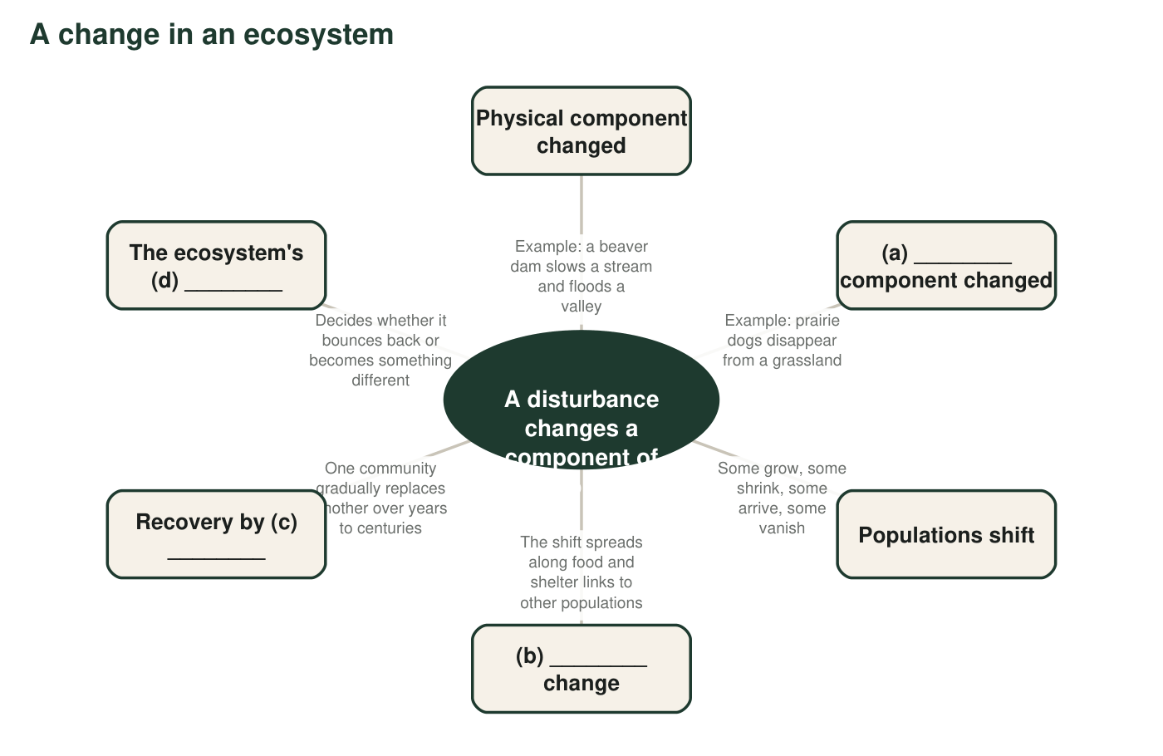
Figure 1. A concept map with the hub filled in and some branches blank. The blank branches are labeled with a letter; write the missing term or phrase for each letter in q2.
2. Write the term that belongs at (a), (b), (c) and (d) in Figure 1.
______________________________________________________________________________________
______________________________________________________________________________________
______________________________________________________________________________________
______________________________________________________________________________________
3. Figure 1 has no branch for evidence. Where would you add it, and what would it connect to? Explain in one or two sentences.
______________________________________________________________________________________
______________________________________________________________________________________
______________________________________________________________________________________

Part C: Which term fits?
4. A lichen grows on bare rock, slowly breaking it into grains and trapping dust that becomes the first thin soil. Which term best describes the lichen, and why?
______________________________________________________________________________________
______________________________________________________________________________________
5. When sea otters were hunted almost to extinction along parts of the Pacific coast, sea urchins (which otters eat) multiplied and ate down the kelp forests, and fish that lived in the kelp declined. Which two terms from the bank describe this story best? Explain each.
______________________________________________________________________________________
______________________________________________________________________________________
6. Zebra mussels arrived in the Great Lakes in the 1980s in the ballast water of ships. They spread rapidly and crowd out native mussels. Which term fits, and which word in the definition tells you it is this term and not simply a 'new species'?
______________________________________________________________________________________
______________________________________________________________________________________
7. A pond looks the same from one summer to the next, yet decaying leaves slowly make it shallower and the mix of species drifts a little each year. Which term describes the pond, and what does the term say that 'unchanging' would miss?
______________________________________________________________________________________
______________________________________________________________________________________

Part D: Apply the words to a new place
A creek runs through a city park. Twenty years ago the city removed a beaver family that kept flooding a trail. The pond behind their dam drained, the willows along its edge died back, and the frogs and ducks that used the pond disappeared. Last year, beavers returned on their own and built a new dam.
8. Write a paragraph about the creek using at least five terms from the word bank correctly. Underline each term. Your paragraph must say which component the beavers change, and whether the current recovery is primary or secondary succession.
______________________________________________________________________________________
______________________________________________________________________________________
______________________________________________________________________________________
______________________________________________________________________________________
______________________________________________________________________________________
______________________________________________________________________________________

Two questions that sort any succession
When you cannot decide between primary and secondary, ask two questions in order. Is there soil? If no soil exists, it is primary. Is anything alive left in the ground, such as roots, seeds, bulbs or burrowing animals? If yes, it is secondary. Primary succession has neither soil nor survivors; secondary has at least one of them. For Part C, read each definition and find the one word in it (for example 'moved by people', 'first', 'chain') that matches the story.

Terms that overlap
Beavers are often called both a keystone species and 'ecosystem engineers' (organisms that physically reshape their habitat). Prairie dogs are also called both. Write a short explanation of how the two labels differ: what does a keystone species do that an ecosystem engineer might not, and the other way around? Then decide whether a lupine on the Mount St. Helens pumice plain earns either label, using the definitions of pioneer species and keystone species to make your case.

