Angela's Tools · Chapter 22: Changing Ecosystems · Worksheet 4 of 10

Reading a Succession Model, Then Building Your Own (Teacher answer key)
Learning target: I can interpret a timeline model of secondary succession, compare it with primary succession, and draw a labeled model showing how each stage changes the ground for the next.
Diagrams and models · about 40 minutes · individual · Standards: MS-LS2-4 (practice), MS-LS2-1 (supports)

Standards connections
MS-LS2-4 (practice): Students read models that connect a physical change (fire, lava) to the sequence of populations that follow, and then construct their own. Modeling the chain from a changed component to shifting populations builds toward arguing about it with evidence.
MS-LS2-1 (supports): Each succession stage is explained by the resources it makes available (soil, shade, nitrogen, shelter), which draws on the resource-availability idea from the earlier chapter.

Answers with reasoning
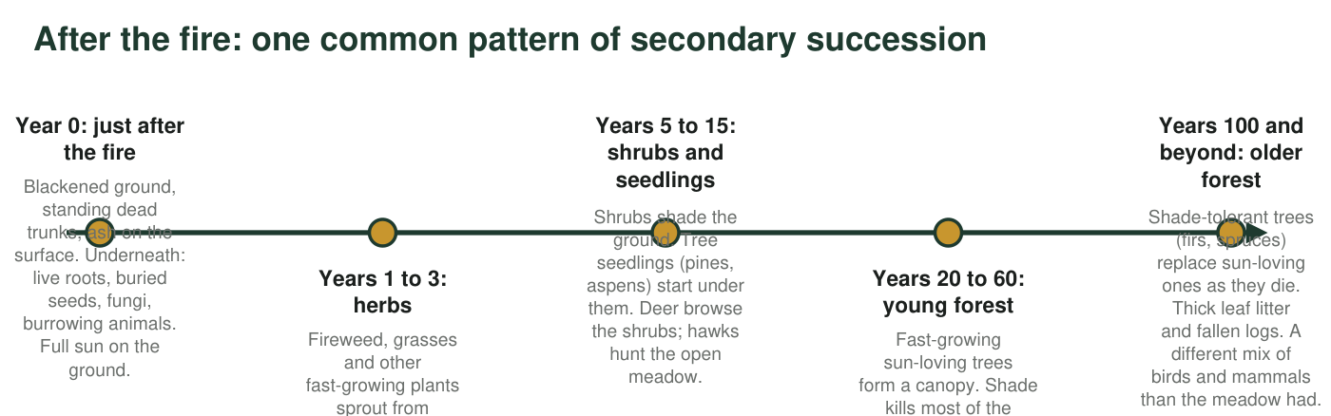
Figure 1. A model of secondary succession after a severe forest fire in a mountain forest of the western United States. Years are typical ranges, not fixed dates.
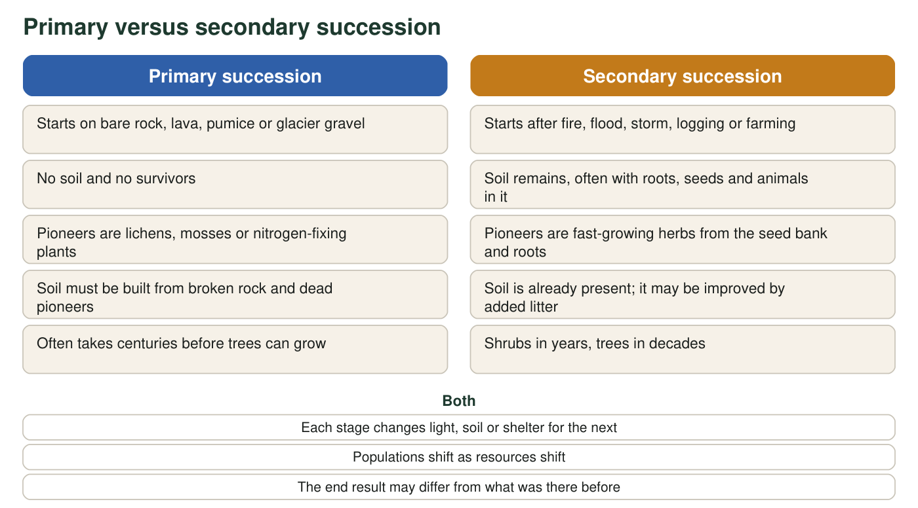
Figure 2. Primary and secondary succession side by side. Items in the middle are true of both.

Part A: Interpret the models
1. In Figure 1, which stage has the most sunlight reaching the ground, and which has the least? Use the stage labels.
Answer: Most sunlight at the ground: Year 0, just after the fire (and nearly as much in years 1 to 3). Least: years 100 and beyond, the older forest with a full canopy of shade-tolerant trees.
Reasoning: The figure states 'full sun on the ground' at year 0 and describes shade increasing through the shrub and canopy stages.
Also acceptable: Accept years 20 to 60 as the least if the student argues the first canopy is the densest; the older forest is the better answer because the figure describes thick litter and shade-tolerant trees.
2. Explain why the herbs and grasses that filled the meadow in years 1 to 3 mostly disappear by years 20 to 60. Name the physical component that changed and the stage that changed it.
Answer: Light reaching the ground changed. The young forest stage (years 20 to 60) formed a canopy that shaded the ground, and most meadow herbs and grasses need full sun, so they died out and shade-tolerant plants replaced them.
Reasoning: This is the clearest example in the figure of a stage changing a physical component for the next; the change is less light, caused by the tree canopy.
Also acceptable: A student who adds that trees also took water and space is correct but must still name light.
Full credit must include:
• Names light (or shade) as the changed component
• Names the young forest canopy as the cause
3. The animals change from stage to stage: mice and seed-eating birds, then deer and hawks, then squirrels and woodpeckers. For one of these changes, explain which resource appeared or disappeared to cause it.
Answer: Examples: seed-eating mice and birds appeared because herbs and grasses produced seeds in years 1 to 3; deer appeared because shrubs provided browse; hawks hunted because the open meadow let them see prey; squirrels and woodpeckers appeared because trees provided cones, nuts and trunks to nest in, while the hawks' open hunting ground disappeared under the canopy.
Reasoning: Any one change explained by a resource appearing or disappearing earns credit. This connects succession to the resource idea.
Also acceptable: Explaining a disappearance (hawks losing open ground) is as good as explaining an arrival.
Full credit must include:
• One animal change named
• A resource that appeared or disappeared is identified as the cause
4. Figure 1 shows sun-loving trees forming the first canopy and shade-tolerant trees replacing them later. Why can the shade-tolerant trees win in the long run even though the sun-loving trees got there first?
Answer: Shade-tolerant seedlings can grow under the canopy, but sun-loving tree seedlings cannot grow in their own parents' shade. So when the sun-loving trees die, there are shade-tolerant young trees waiting underneath to replace them, and no sun-loving replacements.
Reasoning: The mechanism is that the first canopy creates conditions in which only the other group can reproduce. This is the self-replacing logic of later succession.
Also acceptable: Accept 'the first trees make the shade that their own babies cannot survive in.'
Full credit must include:
• States that sun-loving seedlings cannot grow in shade
• States that shade-tolerant seedlings are already growing underneath when the canopy trees die
5. Using Figure 2, give the main reason primary succession usually takes much longer than secondary succession, and name one organism that does the slow early work in primary succession.
Answer: Primary succession has no soil, so soil must be built up from broken rock and the remains of pioneers before most plants can grow, and that takes centuries. Slow early workers: lichens, mosses, or nitrogen-fixing plants such as lupines.
Reasoning: Soil building is the rate-limiting step; secondary succession skips it.
Also acceptable: Accept 'no survivors, so everything must arrive from outside' as an additional reason, but soil must be mentioned.
Full credit must include:
• Soil must be built first
• Names a pioneer organism
6. The caption of Figure 1 says the years are 'typical ranges, not fixed dates.' Give one reason a real burned forest might move through these stages faster, and one reason it might move more slowly.
Answer: Faster: lots of survivors (a less severe fire), nearby unburned forest supplying seeds, a wet climate, or a rich seed bank in the soil. Slower: a very hot fire that killed roots and seeds, dry climate or drought, erosion washing soil away, no seed source nearby, or an invasive species taking over the early stages.
Reasoning: The item reinforces that the timeline is a pattern with variable speed, which corrects the 'predictable schedule' framing.
Also acceptable: Repeated disturbance (another fire) is a strong slowing factor.
Full credit must include:
• One sensible accelerating factor
• One sensible slowing factor

Part B: Build your own model
Draw a four-stage timeline model of primary succession on a cooled lava flow. Stage 1 must show bare lava with cracks. Stages 2, 3 and 4 are yours to choose, but they must end with shrubs or small trees. Label at least one organism in each stage after the first. Between each pair of stages, draw an arrow and write on it what the earlier stage changed about the ground (for example, 'adds thin soil', 'adds usable nitrogen', 'adds shade'). Give your model a title and include a note that says roughly how long the whole sequence might take.
Expected drawing: A full-credit model has four labeled stages beginning with cracked bare lava and ending with shrubs or small trees; at least one organism labeled in stages 2 to 4 (for example lichens and mosses, then ferns or grasses and a nitrogen-fixing plant with insects, then shrubs and birds); three arrow notes that each name a change to the ground (such as 'breaks rock into grains and traps dust', 'adds usable nitrogen and dead plant material, making thin soil', 'deeper soil holds water; shade and shelter'); a title; and a time note in the range of centuries (a few hundred to a thousand years or more).
Reasoning: Score the arrows most heavily: they are where the student shows that each stage changes a physical component for the next. A drawing with lovely stages and no arrow notes is a picture, not a model.
7. Look at your drawing. Which arrow note describes the single most important change, the one without which the later stages could not happen? Explain your choice.
Answer: Most students should choose the arrow where soil first forms (rock broken down and dead pioneers added, or nitrogen added by a pioneer), because without soil and usable nitrogen the grasses, shrubs and trees of later stages have nothing to root in or feed on.
Reasoning: Soil formation is the bottleneck of primary succession. Accept nitrogen addition as the key change if the student argues that pumice or lava has almost none.
Also acceptable: A student who picks 'adds shade' and argues well is thinking, but should be asked what the shrubs were rooted in.
Full credit must include:
• Chooses an arrow about soil or nitrogen
• Explains that later stages depend on it
8. Suppose a second lava flow covers your stage 3 landscape. Does succession start again from stage 1, or from somewhere else? Explain using the idea of survivors.
Answer: It starts again from stage 1 wherever the new lava covers the old ground, because lava buries and burns the soil, roots and seeds, leaving no survivors; this is primary succession again. If the lava leaves islands of the old stage 3 landscape uncovered, those islands keep their survivors and can seed the new rock faster than the first time.
Reasoning: The best answers make the survivor distinction: covered ground restarts at primary succession; uncovered patches act as sources. This mirrors the Mount St. Helens zone difference.
Also acceptable: Accept the island idea as a bonus; it is not required.
Full credit must include:
• States that covered areas restart from bare lava (no survivors)
• Explains in terms of survivors

Teacher notes
Figure 1 is a generalized model of secondary succession in western conifer forests; the stage descriptions (fireweed and grasses from the seed bank, shrubs with pine or aspen seedlings, a sun-loving canopy replaced by shade-tolerant firs and spruces) are typical and the caption makes clear the years are ranges. The cheatgrass fire cycle in the extension is a documented problem in Great Basin sagebrush shrublands: cheatgrass (native to Eurasia) fills the gaps after fire, dries early, and shortens the time between fires until sagebrush, which must regrow from seed, is lost. Watch for two misconceptions in Part B: drawing trees in stage 2 (skipping soil formation) and writing arrow notes that describe the organisms rather than what they changed. Both are worth a short conference. Students who finish early can compare their lava model to the Mount St. Helens pumice plain from Worksheets 1 and 3 and decide which stage the plain has reached.

