Angela's Tools · Chapter 22: Changing Ecosystems · Worksheet 4 of 10

Reading a Succession Model, Then Building Your Own
Learning target: I can interpret a timeline model of secondary succession, compare it with primary succession, and draw a labeled model showing how each stage changes the ground for the next.
Diagrams and models · about 40 minutes · individual · Standards: MS-LS2-4 (practice), MS-LS2-1 (supports)
Name: ____________________________ Date: ____________ Period: ______

Directions
Study Figure 1 and Figure 2 before answering anything. Figure 1 is a model, not a photograph, and the years are typical ranges for a forest in the western United States, not a schedule every forest follows. Answer the questions in Part A using the figures. In Part B, draw your own model of primary succession on a lava flow. Your drawing must have four stages, labels, and an arrow note between each pair of stages saying what the earlier stage changed.
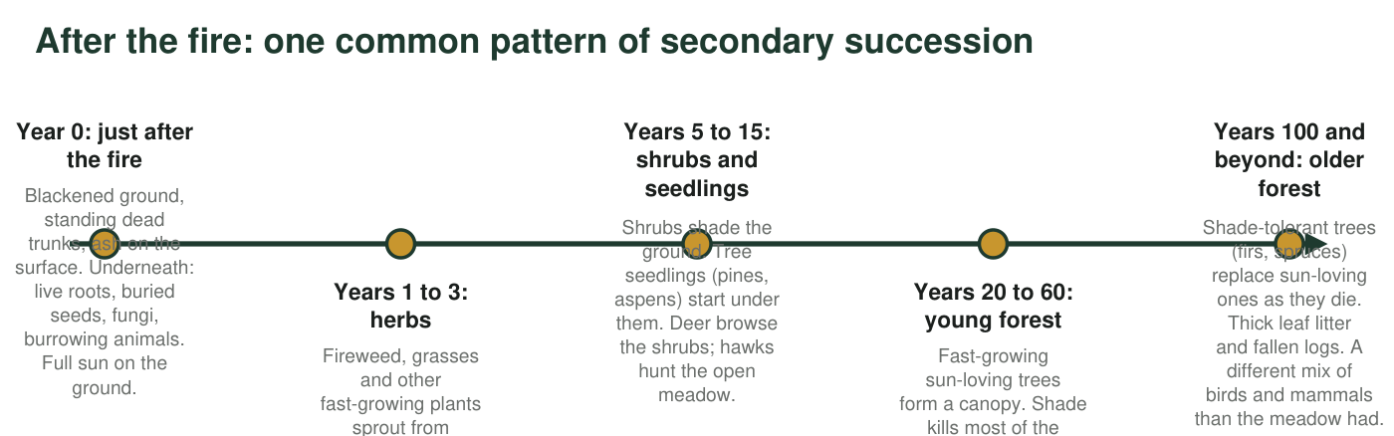
Figure 1. A model of secondary succession after a severe forest fire in a mountain forest of the western United States. Years are typical ranges, not fixed dates.
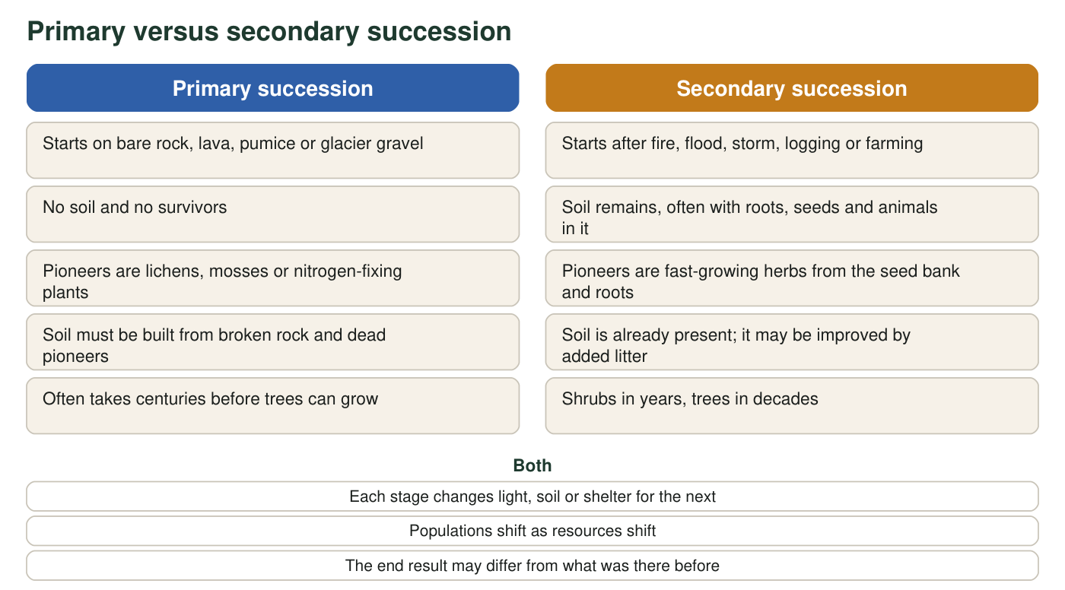
Figure 2. Primary and secondary succession side by side. Items in the middle are true of both.

Part A: Interpret the models
1. In Figure 1, which stage has the most sunlight reaching the ground, and which has the least? Use the stage labels.
______________________________________________________________________________________
______________________________________________________________________________________
2. Explain why the herbs and grasses that filled the meadow in years 1 to 3 mostly disappear by years 20 to 60. Name the physical component that changed and the stage that changed it.
______________________________________________________________________________________
______________________________________________________________________________________
______________________________________________________________________________________
3. The animals change from stage to stage: mice and seed-eating birds, then deer and hawks, then squirrels and woodpeckers. For one of these changes, explain which resource appeared or disappeared to cause it.
______________________________________________________________________________________
______________________________________________________________________________________
______________________________________________________________________________________
4. Figure 1 shows sun-loving trees forming the first canopy and shade-tolerant trees replacing them later. Why can the shade-tolerant trees win in the long run even though the sun-loving trees got there first?
______________________________________________________________________________________
______________________________________________________________________________________
______________________________________________________________________________________
5. Using Figure 2, give the main reason primary succession usually takes much longer than secondary succession, and name one organism that does the slow early work in primary succession.
______________________________________________________________________________________
______________________________________________________________________________________
______________________________________________________________________________________
6. The caption of Figure 1 says the years are 'typical ranges, not fixed dates.' Give one reason a real burned forest might move through these stages faster, and one reason it might move more slowly.
______________________________________________________________________________________
______________________________________________________________________________________
______________________________________________________________________________________

Part B: Build your own model
Draw a four-stage timeline model of primary succession on a cooled lava flow. Stage 1 must show bare lava with cracks. Stages 2, 3 and 4 are yours to choose, but they must end with shrubs or small trees. Label at least one organism in each stage after the first. Between each pair of stages, draw an arrow and write on it what the earlier stage changed about the ground (for example, 'adds thin soil', 'adds usable nitrogen', 'adds shade'). Give your model a title and include a note that says roughly how long the whole sequence might take.

7. Look at your drawing. Which arrow note describes the single most important change, the one without which the later stages could not happen? Explain your choice.
______________________________________________________________________________________
______________________________________________________________________________________
______________________________________________________________________________________
8. Suppose a second lava flow covers your stage 3 landscape. Does succession start again from stage 1, or from somewhere else? Explain using the idea of survivors.
______________________________________________________________________________________
______________________________________________________________________________________
______________________________________________________________________________________

Four stages you can borrow
If you are stuck on Part B, use this sequence and add your own labels and arrow notes: (1) bare lava with cracks; (2) lichens and mosses on the rock, with a few ferns in cracks where water collects; (3) a thin soil layer with grasses, nitrogen-fixing plants and insects; (4) shrubs and small trees with birds. For each arrow, ask: what did the plants in the earlier stage leave behind when they died, and what did they block or trap while alive?

Model a succession that does not reach forest
Not every succession heads toward the community that was there before. In much of the Great Basin, sagebrush shrublands that burn are often taken over by cheatgrass, an invasive annual grass from Eurasia that dries out early in summer and burns easily. The extra fuel brings more frequent fires, and sagebrush, which does not resprout after burning, cannot grow back between them. Draw a second timeline model for this 'fire trap' and compare it with Figure 1. Which physical component is being changed repeatedly, and why does the cycle keep the ecosystem from moving to later stages?

