Angela's Tools · Chapter 23: The Motion of Particles · Worksheet 1 of 10

One Drop, Two Glasses: Why Does Dye Spread Faster in Warm Water? (Teacher answer key)
Learning target: I can record careful observations of dye spreading in cold and warm water, connect them to what I already know, and write a first explanation that I can test later.
Phenomenon exploration · about 30 minutes · individual · Standards: MS-PS1-4 (supports)

Standards connections
MS-PS1-4 (supports): Watching dye spread at two temperatures is the entry phenomenon for the idea that particles in every state move and that warmer samples have faster-moving particles. Students only record and explain here; the model-building that the PE asks for comes later in the chapter.

Answers with reasoning

The scenario
Priya filled two identical clear glasses with the same amount of tap water. She left one glass in the refrigerator overnight and warmed the other one in a bowl of hot water until a thermometer read 45 °C, about as warm as a hot bath. She set both glasses on the table and waited until the water in each was completely still. Then, at the same moment, she let one drop of blue food dye fall into the middle of each glass. She did not stir, bump the table, or touch the glasses. She watched and wrote down what she saw at set times.
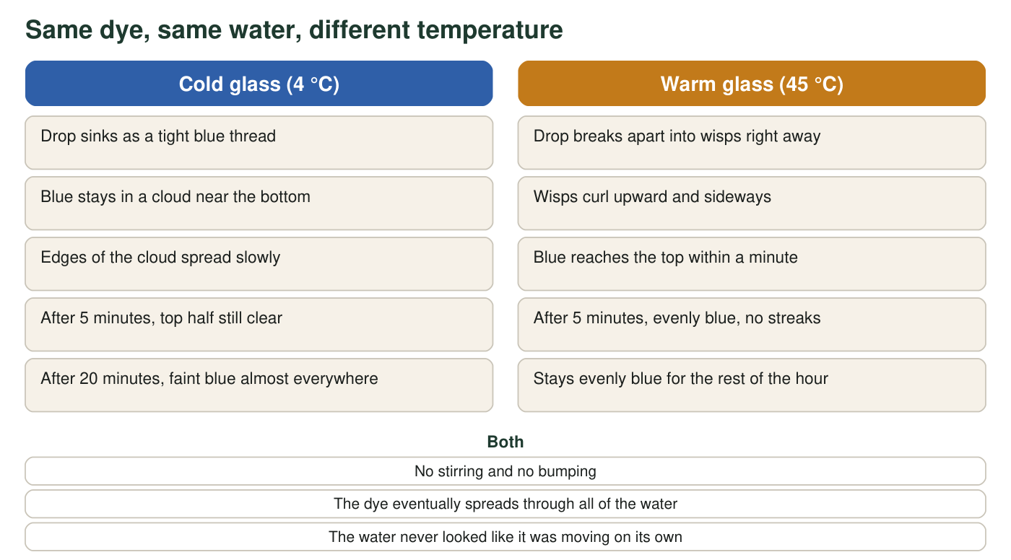
What Priya saw in the two glasses. The glasses, the water volume and the dye drop were the same. Only the temperature was different.
Priya's observation log (teaching scenario)
Simulated teaching dataset (not real measurements).
Time after the drop | Cold glass (4 °C) | Warm glass (45 °C)
10 seconds | Blue thread reaches the bottom; clear above it | Drop already breaking into several wisps
1 minute | Blue cloud fills bottom third | Faint blue reaches the surface
5 minutes | Cloud fills bottom half; sharp boundary | Evenly blue
20 minutes | Faint blue nearly everywhere; bottom still darker | Evenly blue
60 minutes | Evenly blue | Evenly blue

A teaching scenario written to be realistic; the times are not measurements from a real lab. 'Evenly blue' means Priya could no longer see darker and lighter areas.

Part A: What do you notice?
1. Write three things you notice from the figure and the log. Each one must be something you could point to, not a guess about why. Start each with 'I notice...'
Answer: Any three observable statements, for example: the dye in the cold glass stayed near the bottom for minutes; the dye in the warm glass reached the top within a minute; the warm glass was evenly blue by 5 minutes while the top half of the cold glass was still clear; both glasses were evenly blue by 60 minutes; nothing was stirred.
Reasoning: Part A checks that students separate observation from explanation. Statements with 'because' or 'particles' belong in Part C, not here.
Also acceptable: Accept 'the drop sank in the cold glass but broke up in the warm glass.'
Full credit must include:
• Three statements
• Each is observable from the figure or log
• No explanations mixed in
2. By which check time in the log was each glass evenly blue? Use those two check times to calculate how many times longer the cold glass took.
Answer: Warm glass: evenly blue by the 5-minute check. Cold glass: evenly blue by the 60-minute check. 60 ÷ 5 = 12, so by the logged check times the cold glass took about 12 times longer.
Reasoning: The log gives 'evenly blue' first at the 5-minute check (warm) and the 60-minute check (cold). Because the log only checks at set times, each glass may have become even somewhat earlier, so the true ratio could be larger or smaller; a student who notes this is reading carefully.
Also acceptable: Accept 'about 12 times' or 'many times longer' with the division shown.
Full credit must include:
• Names the 5-minute check for the warm glass and the 60-minute check for the cold glass
• Shows the division 60 ÷ 5 = 12
3. Name two things that were the same in both glasses and one thing that was different. Why does keeping things the same matter if Priya wants to explain the difference?
Answer: Same: the glasses, the amount of water, one drop of the same dye, no stirring, the same moment of dropping. Different: the water temperature (4 °C versus 45 °C). Keeping everything else the same means the temperature is the only thing that could have caused the difference in spreading.
Reasoning: This is the fair-test idea. Students should see that a single changed variable lets you blame that variable for the result.
Also acceptable: Accept 'so we know it was the temperature and not something else.'
Full credit must include:
• Two correct 'same' items
• Temperature named as the difference
• Says the single difference is what lets you explain the result

Part B: What do you wonder, and what do you already know?
4. Write two questions this phenomenon makes you want to ask. At least one should begin with 'What would happen if...'
Answer: Any two genuine questions, for example: What would happen if the water were boiling hot? What would happen with a thicker liquid such as syrup? Would the dye spread faster in a smaller amount of water? Does the dye ever stop spreading? Would the cold glass catch up if it warmed to room temperature?
Reasoning: Look for questions that could be investigated. At least one must use the 'What would happen if' frame.
Also acceptable: Questions about the dye itself (does color matter?) are acceptable.
Full credit must include:
• Two questions
• At least one begins 'What would happen if'
5. Think of a time you saw something spread or mix on its own without stirring (for example a smell crossing a room, sugar at the bottom of a cold drink, or tea coloring hot water). Describe it in two sentences. Was it faster or slower when things were warmer?
Answer: Personal examples will vary: a cooking smell reaching a bedroom, a tea bag coloring hot water almost at once but cold water slowly, sugar staying at the bottom of iced tea. Most examples will say the spreading was faster when warmer.
Reasoning: The goal is to connect the phenomenon to prior experience and notice that the warm-is-faster pattern is familiar.
Also acceptable: A student with an example where temperature was unknown should say so; that is honest observation.
Full credit must include:
• A real example of spreading or mixing without stirring
• States whether it was faster or slower when warmer

Part C: Your first explanation
Water looks still, but the dye moved through it anyway. Something in the water must be moving even when the glass looks completely calm. Use that idea in your drawing and your explanation.
6. Draw what you imagine is happening inside each glass at a size far too small to see, one minute after the drop. Use small open circles for water particles and filled circles for dye particles. Add arrows to show motion. Label which glass is which.
Answer: Two labeled boxes. Both show water particles touching or nearly touching (a liquid). The warm box shows longer motion arrows and dye particles spread farther from the drop point; the cold box shows shorter arrows and dye particles still clustered near the bottom. Dye and water particles are the same size in both boxes.
Reasoning: This is a first model and will be revised in W4. Do not mark it down for details the student has not learned yet (for example exact spacing). Watch for two common errors to address later: drawing the cold water with no arrows at all, and drawing the warm particles far apart like a gas.
Also acceptable: A drawing that shows the dye spread wider in the warm glass but gives no arrows still shows the main pattern and earns partial credit.
Full credit must include:
• Both glasses drawn and labeled
• Water and dye particles distinguished
• Arrows show motion in both, with more or longer arrows in the warm glass
7. Write your first explanation of why the dye spread faster in the warm glass. Use the words 'particles' and 'temperature.' End with one sentence that says what you are least sure about.
Answer: A strong first explanation: the water looked still, but its particles were moving and bumping into the dye particles the whole time. In the warm glass the water particles were moving faster, so they bumped the dye particles harder and more often and carried them through the water sooner. Temperature is a sign of how fast the particles are moving. 'I am least sure about why the cold dye sank to the bottom first' or 'whether the particles ever stop moving.'
Reasoning: Accept any explanation that puts moving particles inside still-looking water and links warmer to faster. A student who says the warm water 'has currents' is partly right (warm water near the surface can move slightly) but should also be pushed toward particle motion, since the warm glass was left until still.
Also acceptable: An explanation that says 'heat makes the dye dissolve faster' without particles is a common starting point; mark the missing particle idea for revision rather than as wrong.
Full credit must include:
• Uses 'particles' and 'temperature'
• Connects warm to faster particle motion
• Explains spreading as a result of that motion
• Names one uncertainty
8. Predict: if Priya adds a third glass of room-temperature water (about 22 °C), about how long will the dye take to spread evenly? Give a time between the two results and explain your choice in one sentence.
Answer: A time between 5 and 60 minutes, for example about 15 to 25 minutes, because 22 °C is between 4 °C and 45 °C and the pattern suggests warmer water spreads dye faster.
Reasoning: Any time strictly between the two logged results with a reason based on the temperature being in between earns credit. W5 gives data that shows the relationship is not a straight line, so do not expect the exact midpoint.
Also acceptable: Accept any time strictly between 5 and 60 minutes with a one-sentence reason; an answer nearer the warm result, because the warm glass mixed so much faster, shows careful reading.
Full credit must include:
• Gives a time between the two logged results (5 and 60 minutes)
• Gives a one-sentence reason based on 22 °C lying between 4 °C and 45 °C

Teacher notes
This sheet opens the chapter; collect the Part C explanations and return them during W10 so students can see how their model changed. The scenario is realistic: food dye in still water at 45 °C is evenly spread within a few minutes, while in refrigerated water it stays layered for a long time. In a real cup, two things speed the spreading: faster particle motion (the idea this chapter builds) and gentle bulk currents as the warm water cools unevenly. The chapter focuses on particle motion; if a student raises currents, treat it as a good question for the extension rather than an error. Keep the discussion at the level of 'particles move faster when warmer'; the PE's assessment boundary does not include energy or heat calculations.

