Angela's Tools · Chapter 23: The Motion of Particles · Worksheet 1 of 10

One Drop, Two Glasses: Why Does Dye Spread Faster in Warm Water?
Learning target: I can record careful observations of dye spreading in cold and warm water, connect them to what I already know, and write a first explanation that I can test later.
Phenomenon exploration · about 30 minutes · individual · Standards: MS-PS1-4 (supports)
Name: ____________________________ Date: ____________ Period: ______

Directions
Read the scenario and study the figure and the observation log. Do not look anything up yet. Part A asks only for what you notice; keep opinions out of it. Part B asks what you wonder and what you already know. Part C asks for your first explanation. It is fine to be unsure. A first explanation is a starting point that the rest of the chapter will test, not a final answer.

The scenario
Priya filled two identical clear glasses with the same amount of tap water. She left one glass in the refrigerator overnight and warmed the other one in a bowl of hot water until a thermometer read 45 °C, about as warm as a hot bath. She set both glasses on the table and waited until the water in each was completely still. Then, at the same moment, she let one drop of blue food dye fall into the middle of each glass. She did not stir, bump the table, or touch the glasses. She watched and wrote down what she saw at set times.
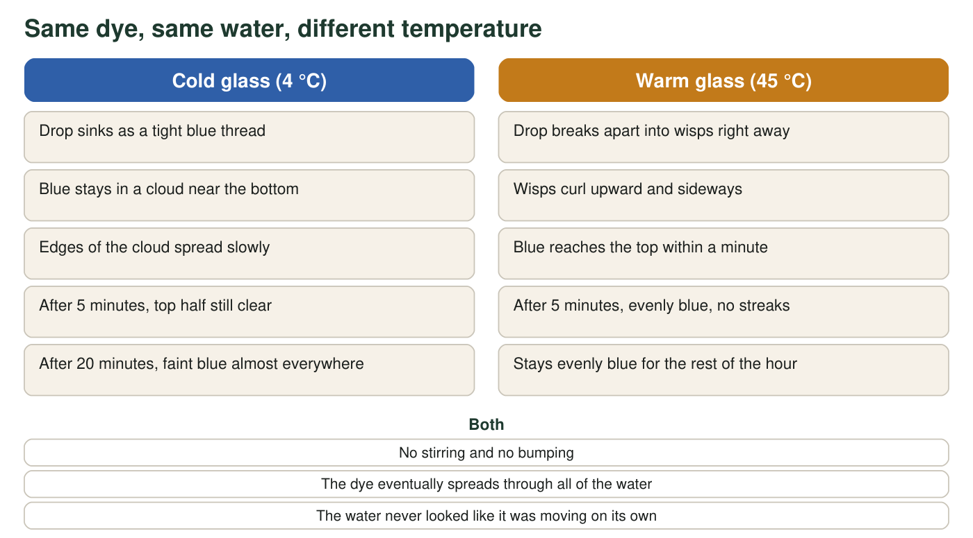
What Priya saw in the two glasses. The glasses, the water volume and the dye drop were the same. Only the temperature was different.
Priya's observation log (teaching scenario)
Simulated teaching dataset (not real measurements).
Time after the drop | Cold glass (4 °C) | Warm glass (45 °C)
10 seconds | Blue thread reaches the bottom; clear above it | Drop already breaking into several wisps
1 minute | Blue cloud fills bottom third | Faint blue reaches the surface
5 minutes | Cloud fills bottom half; sharp boundary | Evenly blue
20 minutes | Faint blue nearly everywhere; bottom still darker | Evenly blue
60 minutes | Evenly blue | Evenly blue

A teaching scenario written to be realistic; the times are not measurements from a real lab. 'Evenly blue' means Priya could no longer see darker and lighter areas.

Part A: What do you notice?
1. Write three things you notice from the figure and the log. Each one must be something you could point to, not a guess about why. Start each with 'I notice...'
______________________________________________________________________________________
______________________________________________________________________________________
______________________________________________________________________________________
2. By which check time in the log was each glass evenly blue? Use those two check times to calculate how many times longer the cold glass took.
______________________________________________________________________________________
______________________________________________________________________________________
3. Name two things that were the same in both glasses and one thing that was different. Why does keeping things the same matter if Priya wants to explain the difference?
______________________________________________________________________________________
______________________________________________________________________________________

Part B: What do you wonder, and what do you already know?
4. Write two questions this phenomenon makes you want to ask. At least one should begin with 'What would happen if...'
______________________________________________________________________________________
______________________________________________________________________________________
______________________________________________________________________________________
5. Think of a time you saw something spread or mix on its own without stirring (for example a smell crossing a room, sugar at the bottom of a cold drink, or tea coloring hot water). Describe it in two sentences. Was it faster or slower when things were warmer?
______________________________________________________________________________________
______________________________________________________________________________________
______________________________________________________________________________________

Part C: Your first explanation
Water looks still, but the dye moved through it anyway. Something in the water must be moving even when the glass looks completely calm. Use that idea in your drawing and your explanation.
6. Draw what you imagine is happening inside each glass at a size far too small to see, one minute after the drop. Use small open circles for water particles and filled circles for dye particles. Add arrows to show motion. Label which glass is which.

7. Write your first explanation of why the dye spread faster in the warm glass. Use the words 'particles' and 'temperature.' End with one sentence that says what you are least sure about.
______________________________________________________________________________________
______________________________________________________________________________________
______________________________________________________________________________________
______________________________________________________________________________________
______________________________________________________________________________________
______________________________________________________________________________________
8. Predict: if Priya adds a third glass of room-temperature water (about 22 °C), about how long will the dye take to spread evenly? Give a time between the two results and explain your choice in one sentence.
______________________________________________________________________________________
______________________________________________________________________________________

Sentence frames for Part C
If the explanation is hard to start, build it from these frames: 'Even though the water looked still, I think the water particles were ______.' 'In the warm glass the particles were ______ than in the cold glass, so the dye particles got bumped ______.' 'The thing I am least sure about is ______.' You can change any word in a frame once it is written down.

Design the next test
Priya's two glasses cannot tell her whether a small change in temperature makes a small change in spreading time, or whether there is a sudden jump somewhere between 4 °C and 45 °C. Design a follow-up investigation with at least four temperatures. Say what you will keep the same, what you will measure, how you will decide the moment the dye is 'evenly spread' so that every trial is judged the same way, and what the result would look like if the relationship is smooth rather than sudden.

