Angela's Tools · Chapter 23: The Motion of Particles · Worksheet 2 of 10

One Particle or Many? Connecting the Words for States and Motion (Teacher answer key)
Learning target: I can explain how the terms for states, changes of state and particle motion are related, tell which terms describe one particle and which describe a whole sample, and choose the right term for a new situation.
Vocabulary in action · about 30 minutes · individual · Standards: MS-PS1-4 (supports)

Standards connections
MS-PS1-4 (supports): A particle model of heating and cooling only works if students keep two levels apart: what one particle has (size, mass, speed) and what a whole sample has (temperature, state, pressure, melting and boiling points). This sheet builds that vocabulary before students draw and use models in W4, W6 and W9.

Answers with reasoning
particle: One of the tiny atoms or molecules a substance is made of. Particles are far too small to see and are always moving.
state of matter: The form a sample takes, solid, liquid or gas, set by how close its particles are and how freely they move.
solid: A state in which particles are packed in a fixed pattern and vibrate around their places without trading places.
liquid: A state in which particles stay close together but slide past one another, so the sample flows and takes the shape of its container.
gas: A state in which particles are far apart and move freely in straight lines until they collide, so the sample spreads to fill its container.
temperature: A measure of how fast the particles of a sample are moving on average. Higher temperature means faster average motion.
thermal energy: The total energy of motion of all the particles in a sample. A bigger sample at the same temperature has more of it.
diffusion: The spreading of particles from where they are crowded to where they are fewer, caused only by their own random motion.
melting point: The temperature at which a pure solid turns into a liquid at a stated pressure. Freezing happens at the same temperature.
boiling point: The temperature at which a pure liquid turns into a gas throughout the liquid at a stated pressure. Lower pressure means a lower boiling point.
evaporation: The escape of the fastest-moving particles from the surface of a liquid into the air. It happens at temperatures below the boiling point.
pressure: The force pushing on each unit of area. A gas makes pressure when its particles collide with the walls around it.
state diagram: A graph of temperature and pressure divided into regions that show where a substance is solid, liquid or gas.
sublimation: A change straight from solid to gas with no liquid in between.

Part A: One particle or a whole sample?
Some words can describe one single particle. Other words only make sense for a sample, a collection of a huge number of particles. For example, one water molecule has a mass, but one water molecule cannot be 'wet'.
1. Sort these twelve words and phrases into the two rows: size, solid, speed, temperature, mass, liquid, pressure, direction of motion, melting point, thermal energy, gas, boiling point. Every word goes in exactly one row.
Answer: One single particle: size, speed, mass, direction of motion. A sample of many particles: solid, liquid, gas, temperature, pressure, melting point, boiling point, thermal energy.
Reasoning: A particle has its own size, mass, speed and direction. States, temperature, pressure, melting and boiling points and thermal energy all describe how a huge number of particles are arranged or moving together; temperature is an average and thermal energy is a total, so both need many particles.
Also acceptable: Accept thermal energy in the first row only if the student writes that one particle has energy of motion but the term thermal energy means the total for the sample; that shows the right idea.
Full credit must include:
• All four single-particle words in the first row
• Solid, liquid and gas in the sample row
• Temperature and thermal energy in the sample row
• Pressure, melting point and boiling point in the sample row
2. Use your sort to answer this question: can a single water molecule be a solid, a liquid or a gas? Explain in two sentences.
Answer: No. Solid, liquid and gas describe how a crowd of particles is arranged and how freely they move past one another, so a single molecule has no state; it is the same molecule in ice, liquid water and water vapor.
Reasoning: This is the key idea behind the misconception that particles themselves melt, soften or expand. States belong to samples, not to particles.
Also acceptable: Accept 'a molecule is not wet or frozen; only a group can be' with the arrangement idea.
Full credit must include:
• Says a single molecule cannot be a solid, liquid or gas
• Explains that state depends on the arrangement or motion of many particles

Part B: Which term fits?
Write the one term from the word bank that best fits each situation.
3. A drop of food coloring is placed on top of a dish of firm, clear gelatin, where nothing can stir or flow. Over two days the color spreads into a wider and wider fuzzy circle. ________
Answer: diffusion
Reasoning: The gel stops the water inside it from flowing, so the only thing moving the dye is the random motion of particles. The dye spreads from the crowded spot to where there is less of it: diffusion.
Also acceptable: None. (If a student asks about smells crossing a room, explain that air currents do most of that carrying; diffusion alone across a room would take far longer than a minute.)
4. A block of frozen carbon dioxide on a lab bench shrinks all afternoon, but the bench stays completely dry. ________
Answer: sublimation
Reasoning: Solid carbon dioxide turns directly into gas at sea-level pressure, so no liquid ever forms.
Also acceptable: None.
5. A jeweler identifies a silvery metal because a pure sample of it always turns to liquid at about 30 °C at sea-level pressure. ________
Answer: melting point
Reasoning: A pure substance melts at a characteristic temperature at a stated pressure, so the melting point can identify it. The metal is gallium (about 30 °C).
Also acceptable: None.
6. Every second, a huge number of air particles strike each square centimeter of the inside of a basketball and push its skin outward. ________
Answer: pressure
Reasoning: Collisions of gas particles with the wall push on each unit of area; that push per area is pressure.
Also acceptable: None.
7. A wet towel on a clothesline dries on a 20 °C day, even though the water never gets anywhere near 100 °C. ________
Answer: evaporation
Reasoning: The fastest water particles at the surface escape into the air at temperatures far below the boiling point.
Also acceptable: Accept 'diffusion' only as a second step (the escaped water vapor then spreads into the air).
8. A chart has temperature along the bottom and pressure up the side, and it is split into three shaded regions labeled with the three states. ________
Answer: state diagram
Reasoning: A graph of temperature against pressure divided into solid, liquid and gas regions is a state diagram (also called a phase diagram).
Also acceptable: Accept 'phase diagram'.
9. A swimming pool at 27 °C and a mug of cocoa at 70 °C: the cocoa has the higher ________, but the pool has far more ________.
Answer: temperature; thermal energy
Reasoning: The cocoa's particles move faster on average, so its temperature is higher, but the pool contains vastly more moving particles, so its total thermal energy is far larger.
Also acceptable: None; the order matters.

Part C: Complete the concept map
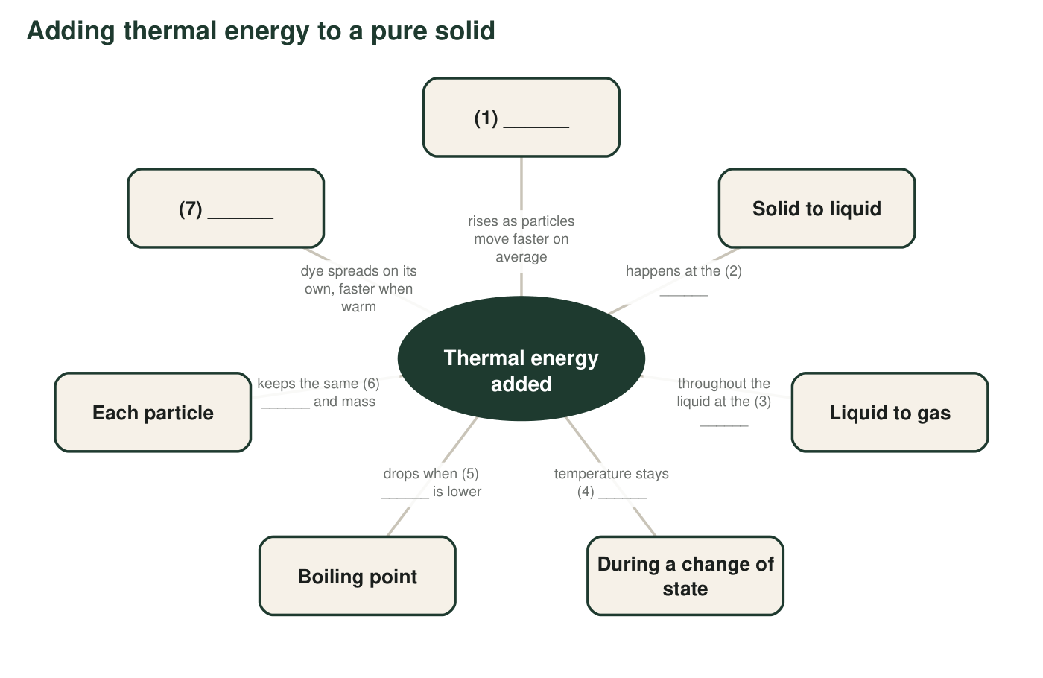
A concept map about heating a pure substance. Each numbered blank is a word or short phrase from the word bank or from what you know.
10. Fill in each numbered blank in the concept map.
Answer: 1 temperature; 2 melting point; 3 boiling point; 4 the same (steady, constant); 5 pressure; 6 size; 7 diffusion.
Reasoning: Blank 4 is the idea students most often miss: while a pure substance melts or boils at a steady pressure, added energy changes the arrangement of the particles rather than their average speed, so the temperature holds steady.
Also acceptable: Blank 4: accept 'steady', 'constant' or 'flat'. Blank 5: accept 'air pressure'.
Full credit must include:
• Temperature and diffusion in blanks 1 and 7
• Melting point and boiling point in the right order
• Blank 4 says the temperature stays the same
• Blank 6 names size

Part D: How are these words related?
11. Water's melting point and its freezing point at sea-level pressure: are they the same temperature or different temperatures? Explain what the particles are doing in each direction.
Answer: The same temperature: 0 °C at sea-level pressure. Melting happens when energy is added and particles break out of their fixed pattern and start sliding past one another; freezing happens when energy is removed and sliding particles settle back into a fixed pattern. Same temperature, opposite directions.
Reasoning: Melting point and freezing point name one boundary crossed in two directions.
Also acceptable: A student who notes that very pure water can cool a little below 0 °C before it starts freezing is going beyond the lesson and is correct.
Full credit must include:
• Says they are the same temperature
• Describes melting as particles leaving fixed positions when energy is added
• Describes freezing as particles locking into fixed positions when energy is removed
12. Evaporation and boiling both turn a liquid into a gas. Describe two ways they are different.
Answer: Evaporation happens only at the surface, while boiling happens throughout the liquid, with bubbles of gas forming inside it. Evaporation happens at any temperature below the boiling point, while boiling happens only at the boiling point for that pressure.
Reasoning: Both are liquid-to-gas changes. Evaporation depends on the fastest surface particles escaping; boiling begins when particles anywhere in the liquid can form bubbles of gas.
Also acceptable: Accept 'evaporation is slow and quiet, boiling makes bubbles' as one of the two differences.
Full credit must include:
• Surface versus throughout
• Any temperature versus at the boiling point
13. A recipe card says, 'Boil the water (100 °C).' Explain why a scientist would say this boiling point is incomplete. Use the word pressure.
Answer: Water boils at 100 °C only at sea-level pressure (about 101 kPa). At lower pressure, such as high in the mountains, it boils at a lower temperature, and at higher pressure, such as in a pressure cooker, at a higher temperature. A complete boiling point states the pressure.
Reasoning: Boiling point depends on the pressure pushing on the liquid's surface, so a temperature alone does not define it.
Also acceptable: Accept an answer that names a specific place (a mountain cabin) instead of a pressure value.
Full credit must include:
• Says boiling point depends on pressure
• Gives the direction (lower pressure, lower boiling point) or an example

Part E: Use the words
14. A backpacker at a high mountain camp scoops snow into a pot, melts it on a stove and then boils the water. Write a paragraph of 4 to 6 sentences that tells this story from the particles' point of view. Use at least six terms from the word bank correctly and underline each one.
Answer: Example: In the snow, the water particles are in a solid: packed in a fixed pattern and vibrating in place. The stove adds thermal energy, and when the snow reaches its melting point of 0 °C the particles break free of their pattern and slide past each other as a liquid. As more energy is added, the temperature of the liquid rises because the particles move faster on average. At the high camp the air pressure is lower, so the water reaches its boiling point below 100 °C, and particles throughout the pot escape into bubbles of gas. The particles never change size; only their motion and spacing change.
Reasoning: Look for terms used with their correct meanings, not just dropped in. The strongest paragraphs connect added thermal energy to faster motion, name the melting and boiling points, and mention lower pressure at altitude.
Also acceptable: A paragraph that describes evaporation from the pot before boiling, or sublimation of some snow, is correct and can count toward the six terms.
Full credit must include:
• At least six word-bank terms, each used correctly and underlined
• Describes particle motion in the solid and the liquid
• Connects added thermal energy to rising temperature or to changes of state
• Notes that the boiling point is lower at the high camp, or that particles keep their size

Teacher notes
Part A is the heart of the sheet. If many students put temperature or a state in the single-particle row, stop and run a quick class discussion: 'Can one molecule be wet? Can one molecule have an average speed?' That idea protects students against the chapter's biggest misconception (that particles themselves melt, soften or expand), which W7 targets directly. In q1, direction of motion is included so that students see a particle has motion of its own while the sample's temperature is an average over many motions. Keep q13 and q14 qualitative; no pressure or energy calculations are expected here. The extension's frost example is real: frost forms by deposition when a surface is below 0 °C and the air holds enough water vapor.

