Angela's Tools · Chapter 23: The Motion of Particles · Worksheet 2 of 10

One Particle or Many? Connecting the Words for States and Motion
Learning target: I can explain how the terms for states, changes of state and particle motion are related, tell which terms describe one particle and which describe a whole sample, and choose the right term for a new situation.
Vocabulary in action · about 30 minutes · individual · Standards: MS-PS1-4 (supports)
Name: ____________________________ Date: ____________ Period: ______

Directions
Read the word bank first; every definition is in plain language and you may use it for every part. Part A asks which words can describe a single particle and which only make sense for a whole sample. Part B gives short situations and asks which term fits best. Part C is a concept map with blanks. Part D asks how pairs of words are related, and Part E asks you to use the words yourself.
particle: One of the tiny atoms or molecules a substance is made of. Particles are far too small to see and are always moving.
state of matter: The form a sample takes, solid, liquid or gas, set by how close its particles are and how freely they move.
solid: A state in which particles are packed in a fixed pattern and vibrate around their places without trading places.
liquid: A state in which particles stay close together but slide past one another, so the sample flows and takes the shape of its container.
gas: A state in which particles are far apart and move freely in straight lines until they collide, so the sample spreads to fill its container.
temperature: A measure of how fast the particles of a sample are moving on average. Higher temperature means faster average motion.
thermal energy: The total energy of motion of all the particles in a sample. A bigger sample at the same temperature has more of it.
diffusion: The spreading of particles from where they are crowded to where they are fewer, caused only by their own random motion.
melting point: The temperature at which a pure solid turns into a liquid at a stated pressure. Freezing happens at the same temperature.
boiling point: The temperature at which a pure liquid turns into a gas throughout the liquid at a stated pressure. Lower pressure means a lower boiling point.
evaporation: The escape of the fastest-moving particles from the surface of a liquid into the air. It happens at temperatures below the boiling point.
pressure: The force pushing on each unit of area. A gas makes pressure when its particles collide with the walls around it.
state diagram: A graph of temperature and pressure divided into regions that show where a substance is solid, liquid or gas.
sublimation: A change straight from solid to gas with no liquid in between.

Part A: One particle or a whole sample?
Some words can describe one single particle. Other words only make sense for a sample, a collection of a huge number of particles. For example, one water molecule has a mass, but one water molecule cannot be 'wet'.
1. Sort these twelve words and phrases into the two rows: size, solid, speed, temperature, mass, liquid, pressure, direction of motion, melting point, thermal energy, gas, boiling point. Every word goes in exactly one row.
Row | Words that belong here
Can describe one single particle
Only makes sense for a sample of many particles

2. Use your sort to answer this question: can a single water molecule be a solid, a liquid or a gas? Explain in two sentences.
______________________________________________________________________________________
______________________________________________________________________________________
______________________________________________________________________________________

Part B: Which term fits?
Write the one term from the word bank that best fits each situation.
3. A drop of food coloring is placed on top of a dish of firm, clear gelatin, where nothing can stir or flow. Over two days the color spreads into a wider and wider fuzzy circle. ________
______________________________________________________________________________________
______________________________________________________________________________________
______________________________________________________________________________________
4. A block of frozen carbon dioxide on a lab bench shrinks all afternoon, but the bench stays completely dry. ________
______________________________________________________________________________________
______________________________________________________________________________________
______________________________________________________________________________________
5. A jeweler identifies a silvery metal because a pure sample of it always turns to liquid at about 30 °C at sea-level pressure. ________
______________________________________________________________________________________
______________________________________________________________________________________
______________________________________________________________________________________
6. Every second, a huge number of air particles strike each square centimeter of the inside of a basketball and push its skin outward. ________
______________________________________________________________________________________
______________________________________________________________________________________
______________________________________________________________________________________
7. A wet towel on a clothesline dries on a 20 °C day, even though the water never gets anywhere near 100 °C. ________
______________________________________________________________________________________
______________________________________________________________________________________
______________________________________________________________________________________
8. A chart has temperature along the bottom and pressure up the side, and it is split into three shaded regions labeled with the three states. ________
______________________________________________________________________________________
______________________________________________________________________________________
______________________________________________________________________________________
9. A swimming pool at 27 °C and a mug of cocoa at 70 °C: the cocoa has the higher ________, but the pool has far more ________.
______________________________________________________________________________________
______________________________________________________________________________________
______________________________________________________________________________________

Part C: Complete the concept map
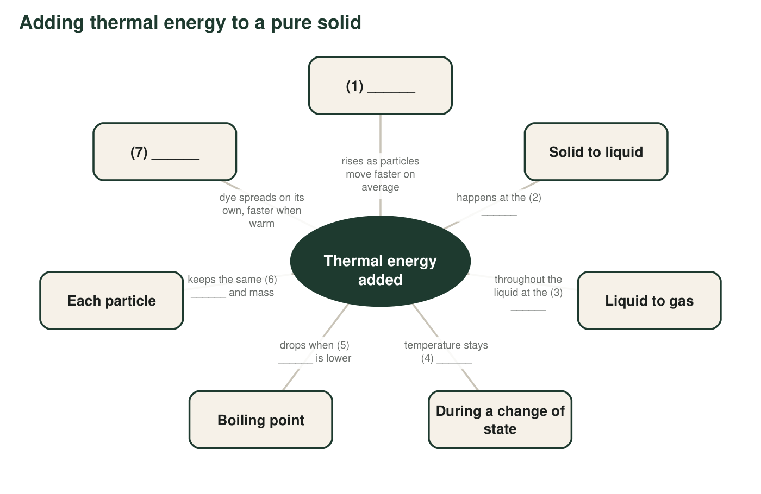
A concept map about heating a pure substance. Each numbered blank is a word or short phrase from the word bank or from what you know.
10. Fill in each numbered blank in the concept map.
Blank | Word or phrase
1
2
3
4
5
6
7

Part D: How are these words related?
11. Water's melting point and its freezing point at sea-level pressure: are they the same temperature or different temperatures? Explain what the particles are doing in each direction.
______________________________________________________________________________________
______________________________________________________________________________________
______________________________________________________________________________________
12. Evaporation and boiling both turn a liquid into a gas. Describe two ways they are different.
______________________________________________________________________________________
______________________________________________________________________________________
______________________________________________________________________________________
13. A recipe card says, 'Boil the water (100 °C).' Explain why a scientist would say this boiling point is incomplete. Use the word pressure.
______________________________________________________________________________________
______________________________________________________________________________________
______________________________________________________________________________________

Part E: Use the words
14. A backpacker at a high mountain camp scoops snow into a pot, melts it on a stove and then boils the water. Write a paragraph of 4 to 6 sentences that tells this story from the particles' point of view. Use at least six terms from the word bank correctly and underline each one.
______________________________________________________________________________________
______________________________________________________________________________________
______________________________________________________________________________________
______________________________________________________________________________________
______________________________________________________________________________________
______________________________________________________________________________________
______________________________________________________________________________________

Ask 'could one particle have this?'
For Part A, picture one single water molecule floating alone. Could you measure its size? Its mass? How fast it is going? Now ask whether that lonely molecule could be 'liquid' or have 'a temperature'. Those words need a crowd. For Part B, cross out any term that names the wrong kind of thing (a state, a change, a quantity, a tool) before you choose.

The change the word bank left out
Frost on a car window on a clear, cold night forms when water vapor in the air turns straight into ice crystals with no liquid step. Scientists call this change deposition. Write your own definition of deposition in the style of the word bank, say which change in the word bank it is the reverse of, and describe what happens to the motion and spacing of the water particles as it happens. Then explain why frost forms only when the glass is below 0 °C.

