Angela's Tools · Chapter 23: The Motion of Particles · Worksheet 4 of 10

Flat Steps on a Heating Curve: Drawing What the Particles Are Doing (Teacher answer key)
Learning target: I can read a heating curve for pure water and draw a particle model that predicts how particle motion, temperature and state change when thermal energy is added or removed.
Diagrams and models · about 45 minutes · individual · Standards: MS-PS1-4 (assesses)

Standards connections
MS-PS1-4 (assesses): Students interpret a heating curve, draw a three-panel particle model of solid, liquid and gas water, and then predict and explain the cooling curve when energy is removed. That drawn, explained model is the evidence the PE asks for. No energy or heat quantities are calculated.

Answers with reasoning

The investigation
A student filled a beaker with crushed ice made from pure (distilled) water, taken straight from an ice-water bath at 0 °C. She put the beaker on a hot plate set to a steady medium heat, stirred gently, and read the thermometer every minute. The lab is at sea level, where the air pressure is about 101 kPa.
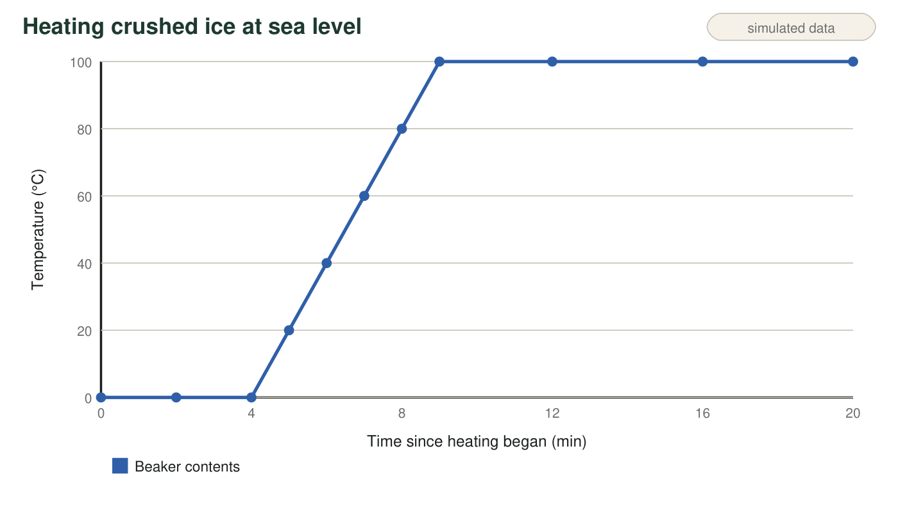
Figure 1. Temperature of the beaker's contents while the hot plate added energy at a steady rate. Segment A is 0-4 minutes, segment B is 4-9 minutes, and segment C is 9-20 minutes.
Observation notes (teaching dataset)
Simulated teaching dataset (not real measurements).
Time (min) | Temperature (°C) | What the student saw
0 | 0 | Mostly ice, a little water at the bottom
2 | 0 | Slush: about half ice, half water
4 | 0 | The last sliver of ice disappears
6 | 40 | Clear liquid; a few tiny bubbles cling to the glass
9 | 100 | Large bubbles form at the bottom and rise to the top
15 | 100 | Steady, rolling boil; the water level is dropping
20 | 100 | Still boiling; noticeably less water in the beaker

A teaching dataset written to match a real heating run; the times are realistic but were not measured in a specific lab.
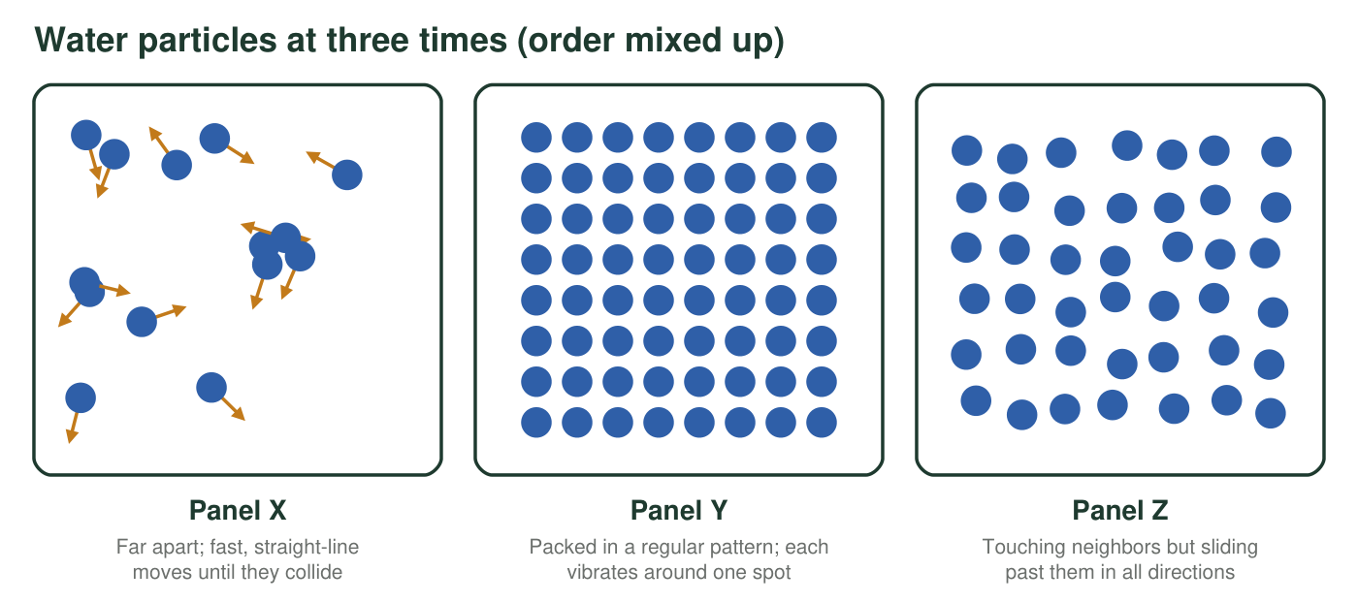
Figure 2. Three close-up particle pictures of the water in the beaker at three different times, in mixed-up order. Each circle is one water molecule; all are drawn the same size.

Part A: Read the diagrams
1. Match each panel in Figure 2 to a state and to one time in Figure 1 when that picture would fit. Give one clue from the panel that you used.
Answer: Panel X: gas (water vapor); fits 9-20 minutes, inside a bubble or the vapor above the boiling water; clue: particles far apart and moving fast in straight lines. Panel Y: solid (ice); fits 0-4 minutes, for example 2 minutes; clue: packed in a regular pattern and only vibrating. Panel Z: liquid; fits roughly 4-20 minutes, for example 7 minutes; clue: touching but sliding past one another.
Reasoning: The arrangement and motion in each panel identify the state; the notes and the graph show when each state is present. Liquid water is present at every time after a little ice melts, so any time from 0 to 20 minutes is defensible for Z if the student says liquid is present then.
Also acceptable: For X, 'the steam bubbles at 15 minutes' or any time from 9 to 20 minutes. For Y, any time from 0 to 4 minutes.
Full credit must include:
• X gas, Y solid, Z liquid
• A time for each that matches when that state is present
• A clue about spacing or motion for each
2. During segment A, the hot plate was adding energy, but the temperature stayed at 0 °C. Where did that energy go? Explain using the particles.
Answer: The energy went into changing the arrangement of the particles: it let water molecules break out of their fixed positions in the ice and start sliding past one another as liquid. Because it was not speeding up the particles on average, the temperature stayed at 0 °C until all the ice had melted.
Reasoning: This is the plateau idea in the PE model: while a pure substance changes state at a steady pressure, added energy changes the arrangement of the particles, not their average motion.
Also acceptable: Accept 'it was used to melt the ice instead of warming it' with some particle language.
Full credit must include:
• Says the energy went into melting the ice
• Explains particles leaving fixed positions
• Links steady temperature to unchanged average motion
3. During segment B, the temperature rose from 0 °C to 100 °C. What happened to the average motion of the water particles? What evidence in Figure 1 tells you?
Answer: The average motion of the water particles increased steadily: they moved faster and faster on average. Evidence: the temperature rose by about 20 °C every minute from 4 to 9 minutes, and temperature tracks average particle motion.
Reasoning: With no change of state happening in segment B, the added energy speeds the particles up, so the temperature climbs.
Also acceptable: Accept 'the particles got more energetic and moved faster' with the graph evidence.
Full credit must include:
• Says average motion increased
• Cites the rising temperature in segment B
• Connects temperature to average particle motion
4. Which statement best describes the water at 12 minutes?
Answer: B. Particles are escaping into bubbles of gas, and the added energy is separating them rather than speeding them up.
Reasoning: At 12 minutes the water is boiling at a steady 100 °C. A is wrong because the hot plate is still on (the water keeps boiling and the level drops), C because particles never change size, D because the gas is water vapor, not air.
Also acceptable: None.
5. The notes describe tiny bubbles at 6 minutes and large bubbles from 9 minutes on. The tiny early bubbles were air that had been dissolved in the water. What is inside the large bubbles, and how do you know they are not air?
Answer: The large bubbles are water vapor: water particles that have separated into the gas state. They appear only once the water reaches its boiling point (100 °C at about 101 kPa), they keep forming for as long as the water boils, and the water level drops as they escape. The small amount of dissolved air had already come out as tiny bubbles at 6 minutes.
Reasoning: A limited amount of air is dissolved in water; it would not keep producing large bubbles for 11 minutes or make the water level fall. Bubbles that start exactly at the boiling point and carry water away are water vapor.
Also acceptable: Accept 'steam' if the student explains it means invisible gas water, not the white cloud.
Full credit must include:
• Names water vapor (gas water)
• Gives evidence: start at the boiling point, keep forming, or water level dropping

Part B: Draw the model
Rules for your model: draw every water particle as a circle of the same size in every panel. Show motion with marks: small zigzags for vibrating in place, short arrows for sliding, long arrows for fast free motion. Put about 12 particles in each panel. Write a one-sentence label under each panel that describes the motion.
Draw three panels: (1) a tiny piece of the ice at 2 minutes, (2) the liquid water at 7 minutes, and (3) the inside of one large bubble at 15 minutes. Under each panel, write the temperature and a one-sentence description of how the particles are moving.
Expected drawing: Panel 1 (0 °C, ice): about 12 circles touching in neat rows, each with small zigzag marks; label such as 'Particles vibrate in place but cannot trade places.' Panel 2 (about 60 °C, liquid): circles still touching or nearly touching but in an irregular arrangement, with short arrows in several directions; label such as 'Particles slide past one another and move faster on average than at 0 °C.' Panel 3 (100 °C, gas): only a few circles, far apart, with long arrows; label such as 'Particles are far apart and move freely in straight lines until they collide.' Circles are the same size in all three panels.
Reasoning: This is the core model of the PE. Check four things: same-size particles, correct spacing for each state, motion shown in every panel including the solid, and a motion label under each. The gas panel shows fewer particles because a close-up of a gas contains fewer particles in the same space, not because particles were lost.
6. Panel 3 (the gas) has far more space between particles than panel 1 (the ice). Explain why your circles must still be the same size in both panels, even though water vapor takes up much more room than ice.
Answer: Each particle is the same water molecule in every state; it does not grow when it becomes a gas. Water vapor takes up more room because the particles are much farther apart and move freely, not because each particle is bigger.
Reasoning: This blocks the misconception that particles expand or change when a substance changes state.
Also acceptable: Accept 'the space between them grows, not the particles'.
Full credit must include:
• Says the particles do not change size
• Explains the larger volume as larger spaces between particles

Part C: Run the model backward
Later, the student switches off the hot plate and puts a covered beaker of 100 °C liquid water into a freezer at −18 °C. She leaves it until long after it has frozen.
7. Sketch the temperature-time graph you predict for the water in the freezer, from 100 °C until it reaches the freezer's temperature. Label the temperature of any flat part and write which change of state is happening there.
Answer: A curve that starts at 100 °C and falls (fastest at first, then more slowly), reaches 0 °C, stays flat at 0 °C for a while labeled 'freezing: liquid to solid', then falls again until it levels off at −18 °C.
Reasoning: Energy is removed the whole time. The temperature drops while the liquid cools, holds at the freezing point while the water turns to ice, and drops again until the ice reaches the freezer's temperature. A curve that slows as it approaches each level is more realistic, but a straight-line sketch with the right shape earns credit.
Also acceptable: No flat step at 100 °C is expected, because the beaker starts as liquid. A student who adds a short plateau at 100 °C and explains it as some vapor condensing should be asked to justify it; it is not required.
Full credit must include:
• Starts at 100 °C and decreases
• One flat part at 0 °C labeled freezing (liquid to solid)
• Falls again after the flat part
• Ends level at −18 °C
8. Describe what happens to the particles' motion, the temperature and the state during each part of your sketch. Use the words removed, average motion and fixed positions.
Answer: From 100 °C down to 0 °C, energy is removed, so the liquid's particles slow down on average and the temperature falls; the water stays liquid. At 0 °C, energy is still being removed, but the particles settle into fixed positions as ice forms, so the temperature stays at 0 °C until all the water has frozen. Below 0 °C, more energy is removed, the particles in the ice vibrate less and less around their fixed positions, and the temperature falls until it matches the freezer at −18 °C. The particles never stop moving and never change size.
Reasoning: This is the PE written in words: for each stage, particle motion, temperature and state are all described, with energy being removed throughout.
Also acceptable: Accept 'the particles lose energy' in place of 'energy is removed'.
Full credit must include:
• Cooling liquid: average motion decreases and temperature falls
• Freezing: particles move into fixed positions while temperature holds at 0 °C
• Cooling solid: vibration decreases and temperature falls to −18 °C
• Uses removed, average motion and fixed positions correctly
9. At a mountain cabin, where the air pressure is about 80 kPa, water boils at about 93.5 °C. If the student repeated the heating run there, which part of Figure 1 would change, and how? Which part would stay almost the same?
Answer: Segment C would change: the boiling step would be flat at about 93.5 °C instead of 100 °C, and segment B would end sooner, at 93.5 °C. Segment A, melting at 0 °C, would stay almost the same, because the melting point of water barely changes with ordinary changes in air pressure.
Reasoning: Lower air pressure lowers the boiling point noticeably; it changes the melting point by only a tiny fraction of a degree.
Also acceptable: Accept 'segment B would be shorter' as part of the answer.
Full credit must include:
• Boiling plateau at about 93.5 °C
• Melting plateau still at about 0 °C

Teacher notes
Figure 1 is a teaching dataset with realistic proportions: with a steady heat source, warming liquid water from 0 °C to 100 °C takes a little longer than melting the same mass of ice, and boiling all of it away would take several times longer again, which is why segment C is still going at 20 minutes. Students do not need any of those numbers; keep every explanation qualitative, as the PE's clarification asks. The drawing is the main evidence for MS-PS1-4: check same-size particles, motion in the solid, and the one-sentence labels. Watch for two errors from W1: cold or solid particles drawn with no motion, and particles drawn bigger in the gas. The Figure 2 particle pictures and the q1 table can be projected for a whole-class check before students draw. Very pure water can briefly cool below 0 °C before ice starts to form; if a student knows this, it is a good extension, not an error in their q7 sketch.

