Angela's Tools · Chapter 23: The Motion of Particles · Worksheet 4 of 10

Flat Steps on a Heating Curve: Drawing What the Particles Are Doing
Learning target: I can read a heating curve for pure water and draw a particle model that predicts how particle motion, temperature and state change when thermal energy is added or removed.
Diagrams and models · about 45 minutes · individual · Standards: MS-PS1-4 (assesses)
Name: ____________________________ Date: ____________ Period: ______

Directions
Figure 1 is a graph of temperature against time for a beaker of crushed ice heated steadily on a hot plate. The observation notes tell you what the student saw. Figure 2 shows three particle pictures of water, in mixed-up order. Work through Part A to read the graph and the pictures, Part B to draw your own particle model, and Part C to predict what happens when energy is removed instead of added. Use a ruler for any graph you sketch.

The investigation
A student filled a beaker with crushed ice made from pure (distilled) water, taken straight from an ice-water bath at 0 °C. She put the beaker on a hot plate set to a steady medium heat, stirred gently, and read the thermometer every minute. The lab is at sea level, where the air pressure is about 101 kPa.
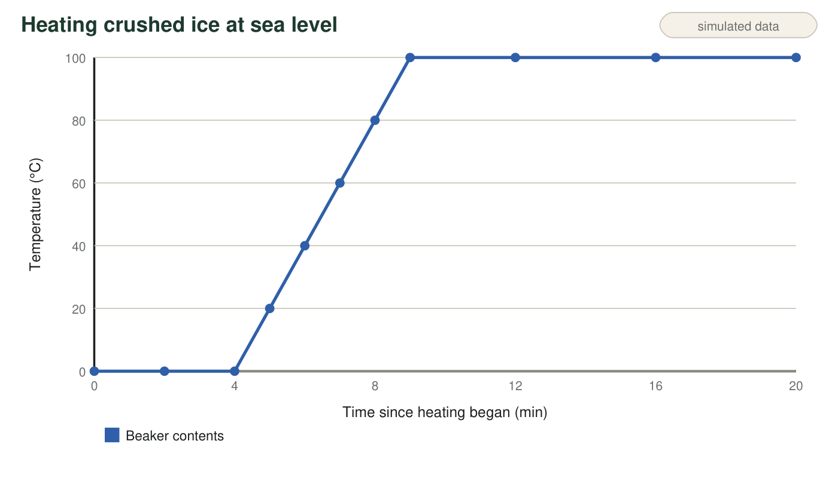
Figure 1. Temperature of the beaker's contents while the hot plate added energy at a steady rate. Segment A is 0-4 minutes, segment B is 4-9 minutes, and segment C is 9-20 minutes.
Observation notes (teaching dataset)
Simulated teaching dataset (not real measurements).
Time (min) | Temperature (°C) | What the student saw
0 | 0 | Mostly ice, a little water at the bottom
2 | 0 | Slush: about half ice, half water
4 | 0 | The last sliver of ice disappears
6 | 40 | Clear liquid; a few tiny bubbles cling to the glass
9 | 100 | Large bubbles form at the bottom and rise to the top
15 | 100 | Steady, rolling boil; the water level is dropping
20 | 100 | Still boiling; noticeably less water in the beaker

A teaching dataset written to match a real heating run; the times are realistic but were not measured in a specific lab.
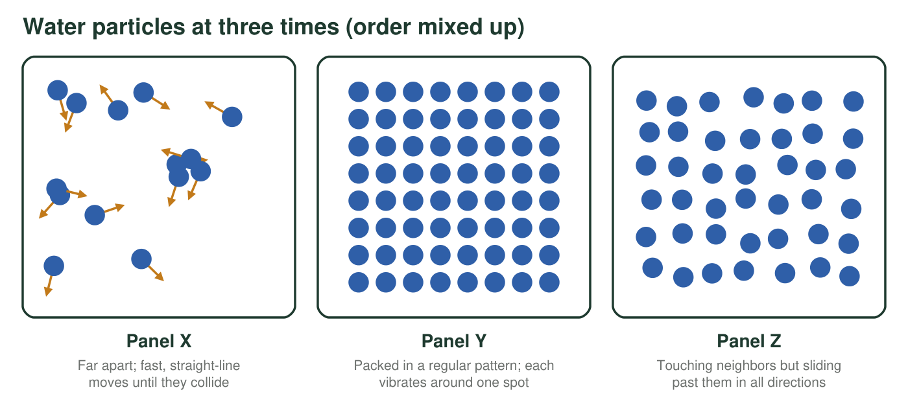
Figure 2. Three close-up particle pictures of the water in the beaker at three different times, in mixed-up order. Each circle is one water molecule; all are drawn the same size.

Part A: Read the diagrams
1. Match each panel in Figure 2 to a state and to one time in Figure 1 when that picture would fit. Give one clue from the panel that you used.
Panel | State | A time that fits (min) | Clue you used
Panel X
Panel Y
Panel Z

2. During segment A, the hot plate was adding energy, but the temperature stayed at 0 °C. Where did that energy go? Explain using the particles.
______________________________________________________________________________________
______________________________________________________________________________________
______________________________________________________________________________________
3. During segment B, the temperature rose from 0 °C to 100 °C. What happened to the average motion of the water particles? What evidence in Figure 1 tells you?
______________________________________________________________________________________
______________________________________________________________________________________
______________________________________________________________________________________
4. Which statement best describes the water at 12 minutes?
○ A. The temperature is steady because the hot plate has stopped adding energy.
○ B. Particles are escaping into bubbles of gas, and the added energy is separating them rather than speeding them up.
○ C. The water particles are swelling as they get hotter, so the bubbles grow.
○ D. The water is changing into air, which is why the level drops.
5. The notes describe tiny bubbles at 6 minutes and large bubbles from 9 minutes on. The tiny early bubbles were air that had been dissolved in the water. What is inside the large bubbles, and how do you know they are not air?
______________________________________________________________________________________
______________________________________________________________________________________
______________________________________________________________________________________

Part B: Draw the model
Rules for your model: draw every water particle as a circle of the same size in every panel. Show motion with marks: small zigzags for vibrating in place, short arrows for sliding, long arrows for fast free motion. Put about 12 particles in each panel. Write a one-sentence label under each panel that describes the motion.
Draw three panels: (1) a tiny piece of the ice at 2 minutes, (2) the liquid water at 7 minutes, and (3) the inside of one large bubble at 15 minutes. Under each panel, write the temperature and a one-sentence description of how the particles are moving.

6. Panel 3 (the gas) has far more space between particles than panel 1 (the ice). Explain why your circles must still be the same size in both panels, even though water vapor takes up much more room than ice.
______________________________________________________________________________________
______________________________________________________________________________________
______________________________________________________________________________________

Part C: Run the model backward
Later, the student switches off the hot plate and puts a covered beaker of 100 °C liquid water into a freezer at −18 °C. She leaves it until long after it has frozen.
7. Sketch the temperature-time graph you predict for the water in the freezer, from 100 °C until it reaches the freezer's temperature. Label the temperature of any flat part and write which change of state is happening there.

8. Describe what happens to the particles' motion, the temperature and the state during each part of your sketch. Use the words removed, average motion and fixed positions.
______________________________________________________________________________________
______________________________________________________________________________________
______________________________________________________________________________________
______________________________________________________________________________________
______________________________________________________________________________________
______________________________________________________________________________________
9. At a mountain cabin, where the air pressure is about 80 kPa, water boils at about 93.5 °C. If the student repeated the heating run there, which part of Figure 1 would change, and how? Which part would stay almost the same?
______________________________________________________________________________________
______________________________________________________________________________________
______________________________________________________________________________________

Read the graph one segment at a time
Cover all of Figure 1 except one segment with a sheet of paper. For that segment, ask three questions and write the answers beside it: Is the temperature going up or staying flat? What state or states are in the beaker (check the notes)? Is the added energy speeding the particles up or changing how they are arranged? Then uncover the next segment. For the drawing, start by copying the arrangement from the matching panel in Figure 2.

Why is the boiling step so long?
In a full run, the boiling step lasts several times longer than the melting step, even though the hot plate adds energy at the same steady rate. Use the particle model to explain why separating particles completely (liquid to gas) takes more energy than letting them slide past one another (solid to liquid). Then predict how the length of the melting step would change if the student started with twice as much ice, and explain your prediction without any calculation.

