Angela's Tools · Chapter 23: The Motion of Particles · Worksheet 10 of 10

The Motion of Particles: Mastery Check (Teacher answer key)
Learning target: I can show that I understand how particles move in each state, how temperature and pressure affect state, and how particle motion, temperature and state change when thermal energy is added or removed.
Retrieval and mastery check · about 40 minutes · individual · Standards: MS-PS1-4 (assesses)

Standards connections
MS-PS1-4 (assesses): Items 1 to 4, 9 and 10 and the synthesis (item 12) ask students to use a particle model to predict and describe particle motion, temperature and state as thermal energy is added or removed, which is the PE as written. Items 5 to 8 cover pressure and how it shifts boiling points, from the same DCI. The only calculation is a pressure calculation; no energy is calculated.

Answers with reasoning

Part A: Retrieval (items 1-11)
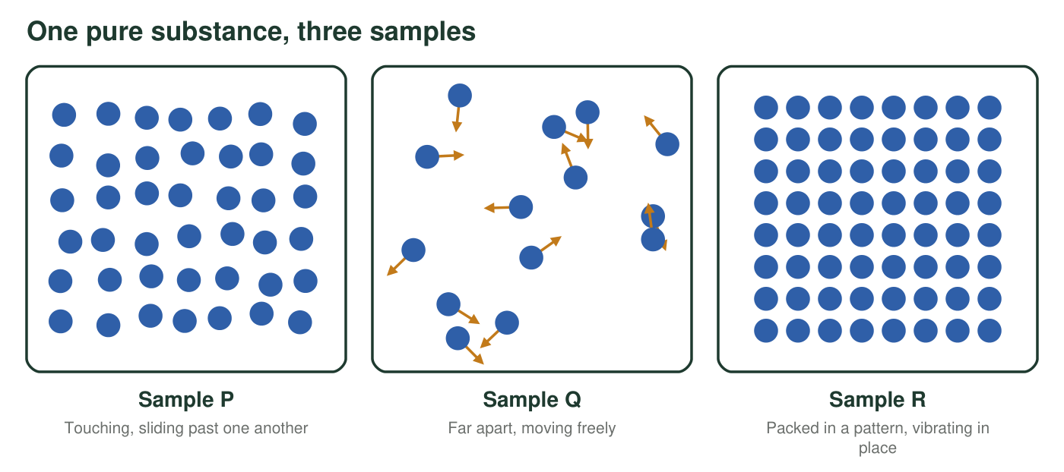
Three close-up views of the same pure substance, all at sea-level pressure. Each sample is well away from its melting and boiling points.
1. Which list puts the three samples in the figure in order from lowest to highest temperature?
Answer: B. R, P, Q
Reasoning: R is a solid (packed, vibrating), P a liquid (touching, sliding) and Q a gas (far apart, moving freely). For one pure substance at one pressure, the solid exists at the lowest temperatures and the gas at the highest, so R, P, Q is lowest to highest.
Also acceptable: None.
2. One cup of water is at 10 °C and another is at 50 °C. Which statement is true?
Answer: B. The particles in the 50 °C cup are moving faster on average.
Reasoning: Temperature tracks average particle motion. A is wrong because particles always move; C because particles do not change size; D because each cup contains a range of speeds, so some particles in the cold cup move faster than some in the warm cup.
Also acceptable: None.
3. With no stirring, a drop of dye spreads through water faster at 45 °C than at 15 °C. Explain why, using particles.
Answer: The water and dye particles are always moving and colliding, and at 45 °C they move faster on average than at 15 °C. Faster particles bump the dye particles more often and harder, so the dye particles wander away from the crowded drop sooner. This spreading by random motion, diffusion, is faster in warmer water.
Reasoning: The key link is higher temperature, faster average motion, faster diffusion.
Also acceptable: Accept an answer that also mentions gentle currents, as long as particle motion is the main explanation.
Full credit must include:
• Particles are always moving
• Higher temperature means faster average motion
• Faster motion spreads the dye sooner (diffusion)
4. True or false: when water boils, its molecules break apart into hydrogen and oxygen.
Answer: False.
Reasoning: Boiling separates whole water molecules from one another; each molecule stays H₂O. Breaking water into hydrogen and oxygen is a chemical change that boiling does not cause.
Also acceptable: None.
5. A syringe full of air is sealed at the tip. Draw two close-up panels of the air inside: before and after the plunger is pushed halfway in, at the same temperature. Show the number, size and spacing of the particles and add motion arrows.
Answer: Two panels with the same number of particles (for example 10) of the same size. Before: particles spread through the whole panel, far apart, with long arrows in random directions. After: the same particles packed into about half the space, still far apart compared with a liquid, still with arrows of the same length, and with more of them near the walls.
Reasoning: Pushing the plunger crowds the same particles closer together, so more of them hit each area of the walls every second (higher pressure). At the same temperature they move at the same average speed, so arrows stay the same length; the air stays a gas, and no particle shrinks.
Also acceptable: A student who adds a note such as 'more hits on the walls' earns full credit even if the arrows are uneven.
Full credit must include:
• Same number of particles in both panels
• Same particle size in both panels
• Closer together after, but still spaced like a gas
• Motion arrows in both, of similar length
Reference values (real, rounded)
Substance | Change of state | Temperature | Pressure
Water | melts or freezes | 0 °C | 101 kPa
Water | boils | 100 °C | 101 kPa
Water | boils | about 85 °C | 58 kPa
Water | boils | about 120 °C | 200 kPa
Carbon dioxide | sublimes (solid to gas); no liquid at this pressure | −78.5 °C | 101 kPa
Gallium | melts or freezes | about 30 °C | 101 kPa
Gallium | boils | above 2,000 °C | 101 kPa

Use this table for item 6. Melting points barely change with ordinary changes in pressure.
6. Predict the state of each pure substance and give a short reason that uses the table.
Answer: a. Liquid: 70 °C is between 0 °C and 100 °C at 101 kPa. b. Gas: 100 °C is above water's boiling point of about 85 °C at 58 kPa. c. Liquid: 100 °C is below water's boiling point of about 120 °C at 200 kPa. d. Gas: −50 °C is warmer than −78.5 °C, and carbon dioxide has no liquid state at 101 kPa. e. Solid: −100 °C is colder than −78.5 °C. f. Liquid: 45 °C is above gallium's melting point of about 30 °C and far below its boiling point. g. Solid: 10 °C is well below about 30 °C.
Reasoning: Every condition is at least 15 °C from a boundary, so the prediction is clear. Items b and c show that the same temperature can give different states at different pressures.
Also acceptable: None.
Full credit must include:
• All seven states correct
• Each reason compares the temperature with the right melting, boiling or sublimation point at that pressure
7. A hiker weighs 600 N. Standing in boots, her weight presses on 0.06 m² of snow; standing in snowshoes, it presses on 0.24 m². Calculate the pressure on the snow in each case in kilopascals (1 kPa = 1,000 N/m²), and say which one is less likely to sink in.
Answer: Boots: 600 N ÷ 0.06 m² = 10,000 N/m² = 10 kPa. Snowshoes: 600 N ÷ 0.24 m² = 2,500 N/m² = 2.5 kPa. The snowshoes press with a quarter of the pressure, so she is less likely to sink in.
Reasoning: Pressure is force divided by area; the same force over four times the area gives one quarter of the pressure.
Also acceptable: Accept 10,000 Pa and 2,500 Pa with the correct conclusion.
8. A plastic bottle is capped tightly on a mountaintop and carried down to sea level, where it is found crushed. Which is the best explanation?
Answer: B. More air particles hit each area of the outside of the bottle than the inside.
Reasoning: The bottle holds the thinner mountaintop air. At sea level the outside air is denser, so more particles collide with each area of the outside, and the outside push crushes the bottle. A misses the cause; C and D are false.
Also acceptable: None.
9. A pure solid is heated steadily at sea-level pressure. Its temperature rises from 20 °C to 44 °C, stays at 44 °C for 6 minutes while it turns to liquid, then rises again. What is its melting point? Explain the flat part using particles.
Answer: Its melting point is 44 °C (at sea-level pressure). During the flat part, the added energy lets the particles break out of their fixed positions and slide past one another as a liquid instead of making them move faster on average, so the temperature stays at 44 °C until all of the solid has melted.
Reasoning: A flat step on a heating curve of a pure substance marks a change of state at constant pressure.
Also acceptable: None.
Full credit must include:
• Melting point 44 °C
• Energy changes the arrangement, not the average motion
• Temperature holds until all the solid has melted
10. Thermal energy is removed steadily from a sealed container of water vapor at 120 °C, kept at 101 kPa, until the contents reach −10 °C. Describe every stage in order. For each stage, say what happens to the particles' motion, to the temperature and to the state.
Answer: (1) The gas cools from 120 °C to 100 °C: energy is removed, the particles slow down on average and the temperature falls; it stays a gas. (2) At 100 °C the vapor condenses: particles come together into a liquid while the temperature stays at 100 °C until all the gas has condensed. (3) The liquid cools from 100 °C to 0 °C: the particles slide past one another more and more slowly and the temperature falls. (4) At 0 °C the water freezes: particles settle into fixed positions while the temperature stays at 0 °C until all of it is ice. (5) The ice cools from 0 °C to −10 °C: the particles vibrate less around their fixed positions and the temperature falls. The particles never stop moving and never change size.
Reasoning: This is the PE as a written model, run in the cooling direction: two cooling stretches with falling temperature and two plateaus at the boiling and melting points, plus the final cooling of the solid.
Also acceptable: Accept four stages if the student combines cooling and condensing correctly but must include both plateaus for full credit.
Full credit must include:
• Five stages in the right order
• Falling temperature with slower average motion in each cooling stretch
• Steady temperature at 100 °C (condensing) and at 0 °C (freezing)
• Correct state at each stage
• Particles keep moving and keep their size
11. True or false: a bathtub of water at 40 °C has more thermal energy than a cup of tea at 80 °C.
Answer: True.
Reasoning: Temperature is an average per particle; thermal energy is the total for the sample. The bathtub holds hundreds of times more water, so it has far more total energy of particle motion even though its particles move more slowly on average.
Also acceptable: None.

Part B: Synthesis (item 12)
At the start of this chapter, a student watched a drop of dye spread faster in warm water than in cold water and wrote this first explanation: 'The dye spread faster in the warm water because heat makes the dye melt and the warm water is moving around. In the cold water nothing was moving, so the dye just sat there.' If you still have your own first explanation from Worksheet 1, you may revise that one instead.
12. Rewrite the explanation as a complete particle-model explanation of 5 to 7 sentences. It must (1) say what the particles are doing in water that looks perfectly still, (2) explain how temperature is related to particle motion, (3) explain why the dye spreads faster in warm water, (4) correct each mistake in the original, and (5) predict what would happen to particle motion, temperature and state if the cold cup kept losing energy until it reached −5 °C.
Answer: Example: Even when water looks perfectly still, its particles are always moving and colliding with each other and with the dye particles. Temperature measures how fast the particles are moving on average, so the particles in the warm water are moving faster on average than those in the cold water. Faster particles knock the dye particles around more often and harder, so the dye spreads away from the crowded drop sooner; this spreading by random motion is diffusion. The dye does not melt: it is already a liquid mixed into water, and particles do not melt or change size. The cold water was moving too, only more slowly, which is why its dye still spread, just more slowly. If the cold cup kept losing energy, its particles would slow down on average and its temperature would fall to 0 °C; then the temperature would stay at 0 °C while the particles settled into fixed positions as the water froze, and once it was all ice the temperature would fall to −5 °C as the particles vibrated less in place.
Reasoning: Score with the five requirements in the prompt. The two corrections that matter most are 'nothing was moving' (particles always move) and 'the dye melts' (no change of state is involved). The cooling prediction is PE evidence.
Also acceptable: A student who notes that gentle currents also help in the warm cup is going beyond the requirements and is correct. A revised Worksheet 1 explanation that meets the same five requirements earns full credit.
Full credit must include:
• Particles move constantly in still water
• Temperature linked to average particle motion
• Faster motion explains faster spreading (diffusion)
• Corrects 'heat makes the dye melt' and 'nothing was moving'
• Predicts slowing, falling temperature, a freezing plateau at 0 °C, and the solid cooling to −5 °C

Teacher notes
Suggested scoring: items 1, 2, 4, 8 and 11 one point each; items 3, 5, 7 and 9 two points each; item 6 three points (one point per two or three correct rows with reasons); item 10 four points; item 12 five points (one per requirement), for 25 points. Items 1 to 4, 9, 10 and 12 carry the MS-PS1-4 evidence. Items 2, 4 and 11 are misconception sentinels (temperature as average motion, particles unchanged by a change of state, temperature versus thermal energy); a student who misses two of them should revisit W7 and W2. All reference values are real: water boils at about 85 °C at 58 kPa and about 120 °C at 200 kPa, carbon dioxide sublimes at −78.5 °C at 101 kPa, gallium melts at 29.76 °C and boils above 2,000 °C. Every state prediction is at least 15 °C from a boundary. If students kept their W1 explanations, let them revise their own in item 12 so they can see how their model changed. Item 7 is a pressure calculation only; no energy or heat calculations appear on this check.

