Angela's Tools · Chapter 23: The Motion of Particles · Worksheet 10 of 10

The Motion of Particles: Mastery Check
Learning target: I can show that I understand how particles move in each state, how temperature and pressure affect state, and how particle motion, temperature and state change when thermal energy is added or removed.
Retrieval and mastery check · about 40 minutes · individual · Standards: MS-PS1-4 (assesses)
Name: ____________________________ Date: ____________ Period: ______

Directions
Answer every item on your own. Part A has eleven retrieval items of different kinds; use the figure and the reference table where an item tells you to. Show your work on the calculation. Part B asks you to write one complete explanation that pulls the chapter together. Read each question twice before you answer.

Part A: Retrieval (items 1-11)
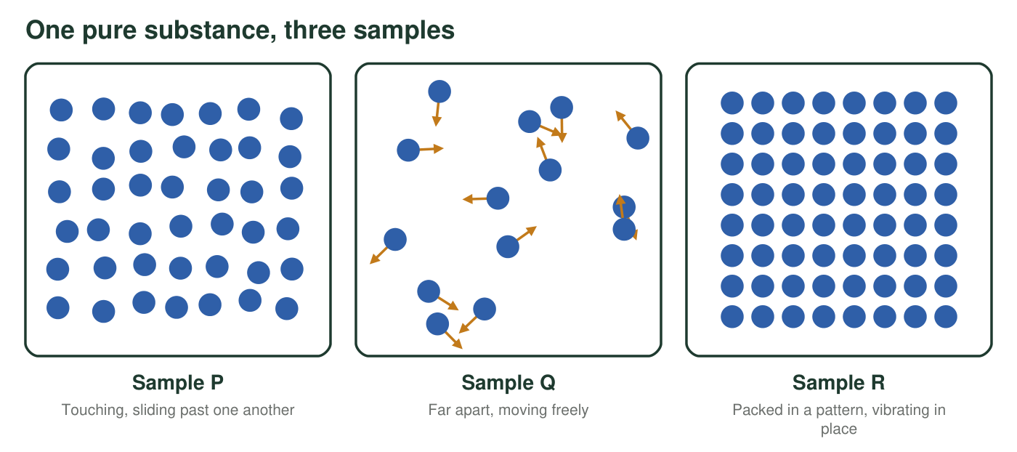
Three close-up views of the same pure substance, all at sea-level pressure. Each sample is well away from its melting and boiling points.
1. Which list puts the three samples in the figure in order from lowest to highest temperature?
○ A. P, Q, R
○ B. R, P, Q
○ C. Q, P, R
○ D. R, Q, P
2. One cup of water is at 10 °C and another is at 50 °C. Which statement is true?
○ A. The particles in the 10 °C cup are not moving.
○ B. The particles in the 50 °C cup are moving faster on average.
○ C. The particles in the 50 °C cup are larger.
○ D. Every particle in the 50 °C cup is moving faster than every particle in the 10 °C cup.
3. With no stirring, a drop of dye spreads through water faster at 45 °C than at 15 °C. Explain why, using particles.
______________________________________________________________________________________
______________________________________________________________________________________
______________________________________________________________________________________
4. True or false: when water boils, its molecules break apart into hydrogen and oxygen.
○ True ○ False Explain:
______________________________________________________________________________________
______________________________________________________________________________________
5. A syringe full of air is sealed at the tip. Draw two close-up panels of the air inside: before and after the plunger is pushed halfway in, at the same temperature. Show the number, size and spacing of the particles and add motion arrows.

Reference values (real, rounded)
Substance | Change of state | Temperature | Pressure
Water | melts or freezes | 0 °C | 101 kPa
Water | boils | 100 °C | 101 kPa
Water | boils | about 85 °C | 58 kPa
Water | boils | about 120 °C | 200 kPa
Carbon dioxide | sublimes (solid to gas); no liquid at this pressure | −78.5 °C | 101 kPa
Gallium | melts or freezes | about 30 °C | 101 kPa
Gallium | boils | above 2,000 °C | 101 kPa

Use this table for item 6. Melting points barely change with ordinary changes in pressure.
6. Predict the state of each pure substance and give a short reason that uses the table.
Substance and conditions | Predicted state | Reason
a. Water at 70 °C and 101 kPa
b. Water at 100 °C and 58 kPa
c. Water at 100 °C and 200 kPa
d. Carbon dioxide at −50 °C and 101 kPa
e. Carbon dioxide at −100 °C and 101 kPa
f. Gallium at 45 °C and 101 kPa
g. Gallium at 10 °C and 101 kPa

7. A hiker weighs 600 N. Standing in boots, her weight presses on 0.06 m² of snow; standing in snowshoes, it presses on 0.24 m². Calculate the pressure on the snow in each case in kilopascals (1 kPa = 1,000 N/m²), and say which one is less likely to sink in.
______________________________________________________________________________________
______________________________________________________________________________________
______________________________________________________________________________________
______________________________________________________________________________________
8. A plastic bottle is capped tightly on a mountaintop and carried down to sea level, where it is found crushed. Which is the best explanation?
○ A. Cold air made the plastic shrink.
○ B. More air particles hit each area of the outside of the bottle than the inside.
○ C. The air particles inside the bottle became smaller.
○ D. The air inside the bottle turned into a liquid.
9. A pure solid is heated steadily at sea-level pressure. Its temperature rises from 20 °C to 44 °C, stays at 44 °C for 6 minutes while it turns to liquid, then rises again. What is its melting point? Explain the flat part using particles.
______________________________________________________________________________________
______________________________________________________________________________________
______________________________________________________________________________________
10. Thermal energy is removed steadily from a sealed container of water vapor at 120 °C, kept at 101 kPa, until the contents reach −10 °C. Describe every stage in order. For each stage, say what happens to the particles' motion, to the temperature and to the state.
______________________________________________________________________________________
______________________________________________________________________________________
______________________________________________________________________________________
______________________________________________________________________________________
______________________________________________________________________________________
______________________________________________________________________________________
______________________________________________________________________________________
11. True or false: a bathtub of water at 40 °C has more thermal energy than a cup of tea at 80 °C.
○ True ○ False Explain:
______________________________________________________________________________________
______________________________________________________________________________________

Part B: Synthesis (item 12)
At the start of this chapter, a student watched a drop of dye spread faster in warm water than in cold water and wrote this first explanation: 'The dye spread faster in the warm water because heat makes the dye melt and the warm water is moving around. In the cold water nothing was moving, so the dye just sat there.' If you still have your own first explanation from Worksheet 1, you may revise that one instead.
12. Rewrite the explanation as a complete particle-model explanation of 5 to 7 sentences. It must (1) say what the particles are doing in water that looks perfectly still, (2) explain how temperature is related to particle motion, (3) explain why the dye spreads faster in warm water, (4) correct each mistake in the original, and (5) predict what would happen to particle motion, temperature and state if the cold cup kept losing energy until it reached −5 °C.
______________________________________________________________________________________
______________________________________________________________________________________
______________________________________________________________________________________
______________________________________________________________________________________
______________________________________________________________________________________
______________________________________________________________________________________
______________________________________________________________________________________
______________________________________________________________________________________
______________________________________________________________________________________

A checklist before you hand it in
For every explanation, check: Did I say the particles are moving in every state, including solids and cold liquids? Did I keep the particles the same size? Did I say 'on average' when I connected temperature to motion? For any state prediction, did I compare the temperature with the melting or boiling point at that pressure?

Write one question of your own
Write one new multiple-choice question about this chapter that would catch the misconception that particles grow, shrink or soften when a substance changes state. Give four options, mark the correct one, and for each wrong option write one sentence explaining what a student who chose it is probably thinking. Then trade with a classmate and answer each other's question.

