Angela's Tools · Chapter 24: Heat, Temperature, and State Changes · Worksheet 1 of 10

The Sweating Glass and the Stubborn Thermometer (Teacher answer key)
Learning target: I can record what I notice and wonder about cold containers in a warm room, use what I already know about particles and energy, and write first explanations for where the water on the outside comes from and why ice water stays at 0 °C.
Phenomenon exploration · about 30 minutes · individual · Standards: MS-PS1-4 (supports)

Standards connections
MS-PS1-4 (supports): Students observe water appearing on cold surfaces and a thermometer that holds at 0 °C while ice melts, and propose first explanations. The chapter's model of particles gaining or losing thermal energy and changing state will explain both; this sheet raises the questions but does not yet build or assess the model.

Answers with reasoning

Observation 1: Three containers on a paper towel
On a warm, sticky September afternoon, the classroom air is 27 °C. Ms. Ortiz takes a sealed, unopened can of purple grape juice out of the refrigerator, where it has been chilling at about 4 °C, and sets it on a dry paper towel. Next to it she sets an identical sealed can of grape juice that has been sitting on the counter all day. Then she fills a tall glass with ice cubes, adds tap water, and sets the glass on the same towel. She tapes a small thermometer probe to the side of the cold can. The class watches for ten minutes.
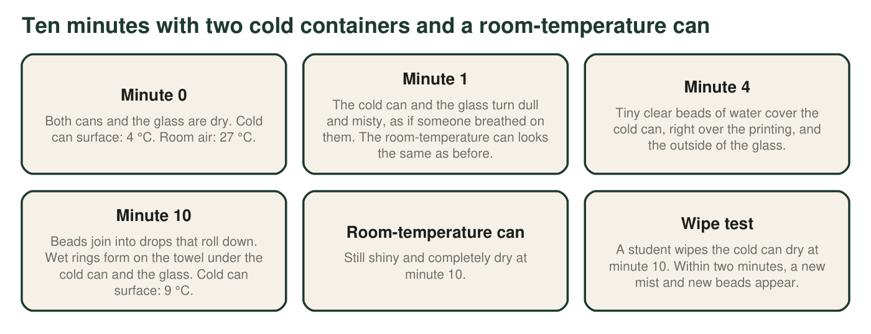
What the class observed. The cans were never opened, and the glass was not overfilled. Temperatures are rounded to the nearest degree.

Observation 2: The thermometer that will not move
Ms. Ortiz stands a thermometer in the glass of ice water and stirs gently every few minutes. The room stays at 27 °C the whole time, so the room is always warmer than the glass. The class records the reading and the ice every ten minutes.
Ice water in a 27 °C room (teaching dataset)
Simulated teaching dataset (not real measurements).
Time (min) | Thermometer in the glass (°C) | What the ice looks like
0 | 0 | Glass packed with ice cubes
10 | 0 | Cubes have rounded edges
20 | 0 | About half the ice is left
30 | 0 | A few small pieces float
40 | 0 | One thin sliver is left
50 | 3 | No ice left
60 | 8 | No ice left

Simulated data for teaching, consistent with what a tall glass of ice water does in a warm room.

Part A: Notice and wonder
1. Write three things you notice in Observations 1 and 2. At least one must compare the cold can with the room-temperature can, and at least one must use a number.
Answer: Examples: water appears on the cold can and the glass but not on the room-temperature can; the cold containers turn misty in about 1 minute; the cold can's surface warms from 4 °C to 9 °C; the drops are clear even though the juice is purple; new drops form after the can is wiped; the ice water reads 0 °C for 40 minutes while the room is 27 °C; the reading rises to 3 °C and then 8 °C only after the ice is gone.
Reasoning: Any accurate observation counts. The comparison of the two cans, the clear (not purple) drops and the long run of 0 °C readings are the most useful clues for later.
Also acceptable: Accept observations about the wet rings or the shrinking ice.
Full credit must include:
• Three observations, not explanations
• At least one compares the cold can with the room-temperature can
• At least one includes a number
2. Write three questions you wonder about. Start each with why, how, where or what would happen if.
Answer: Examples: Where does the water come from if the can is sealed? Why are the drops clear when the juice is purple? Why does the thermometer stay at 0 °C when the room is so warm? What would happen on a dry day? What would happen if we used warm water instead of ice water?
Reasoning: Good questions grow from the observations and could be answered by a test or by the chapter's ideas.
Also acceptable: Questions about method ('Would a different thermometer read the same?') are legitimate and earn credit.
Full credit must include:
• Three questions
• Each begins with one of the given starters
• Each connects to an observation
3. By how many degrees did the cold can's surface temperature change in ten minutes? Show the subtraction. Then say which way you think energy moved between the room air and the can, and why.
Answer: 9 °C − 4 °C = 5 °C. The surface temperature rose by 5 degrees. Energy moved from the warmer room air (and the towel) into the colder can, because energy transfers from warmer objects to cooler ones.
Reasoning: The can warmed, so it gained energy, and the only warmer things around it were the air and the surfaces it touched.
Also acceptable: Accept 'cold moved out of the can' as a starting idea this early, but note it for W7, where students learn that only energy moves.
Full credit must include:
• Shows 9 − 4 = 5 with units
• States that energy moved from the air into the can
• Gives a reason (the air is warmer, or the can warmed up)

Part B: What you already know
4. Name the three states of matter. For each one, describe in a few words how its particles are arranged and how they move.
Answer: Solid: particles packed close together in fixed positions, vibrating in place. Liquid: particles close together but able to slide past one another. Gas: particles far apart, moving fast and freely in all directions.
Reasoning: This recalls the particle model from the previous lesson, which this chapter extends to state changes.
Also acceptable: Accept labeled drawings in place of words.
Full credit must include:
• Names solid, liquid and gas
• Describes spacing for each
• Describes motion for each
5. Water can be an invisible gas called water vapor. Name two places the water vapor in a classroom could come from.
Answer: Examples: people breathing out; water evaporating from wet hands, a mopped floor, plants or a fish tank; humid outdoor air coming in through the door or windows.
Reasoning: Students need to know that ordinary air contains invisible water vapor before the chapter can explain where the drops come from.
Also acceptable: Accept 'the air already has water in it' as one source.
Full credit must include:
• Two plausible sources of water vapor

Part C: Your first explanations
Three students offered ideas about the drops. Ari: 'The juice is seeping out through tiny holes in the metal.' Bea: 'The cold from the can turns into water when it touches the warm air.' Cy: 'Something invisible in the air turns into water when it touches a cold surface.'
6. Test each idea against the observations. In each cell, name a specific observation from the figure or the text. Write 'none' if you cannot find one.
Answer: Ari: fits = water appears on the outside of the can; does not fit = the can is sealed, the drops are clear while the juice is purple, the room-temperature can with the same juice stays dry, and the glass of plain water sweats too. Bea: fits = water appears only on cold things; does not fit = cold is not a substance and cannot turn into matter, and new drops keep forming while the can warms. Cy: fits = drops form only on cold surfaces (cold can and glass) and not on the room-temperature can, and they come back after wiping; does not fit = none in these observations.
Reasoning: Cy's idea is the one the chapter confirms: water vapor in the air condenses on surfaces colder than the air. The clear drops and the dry room-temperature can rule out Ari's idea.
Also acceptable: Accept 'the drops keep growing even though the can is warming' as evidence against Bea.
Full credit must include:
• Every cell names a specific observation or says 'none'
• Uses the clear drops or the dry room-temperature can against Ari's idea
• Recognizes that Cy's idea fits all the observations
7. Write your best explanation so far. Where does the water on the outside of the cold can and the glass come from, and why does none form on the room-temperature can? Use the word energy at least once.
Answer: The water comes from invisible water vapor in the room air. The cold can and the glass are much colder than the air, so energy moves from the air touching them into the containers. The water vapor next to the cold surface loses energy, slows down and turns back into liquid water. The room-temperature can is as warm as the air, so the vapor near it does not lose energy and no drops form.
Reasoning: A strong first draft names the air as the source, links the drops to the containers being colder than the air, and mentions energy leaving the vapor. Do not require the word condensation yet.
Also acceptable: Partial credit for 'water in the air sticks to cold things' without the energy idea.
Full credit must include:
• Names water vapor (or something in the air) as the source
• Explains why only the cold containers get wet
• Uses energy with a direction of transfer
• Gives a reason, not just a claim
8. Look at the table in Observation 2. Energy should be flowing from the 27 °C room into the glass the whole time. For the first 40 minutes the reading did not rise. What do you think that energy was doing? What happened as soon as the ice was gone?
Answer: The energy was melting the ice: it was going into turning solid ice into liquid water instead of raising the temperature. As soon as the ice was gone, the reading began to rise (3 °C at 50 minutes, 8 °C at 60 minutes) because the energy now warmed the water.
Reasoning: This is a first idea about the plateau; the chapter explains it fully with particles (energy freeing molecules from fixed positions without raising their average kinetic energy).
Also acceptable: Accept 'the ice used up the energy' as a first draft; return to the wording in W3 and W4.
Full credit must include:
• Links the energy to melting the ice
• Notes that the temperature rose only after the ice was gone
9. Describe one test the class could do to check one of your explanations. Say what result would support it.
Answer: Examples: weigh the cold can for 15 minutes (if the water comes from the air, the can plus drops gets heavier); put a cold can in a sealed box of very dry air (no drops should form); try a cold empty can (it should still sweat); check the drops on white paper for purple color (none expected); or stir a glass of ice water and keep reading the thermometer after adding more ice (it should stay at 0 °C as long as ice remains).
Reasoning: A good test changes or measures one thing that the explanation makes a prediction about.
Also acceptable: Accept 'compare a humid day with a dry day' with a prediction.
Full credit must include:
• A test that could actually be done
• A stated result that would support the explanation
Keep this page
At the end of the chapter you will reread q6, q7 and q8 and mark what you would keep, change or add. A first explanation that changes is a sign of learning, not a mistake.

Teacher notes
This sheet introduces the chapter's two-part phenomenon. Expect three families of first ideas about the drops, mirrored by Ari, Bea and Cy; do not resolve them yet. W6 gives controlled test results (a mass gain, clear drops from purple juice, a cold empty can, a dry-air box) for a full claim-evidence-reasoning argument, and W7 returns to the idea that cold moves. The stubborn thermometer in q8 is the hook for W3, W4 and W5, which explain why temperature holds steady during a change of state. If students call the mist 'steam', ask what steam usually means and leave the question open for the reading in W3, which separates invisible vapor from visible droplets. Collect the sheet or have students keep it for the end-of-chapter revisit.

