Angela's Tools · Chapter 24: Heat, Temperature, and State Changes · Worksheet 1 of 10

The Sweating Glass and the Stubborn Thermometer
Learning target: I can record what I notice and wonder about cold containers in a warm room, use what I already know about particles and energy, and write first explanations for where the water on the outside comes from and why ice water stays at 0 °C.
Phenomenon exploration · about 30 minutes · individual · Standards: MS-PS1-4 (supports)
Name: ____________________________ Date: ____________ Period: ______

Directions
Read both observations slowly. Study the figure and the table, which show what one class saw. Write what you notice before you write what you wonder. In Part C you will write first explanations. It is fine to be unsure, but give a reason for every idea. Keep this sheet: you will come back to it at the end of the chapter and revise your explanations.

Observation 1: Three containers on a paper towel
On a warm, sticky September afternoon, the classroom air is 27 °C. Ms. Ortiz takes a sealed, unopened can of purple grape juice out of the refrigerator, where it has been chilling at about 4 °C, and sets it on a dry paper towel. Next to it she sets an identical sealed can of grape juice that has been sitting on the counter all day. Then she fills a tall glass with ice cubes, adds tap water, and sets the glass on the same towel. She tapes a small thermometer probe to the side of the cold can. The class watches for ten minutes.
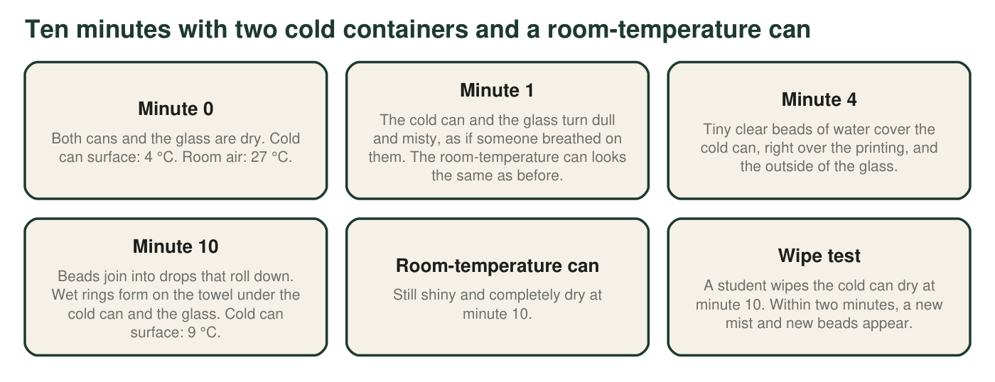
What the class observed. The cans were never opened, and the glass was not overfilled. Temperatures are rounded to the nearest degree.

Observation 2: The thermometer that will not move
Ms. Ortiz stands a thermometer in the glass of ice water and stirs gently every few minutes. The room stays at 27 °C the whole time, so the room is always warmer than the glass. The class records the reading and the ice every ten minutes.
Ice water in a 27 °C room (teaching dataset)
Simulated teaching dataset (not real measurements).
Time (min) | Thermometer in the glass (°C) | What the ice looks like
0 | 0 | Glass packed with ice cubes
10 | 0 | Cubes have rounded edges
20 | 0 | About half the ice is left
30 | 0 | A few small pieces float
40 | 0 | One thin sliver is left
50 | 3 | No ice left
60 | 8 | No ice left

Simulated data for teaching, consistent with what a tall glass of ice water does in a warm room.

Part A: Notice and wonder
1. Write three things you notice in Observations 1 and 2. At least one must compare the cold can with the room-temperature can, and at least one must use a number.
______________________________________________________________________________________
______________________________________________________________________________________
______________________________________________________________________________________
2. Write three questions you wonder about. Start each with why, how, where or what would happen if.
______________________________________________________________________________________
______________________________________________________________________________________
______________________________________________________________________________________
3. By how many degrees did the cold can's surface temperature change in ten minutes? Show the subtraction. Then say which way you think energy moved between the room air and the can, and why.
______________________________________________________________________________________
______________________________________________________________________________________
______________________________________________________________________________________

Part B: What you already know
4. Name the three states of matter. For each one, describe in a few words how its particles are arranged and how they move.
______________________________________________________________________________________
______________________________________________________________________________________
______________________________________________________________________________________
______________________________________________________________________________________
5. Water can be an invisible gas called water vapor. Name two places the water vapor in a classroom could come from.
______________________________________________________________________________________
______________________________________________________________________________________
______________________________________________________________________________________

Part C: Your first explanations
Three students offered ideas about the drops. Ari: 'The juice is seeping out through tiny holes in the metal.' Bea: 'The cold from the can turns into water when it touches the warm air.' Cy: 'Something invisible in the air turns into water when it touches a cold surface.'
6. Test each idea against the observations. In each cell, name a specific observation from the figure or the text. Write 'none' if you cannot find one.
One observation that fits this idea | One observation that does not fit this idea
Ari's idea
Bea's idea
Cy's idea

7. Write your best explanation so far. Where does the water on the outside of the cold can and the glass come from, and why does none form on the room-temperature can? Use the word energy at least once.
______________________________________________________________________________________
______________________________________________________________________________________
______________________________________________________________________________________
______________________________________________________________________________________
______________________________________________________________________________________
______________________________________________________________________________________
8. Look at the table in Observation 2. Energy should be flowing from the 27 °C room into the glass the whole time. For the first 40 minutes the reading did not rise. What do you think that energy was doing? What happened as soon as the ice was gone?
______________________________________________________________________________________
______________________________________________________________________________________
______________________________________________________________________________________
______________________________________________________________________________________
9. Describe one test the class could do to check one of your explanations. Say what result would support it.
______________________________________________________________________________________
______________________________________________________________________________________
______________________________________________________________________________________
Keep this page
At the end of the chapter you will reread q6, q7 and q8 and mark what you would keep, change or add. A first explanation that changes is a sign of learning, not a mistake.

Starters and a particle reminder
For q7, try: 'I think the water comes from ___ because ___.' 'It only forms on cold containers because ___.' For q8, try: 'The energy could be going into ___ instead of ___.' Reminder: particles in a gas are far apart and move fast; particles in a liquid are close together but slide past one another; particles in a solid are held in place and vibrate.

Colder than freezing
Suppose the can came out of a freezer at −15 °C instead of a refrigerator. On a humid day, a white, fuzzy coating forms on it instead of clear drops. Predict what the coating is made of and which state the water skipped on its way there. Then explain why a freezer-cold can is more likely to get this coating than a refrigerator-cold can. You will learn the name of this change in the chapter; for now, describe it in your own words.

