Angela's Tools · Chapter 24: Heat, Temperature, and State Changes · Worksheet 2 of 10

Word Webs: Heat, Temperature, Thermal Energy and Six Changes of State (Teacher answer key)
Learning target: I can tell heat, temperature and thermal energy apart, sort the six changes of state by the energy they need, and use the terms correctly to describe new situations.
Vocabulary in action · about 35 minutes · individual · Standards: MS-PS1-4 (practice), MS-PS3-4 (supports)

Standards connections
MS-PS1-4 (practice): Sorting the six changes by whether thermal energy is added or removed, and naming the change in new situations, builds the language students need to write the predictive particle model the PE asks for. Students do not draw the model on this sheet.
MS-PS3-4 (supports): MS-PS3-4 is a California Grade 6 PE, learned before this lesson. Part A leans on its core idea that a thermometer reads the average kinetic energy of particles, while total thermal energy also depends on how much matter there is. Students sort and apply terms only; they do not plan an investigation or calculate energy.

Answers with reasoning
thermal energy: The energy of every particle in a sample of matter, added up. It depends on how much matter there is, how energetically its particles move, and its state.
temperature: How energetic a substance's particles are on average; it tracks their average kinetic energy. A thermometer reads it.
heat: Energy that flows from something warmer into something cooler because their temperatures differ.
kinetic energy: The energy an object or a particle has because it is moving.
state change: A change from one state (solid, liquid or gas) to another. The particles themselves stay the same; their arrangement and motion change.
melting / freezing: Solid changing to liquid / liquid changing to solid.
evaporation: Liquid changing to gas at the liquid's surface. It happens at many temperatures, faster when warmer.
boiling: Liquid changing to gas all through the liquid, with bubbles of vapor forming inside it. It happens at the boiling point.
condensation: Gas changing to liquid.
sublimation / deposition: Solid changing straight to gas / gas changing straight to solid, skipping the liquid state.
melting point / boiling point: The temperature at which a solid melts (the same temperature at which its liquid freezes) / the temperature at which a liquid boils at a given air pressure.
attraction between particles: The pull that holds a substance's particles close together. Stronger attractions take more energy to overcome.

Part A: Three words people mix up
1. Decide which of the three terms each statement describes. Each term is used at least once. In the second column, write the word or idea in the statement that helped you decide.
Answer: 1. Temperature (clue: thermometer reads it). 2. Heat (clue: energy on the move from warmer to cooler). 3. Thermal energy (clue: more water means more of it; it is a total). 4. Temperature (clue: the same for a spoonful and a pot, so it is an average; 100 °C at sea level). 5. Heat (clue: flows from one object to another because the hand is warmer). 6. Thermal energy (clue: it increases even though the thermometer does not change; the energy goes into freeing particles).
Reasoning: Temperature is an average and does not depend on the amount; thermal energy is a total and grows with the amount and with melting; heat is the transfer. Statement 6 shows that thermal energy can rise while temperature stays the same, which the chapter explains with the flat parts of a heating curve.
Also acceptable: For statement 5, accept 'thermal energy, moving as heat'.
Full credit must include:
• All six terms correct
• Each clue points to the defining idea (average, total or transfer)
2. Say it like a scientist. Rewrite each everyday sentence so that it uses heat, temperature or thermal energy correctly. (a) 'Close the door, you're letting the cold in!' (b) 'This soup has a lot of heat in it.'
Answer: (a) 'Close the door; thermal energy from the warm room is moving as heat out to the colder air outside.' (b) 'This soup has a high temperature, so it has a lot of thermal energy that can move as heat into my mouth and the bowl.'
Reasoning: Cold is not a substance that moves; warmer matter loses energy to cooler matter. Objects store thermal energy, not heat; heat is only the energy that transfers.
Also acceptable: For (a), accept 'You're letting heat out' if the student explains that energy leaves the warm room.
Full credit must include:
• (a) energy moves out from the warm room; no 'cold' moving in
• (b) the soup has a high temperature or thermal energy, not 'heat'

Part B: Sort the six changes of state
3. Complete the table for all six changes. Then circle the two changes that skip the liquid state.
Answer: Melting: solid → liquid, added, opposite = freezing. Freezing: liquid → solid, removed, opposite = melting. Evaporation: liquid → gas, added, opposite = condensation. Condensation: gas → liquid, removed, opposite = evaporation. Sublimation: solid → gas, added, opposite = deposition. Deposition: gas → solid, removed, opposite = sublimation. Circled: sublimation and deposition.
Reasoning: Changes toward a state with freer particles (solid → liquid → gas) need thermal energy added; the reverse changes give thermal energy off to the surroundings.
Also acceptable: Accept boiling as the opposite of condensation, since both evaporation and boiling turn liquid to gas.
Full credit must include:
• All start and end states correct
• Added for melting, evaporation, sublimation; removed for freezing, condensation, deposition
• Opposites paired correctly
• Sublimation and deposition circled
4. True or false: 'For a pure substance at a steady air pressure, the melting point and the freezing point are the same temperature.' Circle your answer and explain in one sentence using the word bank.
Answer: True. A pure substance melts and freezes at the same temperature (for water, 0 °C at normal air pressure); which change happens depends on whether thermal energy is being added or removed.
Reasoning: The word bank defines the melting point as the same temperature at which the liquid freezes. At that temperature, adding energy melts the solid and removing energy freezes the liquid.
Also acceptable: Accept 'True: ice melts at 0 °C and water freezes at 0 °C' as a basic explanation.
Full credit must include:
• Marks true
• Explains that the direction of energy transfer decides which change happens

Part C: Complete the concept map
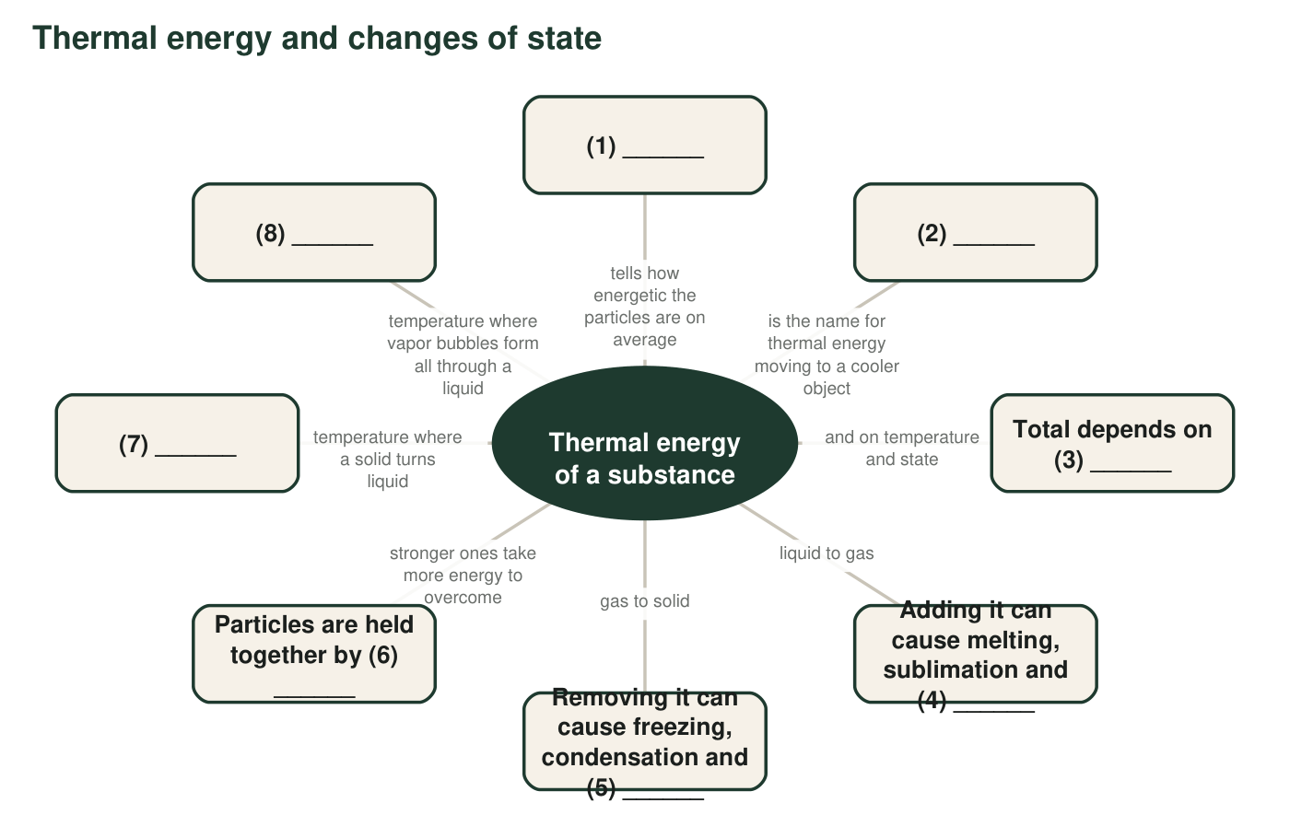
A concept map with eight numbered blanks. Each box links to the center idea.
5. Write the term that belongs in each numbered blank of the concept map.
Answer: 1 temperature; 2 heat; 3 the amount of matter (number of particles, mass); 4 evaporation (or boiling); 5 deposition; 6 attractions between particles; 7 melting point; 8 boiling point.
Reasoning: Each blank matches one definition in the word bank; blank 3 tests the idea that thermal energy is a total.
Also acceptable: Blank 3: accept 'mass', 'how much of the substance' or 'number of particles'. Blank 4: accept 'boiling' or 'vaporization'.
Full credit must include:
• At least seven of eight correct

Part D: Which change is it?
6. Name the change of state in each situation and say whether thermal energy is added to or removed from the substance that is changing.
Answer: a. Deposition; removed (water vapor loses energy to the cold glass and becomes ice). b. Evaporation; added. c. Sublimation; added (the solid turns straight to gas). d. Freezing (solidifying); removed. e. Condensation; removed (water vapor in the humid air loses energy to the cold lenses). f. Boiling; added. g. Sublimation; added (snow turns straight into water vapor).
Reasoning: Each situation is identified by its starting and ending state. The frost (a), the mothballs (c) and the shrinking snowbank (g) skip the liquid state; the snowbank that shrinks without meltwater is sublimation, which really does happen in cold, dry, sunny weather.
Also acceptable: d: accept 'solidification' or 'freezing'; the key point is liquid to solid with energy removed. f: accept 'evaporation (boiling)'.
Full credit must include:
• Seven changes named correctly
• Energy direction correct for each
7. Odd one out. In each set, choose the term that does not belong and give your reason. (a) melting, evaporation, condensation, sublimation. (b) freezing, deposition, condensation, boiling.
Answer: (a) Condensation: it is the only change in the set that needs thermal energy removed; the other three need it added. (b) Boiling: it is the only change that needs thermal energy added; freezing, deposition and condensation all give energy off.
Reasoning: Both sets are sorted by the direction of energy transfer. Other well-reasoned choices can earn credit.
Also acceptable: (a): accept 'sublimation, the only one that skips the liquid state'. (b): accept 'deposition, the only one that skips the liquid state' or 'boiling, the only one that ends as a gas'.
Full credit must include:
• Chooses an odd term for each set
• Gives a reason based on energy direction or on the states involved

Part E: Put the words to work
8. An ice pop at −10 °C is left on a sunny picnic table. It melts into a sticky puddle, and an hour later the puddle has shrunk. Write a paragraph that tells what happens, using at least five of these terms correctly: heat, temperature, thermal energy, kinetic energy, melting point, melting, evaporation, attraction between particles. Underline each term you use.
Answer: Example: The sun and the air are warmer than the ice pop, so heat flows into it. Its particles gain kinetic energy and its temperature rises until it reaches its melting point (about 0 °C, a little lower for sugary ice). Then the added thermal energy goes into breaking particles free of the attractions between particles that hold them in place, so the ice pop melts into a puddle. The puddle keeps gaining energy, and particles at its surface escape into the air by evaporation, so the puddle shrinks and leaves the sugar behind.
Reasoning: A full-credit paragraph follows energy from the warmer surroundings into the ice pop, describes the temperature rising, melting at the melting point and then evaporation, and uses five terms with their scientific meaning.
Also acceptable: Accept 0 °C as the melting point without the sugar caveat. Accept 'the puddle dries up' if evaporation is named.
Full credit must include:
• At least five terms used correctly and underlined
• Heat flows from the warmer surroundings into the ice pop
• Describes melting and then evaporation in the right order
• No use of 'heat' to mean stored energy or temperature

Teacher notes
Statement 6 in q1 previews the flat parts of a heating curve; some students will mark it 'temperature' because nothing on the thermometer changed. Use it to start the discussion in the reading (W3) and the heating-curve diagram (W4). In q6, the lava (a mixture of minerals) hardens over a range of temperatures rather than at one melting point; the change is still freezing. Mothballs are made of compounds that sublime at room temperature; do not bring real mothballs to class because their vapor is toxic. The snowbank in g is real: in cold, dry, sunny weather snow can sublime directly into water vapor.

