Angela's Tools · Chapter 24: Heat, Temperature, and State Changes · Worksheet 2 of 10

Word Webs: Heat, Temperature, Thermal Energy and Six Changes of State
Learning target: I can tell heat, temperature and thermal energy apart, sort the six changes of state by the energy they need, and use the terms correctly to describe new situations.
Vocabulary in action · about 35 minutes · individual · Standards: MS-PS1-4 (practice), MS-PS3-4 (supports)
Name: ____________________________ Date: ____________ Period: ______

Directions
Use the word bank as a reference, but do not just copy definitions: every task asks you to decide how two or more terms are related or which term fits a new situation. Work alone first. Then compare Parts B and D with a partner, and change an answer only if your partner gives you a reason that convinces you.
thermal energy: The energy of every particle in a sample of matter, added up. It depends on how much matter there is, how energetically its particles move, and its state.
temperature: How energetic a substance's particles are on average; it tracks their average kinetic energy. A thermometer reads it.
heat: Energy that flows from something warmer into something cooler because their temperatures differ.
kinetic energy: The energy an object or a particle has because it is moving.
state change: A change from one state (solid, liquid or gas) to another. The particles themselves stay the same; their arrangement and motion change.
melting / freezing: Solid changing to liquid / liquid changing to solid.
evaporation: Liquid changing to gas at the liquid's surface. It happens at many temperatures, faster when warmer.
boiling: Liquid changing to gas all through the liquid, with bubbles of vapor forming inside it. It happens at the boiling point.
condensation: Gas changing to liquid.
sublimation / deposition: Solid changing straight to gas / gas changing straight to solid, skipping the liquid state.
melting point / boiling point: The temperature at which a solid melts (the same temperature at which its liquid freezes) / the temperature at which a liquid boils at a given air pressure.
attraction between particles: The pull that holds a substance's particles close together. Stronger attractions take more energy to overcome.

Part A: Three words people mix up
1. Decide which of the three terms each statement describes. Each term is used at least once. In the second column, write the word or idea in the statement that helped you decide.
Temperature, thermal energy or heat? | The clue that told you
1. It is what a thermometer reads.
2. It is energy on the move from something warmer to something cooler.
3. A bathtub of warm water has more of it than a mug of hot cocoa.
4. It is the same for a spoonful and a whole pot of boiling water at sea level.
5. It flows from your hand into a snowball you are holding.
6. It increases while ice at 0 °C melts into water at 0 °C, even though the thermometer reading stays the same.

2. Say it like a scientist. Rewrite each everyday sentence so that it uses heat, temperature or thermal energy correctly. (a) 'Close the door, you're letting the cold in!' (b) 'This soup has a lot of heat in it.'
______________________________________________________________________________________
______________________________________________________________________________________
______________________________________________________________________________________
______________________________________________________________________________________

Part B: Sort the six changes of state
3. Complete the table for all six changes. Then circle the two changes that skip the liquid state.
Starting state | Ending state | Thermal energy added or removed? | Its opposite change
Melting
Freezing
Evaporation
Condensation
Sublimation
Deposition

4. True or false: 'For a pure substance at a steady air pressure, the melting point and the freezing point are the same temperature.' Circle your answer and explain in one sentence using the word bank.
○ True ○ False Explain:
______________________________________________________________________________________
______________________________________________________________________________________

Part C: Complete the concept map
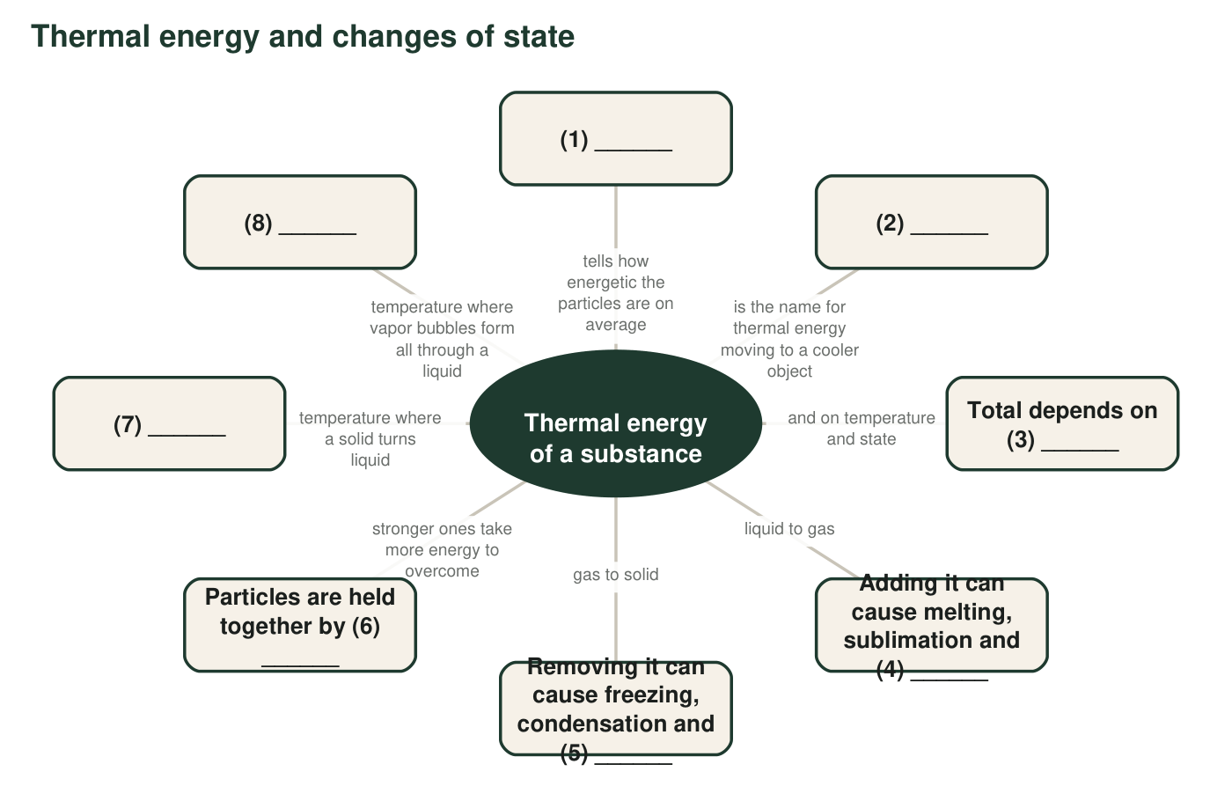
A concept map with eight numbered blanks. Each box links to the center idea.
5. Write the term that belongs in each numbered blank of the concept map.
Term that fills the blank
Blank 1
Blank 2
Blank 3
Blank 4
Blank 5
Blank 6
Blank 7
Blank 8

Part D: Which change is it?
6. Name the change of state in each situation and say whether thermal energy is added to or removed from the substance that is changing.
Change of state | Thermal energy added to or removed from the substance that changes?
a. Feathery frost grows on a car windshield on a clear winter night.
b. A wet swimsuit hanging on a fence dries in the sun.
c. Mothballs in a closet slowly shrink and never leave a puddle.
d. Glowing lava flowing into the ocean hardens into black rock.
e. Your glasses fog up when you walk from a cold, air-conditioned store into a hot, humid parking lot.
f. Big bubbles of vapor rise all through a pot of pasta water.
g. On a bitterly cold, sunny, dry day, a snowbank shrinks but no meltwater appears.

7. Odd one out. In each set, choose the term that does not belong and give your reason. (a) melting, evaporation, condensation, sublimation. (b) freezing, deposition, condensation, boiling.
______________________________________________________________________________________
______________________________________________________________________________________
______________________________________________________________________________________
______________________________________________________________________________________

Part E: Put the words to work
8. An ice pop at −10 °C is left on a sunny picnic table. It melts into a sticky puddle, and an hour later the puddle has shrunk. Write a paragraph that tells what happens, using at least five of these terms correctly: heat, temperature, thermal energy, kinetic energy, melting point, melting, evaporation, attraction between particles. Underline each term you use.
______________________________________________________________________________________
______________________________________________________________________________________
______________________________________________________________________________________
______________________________________________________________________________________
______________________________________________________________________________________
______________________________________________________________________________________
______________________________________________________________________________________

Three questions to ask about any term
For Part A, ask: Is it a reading on a thermometer (an average)? Is it a total for the whole sample (bigger samples have more)? Is it energy moving from one object to another (it needs a temperature difference)? For Parts B and D, ask: What state did it start in, what state did it end in, and did its particles have to break free (energy added) or settle together (energy removed)?

A word that means two things
In everyday speech, people use 'heat' for two different ideas: how hot something is and the energy stored in it. Scientists use it only for energy that moves because of a temperature difference. Find three real sentences that use 'heat' (on a food label, an oven dial, a weather report, a song title or an advertisement). For each, decide whether a scientist would say temperature, thermal energy or heat, and rewrite it. Then argue in two or three sentences whether the everyday meaning is ever useful.

