Angela's Tools · Chapter 24: Heat, Temperature, and State Changes · Worksheet 4 of 10

Reading a Heating Curve and Drawing What the Particles Do (Teacher answer key)
Learning target: I can interpret each part of a heating curve and draw particle models that show how particle motion, temperature and state change as thermal energy is added to or removed from water.
Diagrams and models · about 45 minutes · individual · Standards: MS-PS1-4 (assesses)

Standards connections
MS-PS1-4 (assesses): Students build qualitative molecular-level drawings for four moments on a heating curve and predict a cooling curve, which is the kind of model the clarification statement describes. Water is the pure substance; no step asks for an amount of energy.

Answers with reasoning

Figure 1: Heating 50 grams of ice
A 50 g block of ice from a very cold freezer was placed in a beaker on a hot plate that delivered energy at a steady rate the whole time. A probe recorded the temperature as the ice was stirred. The room was at normal sea-level air pressure. The graph stops at 10 minutes, while the water is still boiling.
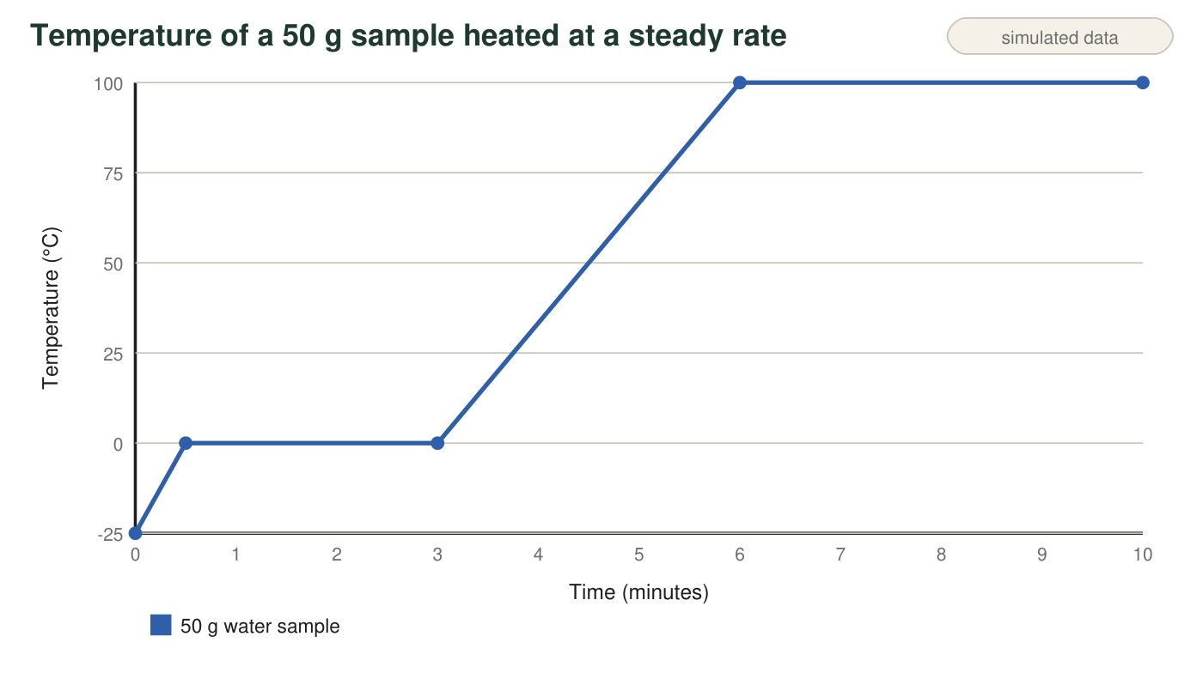
Teaching graph. The four segments are A (0 to 0.5 min), B (0.5 to 3 min), C (3 to 6 min) and D (6 to 10 min). Segment lengths are roughly in proportion to what real water needs; the boiling stretch would continue for many more minutes.
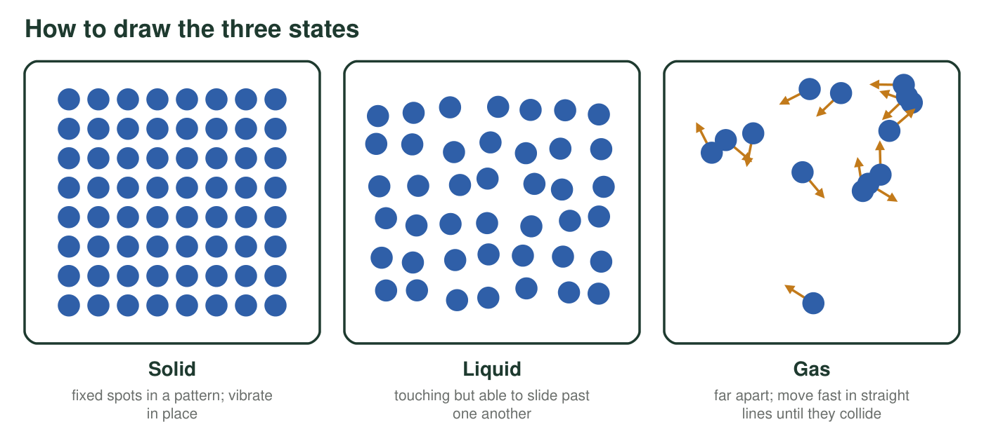
Figure 2. Particle key. Draw each particle as a small circle. Add short motion lines to show how energetically it moves: short wiggles for vibrating in place, longer lines for moving faster.

Part A: Read the curve
1. Complete the table for each segment of Figure 1.
Answer: A: solid (ice); rising; increasing; makes the molecules vibrate harder. B: solid and liquid together (melting); level; steady; frees molecules from their fixed spots (overcomes attractions). C: liquid; rising; increasing; makes the molecules move faster. D: liquid and gas (boiling); level; steady; pulls molecules completely apart into gas.
Reasoning: Rising segments mean the average kinetic energy is increasing; level segments while energy is still being added mean the energy is changing the state instead.
Also acceptable: For D, accept 'liquid turning into gas' or 'boiling'.
Full credit must include:
• States correct for all four segments, with two states in B and D
• Rising for A and C, level for B and D
• Average motion increasing for A and C, steady for B and D
• Energy role described for each
2. Read the melting point and the boiling point of water from the graph. What condition must you state with these two numbers?
Answer: Melting point 0 °C; boiling point 100 °C. These hold at normal (sea-level) air pressure.
Reasoning: The level stretches sit at 0 °C and 100 °C. Boiling points depend on air pressure, so the condition must be stated.
Also acceptable: Accept 'at 1 atmosphere'.
Full credit must include:
• 0 °C and 100 °C
• Names normal or sea-level air pressure
3. How many minutes did segment B last? In segment C, by how many degrees per minute did the temperature rise? Show both calculations with units.
Answer: Segment B: 3 min − 0.5 min = 2.5 min. Segment C: temperature change = 100 °C − 0 °C = 100 °C over 6 min − 3 min = 3 min, so 100 °C ÷ 3 min ≈ 33 °C per minute.
Reasoning: Both values are read from the segment endpoints on the graph.
Also acceptable: Accept 33.3 °C/min or 'about 30 °C/min' if the student reads the endpoints slightly differently and shows the work.
Full credit must include:
• 2.5 min with subtraction shown
• About 33 °C/min with the division shown
4. The thermometer reads 0 °C at 1 minute and again at 2.5 minutes. At which moment does the sample have more thermal energy? Explain how you know.
Answer: At 2.5 minutes. The hot plate added energy steadily between 1 and 2.5 minutes, and that energy freed more molecules from the ice, so more of the sample is liquid. Liquid water at 0 °C has more thermal energy than ice at 0 °C, even though the thermometer reads the same.
Reasoning: Temperature stays level during melting, but thermal energy keeps increasing as energy is added.
Also acceptable: Accept 'later, because the hot plate kept adding energy' with the melting idea.
Full credit must include:
• Chooses 2.5 minutes
• Says energy was still being added
• Links the extra energy to more of the sample being liquid, not to a higher temperature

Part B: Draw the particles
Divide the box into four equal panels labeled 1 to 4. Panel 1: 0.25 min (about −12 °C). Panel 2: 1.5 min (0 °C). Panel 3: 4.5 min (50 °C). Panel 4: 8 min (100 °C). In each panel draw 12 to 16 water molecules as circles, using Figure 2. Show the arrangement, add motion lines, and write the state or states under the panel. Panel 2 must show both ice and liquid. Panel 4 must show liquid, a bubble of vapor inside the liquid, and gas above it.
Expected drawing: Panel 1: tightly packed circles in a regular pattern with short wiggle lines; label solid. Panel 2: a packed cluster (ice) next to touching but disordered circles (liquid); wiggle lines about the same size in both; label solid and liquid. Panel 3: touching, disordered circles with longer motion lines than in Panel 2; label liquid. Panel 4: disordered liquid circles with a bubble containing a few widely spaced circles, and a few widely spaced circles above the liquid with long straight motion lines; label liquid and gas.
Reasoning: The model must show arrangement and motion for each state, a mixture of states during each plateau, and greater motion at higher temperatures. Molecules should stay the same size and shape in every panel.
5. Which of your four panels shows particles with the greatest average kinetic energy? Which shows the least? Explain using the temperatures.
Answer: Greatest: Panel 4 (100 °C). Least: Panel 1 (about −12 °C). Temperature tracks the particles' average kinetic energy, so the highest temperature means the most energetic particles on average, and the lowest means the least.
Reasoning: The four panels are at −12, 0, 50 and 100 °C.
Also acceptable: Accept 'the gas particles in Panel 4 move fastest' if the student also names Panel 1 as least.
Full credit must include:
• Panel 4 greatest, Panel 1 least
• Links temperature to average kinetic energy
6. Panels 2 and 4 were both drawn during a level stretch of the curve. What do the particles in these two panels have in common, and what is different about the change happening in each?
Answer: In common: the temperature is level, so the particles' average kinetic energy is not changing, and two states are present at once. Different: in Panel 2 the energy is freeing molecules from fixed spots in the solid (melting at 0 °C); in Panel 4 it is pulling molecules completely away from one another into gas (boiling at 100 °C).
Reasoning: Both plateaus are changes of state at constant temperature, but they break different amounts of attraction.
Also acceptable: Accept 'both are using energy to change state instead of to heat up'.
Full credit must include:
• Names level temperature or steady average motion
• Names two states present
• Identifies melting versus boiling and what the energy does in each

Part C: Run it backward
7. Predict and sketch a cooling curve: 50 g of liquid water at 50 °C is placed in a freezer set to −20 °C and left overnight. Put time on the horizontal axis and temperature on the vertical axis. Label where the water is liquid, where it is freezing, and where it is solid.
Answer: The sketch starts at 50 °C and slopes down to 0 °C (liquid), runs level at 0 °C for a while (freezing, liquid and solid together), slopes down from 0 °C toward −20 °C (solid), and then levels off at −20 °C (solid at the freezer's temperature).
Reasoning: Removing thermal energy lowers the temperature until freezing begins; the temperature holds during freezing; the ice then cools until it matches the freezer.
Also acceptable: Accept a curve whose sloped parts bend (steep at first, flatter near the end) since cooling slows as the temperature difference shrinks.
Full credit must include:
• Axes labeled with time and temperature
• Starts at 50 °C and ends level at −20 °C
• Level stretch at 0 °C labeled freezing
• Liquid, freezing and solid regions labeled
8. Your cooling curve should have two level stretches. Explain why the temperature stays level during each one. Which one is a change of state, and which one is not?
Answer: At 0 °C the temperature stays level because the water is freezing: as molecules lock into place they give up energy to the freezer, so the temperature does not drop until all the water is ice. That stretch is a change of state. At −20 °C it stays level because the ice has reached the same temperature as the freezer, so there is no longer a temperature difference and no net heat flows. That stretch is not a change of state.
Reasoning: Not every flat part of a temperature graph is a state change. One plateau is a phase change; the other is thermal equilibrium with the surroundings.
Also acceptable: Accept 'it is as cold as the freezer, so it cannot get colder' for the second stretch.
Full credit must include:
• Explains the 0 °C plateau as freezing, with energy given off
• Explains the −20 °C level as equal temperatures and no net heat flow
• Correctly says which is a state change

Teacher notes
The heating curve is a teaching graph; its segment lengths follow the real energy each stage needs for water (warming ice is quick, melting takes several times longer, warming the liquid from 0 to 100 °C takes a little longer than melting, and boiling would take about five times longer than warming the liquid). No question asks for an amount of energy, which keeps the sheet inside the qualitative emphasis of MS-PS1-4. Watch for drawings in which molecules get larger in the liquid or gas: the molecules stay the same; only spacing and motion change. The cooling curve in Part C separates two kinds of level stretches, a change of state and thermal equilibrium, and connects back to W3's extension.

