Angela's Tools · Chapter 24: Heat, Temperature, and State Changes · Worksheet 4 of 10

Reading a Heating Curve and Drawing What the Particles Do
Learning target: I can interpret each part of a heating curve and draw particle models that show how particle motion, temperature and state change as thermal energy is added to or removed from water.
Diagrams and models · about 45 minutes · individual · Standards: MS-PS1-4 (assesses)
Name: ____________________________ Date: ____________ Period: ______

Directions
Study Figure 1, a heating curve for a small sample of water that starts as ice, and use Figure 2 as a key for drawing particles. Complete Part A by reading the graph. In Part B, draw particle models for four moments on the curve. In Part C, predict and sketch what happens when water is cooled instead. Use a ruler for graph lines and pencil for drawings so you can revise.

Figure 1: Heating 50 grams of ice
A 50 g block of ice from a very cold freezer was placed in a beaker on a hot plate that delivered energy at a steady rate the whole time. A probe recorded the temperature as the ice was stirred. The room was at normal sea-level air pressure. The graph stops at 10 minutes, while the water is still boiling.
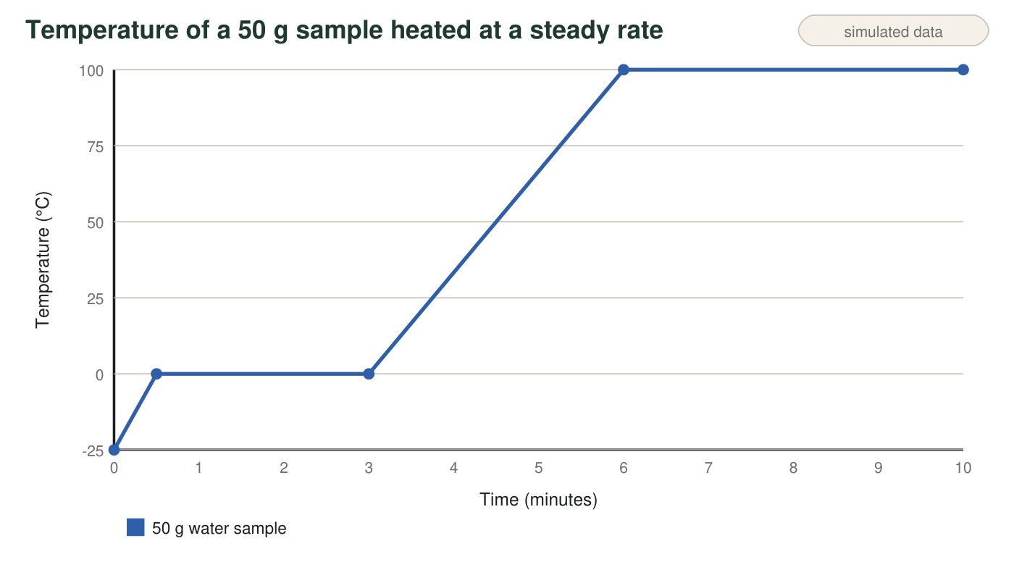
Teaching graph. The four segments are A (0 to 0.5 min), B (0.5 to 3 min), C (3 to 6 min) and D (6 to 10 min). Segment lengths are roughly in proportion to what real water needs; the boiling stretch would continue for many more minutes.
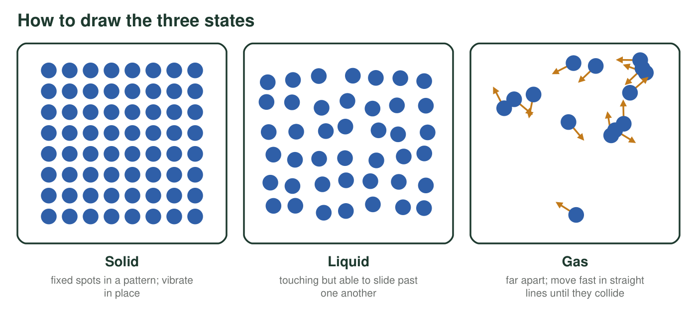
Figure 2. Particle key. Draw each particle as a small circle. Add short motion lines to show how energetically it moves: short wiggles for vibrating in place, longer lines for moving faster.

Part A: Read the curve
1. Complete the table for each segment of Figure 1.
State or states present | Temperature: rising or level? | Average particle motion: increasing or steady? | What the added energy mostly does
Segment A (0 to 0.5 min)
Segment B (0.5 to 3 min)
Segment C (3 to 6 min)
Segment D (6 to 10 min)

2. Read the melting point and the boiling point of water from the graph. What condition must you state with these two numbers?
______________________________________________________________________________________
______________________________________________________________________________________
3. How many minutes did segment B last? In segment C, by how many degrees per minute did the temperature rise? Show both calculations with units.
______________________________________________________________________________________
______________________________________________________________________________________
______________________________________________________________________________________
4. The thermometer reads 0 °C at 1 minute and again at 2.5 minutes. At which moment does the sample have more thermal energy? Explain how you know.
______________________________________________________________________________________
______________________________________________________________________________________
______________________________________________________________________________________

Part B: Draw the particles
Divide the box into four equal panels labeled 1 to 4. Panel 1: 0.25 min (about −12 °C). Panel 2: 1.5 min (0 °C). Panel 3: 4.5 min (50 °C). Panel 4: 8 min (100 °C). In each panel draw 12 to 16 water molecules as circles, using Figure 2. Show the arrangement, add motion lines, and write the state or states under the panel. Panel 2 must show both ice and liquid. Panel 4 must show liquid, a bubble of vapor inside the liquid, and gas above it.

5. Which of your four panels shows particles with the greatest average kinetic energy? Which shows the least? Explain using the temperatures.
______________________________________________________________________________________
______________________________________________________________________________________
______________________________________________________________________________________
6. Panels 2 and 4 were both drawn during a level stretch of the curve. What do the particles in these two panels have in common, and what is different about the change happening in each?
______________________________________________________________________________________
______________________________________________________________________________________
______________________________________________________________________________________
______________________________________________________________________________________

Part C: Run it backward
7. Predict and sketch a cooling curve: 50 g of liquid water at 50 °C is placed in a freezer set to −20 °C and left overnight. Put time on the horizontal axis and temperature on the vertical axis. Label where the water is liquid, where it is freezing, and where it is solid.

8. Your cooling curve should have two level stretches. Explain why the temperature stays level during each one. Which one is a change of state, and which one is not?
______________________________________________________________________________________
______________________________________________________________________________________
______________________________________________________________________________________
______________________________________________________________________________________

Read the graph one segment at a time
Cover all of Figure 1 except one segment with a sheet of paper. Ask two questions: Is the line going up or flat? Is the substance changing state? If the line goes up, the particles are speeding up on average. If it is flat while the hot plate is still on, the energy is going into pulling particles apart. For Panel 2, draw a cluster of ice on one side and loose liquid molecules on the other.

A substance with much weaker attractions
Methane, the main part of natural gas, melts at about −182 °C and boils at about −162 °C at normal air pressure. On graph paper, sketch a heating curve for solid methane warmed at a steady rate from −200 °C to −140 °C. Mark both level stretches and label the state or states in each part. Then explain in two or three sentences what such low melting and boiling points tell you about the attractions between methane molecules compared with water molecules, and predict whether methane could ever be a liquid in a freezer at −20 °C.

