Angela's Tools · Chapter 24: Heat, Temperature, and State Changes · Worksheet 9 of 10

Frost Night at Oak Hollow Vineyard: Choose the Protection Plan (Teacher answer key)
Learning target: I can use a particle model of freezing and evaporation to predict how different frost-protection plans change the temperature of grape buds, evaluate the plans against criteria and constraints, and justify a decision.
Transfer and design · about 55 minutes · pairs · Standards: MS-PS1-4 (assesses), MS-ETS1-2 (practice)

Standards connections
MS-PS1-4 (assesses): Students must predict and explain, with particles, why water that keeps freezing on a bud holds it near 0 °C, why the bud chills once the water stops, and why too little water fails. That is the PE's predictive model applied in a new setting. No step calculates energy; the only arithmetic is water volume.
MS-ETS1-2 (practice): Students score five plans against stated criteria and constraints in a decision table before choosing one. The criteria and test results are supplied, so this practices the evaluation step rather than a full design cycle.

Answers with reasoning

The problem
Oak Hollow is a small family vineyard in a cool California valley. It is early April, and the grapevines have just pushed out tender green buds. Tonight's forecast is clear and calm. The air at vine height will cool from 3 °C at 10 p.m. to about −3 °C at 5 a.m. and will not rise above 0 °C again until about 8 a.m. On clear, calm nights the buds radiate energy to the sky and can become about a degree colder than the air. Young grape buds are damaged if their own temperature drops below about −2 °C.
Criteria and constraints
Criteria (what success means): (1) the lowest bud temperature tonight is −2 °C or warmer; (2) fewer than 10 percent of buds are damaged. Constraints (limits the plan must respect): (1) the vineyard may use at most 300 cubic meters (m³) of water per hectare tonight, all from its own winter-filled pond; pumping from the creek, where young fish live, is not allowed; (2) one worker must be able to start and run the plan.
Five plans tested on matching one-hectare blocks on a similar frost night (teaching dataset)
Simulated teaching dataset (not real measurements).
Plan | What the grower does | Sprinkler hours | Sprinkler rate (m³ per hectare per hour) | Lowest bud temperature (°C) | Buds damaged (%)
A | Nothing (comparison block) | 0 | 0 | -4 | 60
B | Sprinklers on when the air reaches 0.5 °C (12:30 a.m.); left on until all the ice on the vines has melted (9:00 a.m.) | 8.5 | 30 | -0.5 | 2
C | Same as B, but sprinklers turned off at 6:00 a.m. to save water, while the air was still −2.5 °C | 5.5 | 30 | -4 | 65
D | Sprinklers from 12:30 a.m. to 9:00 a.m. at half rate to save water | 8.5 | 15 | -2.5 | 25
E | A wind machine (a tall fan that pulls warmer air down from above) runs all night; tonight's warm layer above the vines is weak | 0 | 0 | -3 | 40

Simulated data for teaching. Sprinklers spray a fine mist of water over the vines. Full rate is 30 m³ of water per hectare per hour.
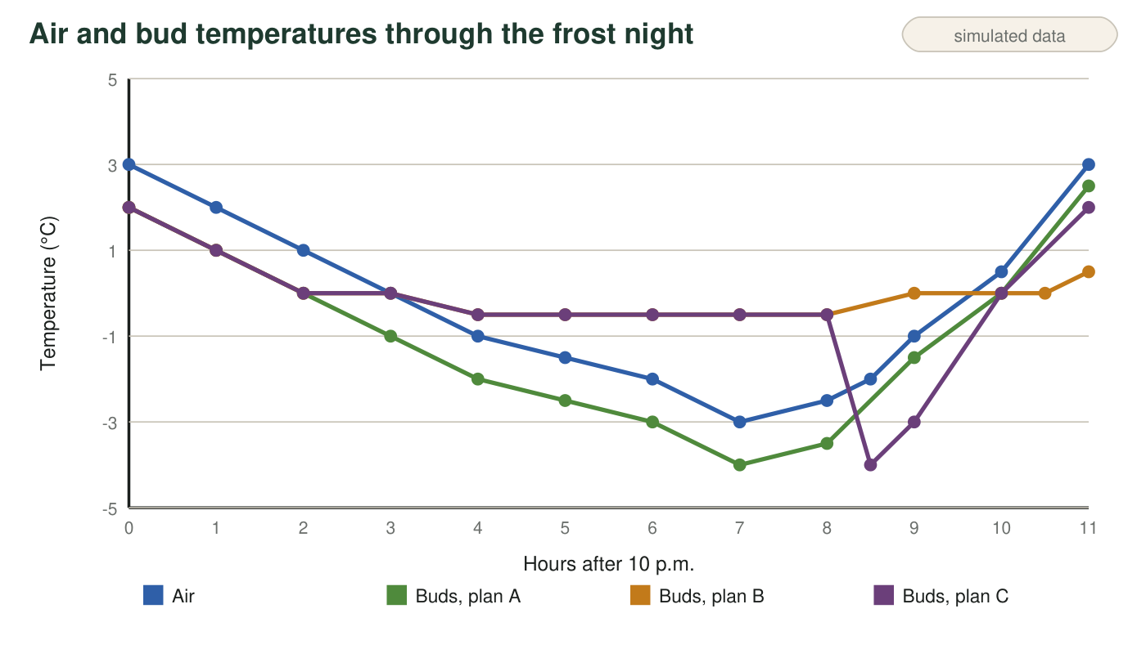
Teaching graph of air temperature and bud temperature for plans A, B and C during the test night. Time is measured in hours after 10 p.m. (3 = 1 a.m., 8 = 6 a.m., 11 = 9 a.m.).

Part A: Use the model to explain the results
1. In plan B, the air fell to −3 °C, yet the buds never dropped below −0.5 °C. Explain why, using what happens to the water molecules as the spray freezes on the buds and where their energy goes.
Answer: As the sprayed water freezes on the bud, its molecules slow, lock into fixed places, and give up energy to the bud and the ice around it. As long as new liquid water keeps arriving and freezing, that released energy keeps the ice-water coat at the freezing point, 0 °C, even though the air is colder. The bud inside the coat stays near 0 °C (−0.5 °C in the data), well above the −2 °C damage point.
Reasoning: Freezing releases energy to the surroundings, and an ice-water mixture holds at the melting point while the change continues. This is the cooling-curve plateau applied to a bud.
Also acceptable: Accept 'the freezing water gives off energy that keeps the bud warm' if the plateau idea (stays at 0 °C while water keeps freezing) is also present.
Full credit must include:
• Freezing releases energy from the water to the bud and coat
• An ice-water mixture stays at 0 °C while liquid keeps freezing
• Links this to the bud staying above −2 °C
2. Look at the graph between 6:00 and 6:30 a.m. (hours 8 to 8.5). After the sprinklers in plan C were shut off, the buds became even colder than the air. Explain why the ice-covered buds lost energy so fast once no new water was freezing on them. Name the change of state that took energy from the buds.
Answer: Once no new water was arriving, nothing was freezing on the buds, so no more energy was being released to them. The ice coat and the bud kept losing energy to the colder air and sky, and water molecules escaping from the wet, icy surface (evaporation and sublimation) carried energy away from the bud. That cooled the buds below the air temperature, to −4 °C. The change of state that took energy from the buds was evaporation of the remaining liquid and sublimation of the ice.
Reasoning: Evaporation and sublimation are energy-in changes for the water, and the energy comes from the surface they leave. That is why growers are warned never to stop sprinklers while the air is still below freezing.
Also acceptable: Accept either evaporation or sublimation named alone if the energy direction is correct.
Full credit must include:
• No more freezing, so no more energy released
• Evaporation and/or sublimation take energy from the buds
• Explains why the buds ended colder than the air
3. Plan D sprayed water all night but at half the rate. Use the model to explain why the buds still fell below −2 °C.
Answer: At half rate, the water arriving each hour froze completely before more arrived, so there was not always liquid water freezing on the buds. Between sprays the coat was solid ice, which can cool below 0 °C, and less freezing meant less energy released each hour to replace the energy lost to the cold air and sky. The buds slowly fell to −2.5 °C.
Reasoning: The plateau at 0 °C lasts only while a mixture of ice and liquid is present. Too little water means the mixture does not last.
Also acceptable: Accept 'the ice froze solid and then got colder like ice in a freezer' as the core idea.
Full credit must include:
• Not enough water freezing per hour to keep an ice-water mixture
• Solid ice alone can cool below 0 °C
• Less energy released than was lost
4. Between 8:00 and 9:00 a.m. (hours 10 to 11), the air warmed from 0.5 °C to 3 °C, but the plan B buds stayed at about 0 °C until the end of that hour. What was happening to the ice coat, and why did the bud temperature hold steady?
Answer: The ice coat was melting. Once the air was warmer than 0 °C (and the sun was up), energy flowed into the ice, and that energy went into freeing water molecules from the solid instead of raising their average kinetic energy, so the ice-water coat and the bud stayed at about 0 °C until the ice was gone. Only then did the bud temperature rise.
Reasoning: This is the melting plateau, the heating-curve version of q1's freezing plateau.
Also acceptable: Accept 'the ice was turning back into water, which keeps it at 0 °C'.
Full credit must include:
• Names melting
• Energy goes into freeing molecules, so temperature holds at 0 °C

Part B: Evaluate the plans
5. Calculate the water each sprinkler plan uses per hectare: hours × rate. Show the work for plans B, C and D, and say which of them stay within the 300 m³ limit.
Answer: B: 8.5 h × 30 m³/h = 255 m³. C: 5.5 h × 30 m³/h = 165 m³. D: 8.5 h × 15 m³/h = 127.5 m³. All three are within the 300 m³ limit.
Reasoning: Hours times rate gives the volume per hectare; all three are below 300 m³.
Also acceptable: Accept 128 m³ for D.
Full credit must include:
• 255, 165 and 127.5 m³ with work shown
• States that all three are within the limit
6. Complete the decision table with yes or no in each cell. Assume every plan can be run by one worker.
Answer: A: no, no, yes, yes, no. B: yes, yes, yes, yes, YES. C: no, no, yes, yes, no. D: no, no, yes, yes, no. E: no, no, yes, yes, no.
Reasoning: Only plan B keeps the buds at −2 °C or warmer (−0.5 °C) and below 10 percent damage (2 percent) while using 255 m³, under the 300 m³ limit. Plans A, C, D and E all let the buds fall below −2 °C.
Also acceptable: None.
Full credit must include:
• Every cell consistent with the data
• Plan B is the only plan that meets everything
7. Plan C used less water than plan B and did worse than doing nothing. Explain why saving water by stopping early was a risky trade-off.
Answer: Stopping early saved 90 m³ (255 − 165) but turned the ice coat from a protector into a problem: with no new water freezing, the coat stopped releasing energy, and evaporation and sublimation from the wet ice pulled energy out of the buds. They fell to −4 °C and 65 percent were damaged, worse than the 60 percent with no protection.
Reasoning: A partial solution can be worse than none when it adds a new way to lose energy.
Also acceptable: Accept an answer without the 90 m³ figure.
Full credit must include:
• Uses the data (−4 °C, 65 percent versus 60 percent)
• Explains that stopping early removed the energy source and left an evaporating or subliming coat

Part C: Decide and justify (on your own)
8. Recommend one plan for tonight. Your recommendation must (1) name the plan, (2) give at least two numbers from the data that show it meets the criteria and constraints, (3) explain with particles why it works, and (4) tell the worker exactly when it is safe to turn the sprinklers off and why.
Answer: Recommend plan B. It kept the lowest bud temperature at −0.5 °C (criterion: −2 °C or warmer) and limited damage to 2 percent (criterion: under 10 percent), and it uses 255 m³ of pond water per hectare, under the 300 m³ limit, with no creek pumping. It works because water keeps arriving and freezing on the buds; each molecule that locks into the ice gives up energy, and the ice-water coat stays at 0 °C as long as freezing continues, even with the air at −3 °C. The worker must leave the sprinklers on after sunrise until the air is above 0 °C and all the ice has melted off the vines (about 9:00 a.m. on the test night). Turning them off earlier, while ice remains and the air is below freezing, lets evaporation and sublimation chill the buds below the air temperature, as plan C showed.
Reasoning: Plan B is the only plan that meets every criterion and constraint, and its success is explained by the freezing plateau.
Also acceptable: A student who recommends B plus the wind machine as an extra layer earns full credit if B's shut-off rule and reasoning are present.
Full credit must include:
• Names plan B
• At least two numbers showing criteria and constraints are met
• Particle explanation: freezing releases energy and holds the coat at 0 °C
• Clear shut-off rule: after the air is above 0 °C and the ice has melted, with the reason
9. Propose one change that could cut the water your chosen plan uses without letting the buds fall below −2 °C. Use the model or the data to explain why your change should still work, and describe how you would test it safely.
Answer: Examples: start the sprinklers a little later, when bud temperature (not air temperature) nears 0 °C, since the buds were safe until then; run the wind machine early in the night and switch on sprinklers only if bud sensors approach −1 °C; sprinkle first the lowest, coldest rows where cold air settles. Each still keeps water freezing on the buds whenever they are below 0 °C, and the shut-off rule stays the same. Test it on a few rows, with bud thermometers and plan B ready to switch on at once if any bud nears −2 °C.
Reasoning: The change must reduce water without breaking the rule that water keeps freezing on the buds whenever they are below 0 °C, and the test must protect the crop.
Also acceptable: Accept 'use bud-temperature sensors to decide when to start' as the change if it is explained.
Full credit must include:
• A specific change that reduces water
• Explains with the model or data why buds stay at −2 °C or warmer
• A safe test with a backup

Scoring rubric
Criterion | 4 Exemplary | 3 Proficient | 2 Developing | 1 Beginning
Use of the particle model | Explains plans B, C and D correctly: freezing releases energy and holds an ice-water mixture at 0 °C; stopping early lets evaporation and sublimation remove energy; too little water lets the coat freeze solid and cool. | Explains B and one of C or D correctly; the other explanation is incomplete. | Explains B with 'the ice keeps it warm' without the energy release or the 0 °C plateau. | No particle reasoning, or reasoning that says the ice or water makes cold.
Evaluation against criteria and constraints | Water volumes correct; decision table complete and consistent with the data; only plan B meets everything. | Decision table complete with one inconsistency, or one water volume wrong. | Decision table partly complete, or criteria and constraints mixed up. | No systematic comparison.
Recommendation and justification | Recommends B with two or more data points, a particle explanation and a correct, reasoned shut-off rule. | Recommends B with data and explanation, but the shut-off rule is vague or unreasoned. | Recommends a plan with little data or no explanation. | Recommends a plan that fails the criteria, with no justification.
Proposed change and test | A specific water-saving change, explained with the model, plus a safe test with a backup plan. | A specific change with explanation, but the test is missing or unsafe. | A change with no explanation. | No change proposed, or a change that breaks the freezing rule (for example, stopping early).

Teacher notes
The vineyard and all values are invented for teaching, but the physics and the pattern are real and match frost-protection practice: sprinkling protects buds only while liquid water keeps freezing on them, the sprinklers must run until the ice has melted after the air rises above freezing, and stopping too soon or applying too little water can leave buds colder than if nothing had been done. Real application rates are in the range used here (about 3 mm of water per hour). The creek constraint echoes real California concerns: in some valleys, frost-night pumping has lowered streams enough to harm young fish, and rules now limit it (see the slide 21 notes). Wind machines are a common real alternative; their weak result here depends on tonight's weak warm layer, which the extension explores. Keep the discussion qualitative: no part of this sheet calculates the energy released by freezing.

