Angela's Tools · Chapter 24: Heat, Temperature, and State Changes · Worksheet 9 of 10

Frost Night at Oak Hollow Vineyard: Choose the Protection Plan
Learning target: I can use a particle model of freezing and evaporation to predict how different frost-protection plans change the temperature of grape buds, evaluate the plans against criteria and constraints, and justify a decision.
Transfer and design · about 55 minutes · pairs · Standards: MS-PS1-4 (assesses), MS-ETS1-2 (practice)
Name: ____________________________ Date: ____________ Period: ______

Directions
Read the problem, the criteria and constraints, and the test results. The vineyard and its numbers are a teaching scenario: the pattern matches what frost-protection guides describe, but the values were invented. Work with a partner on Parts A and B (if you are doing this sheet at home, talk them through with a classmate or family member, or work alone), then write Part C on your own. Every judgment must point to a number in the data or to the particle model.

The problem
Oak Hollow is a small family vineyard in a cool California valley. It is early April, and the grapevines have just pushed out tender green buds. Tonight's forecast is clear and calm. The air at vine height will cool from 3 °C at 10 p.m. to about −3 °C at 5 a.m. and will not rise above 0 °C again until about 8 a.m. On clear, calm nights the buds radiate energy to the sky and can become about a degree colder than the air. Young grape buds are damaged if their own temperature drops below about −2 °C.
Criteria and constraints
Criteria (what success means): (1) the lowest bud temperature tonight is −2 °C or warmer; (2) fewer than 10 percent of buds are damaged. Constraints (limits the plan must respect): (1) the vineyard may use at most 300 cubic meters (m³) of water per hectare tonight, all from its own winter-filled pond; pumping from the creek, where young fish live, is not allowed; (2) one worker must be able to start and run the plan.
Five plans tested on matching one-hectare blocks on a similar frost night (teaching dataset)
Simulated teaching dataset (not real measurements).
Plan | What the grower does | Sprinkler hours | Sprinkler rate (m³ per hectare per hour) | Lowest bud temperature (°C) | Buds damaged (%)
A | Nothing (comparison block) | 0 | 0 | -4 | 60
B | Sprinklers on when the air reaches 0.5 °C (12:30 a.m.); left on until all the ice on the vines has melted (9:00 a.m.) | 8.5 | 30 | -0.5 | 2
C | Same as B, but sprinklers turned off at 6:00 a.m. to save water, while the air was still −2.5 °C | 5.5 | 30 | -4 | 65
D | Sprinklers from 12:30 a.m. to 9:00 a.m. at half rate to save water | 8.5 | 15 | -2.5 | 25
E | A wind machine (a tall fan that pulls warmer air down from above) runs all night; tonight's warm layer above the vines is weak | 0 | 0 | -3 | 40

Simulated data for teaching. Sprinklers spray a fine mist of water over the vines. Full rate is 30 m³ of water per hectare per hour.
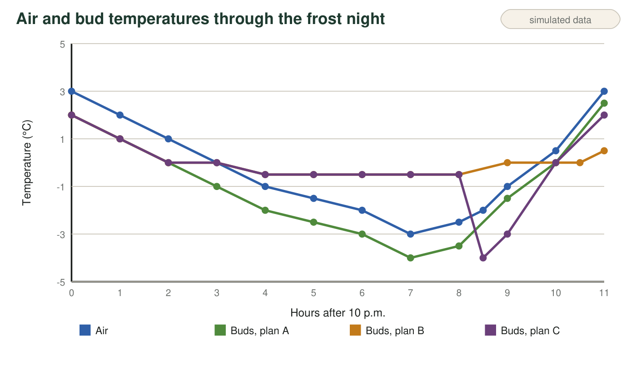
Teaching graph of air temperature and bud temperature for plans A, B and C during the test night. Time is measured in hours after 10 p.m. (3 = 1 a.m., 8 = 6 a.m., 11 = 9 a.m.).

Part A: Use the model to explain the results
1. In plan B, the air fell to −3 °C, yet the buds never dropped below −0.5 °C. Explain why, using what happens to the water molecules as the spray freezes on the buds and where their energy goes.
______________________________________________________________________________________
______________________________________________________________________________________
______________________________________________________________________________________
______________________________________________________________________________________
2. Look at the graph between 6:00 and 6:30 a.m. (hours 8 to 8.5). After the sprinklers in plan C were shut off, the buds became even colder than the air. Explain why the ice-covered buds lost energy so fast once no new water was freezing on them. Name the change of state that took energy from the buds.
______________________________________________________________________________________
______________________________________________________________________________________
______________________________________________________________________________________
______________________________________________________________________________________
3. Plan D sprayed water all night but at half the rate. Use the model to explain why the buds still fell below −2 °C.
______________________________________________________________________________________
______________________________________________________________________________________
______________________________________________________________________________________
4. Between 8:00 and 9:00 a.m. (hours 10 to 11), the air warmed from 0.5 °C to 3 °C, but the plan B buds stayed at about 0 °C until the end of that hour. What was happening to the ice coat, and why did the bud temperature hold steady?
______________________________________________________________________________________
______________________________________________________________________________________
______________________________________________________________________________________

Part B: Evaluate the plans
5. Calculate the water each sprinkler plan uses per hectare: hours × rate. Show the work for plans B, C and D, and say which of them stay within the 300 m³ limit.
______________________________________________________________________________________
______________________________________________________________________________________
______________________________________________________________________________________
______________________________________________________________________________________
6. Complete the decision table with yes or no in each cell. Assume every plan can be run by one worker.
Criterion 1: lowest bud temperature −2 °C or warmer? | Criterion 2: under 10% damaged? | Constraint 1: 300 m³ or less from the pond? | Constraint 2: one worker can run it? | Meets everything?
Plan A
Plan B
Plan C
Plan D
Plan E

7. Plan C used less water than plan B and did worse than doing nothing. Explain why saving water by stopping early was a risky trade-off.
______________________________________________________________________________________
______________________________________________________________________________________
______________________________________________________________________________________

Part C: Decide and justify (on your own)
8. Recommend one plan for tonight. Your recommendation must (1) name the plan, (2) give at least two numbers from the data that show it meets the criteria and constraints, (3) explain with particles why it works, and (4) tell the worker exactly when it is safe to turn the sprinklers off and why.
______________________________________________________________________________________
______________________________________________________________________________________
______________________________________________________________________________________
______________________________________________________________________________________
______________________________________________________________________________________
______________________________________________________________________________________
______________________________________________________________________________________
9. Propose one change that could cut the water your chosen plan uses without letting the buds fall below −2 °C. Use the model or the data to explain why your change should still work, and describe how you would test it safely.
______________________________________________________________________________________
______________________________________________________________________________________
______________________________________________________________________________________
______________________________________________________________________________________

The two rules that decide this problem
Rule 1: when liquid water freezes, its molecules lock into place and give up energy to whatever is touching them, and an ice-water mixture stays at 0 °C as long as some liquid is still freezing. Rule 2: when water evaporates or ice sublimes, the escaping molecules carry energy away, so the surface left behind gets colder. For each plan, ask: is liquid water still arriving and freezing on the buds, or is the water only escaping?

When the wind blows
Some frost nights are windy instead of calm, with cold air sweeping in from elsewhere. On those nights a wind machine has no warm layer of air to pull down, and wind speeds up evaporation from wet buds. Predict how plans B and E would each perform on a windy frost night and explain why, using both rules in the scaffold. Then research one other method California growers use to protect crops from frost and explain the science behind it.

