Angela's Tools · Chapter 25: Volcanic Eruptions and Earthquakes · Lab 1 of 3 · Student recording sheet

The Unlabeled Map: Find the Hidden Plate Boundaries
Investigation question: Using only the locations, depths and magnitudes of 40 earthquakes and the positions of 11 active volcanoes, where are the plate boundaries on this map, what kind is each one, and which towns face which hazards?
Name: ____________________________ Group: ________ Date: ____________

Your role
☐ North plotter: Plots every earthquake and volcano with y = 8 or more on the group map, using the depth colors and magnitude sizes in the key.
☐ South plotter: Plots every earthquake and volcano with y = 7 or less, then checks five of the North plotter's points against the table.
☐ Depth analyst: Builds the cross-section from the earthquakes in the north band (y = 8 or more, x = 10 or more) and leads q3 and q4.
☐ Skeptic and recorder: Fills the classification table, asks 'what is the evidence?' for every interpretation, and records the group's town ranking with its reasons.

Safety
• Paper and pencil only; there are no physical hazards. If you use the floor-sized masking-tape grid option, keep walkways clear and have students step, not run, between points.
• The towns and region are fictional. If students ask about hazards where they live, point them to the official USGS and California Geological Survey hazard maps rather than drawing conclusions from this teaching dataset.

Procedure
1. Read the scenario and the plotting key together. Agree on the grid: x counts squares east, y counts squares north, and each square is 50 km. Ocean lies west of x = 11; land lies to the east.
2. Split the plotting: the North plotter takes every point with y = 8 or more and the South plotter every point with y = 7 or less. Plot each earthquake as a dot colored by depth and sized by magnitude, and each volcano as a small triangle. Write the ID beside every point.
3. Swap and check: each plotter checks five of the other's points against the table. Mark the four towns with a square and their initials.
4. Answer q1 and q2 as a group. Then look for lines and clusters of points. Lightly sketch where you think each boundary runs, but do not label it yet.
5. Depth analyst: plot the cross-section using every earthquake with y = 8 or more and x = 10 or more (distance east on the horizontal axis, depth on the vertical axis, deeper lower). The group answers q3 and q4.
6. Classify each line or cluster in the classification table: where it is, the earthquake depths, the largest magnitude, whether volcanoes are present, your interpretation, and the key evidence. Answer q5 and q6.
7. Highlight the boundaries you are confident about and leave dashed lines where you are unsure. Answer the analysis questions individually: the magnitude comparison (q7), the town forecast (q8) and the remaining questions.
8. Compare maps with one other group. Where your interpretations differ, decide which evidence would settle the disagreement.

Record your observations

Lab 1 recording sheet: The Unlabeled Map
The planning office of a fictional coastal region has lost its map of plate boundaries. It still has a sample of 40 earthquakes from its 100-year catalog and a list of the 11 volcanoes that have erupted in the last 10,000 years. Your job is to rebuild the boundary map from the data alone and then advise four towns. Every number on this sheet is a teaching dataset invented for this lab. On the grid, x counts squares east and y counts squares north; each square is 50 km. Ocean lies west of x = 11 and land lies east of it.
Earthquake sample (40 events)
Simulated teaching dataset (not real measurements).
ID | x (east) | y (north) | Depth (km) | Magnitude
E1 | 8 | 13 | 15 | 4.0
E2 | 11 | 10 | 30 | 7.1
E3 | 12 | 11 | 55 | 5.4
E4 | 12 | 15 | 60 | 6.2
E5 | 17 | 2 | 6 | 4.2
E6 | 14 | 15 | 140 | 5.6
E7 | 10 | 15 | 20 | 6.8
E8 | 16 | 11 | 240 | 5.5
E9 | 14 | 11 | 135 | 6.4
E10 | 3 | 12 | 6 | 4.1
E11 | 3 | 7 | 7 | 4.4
E12 | 16 | 14 | 250 | 6.1
E13 | 11 | 0 | 11 | 5.0
E14 | 10 | 12 | 25 | 8.7
E15 | 11 | 5 | 10 | 7.4
E16 | 1 | 1 | 10 | 3.4
E17 | 11 | 7 | 12 | 5.6
E18 | 11 | 2 | 14 | 6.1
E19 | 3 | 15 | 8 | 4.6
E20 | 18 | 4 | 12 | 6.6
E21 | 11 | 6 | 8 | 4.4
E22 | 11 | 1 | 6 | 3.8
E23 | 15 | 10 | 185 | 5.3
E24 | 13 | 12 | 8 | 3.9
E25 | 12 | 4 | 10 | 4.5
E26 | 6 | 4 | 10 | 6.3
E27 | 3 | 9 | 10 | 5.2
E28 | 15 | 13 | 190 | 5.8
E29 | 17 | 10 | 320 | 5.0
E30 | 11 | 14 | 35 | 5.9
E31 | 6 | 3 | 6 | 4.0
E32 | 19 | 5 | 8 | 4.4
E33 | 13 | 13 | 95 | 6.0
E34 | 3 | 4 | 9 | 4.8
E35 | 13 | 9 | 90 | 5.1
E36 | 11 | 3 | 9 | 4.9
E37 | 16 | 3 | 5 | 3.5
E38 | 18 | 5 | 10 | 5.8
E39 | 17 | 13 | 330 | 6.6
E40 | 7 | 3 | 5 | 3.6

Simulated teaching data for a fictional region. Depth is the depth of the focus below the surface.
Active volcanoes (erupted within the last 10,000 years)
Simulated teaching dataset (not real measurements).
ID | x (east) | y (north)
V1 | 6 | 3
V2 | 13 | 9
V3 | 3 | 14
V4 | 17 | 2
V5 | 16 | 3
V6 | 14 | 15
V7 | 3 | 10
V8 | 14 | 11
V9 | 13 | 13
V10 | 6 | 4
V11 | 3 | 5

Simulated teaching data for a fictional region.
Towns
Simulated teaching dataset (not real measurements).
Town | x | y | Notes
Port Halden | 11 | 13 | Harbor city on the coast
Kettle Bay | 12 | 4 | Town just inland from the coast
Ash Hollow | 14 | 12 | Farming town in the mountains
Plainview | 19 | 12 | Inland city on a wide plain

Fictional towns placed for this teaching dataset.
Plotting key
Earthquake color by depth: red = shallow (0 to 70 km), blue = intermediate (71 to 300 km), black = deep (more than 300 km). Earthquake size by magnitude: small dot = below 5.0, medium dot = 5.0 to 6.9, large dot = 7.0 or more. Volcano: a small triangle. Town: a small square with its initials. Write the ID next to every point.
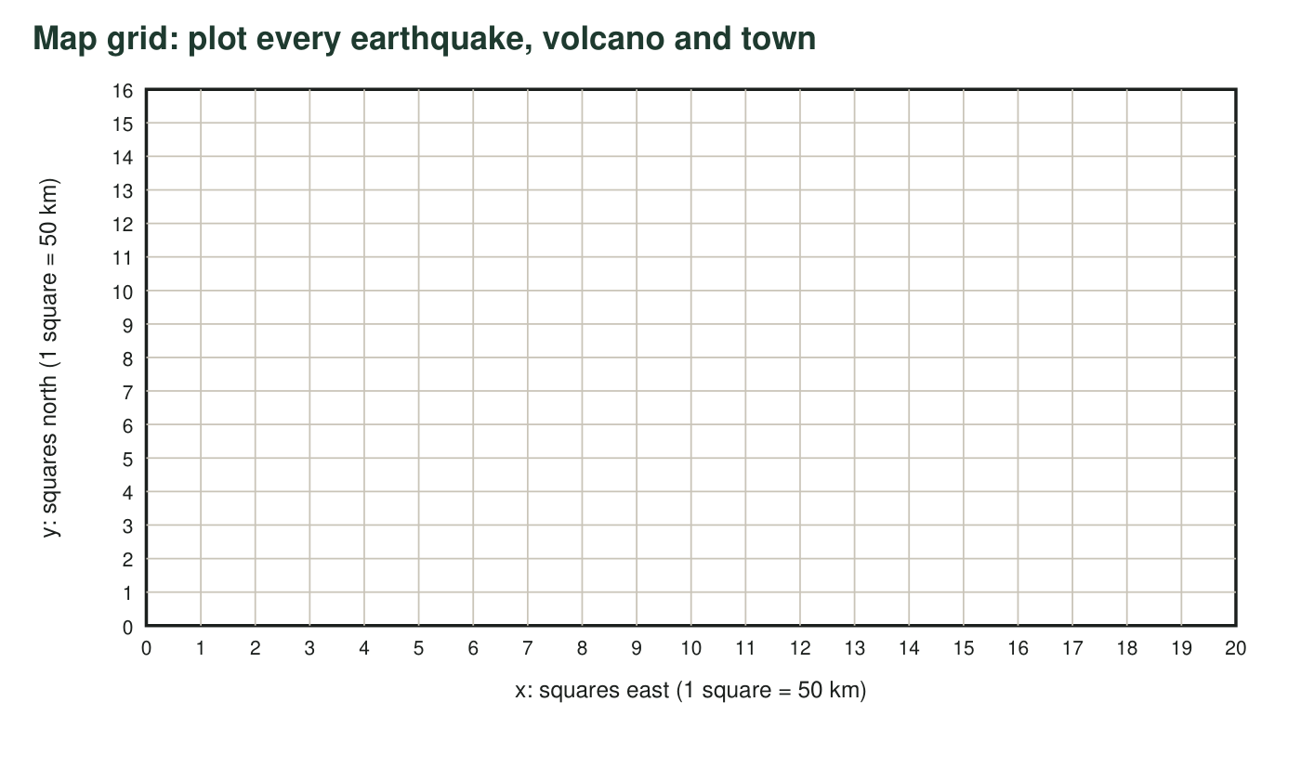
1. Describe the overall pattern on your map. Where are the earthquakes and volcanoes concentrated, and where are they rare?
______________________________________________________________________________________
______________________________________________________________________________________
______________________________________________________________________________________
2. Look at the points along x = 3. Describe their depths, their magnitudes and the volcanoes there. What kind of boundary runs along x = 3? Give your evidence.
______________________________________________________________________________________
______________________________________________________________________________________
______________________________________________________________________________________
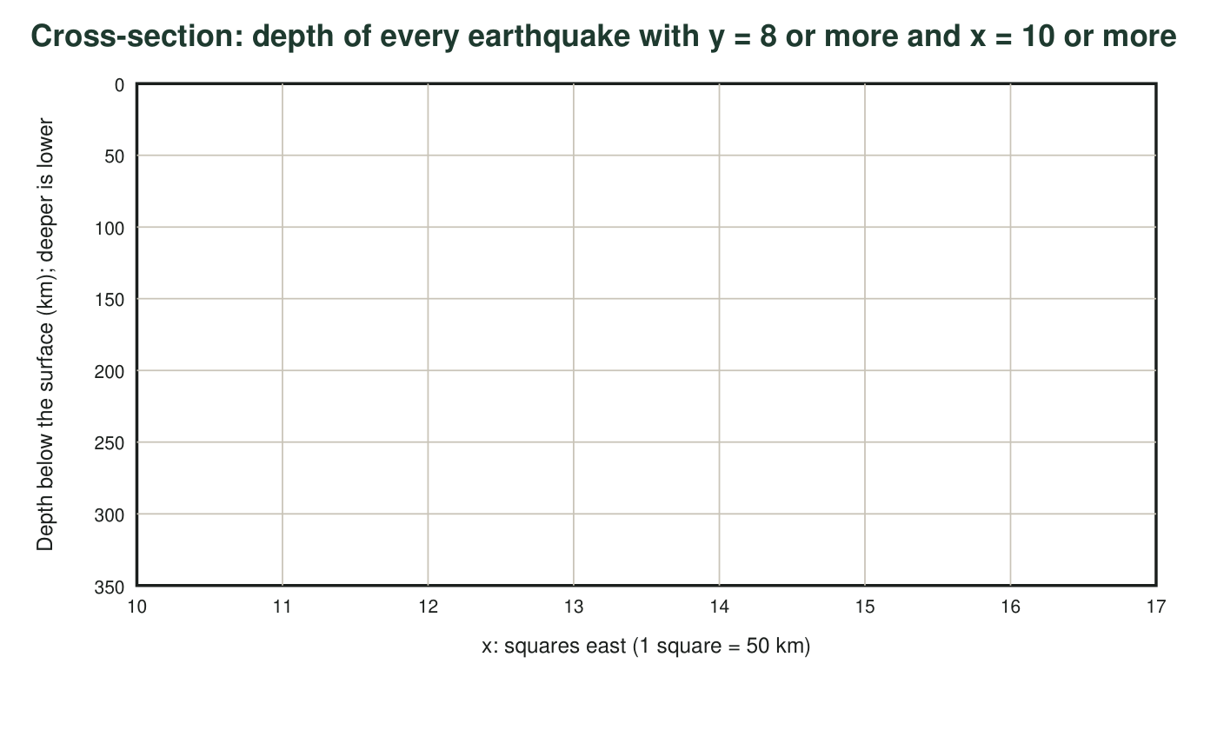
3. Describe the shape the points make on your cross-section. In which direction do the earthquakes get deeper, and by about how many kilometers per grid square? What does this tell you is happening to one of the plates?
______________________________________________________________________________________
______________________________________________________________________________________
______________________________________________________________________________________
______________________________________________________________________________________
4. About how deep is the sinking plate beneath the chain of volcanoes at x = 13 to 14? Explain why the volcanoes form above the sinking plate at that depth instead of right at the trench.
______________________________________________________________________________________
______________________________________________________________________________________
______________________________________________________________________________________
______________________________________________________________________________________
Classification table
Line or cluster | Where (coordinates) | Earthquake depths | Largest magnitude | Volcanoes? | Interpretation | Key evidence
1
2
3
4
5
6

5. The earthquakes along x = 11 south of y = 8 have no volcanoes near them. What kind of boundary is this, and why does it have no volcanoes?
______________________________________________________________________________________
______________________________________________________________________________________
______________________________________________________________________________________
6. Two volcanoes and three earthquakes cluster near (6, 3) and (6, 4), far from any line of points. What setting explains them? What evidence supports your answer?
______________________________________________________________________________________
______________________________________________________________________________________
______________________________________________________________________________________

Analysis questions
7. Earthquakes E15 (magnitude 7.4) and E21 (magnitude 4.4) both happened on the line along x = 11. How many times more ground motion did E15 produce on a seismogram, and about how many times more energy did it release? Show your work.
______________________________________________________________________________________
______________________________________________________________________________________
______________________________________________________________________________________
8. Forecast: rank Port Halden, Kettle Bay, Ash Hollow and Plainview from greatest to least earthquake hazard. For each town, name its main hazard or hazards (shaking, tsunami, volcanic) and cite the data that support your ranking.
______________________________________________________________________________________
______________________________________________________________________________________
______________________________________________________________________________________
______________________________________________________________________________________
______________________________________________________________________________________
______________________________________________________________________________________
______________________________________________________________________________________
______________________________________________________________________________________
9. A planner says the land around (18, 5) is safe for a new hospital because it is far from every plate boundary. Use the data to respond.
______________________________________________________________________________________
______________________________________________________________________________________
______________________________________________________________________________________
10. Volcanoes V4 and V5 and two small, shallow earthquakes near (16, 3) and (17, 2) do not sit on any of the boundaries you found. Propose two possible explanations and name one kind of data that would help you decide between them.
______________________________________________________________________________________
______________________________________________________________________________________
______________________________________________________________________________________
______________________________________________________________________________________
______________________________________________________________________________________
11. The catalog covers only 100 years. Explain why a part of the map with no large earthquakes in the catalog could still have one in the future. Use one of the boundaries you found as an example.
______________________________________________________________________________________
______________________________________________________________________________________
______________________________________________________________________________________
12. Recommend one way to mitigate the main hazard at Port Halden and one way to mitigate the main hazard at Ash Hollow. Explain how each would reduce harm.
______________________________________________________________________________________
______________________________________________________________________________________
______________________________________________________________________________________
______________________________________________________________________________________

