Angela's Tools · Chapter 25: Volcanic Eruptions and Earthquakes · Worksheet 1 of 10

Fifteen Seconds and Fifty-Nine Days: Two Hazards, Two Kinds of Warning (Teacher answer key)
Learning target: I can describe how a 1980 eruption and a 1989 earthquake differed in the warning they gave, ask questions about why, and write a first explanation of how people could plan for an event no one can predict.
Phenomenon exploration · about 30 minutes · individual · Standards: MS-ESS3-2 (supports), MS-ESS2-3 (supports)

Standards connections
MS-ESS3-2 (supports): The two cases set up the contrast in the PE's clarification statement: volcanic eruptions are often preceded by measurable signs, while earthquakes strike without notice. Students raise the questions the chapter's data work will answer; nothing here is assessed yet.
MS-ESS2-3 (supports): Part B asks students to recall the two kinds of plate boundary from Lesson 16 (a sinking plate and two plates sliding past each other) as background for why these hazards happened where they did.

Answers with reasoning

Case file 1: The bridge
At 5:04 p.m. on October 17, 1989, rock deep beneath the Santa Cruz Mountains suddenly slipped along a fault. The Loma Prieta earthquake, magnitude 6.9, shook the region hard for about 15 seconds. Roughly 100 km to the north, a section of the San Francisco-Oakland Bay Bridge's upper deck, about 15 m long, broke loose and dropped onto the deck below. In Oakland, a double-decker freeway collapsed. Sixty-three people died. No one had recognized any warning sign beforehand. Years later, engineers replaced the bridge's whole eastern half with a new span designed to reopen quickly after the strongest shaking expected in about 1,500 years.
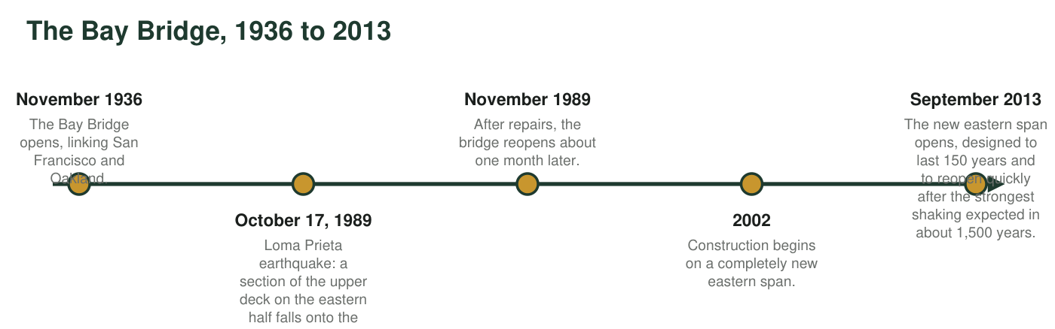
Figure 1. A timeline of the San Francisco-Oakland Bay Bridge. Dates are from Caltrans and the Metropolitan Transportation Commission.

Case file 2: The mountain
Nine years earlier and about 1,000 km to the north, Mount St. Helens in Washington had behaved very differently. On March 20, 1980, a magnitude 4.2 earthquake began a swarm of small quakes beneath the volcano. A week later, steam explosions blasted a new crater in the summit. By late April, the volcano's north side was bulging outward by up to about 1.5 meters per day as magma pushed in from below, and officials had closed the area nearest the mountain. On May 18 an earthquake shook the bulge loose in a huge landslide, and the volcano erupted sideways. Fifty-seven people died. Scientists had forecast that an eruption was likely, but not its exact day or its sideways direction.
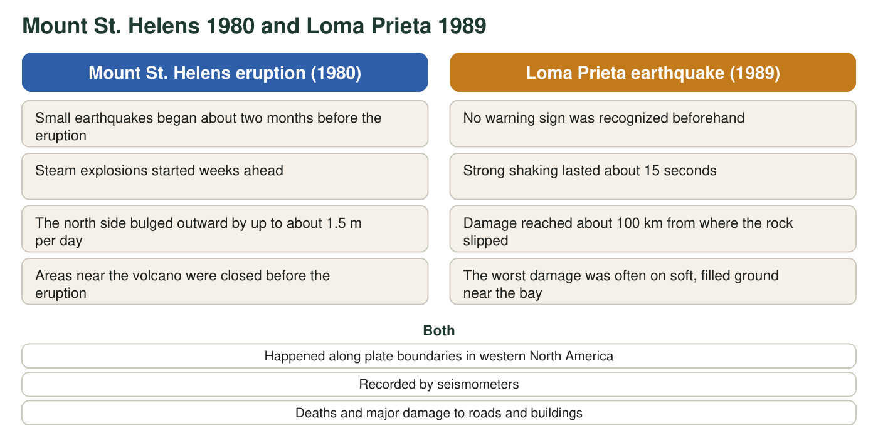
Figure 2. Comparing the warning before the two events.

Part A: Notice and wonder
1. Write three things you notice in the case files and figures. At least one must use a number.
Answer: Examples: Mount St. Helens gave about two months of signals; the Loma Prieta shaking lasted only about 15 seconds; the bridge was about 100 km from where the rock slipped; the volcano's side bulged up to about 1.5 m per day; 63 people died in 1989 and 57 in 1980; the new span is designed for shaking expected once in about 1,500 years; the bridge reopened about a month after the earthquake.
Reasoning: Any accurate observation from the case files or figures counts. At least one must include a number.
Also acceptable: Accept comparisons ('the volcano gave warning but the earthquake didn't') as observations when they restate the evidence.
Full credit must include:
• Three observations drawn from the case files or figures
• At least one uses a number
• Observations, not explanations
2. Write three questions you wonder about. Start each with why, how or what would happen if.
Answer: Examples: Why did the volcano swell before erupting? How can a bridge 100 km away be damaged? Why didn't the fault give any sign? How do engineers know what shaking happens once in 1,500 years? What would happen if scientists could see stress building in the fault? Why was damage worst on soft ground?
Reasoning: Questions should arise from the cases and be answerable by the chapter's ideas or by investigation.
Also acceptable: Questions about methods ('How did they measure the bulge?') are legitimate science questions and earn credit.
Full credit must include:
• Three questions
• Each begins with why, how or what would happen if
• Each connects to one of the cases
3. Count the days from the first earthquake under Mount St. Helens (March 20) to the eruption (May 18). March has 31 days and April has 30. Show your counting. Then write how much recognized warning the Loma Prieta earthquake gave.
Answer: March 21 to 31: 11 days. April: 30 days. May 1 to 18: 18 days. 11 + 30 + 18 = 59 days of signals before the eruption. Loma Prieta gave no recognized warning (0 days); the strong shaking itself lasted about 15 seconds.
Reasoning: Counting the days after March 20 through May 18 gives 59. The contrast between about two months and none is the chapter's central puzzle.
Also acceptable: Accept 58 or 60 if the student explains whether the start or end day was counted. Accept 'about two months'.
4. Written records of earthquakes in California go back only about 250 years. How many times longer than that is the 1,500-year span the new bridge was designed for? Show the division. Then write one way you think engineers could learn about shaking that strong.
Answer: 1,500 ÷ 250 = 6, so the design span is about 6 times longer than California's written record. Ideas for how engineers could learn about such shaking: study soil layers broken by prehistoric earthquakes, use the frequency of quakes of different magnitudes to estimate how often the rare biggest ones happen, measure how fast the faults are loading with stress, study similar faults elsewhere in the world.
Reasoning: This anticipates the chapter's point that forecasts of rare events come from long geologic records, frequency-magnitude patterns and plate-motion rates, not from written history alone. Any reasonable idea earns credit at this stage.
Also acceptable: Accept 'computer models' or 'test models on shake tables' as initial ideas; they will be refined in the chapter.
Full credit must include:
• Correct division (6 times)
• One plausible source of information beyond written records

Part B: What you already know
Mount St. Helens sits above a place where a small ocean plate is sinking beneath the North American Plate. The Loma Prieta earthquake happened in the San Andreas Fault system, where the Pacific Plate and the North American Plate slide past each other.
5. From Lesson 16: what are these two kinds of plate boundary called? Which kind do you think also produces volcanoes, and why might the other kind produce earthquakes but no volcanoes?
Answer: A sinking plate beneath another plate is a convergent boundary (a subduction zone); two plates sliding past each other is a transform boundary. The convergent, sinking-plate boundary also makes volcanoes, because something about the sinking plate lets rock deep below melt into magma. At a transform boundary the plates only grind sideways, so the rock gets stuck and snaps (earthquakes) but no plate goes down to make magma.
Reasoning: This recalls Lesson 16 boundary types and previews the melting explanation (water from the sinking plate) that the chapter will teach.
Also acceptable: Accept 'plates crash together' for convergent and 'plates slide sideways' for transform. A first-draft melting reason (heat, friction) is acceptable here; the chapter corrects it.
Full credit must include:
• Names convergent (subduction) and transform boundaries
• Links volcanoes to the sinking-plate boundary
• Gives a reason the sliding boundary has quakes but no magma

Part C: Your first explanations
6. Write your best explanation of why Mount St. Helens gave about two months of signals before it erupted, while the fault under the Santa Cruz Mountains gave none that anyone recognized. What might be moving or changing underground before each event?
Answer: Example first explanation: before the eruption, magma was moving up into the volcano. It pushed the rock apart, causing small earthquakes, and it filled the mountain like a balloon, making the side bulge; heat from the magma turned groundwater to steam and caused explosions. Those changes could be measured at the surface. Before the earthquake, the rock on both sides of the fault was stuck while the plates kept moving, so stress was building inside solid rock deep underground. That stress does not make the ground swell or crack at the surface in any way people have learned to recognize, so it gave no warning until the rock suddenly slipped.
Reasoning: A strong first draft identifies a moving material (magma) that produces measurable side effects versus stress silently building in locked rock. The chapter will confirm this with precursor data and the stick-slip model.
Also acceptable: Partial credit for 'the volcano was getting ready' without a mechanism. Ideas like 'gas building up' earn credit if tied to a signal.
Full credit must include:
• Proposes something moving or changing under the volcano (magma rising)
• Connects that change to at least one observed signal (quakes, bulge or steam)
• Proposes why the fault gave no recognized signal (stress building in stuck rock)
7. Nobody can name the date of the next big Bay Area earthquake. How could engineers still design a bridge to survive it? List the information you think they would need, and explain why each piece matters.
Answer: Example: engineers would need to know how strong the shaking at the bridge could get (the largest likely magnitude on nearby faults and how the ground under the bridge shakes), how often quakes of each size happen there, and how important the bridge is (how many people use it and whether emergency vehicles need it right after a quake). They would also need to know the budget and how long the bridge must last. These matter because a bridge cannot be built to survive anything at any cost; knowing the likely shaking and the bridge's importance lets them choose how strong to make it.
Reasoning: This anticipates the chapter's engineering section: hazard data (magnitude, frequency, local ground) combined with a structure's importance define the design criteria.
Also acceptable: Accept 'test models on a shake table' as one idea if hazard information is also named.
Full credit must include:
• Names at least two kinds of hazard information (strength, frequency, ground type, distance to faults)
• Names a factor about the bridge itself (importance, traffic, lifespan) or a constraint (cost)
• Explains why the information matters to the design
8. Choose one of your explanations. What is one measurement or record a scientist could collect to test it? Say what result would support your idea.
Answer: Examples: put seismometers and GPS stations on a restless volcano and check whether earthquakes and swelling increase before eruptions (supports q6 if they do); measure the slow bending of rock beside a fault with GPS and look for any change before a quake (supports q6 if nothing changes); dig into soil layers along a fault to count past large quakes (supports q7's idea that the past tells engineers how often strong quakes happen).
Reasoning: The test must be a measurement tied to the student's explanation and must name a result that would support it.
Also acceptable: Accept 'compare damage on soft and firm ground in the same earthquake' if tied to an explanation of the 100 km damage.
Full credit must include:
• Names a measurable quantity or record
• States the result that would support the explanation
Keep this page
At the end of the chapter you will reread q6 and q7 and mark what you would keep, change or add. A first explanation that changes is a sign of learning, not a mistake.

Teacher notes
All facts are real. Loma Prieta: October 17, 1989, 5:04 p.m. local time, magnitude 6.9, about 15 seconds of strong shaking, 63 deaths; a section of the Bay Bridge's upper deck (about 15 m, or 50 ft) fell and the Cypress Street Viaduct in Oakland collapsed. The bridge opened in November 1936, reopened about a month after the quake (November 1989), construction of the new east span began in 2002, and it opened in September 2013 with a 150-year design life and the 1,500-year shaking goal (Metropolitan Transportation Commission fact sheet). Mount St. Helens: a magnitude 4.2 earthquake on March 20, 1980 began the unrest, steam explosions began March 27, the north flank bulged up to about 1.5 m per day, and the May 18 eruption (triggered when an earthquake set off a landslide of the bulge) killed 57 people. 'About 1,000 km' between the two is a rounded straight-line distance. This sheet matches the chapter phenomenon and pairs it with a volcano so the clarification statement's contrast appears on day one. Expect students to say animals or 'earthquake weather' warn of quakes; record those ideas and return to them when the chapter explains that no reliable earthquake precursor is known. The 250-year written record is approximate (Spanish written records in California begin in 1769).

