Angela's Tools · Chapter 25: Volcanic Eruptions and Earthquakes · Worksheet 1 of 10

Fifteen Seconds and Fifty-Nine Days: Two Hazards, Two Kinds of Warning
Learning target: I can describe how a 1980 eruption and a 1989 earthquake differed in the warning they gave, ask questions about why, and write a first explanation of how people could plan for an event no one can predict.
Phenomenon exploration · about 30 minutes · individual · Standards: MS-ESS3-2 (supports), MS-ESS2-3 (supports)
Name: ____________________________ Date: ____________ Period: ______

Directions
Read both case files and study the two figures. All the facts are real. Write what you notice before you write what you wonder. Your explanations in Part C are first drafts: it is fine to be unsure, but give a reason for every idea. Keep this sheet; you will return to it at the end of the chapter.

Case file 1: The bridge
At 5:04 p.m. on October 17, 1989, rock deep beneath the Santa Cruz Mountains suddenly slipped along a fault. The Loma Prieta earthquake, magnitude 6.9, shook the region hard for about 15 seconds. Roughly 100 km to the north, a section of the San Francisco-Oakland Bay Bridge's upper deck, about 15 m long, broke loose and dropped onto the deck below. In Oakland, a double-decker freeway collapsed. Sixty-three people died. No one had recognized any warning sign beforehand. Years later, engineers replaced the bridge's whole eastern half with a new span designed to reopen quickly after the strongest shaking expected in about 1,500 years.
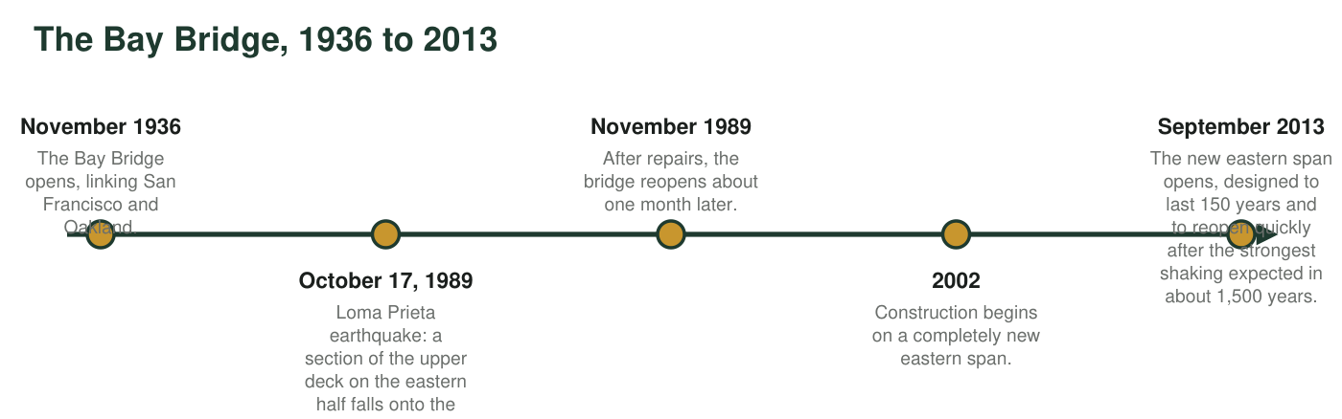
Figure 1. A timeline of the San Francisco-Oakland Bay Bridge. Dates are from Caltrans and the Metropolitan Transportation Commission.

Case file 2: The mountain
Nine years earlier and about 1,000 km to the north, Mount St. Helens in Washington had behaved very differently. On March 20, 1980, a magnitude 4.2 earthquake began a swarm of small quakes beneath the volcano. A week later, steam explosions blasted a new crater in the summit. By late April, the volcano's north side was bulging outward by up to about 1.5 meters per day as magma pushed in from below, and officials had closed the area nearest the mountain. On May 18 an earthquake shook the bulge loose in a huge landslide, and the volcano erupted sideways. Fifty-seven people died. Scientists had forecast that an eruption was likely, but not its exact day or its sideways direction.
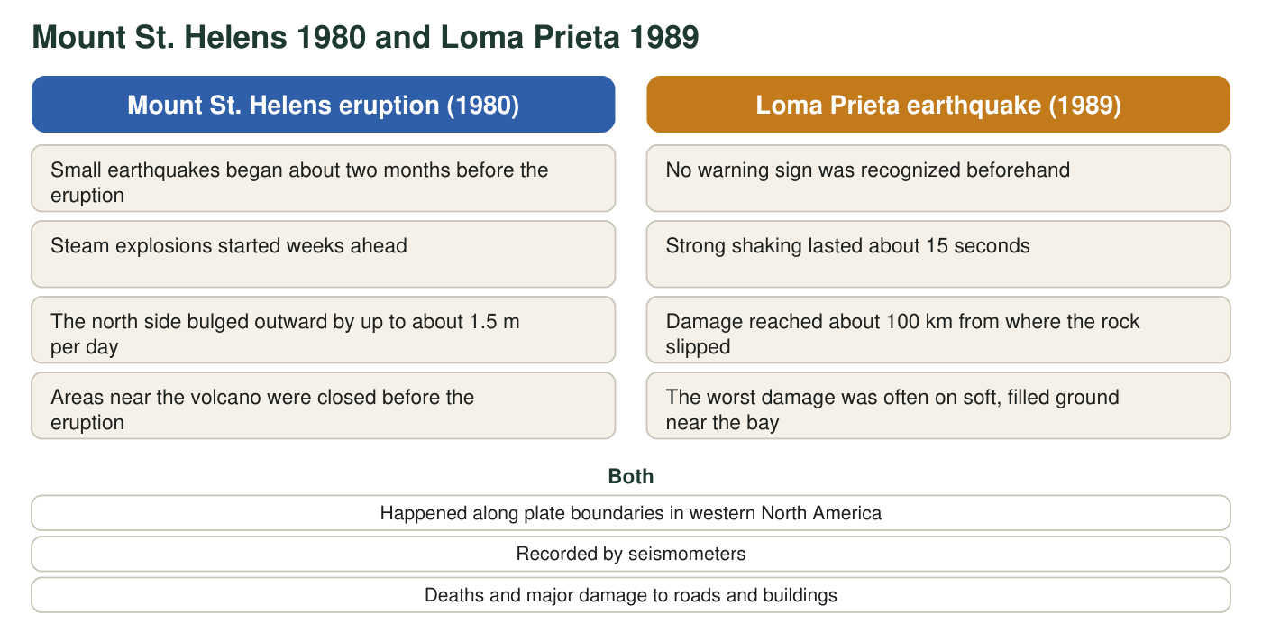
Figure 2. Comparing the warning before the two events.

Part A: Notice and wonder
1. Write three things you notice in the case files and figures. At least one must use a number.
______________________________________________________________________________________
______________________________________________________________________________________
______________________________________________________________________________________
2. Write three questions you wonder about. Start each with why, how or what would happen if.
______________________________________________________________________________________
______________________________________________________________________________________
______________________________________________________________________________________
3. Count the days from the first earthquake under Mount St. Helens (March 20) to the eruption (May 18). March has 31 days and April has 30. Show your counting. Then write how much recognized warning the Loma Prieta earthquake gave.
______________________________________________________________________________________
______________________________________________________________________________________
______________________________________________________________________________________
4. Written records of earthquakes in California go back only about 250 years. How many times longer than that is the 1,500-year span the new bridge was designed for? Show the division. Then write one way you think engineers could learn about shaking that strong.
______________________________________________________________________________________
______________________________________________________________________________________
______________________________________________________________________________________

Part B: What you already know
Mount St. Helens sits above a place where a small ocean plate is sinking beneath the North American Plate. The Loma Prieta earthquake happened in the San Andreas Fault system, where the Pacific Plate and the North American Plate slide past each other.
5. From Lesson 16: what are these two kinds of plate boundary called? Which kind do you think also produces volcanoes, and why might the other kind produce earthquakes but no volcanoes?
______________________________________________________________________________________
______________________________________________________________________________________
______________________________________________________________________________________
______________________________________________________________________________________

Part C: Your first explanations
6. Write your best explanation of why Mount St. Helens gave about two months of signals before it erupted, while the fault under the Santa Cruz Mountains gave none that anyone recognized. What might be moving or changing underground before each event?
______________________________________________________________________________________
______________________________________________________________________________________
______________________________________________________________________________________
______________________________________________________________________________________
______________________________________________________________________________________
______________________________________________________________________________________
7. Nobody can name the date of the next big Bay Area earthquake. How could engineers still design a bridge to survive it? List the information you think they would need, and explain why each piece matters.
______________________________________________________________________________________
______________________________________________________________________________________
______________________________________________________________________________________
______________________________________________________________________________________
______________________________________________________________________________________
______________________________________________________________________________________
8. Choose one of your explanations. What is one measurement or record a scientist could collect to test it? Say what result would support your idea.
______________________________________________________________________________________
______________________________________________________________________________________
______________________________________________________________________________________
Keep this page
At the end of the chapter you will reread q6 and q7 and mark what you would keep, change or add. A first explanation that changes is a sign of learning, not a mistake.

Sentence starters
For q6: 'Before the eruption, something underground was ___, which caused ___. Before the earthquake, the rock was ___, but that did not show because ___.' For q7: 'Engineers would need to know how strong ___, how often ___, and how important ___. This matters because ___.' For q3, count 11 days left in March after the 20th, then add the days in April and the days in May up to the 18th.

Why so far away?
The Bay Bridge and the Oakland freeway were about 100 km from where the rock slipped, yet nearer towns had less damage in some places. Look at a USGS page about the 1989 earthquake and find out what the ground was like under the collapsed freeway and in San Francisco's Marina District. Write a paragraph proposing why the type of ground could matter as much as distance, and what a hazard map would need to show because of it.

