Angela's Tools · Chapter 25: Volcanic Eruptions and Earthquakes · Worksheet 2 of 10

Twelve Words for Restless Ground: Sorting, Linking and Using Hazard Terms (Teacher answer key)
Learning target: I can explain how the chapter's hazard terms relate to one another and use them accurately to describe earthquakes, eruptions, forecasts and ways to reduce harm.
Vocabulary in action · about 30 minutes · individual · Standards: MS-ESS3-2 (supports)

Standards connections
MS-ESS3-2 (supports): Precursor event, frequency, magnitude, forecast and mitigate are the words the PE's data analysis depends on. Sorting and linking them, and separating forecast from prediction, prepares students to interpret hazard data in W5 and W6.

Answers with reasoning
natural hazard: A natural event, such as an earthquake, eruption, landslide or flood, that can hurt people or damage what they have built. It becomes a disaster only where people or property are in its path.
magma: Melted or partly melted rock, with dissolved gases and crystals, below Earth's surface. Magma that reaches the surface is called lava.
hot spot: A place where an unusually hot plume of mostly solid rock rises from deep in the mantle and partly melts, feeding volcanoes that can be far from any plate boundary.
pyroclastic flow: A ground-hugging avalanche of hot gas, ash and rock that races down a volcano during an explosive eruption, often faster than 80 km per hour.
precursor event: A smaller, measurable change that often comes before a larger event, such as small earthquakes, extra gas or swelling ground before an eruption.
forecast: A scientific estimate of how likely an event is in an area over a span of time. A prediction would name the exact time, place and size.
frequency: How often an event happens in a set amount of time.
magnitude: A number for the size of an earthquake at its source. Each step of 1 means about 10 times more ground motion on a seismogram and about 32 times more energy.
focus: The place underground where rock first slips and an earthquake begins.
epicenter: The point on Earth's surface directly above an earthquake's focus.
seismic wave: A wave of vibration that carries an earthquake's energy through rock. Body waves travel through Earth's interior; slower surface waves travel along the ground.
mitigate: To lessen the harm a hazard causes, for example with stronger buildings, monitoring, land-use rules or evacuation plans. It does not stop the hazard itself.

Part A: Sort the terms
1. Write each of the twelve terms in the row where it fits best. Use every term once. Below the table, choose one term that could fit in two rows and explain why.
Answer: Inside Earth: magma, hot spot, focus. Measured or estimated: precursor event, frequency, magnitude, forecast, epicenter. Reaches people or what people do: natural hazard, pyroclastic flow, seismic wave, mitigate. Two-row example: seismic wave starts inside Earth at the focus but also reaches people as shaking, and scientists measure it with seismometers.
Reasoning: The sort tests whether students see each term's role. Several terms reasonably fit two rows, so judge the justification more than the exact placement.
Also acceptable: Accept epicenter under 'inside Earth' (it is defined from the focus) or under 'reaches people' (where shaking is often strong). Accept natural hazard in any row if explained as the umbrella term.
Full credit must include:
• All twelve terms placed once
• Placements are defensible
• One dual-row term is explained with a reason

Part B: Which term fits?
2. Scientists gave the region a 72 percent chance of a large earthquake in the next 30 years. That statement is a __________, not a prediction.
Answer: forecast
Reasoning: A probability over a time window is a forecast; a prediction would name a specific time.
3. The rock first slipped 18 km below the surface, at the __________. The town on the surface directly above that point was at the __________.
Answer: focus; epicenter
Reasoning: The focus is underground where slip begins; the epicenter is the surface point directly above it.
4. A volcano's side swelled by several centimeters in a month and its gas output doubled. Scientists treated these changes as __________ suggesting that magma was rising.
Answer: precursor events
Reasoning: Swelling and increased gas are measurable changes that often come before an eruption.
Also acceptable: Accept 'precursors'.
5. Near the gorge, magnitude 5 quakes happen about twice a decade, but magnitude 7 quakes come only every few centuries. 'Twice a decade' describes the quakes' __________; the 5 and the 7 are their __________.
Answer: frequency; magnitudes
Reasoning: How often is frequency; the size numbers are magnitudes.
6. The Hawaiian volcanoes erupt in the middle of the Pacific Plate because they sit above a __________.
Answer: hot spot
Reasoning: Hot-spot volcanoes form above a rising plume of hot mantle rock, not at a plate boundary.
Also acceptable: Accept 'mantle plume'.
7. Requiring public schools to be built to stronger earthquake standards is one way California tries to __________ earthquake harm.
Answer: mitigate
Reasoning: Stronger building standards lessen harm without stopping the earthquake.
Also acceptable: Accept 'reduce' only if the student also writes 'mitigate' somewhere on the sheet.

Part C: Link the ideas
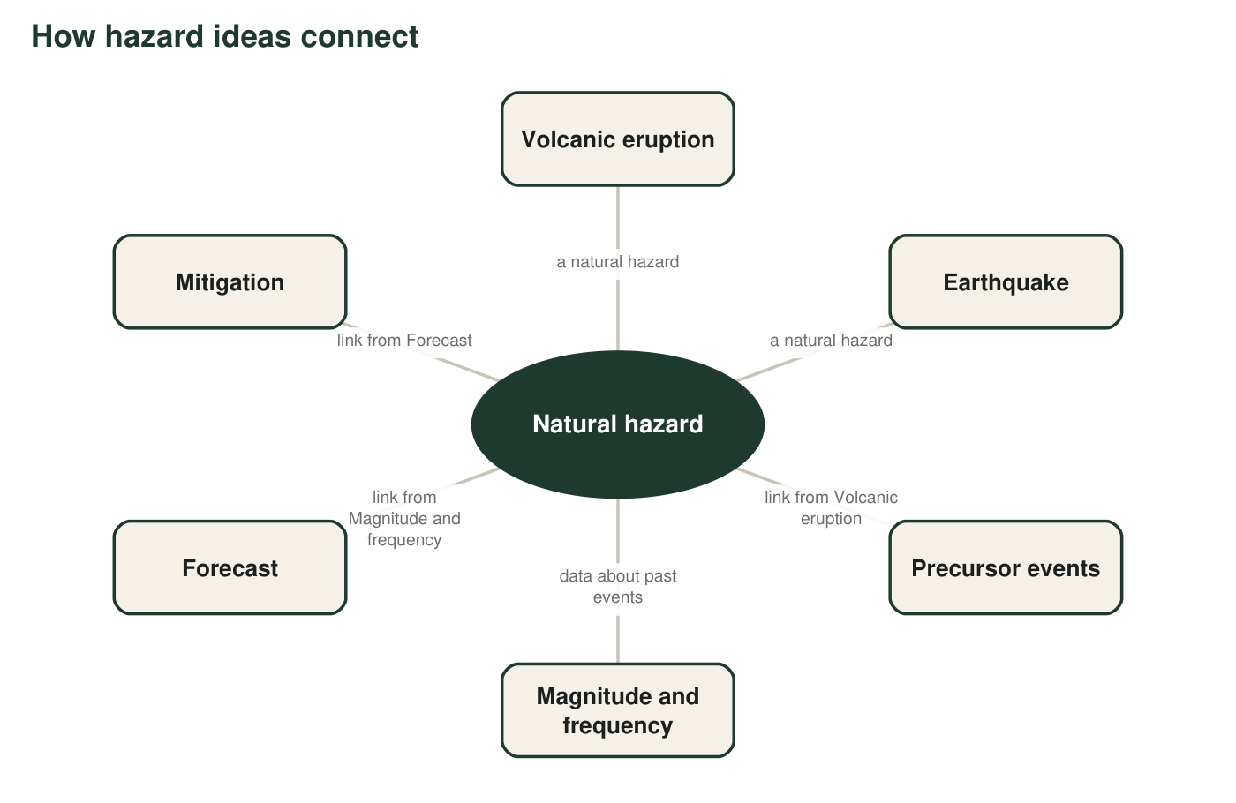
A concept map with the links left blank. Each arrow needs a short verb phrase so that 'box, phrase, box' reads as a true sentence.
8. Write a linking phrase for each pair. Example: 'Seismic waves → carry energy away from → the focus.' Careful: one of the pairs needs a phrase with not in it.
Answer: Volcanic eruption → is often preceded by → precursor events. Earthquake → has no known reliable / is not reliably preceded by → precursor events. Magnitude and frequency → of past events are used to make a → forecast. Forecast → guides decisions about / tells communities where to focus → mitigation. Volcanic eruption → (explosive ones) can produce → pyroclastic flow.
Reasoning: The 'not' link is the earthquake-to-precursor pair, which captures the PE clarification statement's contrast.
Also acceptable: Accept any accurate verb phrase. For the pyroclastic flow link, accept 'can send out' or 'may produce'.
Full credit must include:
• Each phrase makes a true sentence
• The earthquake link states that there are no reliable precursors
• The forecast link connects data to likelihood, not to an exact date

Part D: Odd one out
9. In each set, pick the term that does not belong with the other three and explain the connection the other three share.
Answer: Set 1: pyroclastic flow; the other three describe earthquakes. Set 2: frequency; the other three are volcanic materials or places where magma forms. Set 3: mitigate; the other three are about knowing or measuring a hazard, while mitigate is an action people take to reduce harm.
Reasoning: Each set has one term from a different category; students must name the shared connection.
Also acceptable: Set 3: accept 'precursor event' if the student argues it is the only one that does not apply to earthquakes. Set 2: accept 'hot spot' if argued as the only place rather than material, with frequency also discussed.
Full credit must include:
• Correct odd term in each set
• The shared connection of the other three is stated

Part E: Use the words
10. A news report says: 'The epicenter was in the Santa Cruz Mountains, but some of the worst damage happened about 100 km away.' Explain why this is not a contradiction. Use epicenter, focus and seismic wave correctly.
Answer: The focus is the place underground where the rock first slipped, and the epicenter is the point on the surface directly above it. The earthquake's energy travels outward from the focus as seismic waves, so the waves reached places 100 km away. Damage depends on how strongly the ground shakes at each place and on what is built there, not only on distance from the epicenter, so a distant place on soft ground or with a weak structure can be damaged more.
Reasoning: The answer must use all three terms correctly and explain that shaking spreads by waves and varies by location.
Also acceptable: Accept a mention of soft or filled ground making shaking stronger.
Full credit must include:
• Focus and epicenter used correctly
• Seismic waves carry the energy outward to distant places
• Explains that damage depends on local conditions, not only distance
11. Port Alba is a fictional coastal town 20 km from an active volcano and 5 km from an active fault. Write a paragraph for the town's website explaining what scientists can and cannot tell residents about each hazard and what the town is doing about them. Use at least six word-bank terms correctly and underline each one.
Answer: Example: 'Port Alba faces two natural hazards. Scientists watch the volcano for precursor events, such as swarms of small quakes, extra gas and swelling ground, which show magma rising; these let them forecast that an eruption is becoming likely, though not its exact day. Explosive eruptions can send pyroclastic flows down the valleys, so the town keeps homes out of those zones and practices evacuations. The fault gives no reliable warning. Using the magnitude and frequency of past quakes, scientists forecast the chance of a strong quake over the coming decades. The town mitigates that hazard by strengthening schools and bridges.' (Bold marks the words a student would underline.)
Reasoning: Full credit requires six or more terms used accurately, and correct statements about what can be forecast for each hazard.
Also acceptable: Any accurate paragraph meeting the criteria earns credit; the order of ideas does not matter.
Full credit must include:
• Six or more word-bank terms, each used correctly
• States that eruption forecasts come from precursors
• States that earthquakes are forecast as chances over time, not predicted
• Names at least one mitigation

Teacher notes
The word bank follows the chapter's vocabulary list, with definitions shortened for students. Part A has no single correct sort; use it to start discussion about how a term like seismic wave belongs to both cause and effect. The q8 'not' link is the central idea of the PE's clarification statement. In q11, students writing about Port Alba often claim the volcano can be 'predicted'; push them toward 'forecast' and 'more likely'. In the model answer, bold marks the words a student would underline. The extension introduces intensity, which the chapter's accuracy notes distinguish from magnitude.

