Angela's Tools · Chapter 25: Volcanic Eruptions and Earthquakes · Worksheet 4 of 10

California's Restless Edge: Modeling Where Magma and Earthquakes Come From (Teacher answer key)
Learning target: I can use diagrams of plate settings to explain why some places have volcanoes and earthquakes while others have only earthquakes, and draw a labeled model of a subduction zone.
Diagrams and models · about 45 minutes · individual · Standards: MS-ESS3-2 (practice), MS-ESS2-3 (supports)

Standards connections
MS-ESS3-2 (practice): The disciplinary core idea for this PE says that mapping past hazards together with an understanding of the related geologic forces helps forecast where future events are likely. Students model those forces for California's plate settings, which builds toward forecasting locations; the sheet does not ask them to analyze hazard data.
MS-ESS2-3 (supports): Students draw a trench and a sinking plate and explain why earthquake depths trace the plate, using the seafloor structures and plate boundaries from Lesson 16. Plate motion is background here; the sheet does not ask students to reconstruct past plate motions.

Answers with reasoning

Part A: Read the models
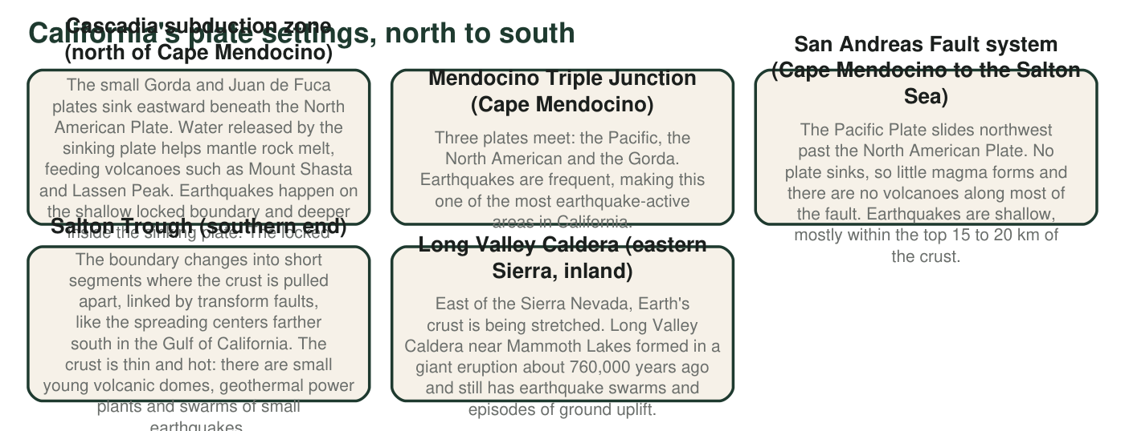
Figure 1. Five plate settings in and near California. Descriptions are simplified; real plate boundaries are zones of many faults.
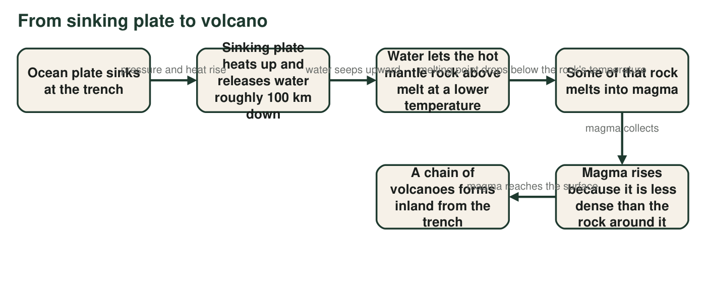
Figure 2. How magma forms above a sinking plate. The mantle is mostly solid rock; it melts only where something changes its melting conditions.
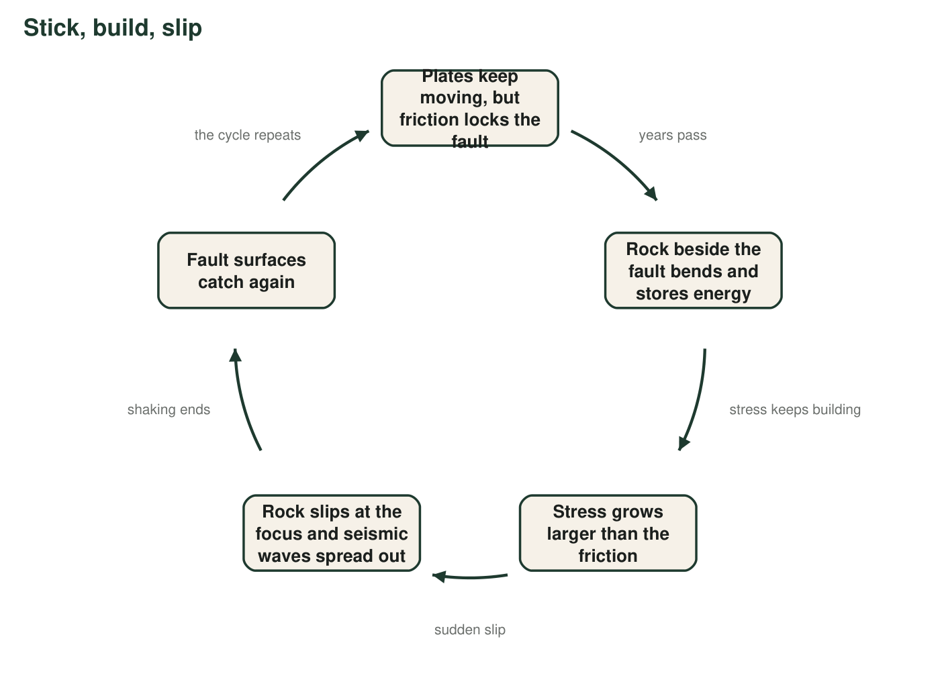
Figure 3. The stick-slip cycle on a fault. One trip around the loop can take decades to centuries; the slip itself lasts seconds to minutes.
1. According to Figure 1, which setting produces many earthquakes but almost no magma?
Answer: B. The San Andreas Fault system.
Reasoning: Figure 1 says plates slide past each other there, no plate sinks, little magma forms and there are no volcanoes along most of the fault, while earthquakes are common. The other three settings all have magma.
2. Use Figures 1 and 2 to explain why northern California has volcanoes like Mount Shasta, but the land along the San Andreas Fault does not.
Answer: In northern California the Gorda and Juan de Fuca plates sink beneath North America (Figure 1). As a sinking plate goes deep it releases water, which lets the hot mantle rock above it melt at a lower temperature, so magma forms and rises to build volcanoes like Shasta (Figure 2). Along the San Andreas, the plates slide sideways past each other; no plate sinks, so no water is carried down and no magma forms. That boundary makes earthquakes but not volcanoes.
Reasoning: The answer must contrast subduction (with its melting mechanism) and transform motion (with no melting mechanism).
Also acceptable: Accept 'convergent' and 'transform' as boundary names if the motion is described correctly.
Full credit must include:
• Says a plate sinks in the north and plates slide sideways along the San Andreas
• Explains that water from the sinking plate leads to melting
• States that no sinking plate means no magma along the transform boundary
3. In Figure 2, the mantle rock above the sinking plate melts even though it does not get hotter. Explain how that can happen.
Answer: Water released from the sinking plate seeps into the hot mantle rock above and lowers the temperature at which that rock melts. The rock's temperature stays about the same, but its melting point drops below it, so part of the rock melts.
Reasoning: This is flux melting. The textbook says material from the sinking plate mixes with the mantle; the more accurate statement is that water is the main trigger.
Also acceptable: Accept 'the melting point drops' or 'water makes rock melt at a lower temperature'.
Full credit must include:
• Names water from the sinking plate
• Explains that the melting temperature is lowered rather than the rock being heated
4. In Figure 3, which step is the earthquake that people feel? What is stored during the long quiet part of the cycle, and why does the cycle start over?
Answer: The step 'Rock slips at the focus and seismic waves spread out' is the earthquake people feel. During the long quiet part, energy is stored in the bent rock beside the locked fault (stress builds). The cycle starts over because the plates keep moving after the slip, the fault surfaces catch again, and stress starts building again.
Reasoning: Students must identify the brief slip as the quake and the long locked interval as the time of stress build-up.
Also acceptable: Accept 'elastic energy' or 'strain'.
Full credit must include:
• Identifies the slip step as the earthquake
• Says energy or stress is stored in bent rock
• Explains that continuing plate motion reloads the locked fault

Part B: Draw your own model
Draw a side view (cross-section) of the Cascadia subduction zone, with the Pacific Ocean on the left and inland northern California on the right. Label: the ocean plate, the North American Plate, the trench, an arrow showing which way the ocean plate moves, the mantle, the place where water is released and magma forms, magma rising, and a volcano. Mark at least six earthquake foci with an X: some on the shallow locked boundary near the coast and some deeper inside the sinking plate farther inland.
Expected drawing: A thin ocean plate on the left bends down beneath a thicker North American Plate at a trench near the coast, with an arrow pointing toward and under the continent. The mantle lies below both plates. Above the sinking plate, well inland, a label shows water released and magma forming; a path of magma rises to a volcano on the surface (labeled, for example, Mount Shasta). At least six X marks: several on the shallow contact between the plates near the coast, and several deeper inside or along the top of the sinking plate farther inland.
Reasoning: The model must show the geometry that explains both hazards: a locked shallow boundary for the largest quakes, a deepening plate for deeper quakes, and melting above the deep plate for volcanoes.

Part C: Use your model
5. Complete the table using your drawing.
Answer: Shallowest earthquakes: near the coast, on the contact between the two plates, because that is where the plates are locked together and stress builds. Deepest earthquakes: farther inland, inside the sinking plate, because the plate continues to bend and crack as it goes down. Magma forming: inland and deep, just above the sinking plate, where water released from the plate lets the mantle rock melt at a lower temperature. Volcano: inland, on the surface above where magma forms, because the less dense magma rises straight up through the crust.
Reasoning: Each position follows from the subduction geometry students drew.
Also acceptable: Accept 'where the plates rub together' for the shallow quakes.
Full credit must include:
• Shallow quakes near the coast on the locked boundary
• Deep quakes inland within the sinking plate
• Magma above the deep part of the sinking plate
• Volcano inland above the magma source
• A reason for each
6. Seismologists plot quake foci along a line from the Cascadia coast inland. The foci get deeper the farther inland they are. What does this pattern trace?
Answer: A. The top of the sinking ocean plate.
Reasoning: Earthquakes at subduction zones happen on and within the sinking plate, so their foci outline it as it dives under the continent. Magma does rise inland, but it does not make a sloping band of quakes.
7. Which California setting in Figure 1 can produce the largest earthquakes? Use your model and Figure 1 to explain why.
Answer: The Cascadia subduction zone. Its locked boundary between the sinking plate and North America is very long (it runs from northern California to Canada) and wide, so a huge area of fault can slip at once, storing and releasing far more energy than the narrower, near-vertical San Andreas. Figure 1 shows it produced a magnitude 9 earthquake in 1700, and a magnitude 9 releases about 32 times the energy of a magnitude 8 and about 1,000 times that of a magnitude 7.
Reasoning: Earthquake size depends on the area of fault that slips. Gently sloping subduction boundaries offer the largest locked areas on Earth.
Also acceptable: Accept a reason based on the 1700 earthquake alone for partial credit; full credit needs the fault-area idea or a correct energy comparison.
Full credit must include:
• Names Cascadia
• Explains that a larger area of locked fault can slip
• Uses the 1700 magnitude 9 as evidence
8. The Hawaiian volcanoes sit more than 3,000 km from the nearest plate boundary. Which part of your model cannot explain them, and what does explain them?
Answer: The subduction part of the model cannot explain Hawaii, because no plate is sinking there. Hawaii sits above a hot spot: a plume of unusually hot rock rising from deep in the mantle partly melts as the pressure on it drops near the top, and the magma builds volcanoes as the Pacific Plate moves over it.
Reasoning: Hot spots are the main exception to the boundary pattern. The answer should not say the plume heats the rock above it or that the mantle is liquid.
Also acceptable: Accept 'a hot spot under the Pacific Plate' without the pressure detail.
Full credit must include:
• Says the model needs a sinking plate, which Hawaii lacks
• Names a hot spot or mantle plume as the explanation
9. Name two things your drawing leaves out or shows inaccurately, and say why a scientist would still find the model useful.
Answer: Examples: it shows one flat slice of a three-dimensional system; the sizes and depths are not to scale; the plate motion is too slow to see; magma does not travel in a single pipe; real quakes are scattered, not neatly placed. It is still useful because it shows the arrangement that explains where shallow quakes, deep quakes, magma and volcanoes occur, which lets scientists forecast where hazards are likely.
Reasoning: Students should name concrete limitations and connect the model's value to explaining and forecasting locations.
Also acceptable: Accept 'it doesn't show time' or 'it leaves out other faults' as limitations.
Full credit must include:
• Two specific limitations
• One reason the model is useful anyway

Teacher notes
Figure 1 is simplified from USGS descriptions of California tectonics. Points that are accurate but easy to overstate: the San Andreas is the main fault of a broad plate-boundary zone, not a single crack; there are volcanoes near parts of the plate boundary (Clear Lake, the Salton Buttes), so Figure 1 says 'most of the fault'; Cascadia's subducting plate is young and warm, so its earthquakes reach tens of kilometers deep, not the 600 to 700 km seen at some other subduction zones. The textbook says crustal material from the sinking plate lowers the mantle's melting temperature; Figure 2 names water, the main trigger. The textbook also calls convergent-boundary earthquakes 'deep'; the largest subduction earthquakes, including Cascadia 1700, start on the shallow locked boundary, so q5 and q7 keep both. The Hawaiian hot spot is more than 3,000 km from the nearest plate boundary (USGS). The extension's triple-junction history is a simplified version of a well-supported explanation for the end of volcanism along the central California coast; treat it as enrichment.

