Angela's Tools · Chapter 25: Volcanic Eruptions and Earthquakes · Worksheet 4 of 10

California's Restless Edge: Modeling Where Magma and Earthquakes Come From
Learning target: I can use diagrams of plate settings to explain why some places have volcanoes and earthquakes while others have only earthquakes, and draw a labeled model of a subduction zone.
Diagrams and models · about 45 minutes · individual · Standards: MS-ESS3-2 (practice), MS-ESS2-3 (supports)
Name: ____________________________ Date: ____________ Period: ______

Directions
Study Figure 1 first. It describes five places along California, from the north coast to the Salton Sea and inland to the eastern Sierra. Figures 2 and 3 show two processes as step-by-step models. Use all three figures to answer Part A. In Part B you will draw your own labeled model, then answer questions about it in Part C. Draw in pencil so that you can revise.

Part A: Read the models
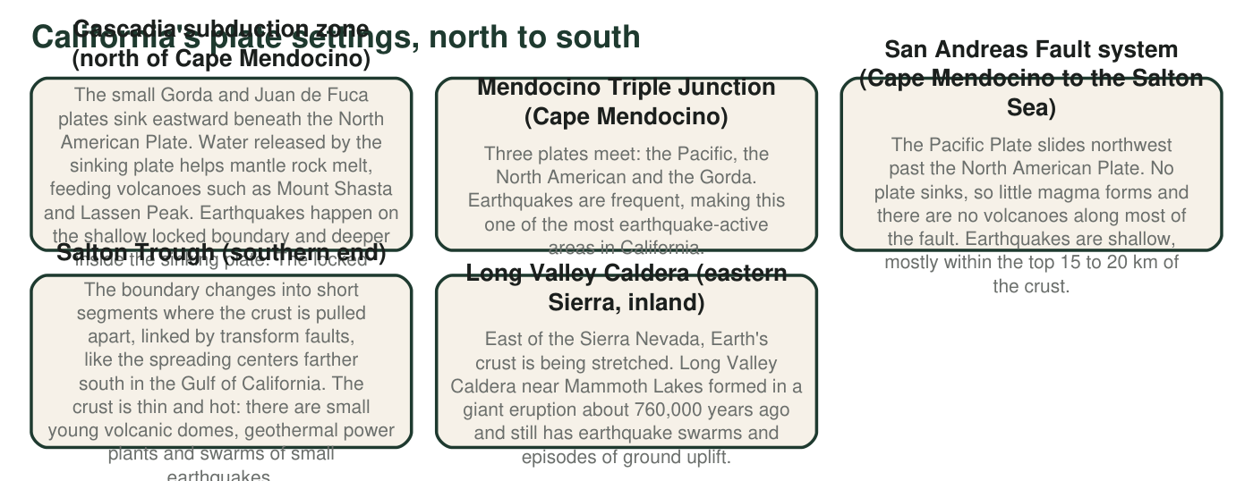
Figure 1. Five plate settings in and near California. Descriptions are simplified; real plate boundaries are zones of many faults.
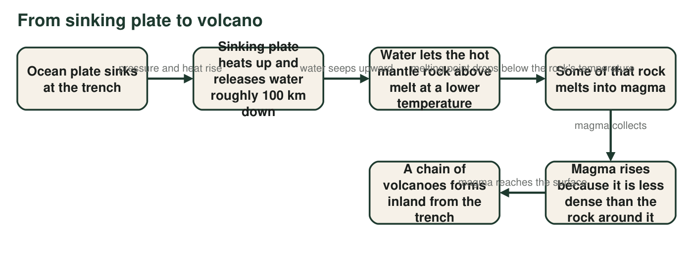
Figure 2. How magma forms above a sinking plate. The mantle is mostly solid rock; it melts only where something changes its melting conditions.
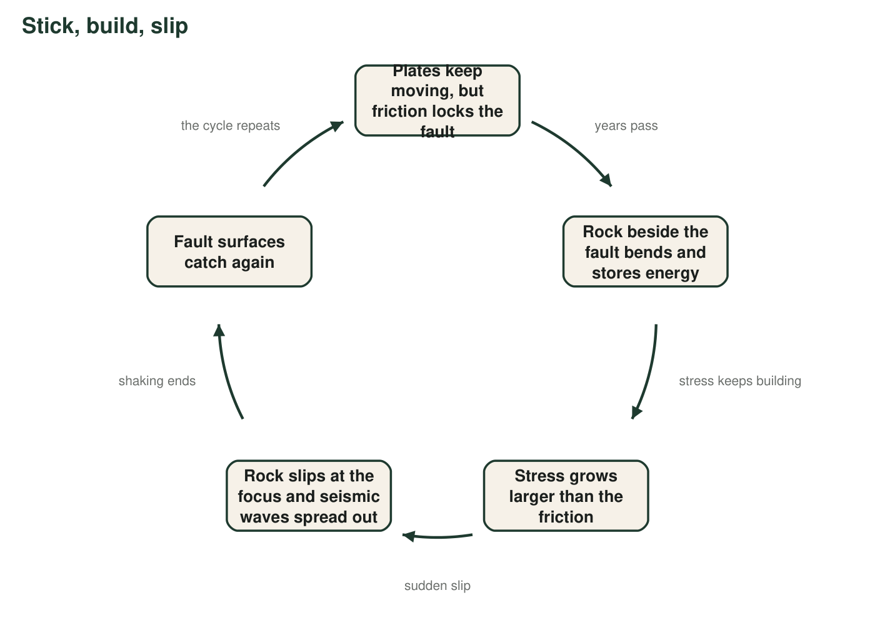
Figure 3. The stick-slip cycle on a fault. One trip around the loop can take decades to centuries; the slip itself lasts seconds to minutes.
1. According to Figure 1, which setting produces many earthquakes but almost no magma?
○ A. The Cascadia subduction zone
○ B. The San Andreas Fault system
○ C. The Salton Trough
○ D. Long Valley Caldera
2. Use Figures 1 and 2 to explain why northern California has volcanoes like Mount Shasta, but the land along the San Andreas Fault does not.
______________________________________________________________________________________
______________________________________________________________________________________
______________________________________________________________________________________
______________________________________________________________________________________
3. In Figure 2, the mantle rock above the sinking plate melts even though it does not get hotter. Explain how that can happen.
______________________________________________________________________________________
______________________________________________________________________________________
______________________________________________________________________________________
4. In Figure 3, which step is the earthquake that people feel? What is stored during the long quiet part of the cycle, and why does the cycle start over?
______________________________________________________________________________________
______________________________________________________________________________________
______________________________________________________________________________________

Part B: Draw your own model
Draw a side view (cross-section) of the Cascadia subduction zone, with the Pacific Ocean on the left and inland northern California on the right. Label: the ocean plate, the North American Plate, the trench, an arrow showing which way the ocean plate moves, the mantle, the place where water is released and magma forms, magma rising, and a volcano. Mark at least six earthquake foci with an X: some on the shallow locked boundary near the coast and some deeper inside the sinking plate farther inland.

Part C: Use your model
5. Complete the table using your drawing.
Where on your drawing (near the coast or inland, shallow or deep) | Why it happens there
Shallowest earthquakes
Deepest earthquakes
Magma forming
Volcano

6. Seismologists plot quake foci along a line from the Cascadia coast inland. The foci get deeper the farther inland they are. What does this pattern trace?
○ A. The top of the sinking ocean plate
○ B. The path of magma rising to the volcanoes
○ C. The boundary between the crust and the core
○ D. The edge of the San Andreas Fault
7. Which California setting in Figure 1 can produce the largest earthquakes? Use your model and Figure 1 to explain why.
______________________________________________________________________________________
______________________________________________________________________________________
______________________________________________________________________________________
______________________________________________________________________________________
8. The Hawaiian volcanoes sit more than 3,000 km from the nearest plate boundary. Which part of your model cannot explain them, and what does explain them?
______________________________________________________________________________________
______________________________________________________________________________________
______________________________________________________________________________________
9. Name two things your drawing leaves out or shows inaccurately, and say why a scientist would still find the model useful.
______________________________________________________________________________________
______________________________________________________________________________________
______________________________________________________________________________________

A drawing checklist
Start with two long slabs: a thin ocean plate on the left that bends down under a thicker North American Plate on the right. The trench is the low point where the bend begins. Put the volcano well inland, above where the sinking plate is deep. Draw magma as a thin path rising from just above the sinking plate. Place X marks along the top of the sinking plate and inside it: shallow near the trench, deeper toward the right.

A boundary that is moving north
The Mendocino Triple Junction is slowly moving north along the coast as the Pacific Plate slides past. Scientists think that as it passed, no sinking plate was left beneath parts of central California, one reason subduction volcanoes stopped forming there while the San Andreas grew longer. Draw two quick sketches of the California coast, one long ago and one today, showing where subduction and the transform boundary were. Explain how this helps account for the old volcanic rock found in parts of central California.

