Angela's Tools · Chapter 26: Mass Wasting, Tsunamis, and Floods · Worksheet 1 of 10

One County, Three Hazards: Del Norte's Tsunamis, Floods and Sliding Highway (Teacher answer key)
Learning target: I can describe patterns in where and how landslides, floods and tsunamis strike, connect them to what I already know about gravity, water and earthquakes, and write first explanations and questions to test.
Phenomenon exploration · about 30 minutes · individual · Standards: MS-ESS3-2 (supports)

Standards connections
MS-ESS3-2 (supports): Students notice that one stretch of coast faces three hazards, that different hazards cluster in different landscapes, and that tsunamis arrive hours after distant earthquakes. Those location, frequency and timing patterns are the kind of hazard data the PE asks students to analyze; this sheet raises the questions, and later sheets do the analysis and forecasting.

Answers with reasoning

Observation 1: One county, three hazards
Del Norte County is the far northwest corner of California, where steep, forested mountains meet the Pacific Ocean. Its main town is Crescent City, a fishing port with a small-boat harbor. Highway 101 is the county's main link to the rest of the state. Figure 1 lists four events from the county's recent history.
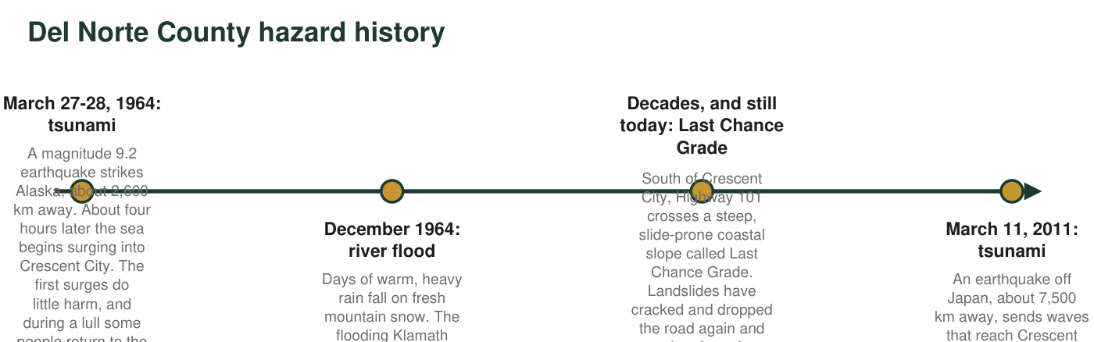
Figure 1. Four hazard events in Del Norte County. Distances are straight-line distances from each earthquake to Crescent City.

Observation 2: Two landscapes, two kinds of disaster
When hazard scientists map reported landslides and floods across the country, another pattern jumps out. The steep, rainy Coast Ranges of Northern California report landslides almost every wet winter. Counties along the broad, flat valleys of the Missouri and Mississippi Rivers in the state of Missouri report floods far more often than landslides. Figure 2 compares the two landscapes, and Figure 3 shows teaching estimates of reported events in one county from each region.
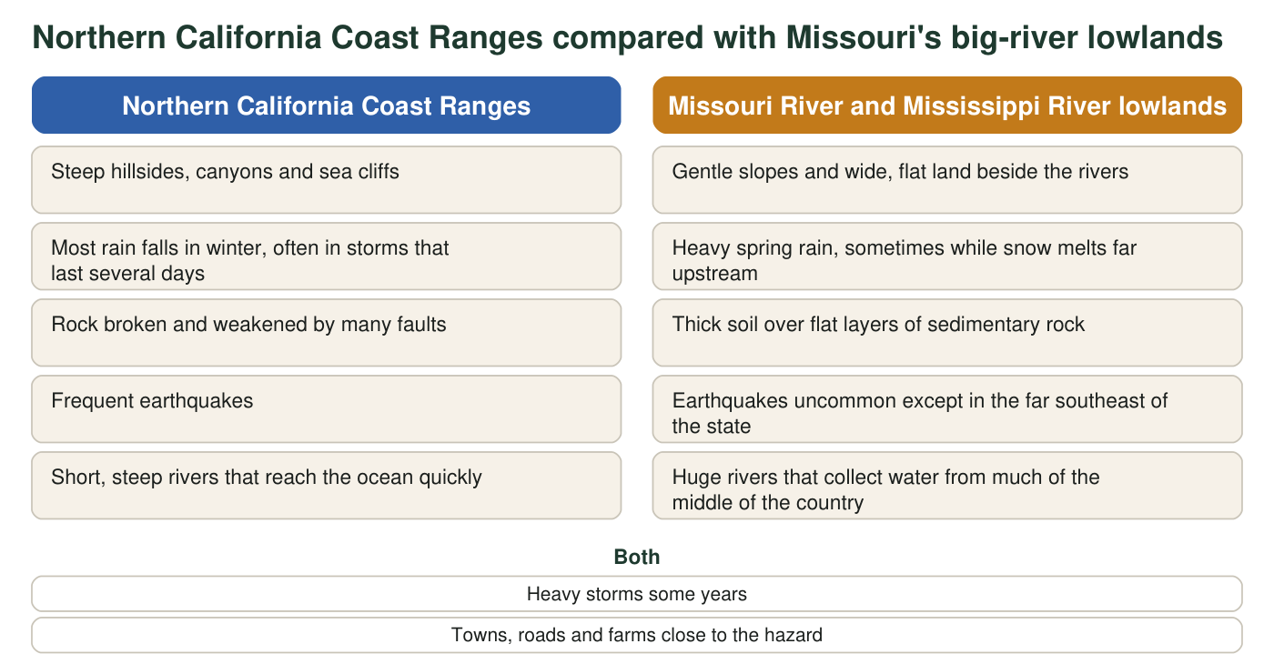
Figure 2. Features of two regions. The lists describe typical conditions, not every place in each region.
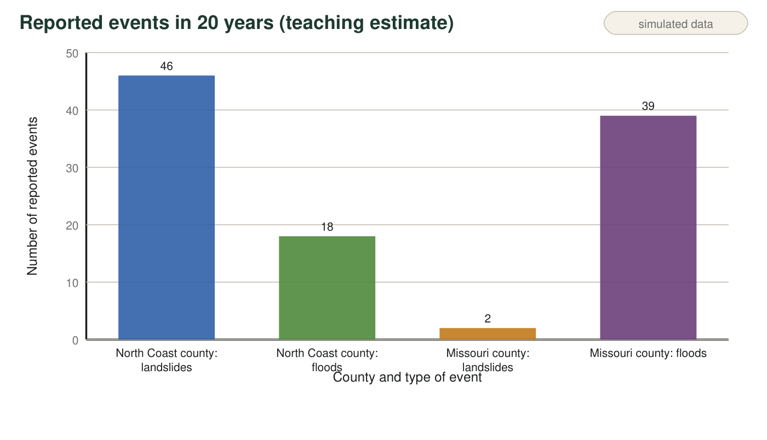
Figure 3. Teaching estimate of reported landslides and floods over 20 years in one Northern California coastal county and one Missouri river county. The numbers are invented to match the real pattern on national hazard maps; they are not an official count.

Part A: Notice and wonder
1. Write three things you notice in Figures 1 to 3. At least one must use a number.
Answer: Examples: Crescent City was hit by tsunamis from both Alaska (1964) and Japan (2011); the 2011 waves took about 10 hours, much longer than the 1964 waves' four hours; the fourth surge in 1964 was the largest; the 1964 flood came from warm rain on snow; Last Chance Grade keeps sliding after wet winters; the North Coast county reported 46 landslides but the Missouri county only 2; the Missouri county reported 39 floods, more than twice the North Coast county's 18.
Reasoning: Any accurate observation from the three figures earns credit, as long as at least one includes a number.
Also acceptable: Accept observations that compare bars for one hazard ('the flood bars are closer together than the landslide bars') when paired with a number.
Full credit must include:
• Three observations drawn from Figures 1 to 3
• At least one uses a number
• Observations, not explanations
2. Write three questions you wonder about after reading both observations. Start each with why, how or what would happen if.
Answer: Examples: Why was the fourth surge the biggest? How can a wave cross an ocean in a few hours? Why does one county get tsunamis, floods and landslides? What would happen if a big earthquake struck right off the Del Norte coast? How does rain on snow make a river flood? Why do steep places have more landslides?
Reasoning: Questions should come from the observations and be answerable with investigation or the chapter's ideas.
Also acceptable: Questions about the data ('How do scientists count landslides?') are valid science questions and earn credit.
Full credit must include:
• Three questions
• Each begins with why, how or what would happen if
• Each connects to one of the observations
3. In Figure 3, how many times more landslides did the North Coast county report than the Missouri county? Show the division.
Answer: 46 ÷ 2 = 23. The North Coast county reported 23 times as many landslides as the Missouri county.
Reasoning: A simple ratio of the two landslide bars. Students should write the division, not only the result.
Also acceptable: Accept '23 times' or '23:1'.
4. Calculate the average speed of each tsunami in Figure 1 in kilometers per hour: the 1964 waves traveled about 2,600 km in about 4 hours, and the 2011 waves about 7,500 km in about 10 hours. Then explain which tsunami gave Crescent City more warning time, and why.
Answer: 1964: 2,600 km ÷ 4 h = 650 km/h. 2011: 7,500 km ÷ 10 h = 750 km/h. The 2011 tsunami gave more warning time (about 10 hours versus about 4) because its source was much farther away; even though it traveled a little faster on average, it had nearly three times as far to go.
Reasoning: Average speed is distance divided by time. Both averages are hundreds of km/h, the speed of tsunamis over deep ocean. The 2011 path crossed more of the deep Pacific, which is consistent with its higher average; warning time depends mostly on distance from the source.
Also acceptable: Accept 630 to 670 km/h for 1964 (with the measured first-wave travel time of about 4.1 hours, 2,600 ÷ 4.1 = 634 km/h) and 750 to 770 km/h for 2011.
Full credit must include:
• Both speeds calculated with work shown
• Identifies 2011 as giving more warning
• Explains warning time by distance from the source

Part B: What you already know
5. From earlier lessons: what force pulls soil, rock and water downhill? And what can happen to the seafloor during a very large earthquake where one tectonic plate sinks beneath another?
Answer: Gravity pulls soil, rock and water downhill. In a very large earthquake at a subduction zone, the edge of the upper plate can suddenly spring upward while other parts drop, so a large area of seafloor moves up or down in seconds and moves the water above it.
Reasoning: This activates prior learning about gravity and about plate boundaries from the previous lesson. Full detail about which plate moves is not expected yet.
Also acceptable: Accept 'the plates slip and the ocean floor jumps' or 'the ground under the ocean shifts and shoves the water.'
Full credit must include:
• Names gravity
• States that the seafloor can suddenly move up or down (or shift) during the earthquake

Part C: Your first explanations
6. Write your best explanation of why the North Coast county reports many more landslides, while the Missouri county reports many more floods. Use at least two differences from Figure 2 and say how each one makes one hazard more likely.
Answer: Steep slopes give gravity a stronger pull along the ground, so soil and rock on the North Coast hills are closer to sliding. Long winter storms soak the ground, and soaked soil is heavier and weaker. Rock broken by faults has many weak surfaces, and earthquakes shake slopes. In Missouri the land beside the big rivers is nearly flat, so there is little slope for material to slide down, but those rivers collect rain and snowmelt from an enormous area, so when spring storms add more water than the channel can carry, the water spreads over the flat land as a flood.
Reasoning: A strong first explanation ties each hazard to at least two conditions from Figure 2. The chapter will confirm that slope, saturation and material control mass wasting and that runoff from big drainage areas drives river floods.
Also acceptable: Partial credit for listing differences without saying how each one changes the chance of a hazard.
Full credit must include:
• Uses at least two differences from Figure 2
• Explains how slope or water makes landslides more likely on the North Coast
• Explains why flat land beside big rivers floods
7. How could an earthquake in Alaska damage Crescent City four hours later, when no one in town felt strong shaking? And why might the fourth surge have been bigger than the first? Write a first explanation.
Answer: The Alaska earthquake suddenly moved a large area of seafloor, which pushed the ocean water above it and started a series of waves spreading across the Pacific. In deep water the waves were low but very fast, about 650 km/h on average, so they reached Crescent City about four hours later, long after the shaking in Alaska had stopped; the shaking itself was not strong enough to feel in California. Tsunami waves arrive one after another, many minutes apart, and later waves can be bigger than the first, for example when waves from different directions or reflections off the coast add together, so the fourth surge could be the largest.
Reasoning: This first explanation anticipates the chapter's model of a tsunami as a series of waves set off by a sudden shift of the seafloor, and the danger of treating the first surge as the whole event.
Also acceptable: Accept 'the earthquake made a giant wave' as a starting idea if the time delay is explained by distance; the series-of-waves idea can be partial at this stage.
Full credit must include:
• Links the earthquake to sudden movement of the seafloor or water
• States that waves traveled across the ocean for hours
• States that a tsunami arrives as several waves and later ones can be larger
8. Look at the four events in Figure 1. Which hazards do you think could be forecast hours or days ahead, and which might give almost no notice? Give a reason for each.
Answer: Example: The December 1964 flood could be forecast hours or days ahead, because the storms and the rising river could be watched as they built up. The 1964 and 2011 tsunamis gave hours of notice once the earthquakes happened, because the sources were far away, but no one knew beforehand when the earthquakes would strike. Landslides at Last Chance Grade are more likely after wet winters, so there is some warning that danger is high, but the exact moment a slope fails is hard to forecast. A big earthquake right off the coast would give almost no notice.
Reasoning: This first sort previews the chapter's central contrast: weather-driven hazards have signals that build up, while earthquake-triggered hazards can be forecast only after the trigger, with warning time set by distance.
Also acceptable: Any reasoned sort earns credit at this stage; note students who already separate 'when the trigger happens' from 'when the waves arrive'.
Full credit must include:
• Places each event in a category with a reason
• Recognizes that weather-driven hazards can be watched as they build
• Recognizes that tsunami warning time depends on when the earthquake happens and how far away it is
9. If you were in charge of keeping Highway 101 open at Last Chance Grade, name two kinds of data you would collect, and say how each would help you forecast trouble.
Answer: Examples: rainfall totals and soil wetness (soaked slopes fail more easily); measurements of how much the road and slope are moving, using cracks, survey markers or GPS (a slope that speeds up is closer to failing); maps of slope steepness and old slide scars (where failures are most likely); records of past road damage (which sections fail most often).
Reasoning: Any two relevant data types with a clear reason earn credit. These match the kinds of data the PE's clarification names: locations, magnitudes and frequencies, plus measured precursors.
Also acceptable: Accept earthquake shaking records or groundwater levels if the reason is explained.
Full credit must include:
• Names two kinds of data
• Explains how each helps forecast slope failure
Keep this page
At the end of the chapter you will reread q6, q7 and q8 and mark what you would keep, change or add. A first explanation that changes is a sign of learning, not a mistake.

Teacher notes
This sheet introduces the chapter phenomenon (Del Norte County) and the textbook's two-landscape pattern. Figure 1 facts were checked: the 1964 Alaska tsunami's first surge reached Crescent City about 4.1 hours after the earthquake, the fourth surge was the largest, and 11 people died in Crescent City; in late December 1964 warm rain on fresh snow flooded the Klamath River, which wiped out most of the town of Klamath and washed out two spans at the south end of the Douglas Memorial Bridge on Highway 101 (National Park Service history); Last Chance Grade is a chronically sliding stretch of Highway 101 south of Crescent City; the 2011 Tohoku tsunami reached Crescent City about 9 hours 48 minutes after the earthquake, destroyed most of the docks in the small-boat harbor after warnings had cleared it, and the one California death was near the mouth of the Klamath River, not in Crescent City. Figure 3 is simulated but follows the real pattern on national maps: high landslide potential in the Pacific coast ranges and very high flood counts in many Missouri counties. Expect students to call the tsunami a single 'tidal wave'; do not correct it yet, because W7 addresses it. Collect or keep the sheets for the end-of-chapter revisit.

