Angela's Tools · Chapter 26: Mass Wasting, Tsunamis, and Floods · Worksheet 1 of 10

One County, Three Hazards: Del Norte's Tsunamis, Floods and Sliding Highway
Learning target: I can describe patterns in where and how landslides, floods and tsunamis strike, connect them to what I already know about gravity, water and earthquakes, and write first explanations and questions to test.
Phenomenon exploration · about 30 minutes · individual · Standards: MS-ESS3-2 (supports)
Name: ____________________________ Date: ____________ Period: ______

Directions
Read both observations and study the three figures. The bar chart in Figure 3 uses teaching numbers that show a real pattern; they are not an official count. Write what you notice before you write what you wonder. Your explanations in Part C are first drafts: being unsure is fine, but give a reason for every idea. Keep this sheet, because you will revise it at the end of the chapter.

Observation 1: One county, three hazards
Del Norte County is the far northwest corner of California, where steep, forested mountains meet the Pacific Ocean. Its main town is Crescent City, a fishing port with a small-boat harbor. Highway 101 is the county's main link to the rest of the state. Figure 1 lists four events from the county's recent history.
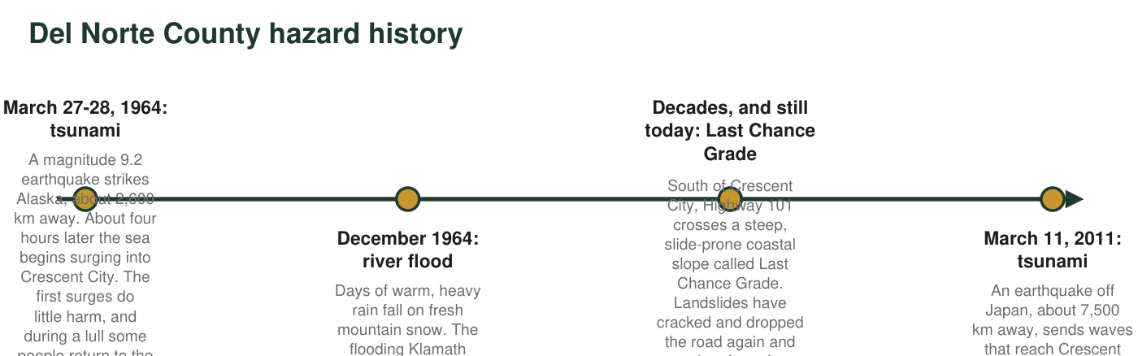
Figure 1. Four hazard events in Del Norte County. Distances are straight-line distances from each earthquake to Crescent City.

Observation 2: Two landscapes, two kinds of disaster
When hazard scientists map reported landslides and floods across the country, another pattern jumps out. The steep, rainy Coast Ranges of Northern California report landslides almost every wet winter. Counties along the broad, flat valleys of the Missouri and Mississippi Rivers in the state of Missouri report floods far more often than landslides. Figure 2 compares the two landscapes, and Figure 3 shows teaching estimates of reported events in one county from each region.
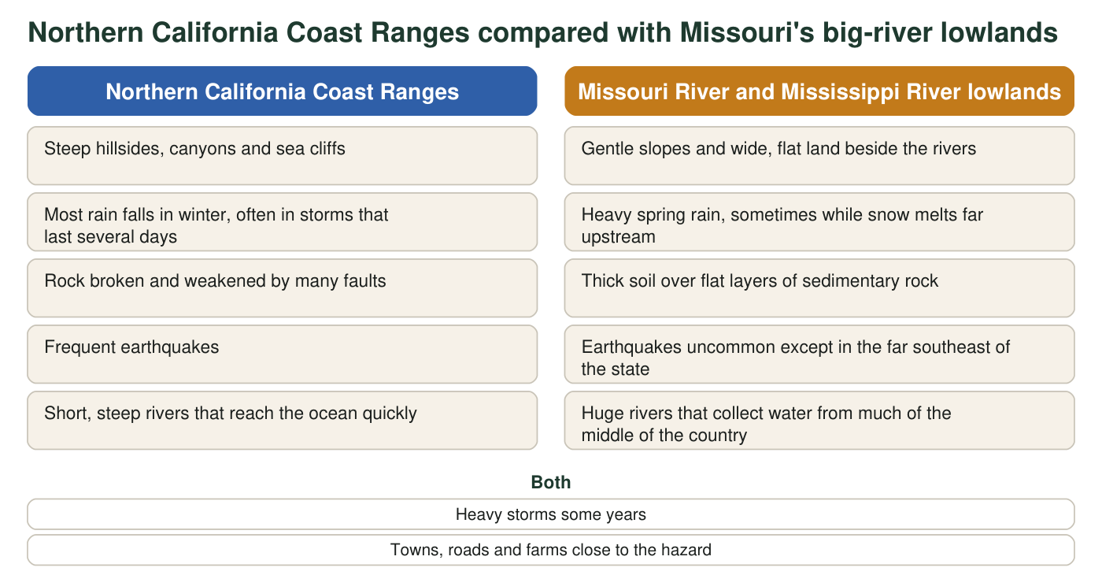
Figure 2. Features of two regions. The lists describe typical conditions, not every place in each region.
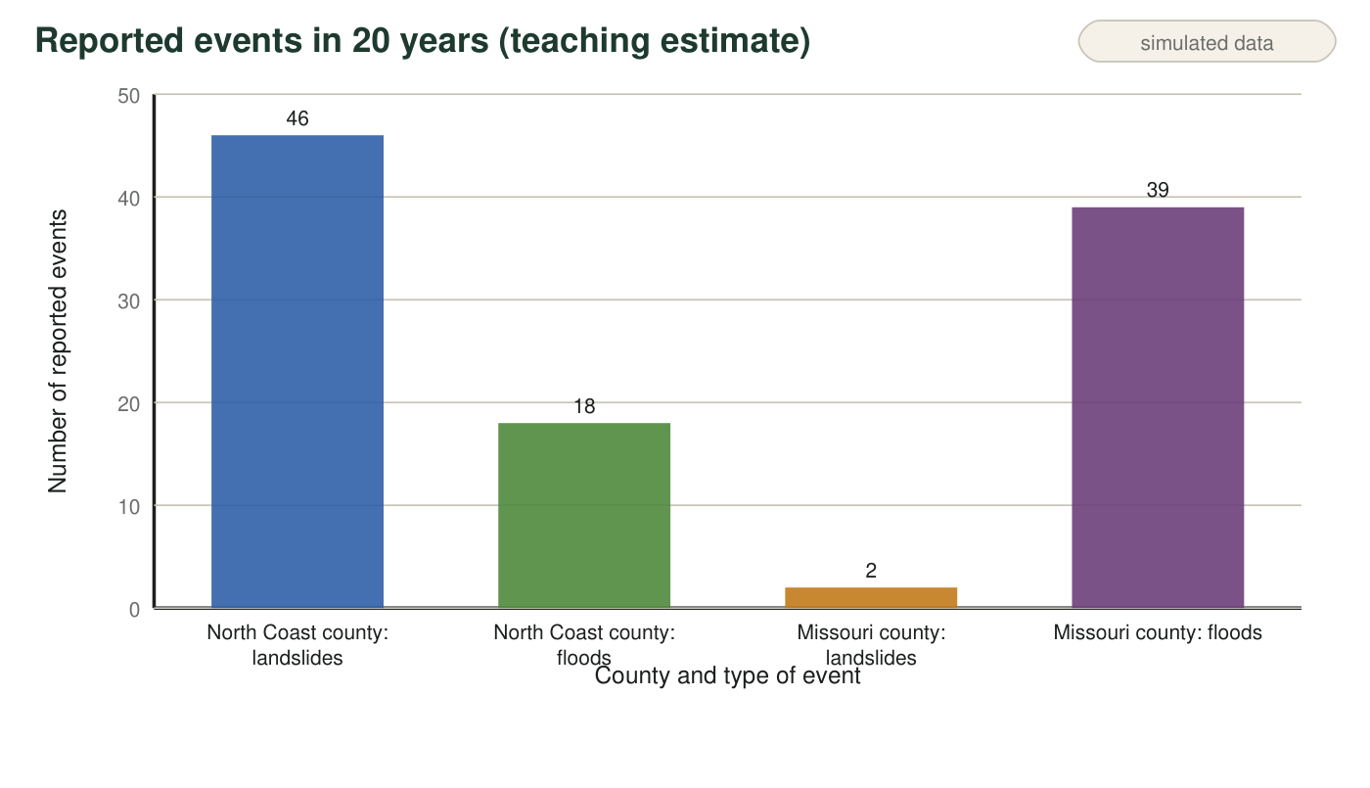
Figure 3. Teaching estimate of reported landslides and floods over 20 years in one Northern California coastal county and one Missouri river county. The numbers are invented to match the real pattern on national hazard maps; they are not an official count.

Part A: Notice and wonder
1. Write three things you notice in Figures 1 to 3. At least one must use a number.
______________________________________________________________________________________
______________________________________________________________________________________
______________________________________________________________________________________
2. Write three questions you wonder about after reading both observations. Start each with why, how or what would happen if.
______________________________________________________________________________________
______________________________________________________________________________________
______________________________________________________________________________________
3. In Figure 3, how many times more landslides did the North Coast county report than the Missouri county? Show the division.
______________________________________________________________________________________
______________________________________________________________________________________
4. Calculate the average speed of each tsunami in Figure 1 in kilometers per hour: the 1964 waves traveled about 2,600 km in about 4 hours, and the 2011 waves about 7,500 km in about 10 hours. Then explain which tsunami gave Crescent City more warning time, and why.
______________________________________________________________________________________
______________________________________________________________________________________
______________________________________________________________________________________
______________________________________________________________________________________

Part B: What you already know
5. From earlier lessons: what force pulls soil, rock and water downhill? And what can happen to the seafloor during a very large earthquake where one tectonic plate sinks beneath another?
______________________________________________________________________________________
______________________________________________________________________________________
______________________________________________________________________________________
______________________________________________________________________________________

Part C: Your first explanations
6. Write your best explanation of why the North Coast county reports many more landslides, while the Missouri county reports many more floods. Use at least two differences from Figure 2 and say how each one makes one hazard more likely.
______________________________________________________________________________________
______________________________________________________________________________________
______________________________________________________________________________________
______________________________________________________________________________________
______________________________________________________________________________________
______________________________________________________________________________________
7. How could an earthquake in Alaska damage Crescent City four hours later, when no one in town felt strong shaking? And why might the fourth surge have been bigger than the first? Write a first explanation.
______________________________________________________________________________________
______________________________________________________________________________________
______________________________________________________________________________________
______________________________________________________________________________________
______________________________________________________________________________________
8. Look at the four events in Figure 1. Which hazards do you think could be forecast hours or days ahead, and which might give almost no notice? Give a reason for each.
______________________________________________________________________________________
______________________________________________________________________________________
______________________________________________________________________________________
______________________________________________________________________________________
9. If you were in charge of keeping Highway 101 open at Last Chance Grade, name two kinds of data you would collect, and say how each would help you forecast trouble.
______________________________________________________________________________________
______________________________________________________________________________________
______________________________________________________________________________________
Keep this page
At the end of the chapter you will reread q6, q7 and q8 and mark what you would keep, change or add. A first explanation that changes is a sign of learning, not a mistake.

Sentence starters for Part C
For q6 try: 'Steep slopes make landslides more likely because ___.' 'Long winter storms soak the ground, which ___.' 'Flat land beside a huge river floods because ___.' For q7 try: 'The earthquake moved the seafloor, which pushed ___. The waves crossed the ocean at about ___ km/h, so they needed ___ hours. A tsunami is not one wave but ___.' For q8 try: 'Storms can be seen coming because ___, but earthquakes ___.'

Find the exception
Floods also happen on the North Coast, and some Missouri river bluffs do slide. Pick one of these exceptions and write a short paragraph explaining what local conditions could make it happen there. Then argue whether a hazard map that shows only one hazard per region would help or mislead a family deciding where to live in Del Norte County.

