Angela's Tools · Chapter 26: Mass Wasting, Tsunamis, and Floods · Worksheet 2 of 10

Trigger, Event or Defense? Sorting the Language of Hazards (Teacher answer key)
Learning target: I can explain how the chapter's hazard terms relate to one another, sort them by the job they do, and apply them to new situations.
Vocabulary in action · about 35 minutes · pairs · Standards: MS-ESS3-2 (supports)

Standards connections
MS-ESS3-2 (supports): Students separate the causes of hazards, the hazard events themselves and the ways people forecast and reduce harm, and they distinguish a forecast from an exact prediction. That language is background the PE's data analysis depends on.

Answers with reasoning
mass wasting: Any downhill movement of soil, rock or other earth material that is driven by gravity, whether it takes years or seconds.
landslide: A general name for a mass of rock, soil or debris that breaks loose and moves down a slope; scientists often use it for every kind of slope movement.
creep: Mass wasting so slow that soil shifts only millimeters to centimeters a year; tilted fence posts and trunks that curve at the base are clues.
debris flow: A fast, water-soaked slurry of mud, sand, boulders and often trees that pours down a channel like wet concrete. A mudflow is a debris flow made mostly of fine particles.
rock fall: Blocks of rock breaking off a cliff or very steep slope and dropping, bouncing or rolling downhill.
saturated: Holding as much water as the spaces between grains can take, so every pore space is full.
tsunami: A series of very long ocean waves set off when a huge volume of water is suddenly pushed up or down, usually by an undersea earthquake.
DART system: NOAA's deep-ocean tsunami stations: a seafloor pressure sensor sends readings by sound to a buoy, which relays them by satellite to warning centers.
runoff: Rain or snowmelt that flows over the ground surface because it cannot soak in fast enough.
storm surge: A rise of the sea above the normal tide, pushed toward shore mainly by a strong storm's winds.
atmospheric river: A long, narrow band of air carrying a huge amount of water vapor; when it reaches mountains it can drop days of heavy rain and snow.
recurrence interval: The average number of years between floods at least as large as a given size, estimated from past records. One divided by it gives the chance of such a flood in any one year.
mitigation: Actions that reduce the harm a hazard can do, such as walls, drains, warning systems, building rules and evacuation plans. It lowers risk but cannot remove it.
forecast: A data-based statement of how likely an event is in a place during a period of time, rather than the exact moment it will happen.

Part A: Put the slope hazards in order
1. For each kind of slope movement, fill in its usual speed (very slow, slow to very fast, very fast), how much water usually matters, and one clue you could see on the land.
Answer: Creep: very slow; water not needed (it happens in wet or dry conditions, though wet ground can speed it up); clues are tilted fences, poles or gravestones and tree trunks curved at the base. Landslide (a slide): slow to very fast; water often matters, because many slides start when the ground is saturated, though shaking or a road cut can also set one off; clues are a crack or curved scar at the top and a bulging, jumbled mass below. Debris flow: very fast; the material is soaked, with so much water it pours like wet concrete; clues are mud and boulders spread across a fan at a canyon mouth and channels scoured to bare rock. Rock fall: very fast; water not needed (it happens wet or dry); clues are piles of broken rock at the foot of a cliff and fresh, pale scars on the cliff face.
Reasoning: The table builds the relationship among the four kinds: speed and the role of water. Creep and rock fall are not tied to rain; debris flows depend on water; slides range widely in speed and are often, but not always, set off by saturation.
Also acceptable: Accept 'fast' for landslide if the student cites a fast example; accept 'freezing and thawing water can loosen rock' as a water role for rock fall.
Full credit must include:
• Creep is slowest and rock fall and debris flow are very fast
• Water is marked as essential for debris flows and often important for slides
• A plausible clue for each kind

Part B: Complete the concept map
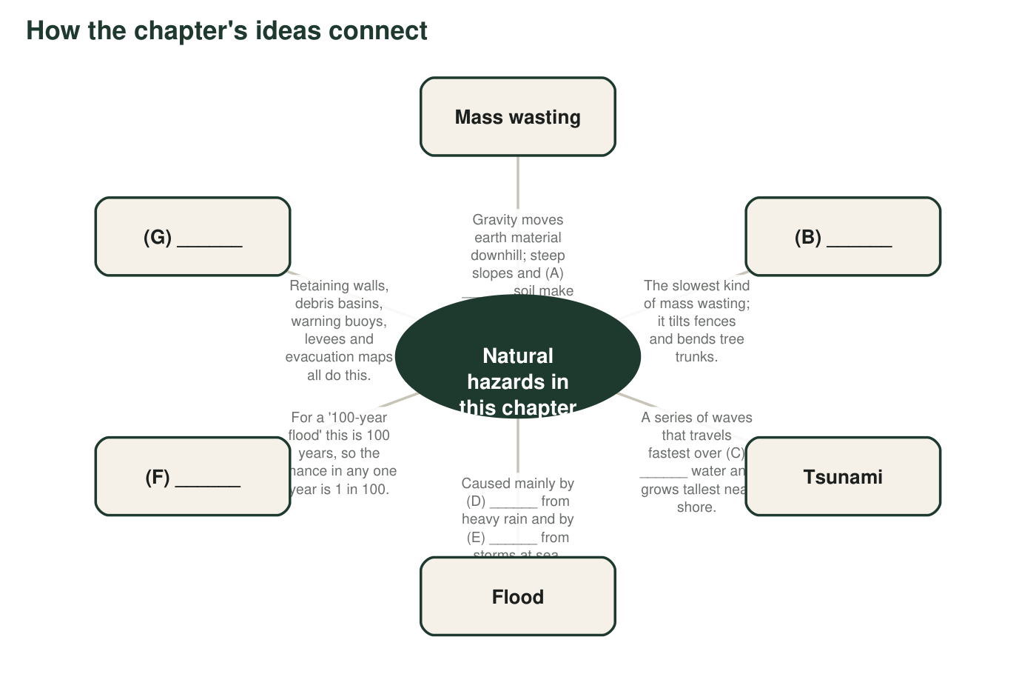
Figure 1. A concept map of the chapter with seven blanks, A to G. Each blank is one term from the term bank, except C, which is one word that describes the ocean.
2. Write the term that belongs in each blank. A: ______ B: ______ C: ______ D: ______ E: ______ F: ______ G: ______
Answer: A: saturated. B: creep. C: deep. D: runoff. E: storm surge. F: recurrence interval. G: mitigation.
Reasoning: Each blank is fixed by its description: soaked soil (saturated), slowest mass wasting (creep), tsunami speed rises with depth (deep), the two flood causes (runoff and storm surge), the 100-year figure (recurrence interval), and actions that reduce harm (mitigation).
Also acceptable: Accept 'soaked' or 'water-filled' for A; accept 'deep ocean' for C.

Part C: Which term fits?
3. For each situation, write the one term from the term bank that fits best and the clue in the situation that told you.
Answer: a. runoff (water flows over pavement that it cannot soak into). b. rock fall (rock breaks off a cliff and drops). c. debris flow (fast slurry of mud, boulders and trees down a canyon). d. storm surge (wind pushes seawater above the normal tide onto the coast). e. DART system (deep-seafloor pressure readings confirm a tsunami). f. creep (slow, year-by-year tilting). g. atmospheric river (a long, narrow band of water vapor). h. mitigation (drains and a wall reduce harm before a slide).
Reasoning: Each scenario contains one decisive clue. In e, 'pressure readings from the deep seafloor' points to the DART system rather than to seismometers, which detect the earthquake itself.
Also acceptable: For e, accept 'tsunami' if the clue explains that the readings detect a tsunami passing. For h, accept 'retaining wall' or 'slope drains' only if the student adds that it is mitigation. For c, accept 'mudflow'.
Full credit must include:
• At least seven of eight terms correct
• Each clue quotes or paraphrases the decisive detail

Part D: Explain the connections (on your own)
4. Explain how being saturated and mass wasting are connected. Use the word gravity in your answer.
Answer: Gravity is always pulling the soil and rock on a slope downhill. When the soil is saturated, every pore space is full of water, which adds weight and pushes the grains apart so friction between them drops. With less friction holding the slope and more weight pulling on it, gravity can win, and the slope moves downhill as mass wasting.
Reasoning: The connection is causal: saturation weakens the slope; gravity does the moving. Water is not acting as a lubricant; it is reducing the grip between grains.
Also acceptable: Accept 'water makes the soil heavy and slippery, so gravity pulls it down' as a basic version.
Full credit must include:
• Gravity is the force that moves the material
• Saturation adds weight or reduces friction or grip between grains
• Links the two: saturation makes it easier for gravity to move the slope
5. A river's '25-year flood' has a recurrence interval of 25 years. What is the chance of a flood at least that big in any one year? Show how you know, and explain why '25 years' does not mean the flood comes every 25 years.
Answer: 1 ÷ 25 = 0.04 = 4 percent each year. The 25 years is an average spacing found from a long record. Floods that size can come two years in a row or not for 50 years, because every year starts with the same 4 percent chance.
Reasoning: The annual chance is the reciprocal of the recurrence interval. Each year's chance does not depend on when the last big flood happened.
Also acceptable: Accept '1 in 25' or 0.04.
Full credit must include:
• Calculates 4 percent (1/25)
• States that the interval is an average
• States that each year has the same chance regardless of the last flood
6. A scientist says, 'The canyons below this burn scar have a high chance of debris flows during the next two rainy seasons.' Is that a forecast or an exact prediction? Explain why she cannot give a date and time.
Answer: It is a forecast. It gives a likelihood for a place and a time window. She cannot give a date because a debris flow needs a burst of intense rain on the burned slopes, and no one can know far in advance exactly when such a storm will arrive or exactly which slope will let go first.
Reasoning: This separates a probability statement over a time window from an exact prediction. Warnings of hours to a day or two become possible only once a storm with intense rain is forecast.
Also acceptable: Accept 'forecast, because it says high chance, not when'.
Full credit must include:
• Identifies a forecast
• Explains that the trigger (intense rain) and exact timing are uncertain
7. People sometimes call a tsunami a 'tidal wave.' Use the definition of tsunami to explain why that name is wrong.
Answer: Tides are the slow daily rise and fall of the sea caused by the pull of the Moon and Sun. A tsunami is a group of waves that forms when a huge volume of water is suddenly pushed up or down, usually by an undersea earthquake. Tides have nothing to do with it, so 'tidal wave' names the wrong cause.
Reasoning: The misconception comes from the way a tsunami can look like a fast-rising tide at the shore.
Also acceptable: Accept 'it is not caused by tides; it is caused by the seafloor moving'.
Full credit must include:
• States that tides come from the Moon and Sun
• States that a tsunami comes from a sudden push on the water, usually an undersea earthquake
8. Which term does not belong with the others: creep, landslide, storm surge, rock fall? Explain what the other three share that it does not.
Answer: Storm surge does not belong. Creep, landslides and rock falls are all kinds of mass wasting: earth material moving downhill because of gravity. Storm surge is seawater pushed onto the coast by storm winds.
Reasoning: The odd-one-out task checks the category (mass wasting) rather than the definitions.
Also acceptable: A student who argues that rock fall is odd because it needs no water should get partial credit only if storm surge is also discussed; the intended category is mass wasting.
Full credit must include:
• Chooses storm surge
• Names mass wasting or gravity moving earth material as the shared feature

Teacher notes
The term bank uses the chapter vocabulary (except scour, which Lab 2 introduces) and adds rock fall, recurrence interval and forecast, which later worksheets use. Debris flow is the term California agencies and the USGS use for post-fire flows; the textbook's mudflow is a debris flow made mostly of fine particles. The textbook also lists earthflows; they are one kind of landslide that ranges from very slow to rapid, so the sorting table folds them into 'landslide.' Concept-map blank C is a word, not a term, and plants the depth-speed link that W4 and W6 develop. Listen for pairs who sort by water alone in Part A; push them to separate speed from the role of water. In Part D, q5 previews the recurrence-interval calculation used in W5, and q4 targets the idea that water 'lubricates' slopes.

