Angela's Tools · Chapter 26: Mass Wasting, Tsunamis, and Floods · Worksheet 2 of 10

Trigger, Event or Defense? Sorting the Language of Hazards
Learning target: I can explain how the chapter's hazard terms relate to one another, sort them by the job they do, and apply them to new situations.
Vocabulary in action · about 35 minutes · pairs · Standards: MS-ESS3-2 (supports)
Name: ____________________________ Date: ____________ Period: ______

Directions
Read the term bank first. You will not match words to definitions; instead you will compare terms, order them, fill a concept map and decide which term fits a new situation. Work with a partner on Parts A to C, talking through every choice, then answer Part D on your own. Every answer needs a reason.
mass wasting: Any downhill movement of soil, rock or other earth material that is driven by gravity, whether it takes years or seconds.
landslide: A general name for a mass of rock, soil or debris that breaks loose and moves down a slope; scientists often use it for every kind of slope movement.
creep: Mass wasting so slow that soil shifts only millimeters to centimeters a year; tilted fence posts and trunks that curve at the base are clues.
debris flow: A fast, water-soaked slurry of mud, sand, boulders and often trees that pours down a channel like wet concrete. A mudflow is a debris flow made mostly of fine particles.
rock fall: Blocks of rock breaking off a cliff or very steep slope and dropping, bouncing or rolling downhill.
saturated: Holding as much water as the spaces between grains can take, so every pore space is full.
tsunami: A series of very long ocean waves set off when a huge volume of water is suddenly pushed up or down, usually by an undersea earthquake.
DART system: NOAA's deep-ocean tsunami stations: a seafloor pressure sensor sends readings by sound to a buoy, which relays them by satellite to warning centers.
runoff: Rain or snowmelt that flows over the ground surface because it cannot soak in fast enough.
storm surge: A rise of the sea above the normal tide, pushed toward shore mainly by a strong storm's winds.
atmospheric river: A long, narrow band of air carrying a huge amount of water vapor; when it reaches mountains it can drop days of heavy rain and snow.
recurrence interval: The average number of years between floods at least as large as a given size, estimated from past records. One divided by it gives the chance of such a flood in any one year.
mitigation: Actions that reduce the harm a hazard can do, such as walls, drains, warning systems, building rules and evacuation plans. It lowers risk but cannot remove it.
forecast: A data-based statement of how likely an event is in a place during a period of time, rather than the exact moment it will happen.

Part A: Put the slope hazards in order
1. For each kind of slope movement, fill in its usual speed (very slow, slow to very fast, very fast), how much water usually matters, and one clue you could see on the land.
Usual speed | How much water matters | A clue you could see
Creep
Landslide (a slide)
Debris flow
Rock fall

Part B: Complete the concept map
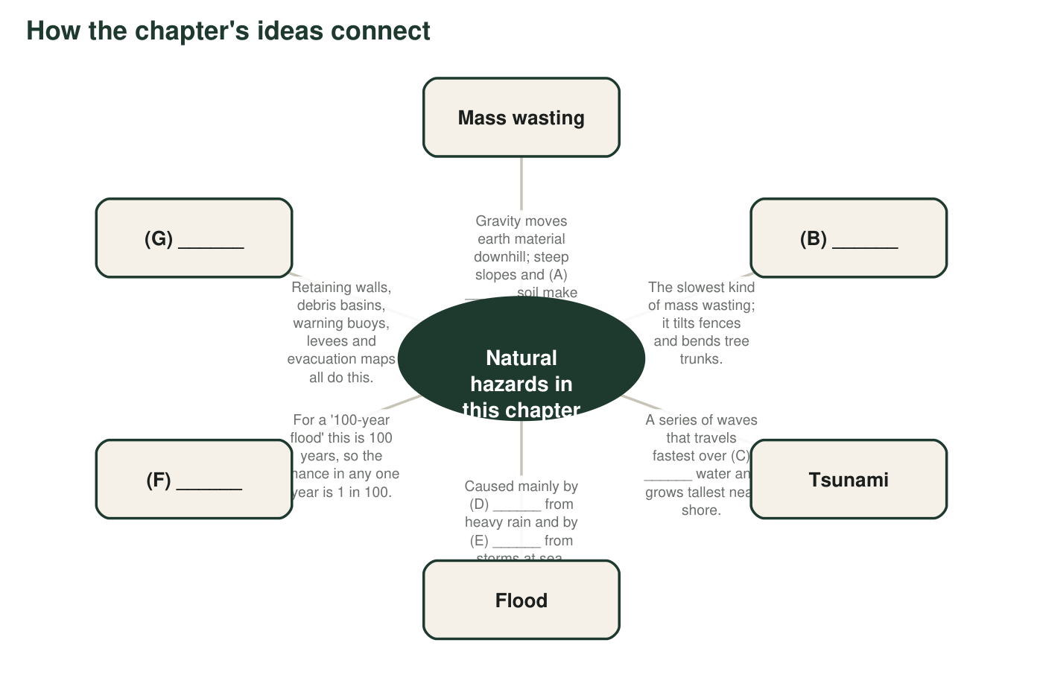
Figure 1. A concept map of the chapter with seven blanks, A to G. Each blank is one term from the term bank, except C, which is one word that describes the ocean.
2. Write the term that belongs in each blank. A: ______ B: ______ C: ______ D: ______ E: ______ F: ______ G: ______
______________________________________________________________________________________
______________________________________________________________________________________
______________________________________________________________________________________

Part C: Which term fits?
3. For each situation, write the one term from the term bank that fits best and the clue in the situation that told you.
Term that fits best | The clue that told you
a. Pavement and roofs cover a new neighborhood, and after a storm the gutters overflow even though the creek is far away.
b. Boulders the size of cars break off a granite cliff in Yosemite Valley and crash onto the pile of rock below.
c. Heavy rain on hills burned by a wildfire sends a fast slurry of mud, boulders and tree trunks down a canyon into a town.
d. Hurricane winds pile the Gulf of Mexico several meters above the normal tide onto a coastal town.
e. After an undersea earthquake, a warning center confirms that waves really formed by checking pressure readings from the deep Pacific seafloor.
f. Fence posts on a grassy hillside lean a little farther downhill every year.
g. Satellites track a long, narrow band of water vapor stretching from near Hawaii to California, three days before heavy rain begins.
h. Engineers drill drain pipes into a hillside above a highway and build a wall at its base.

Part D: Explain the connections (on your own)
4. Explain how being saturated and mass wasting are connected. Use the word gravity in your answer.
______________________________________________________________________________________
______________________________________________________________________________________
______________________________________________________________________________________
5. A river's '25-year flood' has a recurrence interval of 25 years. What is the chance of a flood at least that big in any one year? Show how you know, and explain why '25 years' does not mean the flood comes every 25 years.
______________________________________________________________________________________
______________________________________________________________________________________
______________________________________________________________________________________
6. A scientist says, 'The canyons below this burn scar have a high chance of debris flows during the next two rainy seasons.' Is that a forecast or an exact prediction? Explain why she cannot give a date and time.
______________________________________________________________________________________
______________________________________________________________________________________
______________________________________________________________________________________
7. People sometimes call a tsunami a 'tidal wave.' Use the definition of tsunami to explain why that name is wrong.
______________________________________________________________________________________
______________________________________________________________________________________
______________________________________________________________________________________
8. Which term does not belong with the others: creep, landslide, storm surge, rock fall? Explain what the other three share that it does not.
______________________________________________________________________________________
______________________________________________________________________________________
______________________________________________________________________________________

Three sorting questions
When a term confuses you, ask three questions about it. What moves (soil and rock, river water, seawater or air full of water vapor)? What makes it move (gravity on a slope, rain that cannot soak in, storm winds, or a sudden push on the seafloor)? Is it a hazard, a condition that makes a hazard more likely, or something people do about a hazard? Write the three answers in the margin next to the term before you use it.

Hazard or risk?
Scientists separate a hazard (the natural event, like a debris flow) from risk (the chance that the event harms people or property). Write a short paragraph explaining how two towns could face the same debris-flow hazard but very different risk. Use at least three terms from the term bank, and describe one mitigation that lowers risk without changing the hazard at all.

