Angela's Tools · Chapter 26: Mass Wasting, Tsunamis, and Floods · Worksheet 4 of 10

From Trench to Beach: Modeling a Tsunami and the Sensor That Catches It (Teacher answer key)
Learning target: I can interpret a diagram of a tsunami's trip from its source to the shore, build a cross-section model showing how its speed, height and crest spacing change with depth, and trace how a deep-ocean sensor's data reach a warning center.
Diagrams and models · about 45 minutes · individual · Standards: MS-ESS3-2 (practice)

Standards connections
MS-ESS3-2 (practice): Students model why a tsunami is low and fast in deep water but slow and tall near shore, and how the DART system turns a deep-ocean pressure change into a warning. That model explains why tsunami arrival can be forecast once the triggering earthquake has happened and why the sensors sit where they do, which prepares students for the PE's data analysis in W6.

Answers with reasoning

Figure 1: One tsunami, five places
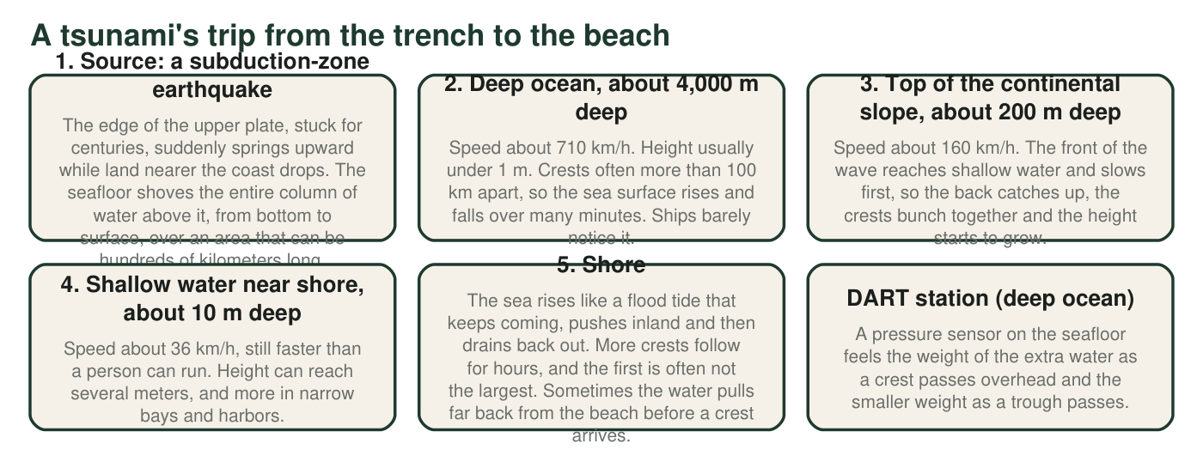
Figure 1. Stages of one tsunami from source to shore. Speeds are calculated from ocean depth for long waves like tsunamis and rounded; heights and spacing are typical values, and real events vary.
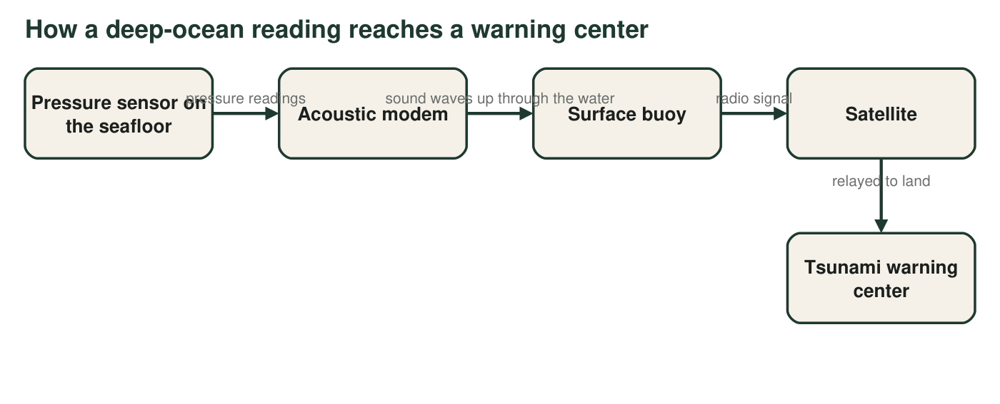
Figure 2. The path of a DART reading. Radio waves do not travel far through seawater, but sound does.

Part A: Read the figures
1. Using stage 1, explain what sets a tsunami in motion. How is that different from the way wind makes ordinary waves, which disturb only water near the surface?
Answer: A sudden movement of the seafloor during a subduction-zone earthquake lifts (or drops) the whole column of water above it, from the seafloor to the surface. Wind only pushes on the surface, so wind waves move water near the top; a tsunami moves the entire depth of the ocean, which is why it carries so much water and energy.
Reasoning: The contrast between whole-column motion and surface-only motion explains why tsunamis are so different from wind waves.
Also acceptable: Accept 'the earthquake pushes the bottom of the ocean, which pushes all the water above it'.
Full credit must include:
• Names the sudden seafloor movement from the earthquake
• States that the whole water column moves
• Contrasts with wind affecting only the surface
2. Using stages 2 and 4, how many times faster does the tsunami travel in the deep ocean than in shallow water near shore? Show the division and round to the nearest whole number.
Answer: 710 km/h ÷ 36 km/h ≈ 19.7, about 20 times faster in the deep ocean.
Reasoning: The ratio of the two given speeds. Both come from the long-wave speed relationship, in which speed depends only on depth.
Also acceptable: Accept 19 or 20 with the division shown.
3. Describe how the height of the wave and the distance between crests change from stage 2 to stage 4. Use stage 3 to explain why slowing down makes the wave taller.
Answer: The height grows from under 1 m in the deep ocean to several meters near shore, and the crests get much closer together. Stage 3 explains it: the front of the wave reaches shallow water first and slows down while the back is still moving fast, so the back catches up. The same water is squeezed into a shorter distance and shallower depth, so it piles up higher.
Reasoning: Shoaling: slowing compresses the wave horizontally, and the energy that was spread through a deep column is concentrated in shallow water, raising the height.
Also acceptable: Accept 'the wave runs into the shallow bottom and has nowhere to go but up' if the slowing is also mentioned.
Full credit must include:
• Height increases
• Crest spacing decreases
• Explains that the front slows first and the back catches up, piling water higher
4. A sailor 150 km offshore, over water 4,000 m deep, says nothing unusual happened while the tsunami passed under her boat. Use Figure 1 to explain why she could be right.
Answer: In 4,000 m of water the tsunami is usually less than 1 m tall and its crests are often more than 100 km apart, so the sea surface rises less than a meter slowly over many minutes. That gentle rise is hidden among ordinary wind waves, so she would not notice it.
Reasoning: Low height and very long wavelength make deep-water tsunamis nearly impossible to feel on a ship.
Also acceptable: Accept 'it is too low and too long to feel' with a reference to stage 2.
Full credit must include:
• Uses the small height in deep water
• Uses the long distance between crests or slow rise over minutes
5. Give two reasons the DART pressure sensor is placed on the deep seafloor instead of floating at the surface or sitting in shallow water near the coast.
Answer: First, the surface is always moving with wind waves, so a floating sensor would record constant motion that hides the small tsunami signal, while the deep seafloor is still and the sensor can measure tiny pressure changes. Second, a station far out in deep water detects the tsunami long before it reaches the coast, which gives more warning time, and it measures the wave before shallow water changes it.
Reasoning: One reason is about clean measurement; the other is about early detection and lead time.
Also acceptable: Accept 'the buoy would bob up and down with every wave' as the first reason.
Full credit must include:
• A still seafloor avoids the noise of surface waves
• Deep, far-out placement detects the wave earlier, giving more warning
6. Use Figure 2 to explain why the data travel by sound from the sensor to the buoy but by radio from the buoy to the satellite.
Answer: Radio waves do not travel far through seawater, so the sensor 4,000 m down cannot radio the surface; sound travels long distances through water, so an acoustic modem sends the data up as sound. In air, radio works well, so the buoy uses radio to reach the satellite.
Reasoning: Each link uses the kind of wave that travels well through its medium.
Also acceptable: None.
Full credit must include:
• Radio does not travel well through water
• Sound travels well through water
• Radio works through air to the satellite

Part B: Build your own model
Draw a side view (cross-section) of the ocean from the earthquake source on the left to the beach on the right. Draw the seafloor dropping into a trench, then running across a deep ocean floor, then rising up a continental slope to a shallow shelf and the beach. Draw an arrow showing the seafloor moving at the source. Draw the same tsunami crest at three places: the deep ocean, the top of the continental slope where it meets the shelf, and the shallow shelf near the beach. Make the crest taller and the crests closer together as the water gets shallower, and label each place with its depth and approximate speed. Add a DART sensor on the deep seafloor and a buoy above it, and draw arrows showing the data path to a warning center on land.
Expected drawing: A cross-section with a trench on the left, a long deep ocean floor labeled about 4,000 m, a continental slope rising to about 200 m at the shelf edge, a shallow shelf labeled about 10 m and a beach. An arrow at the source shows the seafloor moving up (or up on one side and down on the other). Three crests: a long, low one over deep water labeled about 710 km/h; a shorter, taller one at the shelf edge labeled about 160 km/h; a short, tall one on the shelf labeled about 36 km/h, with crests drawn closer together toward shore. A sensor on the deep seafloor, a buoy directly above it, and arrows from sensor to buoy (sound), buoy to satellite and satellite to a warning center on land.
Reasoning: The drawing must show the model's key relationship: shallower water means slower, taller and more closely spaced crests, plus the data path that makes forecasting possible.
7. On your drawing, circle the place where the tsunami is most dangerous to people. Explain your choice using both height and speed.
Answer: Near or at the shore (the shallow shelf and beach). There the wave is tallest, several meters or more, and although it has slowed to about 36 km/h, that is still faster than a person can run, and the water keeps pushing inland as a flood for many minutes.
Reasoning: Danger depends on height and on where people are; the deep-ocean wave is fast but low and far from people.
Also acceptable: Accept the inside of a harbor or bay if the student explains that height increases there.
Full credit must include:
• Chooses the shallow shelf or shore
• Uses height
• Uses speed (still faster than people can run)
8. Where did you put the DART station: close to the earthquake source or close to the beach? Explain how that placement affects the warning time for the town on your beach.
Answer: A station placed near the source detects the tsunami minutes after it forms, while the wave still has a long way to travel, so the warning center can confirm the tsunami and warn the town with more time to spare. A station near the beach would detect the wave only shortly before it arrives, leaving almost no warning time.
Reasoning: Warning time is the travel time from the detector to the town minus the time needed to process and send the warning.
Also acceptable: If a student placed it near the beach, award credit for correctly explaining that this gives less warning and proposing to move it.
Full credit must include:
• States where the station was placed
• Explains that closer to the source means earlier detection and more warning time
9. Every model leaves things out. Name two things about a real tsunami that your drawing cannot show, and explain why each one matters for keeping people safe.
Answer: Examples: Real crests are often more than 100 km apart, so a to-scale drawing is impossible, and the long spacing is why the water keeps rising for many minutes. A tsunami spreads in all directions, not along one line, so many coasts can be hit. There is a series of crests over hours, and the first is often not the largest, so people must stay away until officials say it is safe. Harbors and bays can make it taller. The wave also bends around islands and seafloor ridges.
Reasoning: Naming model limits and linking each to safety shows understanding of what the cross-section simplifies.
Also acceptable: Accept 'it is not to scale' only if the student explains what the real scale means for the wave's behavior.
Full credit must include:
• Two real features the drawing cannot show
• Each linked to why it matters for safety or warnings

Teacher notes
The speeds in Figure 1 come from the long-wave (shallow-water) relationship, speed = square root of (gravity × depth): about 198 m/s (713 km/h) at 4,000 m, 44 m/s (159 km/h) at 200 m and 9.9 m/s (36 km/h) at 10 m. Students do not need the formula; W6 has them discover the depth pattern from data. Stage 1 describes the upper plate springing up, which is the accurate picture for great subduction earthquakes; the textbook describes the sinking plate dragging water down. Either way the key is a sudden up-or-down shift of the seafloor. The extension's claim about Crescent City is accurate: studies link its offshore seafloor shape and the way its harbor resonates to the focusing of tsunami energy, and its harbor was damaged by tsunamis in 1964 (Alaska), 2006 (Kuril Islands) and 2011 (Japan). Common drawing errors are making the deep-ocean wave tall (the 'giant wave crossing the ocean' image) and drawing the DART buoy in shallow water.

