Angela's Tools · Chapter 26: Mass Wasting, Tsunamis, and Floods · Worksheet 4 of 10

From Trench to Beach: Modeling a Tsunami and the Sensor That Catches It
Learning target: I can interpret a diagram of a tsunami's trip from its source to the shore, build a cross-section model showing how its speed, height and crest spacing change with depth, and trace how a deep-ocean sensor's data reach a warning center.
Diagrams and models · about 45 minutes · individual · Standards: MS-ESS3-2 (practice)
Name: ____________________________ Date: ____________ Period: ______

Directions
Study Figure 1 from left to right: it follows one tsunami from the earthquake that starts it to the beach. Figure 2 follows the data from a deep-ocean sensor to the people who issue warnings. Answer Part A using the figures. Then draw your own cross-section model in the box and use it to answer Part B. Work in pencil so you can revise.

Figure 1: One tsunami, five places
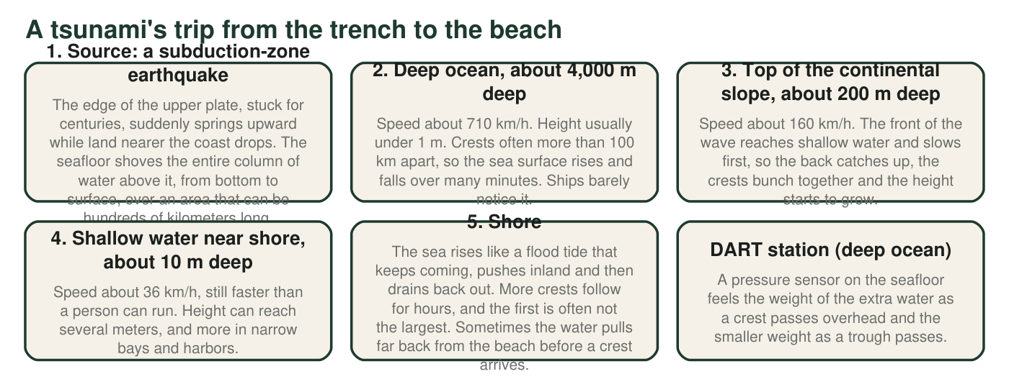
Figure 1. Stages of one tsunami from source to shore. Speeds are calculated from ocean depth for long waves like tsunamis and rounded; heights and spacing are typical values, and real events vary.
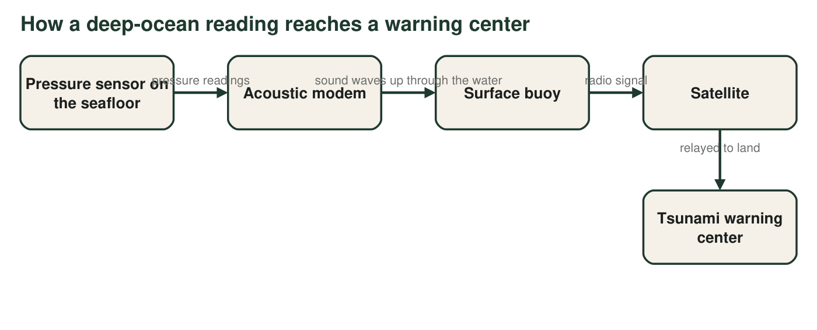
Figure 2. The path of a DART reading. Radio waves do not travel far through seawater, but sound does.

Part A: Read the figures
1. Using stage 1, explain what sets a tsunami in motion. How is that different from the way wind makes ordinary waves, which disturb only water near the surface?
______________________________________________________________________________________
______________________________________________________________________________________
______________________________________________________________________________________
2. Using stages 2 and 4, how many times faster does the tsunami travel in the deep ocean than in shallow water near shore? Show the division and round to the nearest whole number.
______________________________________________________________________________________
______________________________________________________________________________________
3. Describe how the height of the wave and the distance between crests change from stage 2 to stage 4. Use stage 3 to explain why slowing down makes the wave taller.
______________________________________________________________________________________
______________________________________________________________________________________
______________________________________________________________________________________
4. A sailor 150 km offshore, over water 4,000 m deep, says nothing unusual happened while the tsunami passed under her boat. Use Figure 1 to explain why she could be right.
______________________________________________________________________________________
______________________________________________________________________________________
______________________________________________________________________________________
5. Give two reasons the DART pressure sensor is placed on the deep seafloor instead of floating at the surface or sitting in shallow water near the coast.
______________________________________________________________________________________
______________________________________________________________________________________
______________________________________________________________________________________
6. Use Figure 2 to explain why the data travel by sound from the sensor to the buoy but by radio from the buoy to the satellite.
______________________________________________________________________________________
______________________________________________________________________________________

Part B: Build your own model
Draw a side view (cross-section) of the ocean from the earthquake source on the left to the beach on the right. Draw the seafloor dropping into a trench, then running across a deep ocean floor, then rising up a continental slope to a shallow shelf and the beach. Draw an arrow showing the seafloor moving at the source. Draw the same tsunami crest at three places: the deep ocean, the top of the continental slope where it meets the shelf, and the shallow shelf near the beach. Make the crest taller and the crests closer together as the water gets shallower, and label each place with its depth and approximate speed. Add a DART sensor on the deep seafloor and a buoy above it, and draw arrows showing the data path to a warning center on land.

7. On your drawing, circle the place where the tsunami is most dangerous to people. Explain your choice using both height and speed.
______________________________________________________________________________________
______________________________________________________________________________________
______________________________________________________________________________________
8. Where did you put the DART station: close to the earthquake source or close to the beach? Explain how that placement affects the warning time for the town on your beach.
______________________________________________________________________________________
______________________________________________________________________________________
______________________________________________________________________________________
9. Every model leaves things out. Name two things about a real tsunami that your drawing cannot show, and explain why each one matters for keeping people safe.
______________________________________________________________________________________
______________________________________________________________________________________
______________________________________________________________________________________

Draw the seafloor first
Start your drawing with the seafloor line only: a deep notch on the left for the trench, a long flat deep floor, a ramp up (the continental slope), then a short flat shelf and the beach. Write the depths under each part: about 4,000 m on the deep floor, about 200 m where the ramp meets the shelf, and about 10 m on the shelf near the beach. Then copy the three speeds from Figure 1 onto the matching parts. Only after that, draw the waves: a long, low bump over deep water, a shorter, taller bump at the shelf edge, and a short, tall bump on the shelf near the beach.

Why bays make it worse
Crescent City is known as one of the most tsunami-prone harbors on the U.S. West Coast, damaged in 1964, 2006 and 2011. Research how the shape of the seafloor offshore and the shape of a harbor can focus tsunami energy. Then add a narrow bay to your drawing (as a top view in the margin) and explain, using the idea of water being squeezed into a smaller space, why the same tsunami could be taller inside the bay than on a straight beach nearby.

