Angela's Tools · Chapter 27: Biodiversity · Worksheet 1 of 10

From 51 Birds to 325: The Parrot That Almost Vanished
Learning target: I can describe what happened to the kākāpō, record what I notice and wonder, and write a first explanation of why a species nearly disappeared and why a growing population can still be at risk.
Phenomenon exploration · about 35 minutes · individual · Standards: MS-LS2-4 (practice), MS-LS2-5 (supports)
Name: ____________________________ Date: ____________ Period: ______

Directions
Read about the kākāpō (say KAH-kah-poh), then study the timeline and the population table. The counts in the table are real numbers reported by New Zealand's Department of Conservation. Write what you notice before you write what you wonder. Your explanations in Part C are first drafts: it is fine to be unsure, but give a reason for every idea. Keep this page, because you will come back to it at the end of the chapter.

Meet the kākāpō
The kākāpō is a large, moss-green parrot that lives only in New Zealand. It cannot fly, it is active at night, it eats only plants, and it can live for many decades. For millions of years New Zealand had no land mammals except bats, so the kākāpō's natural enemies were large birds of prey, such as Haast's eagle, which went extinct centuries ago. When a kākāpō is disturbed, it freezes and stays perfectly still. Its mottled green feathers then blend into the forest, which made it very hard to spot for a predator searching from the air.
Then people arrived. Polynesian settlers reached New Zealand about 700 years ago. They hunted kākāpō for food and feathers, and the dogs and rats they brought also ate the birds and their eggs. Later, European settlers cleared large areas of forest and brought cats, stoats and two more kinds of rats. These mammals can track prey by smell, and kākāpō have a strong, musty scent. A bird that freezes in place is easy prey for a hunter that follows its nose.
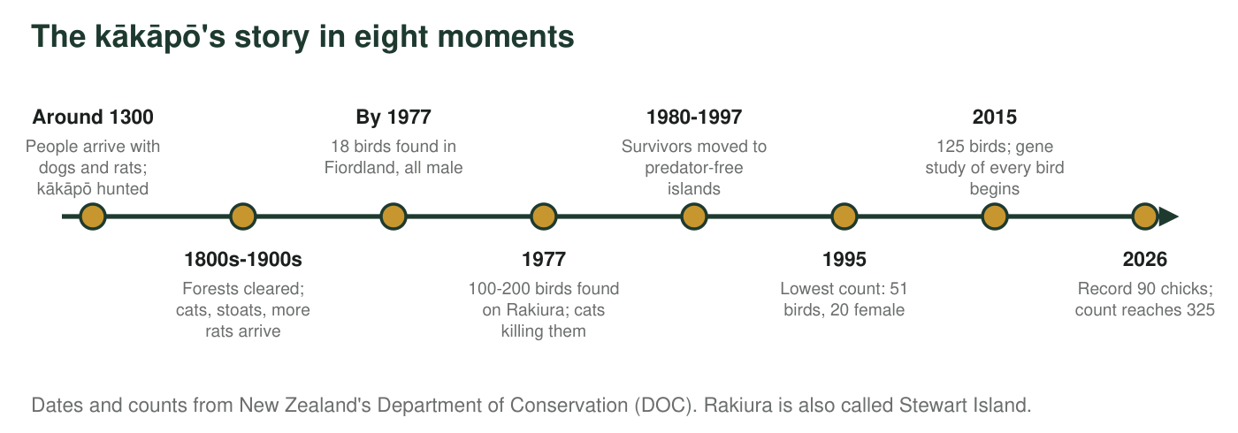
Known kākāpō alive (real counts reported by DOC)
Date of count | Known kākāpō alive
1995 | 51
2015 | 125
30 June 2025 | 242
1 September 2026 | 325

Every kākāpō is named and tracked, so these are counts of individual birds, not estimates. The September 2026 count includes the 90 chicks from the 2026 breeding season, which DOC added once the youngest surviving chick was 150 days old.
Two more clues
Clue 1: Kākāpō breed only in years when rimu trees produce a huge crop of fruit, which happens about once every two to four years. There was no breeding at all in 2025. Clue 2: Every kākāpō alive today descends from a small group of survivors, so many of the birds are closely related. Many kākāpō eggs never hatch because they are infertile, a problem scientists link to low genetic diversity (little variety in the genes the birds carry).

Part A: Notice and wonder
1. Write three things you notice in the timeline, the table or the clues. At least one must use a number.
______________________________________________________________________________________
______________________________________________________________________________________
______________________________________________________________________________________
2. Write three questions you wonder about. Start each with why, how or what would happen if.
______________________________________________________________________________________
______________________________________________________________________________________
______________________________________________________________________________________
3. How many times larger was the September 2026 population than the 1995 population? Show the division and round to one decimal place.
______________________________________________________________________________________
______________________________________________________________________________________
4. Between 30 June 2025 and 1 September 2026 the count went from 242 to 325. Find the increase. The 2026 season added 90 chicks. What does the difference between your answer and 90 tell you about the birds that were already alive?
______________________________________________________________________________________
______________________________________________________________________________________
______________________________________________________________________________________

Part B: What you already know
5. In earlier lessons you studied how organisms interact. Name the kind of interaction between a stoat and a kākāpō. Then explain why a predator brought in from another land can be far more dangerous to a species than a predator it has lived alongside for thousands of years.
______________________________________________________________________________________
______________________________________________________________________________________
______________________________________________________________________________________
______________________________________________________________________________________

Part C: Your first explanation
6. Why did the kākāpō come so close to disappearing? Write your best explanation using at least two pieces of evidence from the description, the timeline or the clues. Include at least one cause that came from people.
______________________________________________________________________________________
______________________________________________________________________________________
______________________________________________________________________________________
______________________________________________________________________________________
______________________________________________________________________________________
______________________________________________________________________________________
7. There are now 325 kākāpō, more than six times as many as in 1995, yet scientists still call the species critically endangered. Using the clues and the timeline, explain two reasons why 325 birds may still not be safe.
______________________________________________________________________________________
______________________________________________________________________________________
______________________________________________________________________________________
______________________________________________________________________________________
______________________________________________________________________________________
______________________________________________________________________________________
8. Scientists describe biodiversity at three levels: the variety of genes within one species, the variety of species in a place, and the variety of ecosystems in a region. Which level or levels does the kākāpō story involve? Give one piece of evidence for each level you choose.
______________________________________________________________________________________
______________________________________________________________________________________
______________________________________________________________________________________
9. Name one measurement or observation scientists could make to test one idea in your explanation. Say what result would support your idea.
______________________________________________________________________________________
______________________________________________________________________________________
______________________________________________________________________________________
Keep this page
At the end of the chapter you will reread your answers to q6 and q7 and mark what you would keep, change or add. An explanation that changes is a sign of learning, not a mistake.

Sentence starters for Part C
Use these starters if they help. 'One cause was ___, and the evidence is ___.' 'Before people arrived, freezing protected kākāpō because ___. After cats and stoats arrived, freezing failed because ___.' 'A population can grow and still be at risk because ___.' Look back at the timeline: anything that happened just before the numbers fell is a possible cause.

Two rescues side by side
In 1982 only 22 California condors were left in the world, and by 1987 every remaining wild condor had been captured for a breeding program. Birds raised in that program have been released since 1992, and by the end of 2025 the U.S. Fish and Wildlife Service counted 607 condors, 392 of them flying free. Lead poisoning, mostly from eating carcasses that contain fragments of lead bullets, was the leading known cause of death in the wild. Make a two-column timeline that compares the condor and the kākāpō. Then write a paragraph: how were the threats and the rescues alike and different, and why is neither species considered safe yet?

