Angela's Tools · Chapter 27: Biodiversity · Worksheet 2 of 10

Variety and Loss: Sorting and Using the Language of Biodiversity (Teacher answer key)
Learning target: I can tell apart the three levels of biodiversity, choose the term that fits a real situation, and explain how pairs of biodiversity terms are related.
Vocabulary in action · about 35 minutes · individual · Standards: MS-LS2-5 (supports), MS-LS2-4 (supports)

Standards connections
MS-LS2-5 (supports): Students need precise words for what a conservation design is trying to protect (genetic, species and ecosystem diversity, ecosystem services) and what it is fighting (habitat loss, fragmentation, invasive species) before they can evaluate competing designs.
MS-LS2-4 (supports): Terms such as extirpation, habitat fragmentation and invasive species name the changes to ecosystem components that later arguments in the chapter connect to population changes.

Answers with reasoning
biodiversity: The variety of life in a place, described at three levels: the genes within species, the species, and the ecosystems.
genetic diversity: The variety of inherited instructions (genes) among individuals of one species. It is why members of the same species differ in traits such as size or disease resistance.
species diversity: The variety of species in a place. It depends on how many species there are and on how evenly the individuals are spread among them.
ecosystem diversity: The variety of different ecosystems in a region, such as kelp forests, salt marshes, oak woodlands and deserts.
species richness: The number of different species found in a place or a sample. It counts kinds, not individuals.
biodiversity index: A single number that combines species richness with evenness (how equally individuals are shared among the species). Simpson's index of diversity runs from 0, when every individual belongs to one species, toward 1, when many species are evenly mixed.
niche: The role a species plays in its ecosystem: what it eats, where and when it is active, and how it affects other species.
keystone species: A species whose effect on its ecosystem is much larger than its numbers suggest, so removing it changes many other populations.
native species: A species that lives in a place naturally, without people having brought it there.
endemic species: A native species found in only one region of the world and nowhere else.
invasive species: A species that people carried outside its natural range and that spreads and causes harm to native species, ecosystems, the economy or human health.
habitat loss: The destruction or change of the places where organisms live, for example when a marsh is filled in or a forest is cleared.
habitat fragmentation: Breaking a large habitat into smaller, separated patches, for example with roads or housing, so organisms cannot move freely between them.
extirpation: The loss of every member of a species from one place while the species still survives somewhere else.
extinction: The loss of every member of a species everywhere. An extinct species cannot come back.
ecosystem services: The benefits people get from ecosystems, such as clean water, pollination of crops, fertile soil, flood control and food.
biomimicry: Solving a design problem by copying a structure or process that evolved in a living thing.

Part A: Which level of biodiversity?
1. For each example, write genetic, species or ecosystem diversity, and name the clue that told you.
Answer: 1. Genetic: seedlings of one species differ in drought survival. 2. Species: 14 kinds in one place. 3. Ecosystem: several kinds of ecosystems in one county. 4. Genetic: close relatives within one species. 5. Species: number of bird species in two places. 6. Ecosystem: a stream, a meadow and chaparral are different ecosystems. 7. Genetic: variety of genes within one species' populations. 8. Species: same number of species but very uneven numbers, which lowers species diversity.
Reasoning: The clue is whether the variety is among individuals of one species (genetic), among species in one place (species) or among ecosystems in a region (ecosystem). Example 8 shows that species diversity includes evenness, not only the count.
Also acceptable: For example 6, accept 'ecosystem' only. For example 8, a student who writes 'species (evenness)' is reasoning well.
Full credit must include:
• All eight levels correct
• Each clue names one species, many species or many ecosystems

Part B: Which term fits?
Write the one term from the word bank that best fits each situation. Each term is used no more than once in Part B.
2. Fur hunters killed the last sea otters on the coast of Washington State around 1910, but otters survived in Alaska and California.
Answer: extirpation
Reasoning: Otters were lost from Washington but survived elsewhere, so the loss was local, not global.
Also acceptable: None.
3. The southern gastric-brooding frog of Queensland, Australia, raised its young in its stomach. It has not been seen anywhere on Earth since the early 1980s.
Answer: extinction
Reasoning: The frog is gone everywhere, not just from one place. It is now classified as extinct.
Also acceptable: None.
4. Highway iceplant from South Africa was planted to hold soil in place, then spread across California's coastal dunes and crowded out the native wildflowers.
Answer: invasive species
Reasoning: People carried iceplant outside its native range, and it spread and harmed native plants.
Also acceptable: Accept 'habitat loss' only with an explanation that the dunes changed; the best fit is invasive species.
5. Freeways surround the Santa Monica Mountains, so the mountain lions there live in an area they can rarely leave.
Answer: habitat fragmentation
Reasoning: The freeways break the lions' habitat into a separated patch that animals rarely leave.
Also acceptable: Accept 'habitat loss' for partial credit; the situation describes separation, which is fragmentation.
6. Marsh plants and soil microbes remove nitrogen from farm runoff before it reaches the bay, which saves a city money on water treatment.
Answer: ecosystem services
Reasoning: Cleaning water is a benefit that people get from an ecosystem.
Also acceptable: None.
7. The island fox lives on six of California's Channel Islands and nowhere else in the world.
Answer: endemic species
Reasoning: The island fox is native and found nowhere else on Earth.
Also acceptable: Accept 'endemic'. 'Native species' is true but less precise; give partial credit.
8. A lesser anteater climbs trees and tears open ant and termite nests with its claws, then laps up the insects with a long, sticky tongue.
Answer: niche
Reasoning: The sentence describes what the anteater eats and how it gets its food, which is its role in the ecosystem.
Also acceptable: None.
9. A student sorts the beetles from a trap and finds 9 different kinds. She records 9, no matter how many beetles of each kind there are.
Answer: species richness
Reasoning: Richness counts kinds and ignores how many individuals of each kind there are.
Also acceptable: None.
10. When scientists removed one kind of sea star from a rocky shore, mussels took over the rocks and many other species disappeared from that shore.
Answer: keystone species
Reasoning: Removing one predator changed many other populations, an effect much larger than its numbers suggest. This describes a classic experiment on the Washington coast.
Also acceptable: None.
11. Engineers built a bandage pad covered in tiny pillars like those on gecko toes, then coated it with a sticky material like the glue mussels use to hold onto wet rocks.
Answer: biomimicry
Reasoning: Copying the structure of gecko toe pads and the chemistry of mussel glue is borrowing designs that evolved in living things. The real adhesive was a lab prototype tested in wet and dry conditions.
Also acceptable: None.

Part C: Complete the concept map
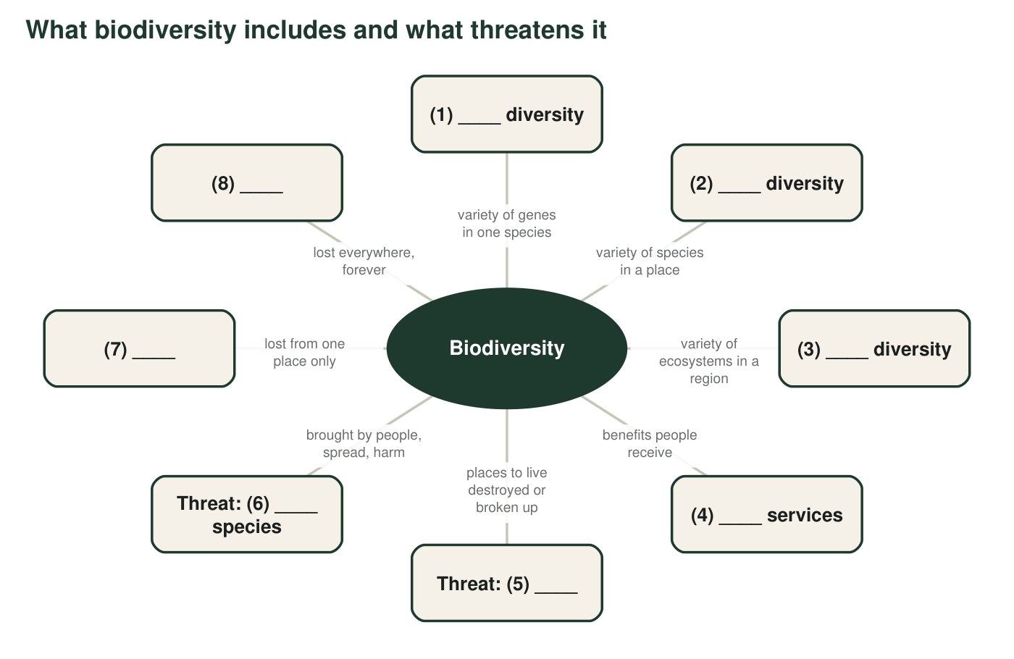
12. Write the missing word for each numbered blank in the concept map.
Answer: (1) genetic; (2) species; (3) ecosystem; (4) ecosystem; (5) habitat loss (or habitat fragmentation); (6) invasive; (7) extirpation; (8) extinction.
Reasoning: The map connects the three levels, the benefits to people, the two threats the chapter models, and the two scales of loss.
Also acceptable: Accept 'habitat fragmentation' or 'habitat loss' for (5).

Part D: How the terms are related
13. Every endemic species is a native species, but not every native species is endemic. Explain why, using the island fox and the mountain lion, which lives naturally from Canada to South America.
Answer: Endemic means native and found in only one region. The island fox is native to the Channel Islands and lives nowhere else, so it is both native and endemic. The mountain lion is native to California, but it also lives naturally across much of North and South America, so it is native to California but not endemic to it.
Reasoning: Endemic is a narrower category inside native.
Also acceptable: Accept a correct diagram of one circle inside another with the two animals placed correctly.
Full credit must include:
• States that endemic means native to only one region
• Uses the island fox as endemic
• Uses the mountain lion as native but not endemic
14. Explain how species richness and a biodiversity index are different. Use example 8 from Part A to show why two places with the same richness can have different index values.
Answer: Species richness is just the number of species. A biodiversity index also includes evenness, how equally the individuals are shared among the species. The two meadows in example 8 have the same richness (5), but the meadow where almost every plant is one grass has a much lower index (closer to 0), because if you pick two plants at random they will nearly always be the same grass.
Reasoning: This prepares students for Simpson's index on Worksheet 5 and Lab 1, which combines richness and evenness.
Also acceptable: Accept 'one meadow is dominated by one species' as a description of unevenness.
Full credit must include:
• Defines richness as a count of species
• Says the index also includes evenness
• Uses example 8 to show the same richness with different index values
15. Is every species that is not native to California an invasive species? Use the definitions to explain, and give an example of a non-native species that is not invasive.
Answer: No. A non-native species is only invasive if it spreads and causes harm. Many non-native species, such as tomatoes, oranges or most garden flowers, grow where people plant them and do not spread into wild places or harm native species, so they are non-native but not invasive.
Reasoning: The definition of invasive includes spread and harm; being non-native is necessary but not enough.
Also acceptable: Accept any common crop or garden plant that does not spread on its own.
Full credit must include:
• Answers no
• States that invasive requires spreading and harm
• Gives a valid non-native, non-invasive example
16. A species can be extirpated from many places and still not be extinct. Explain why this matters for bringing a species back to a place, using the sea otters in q2.
Answer: Because an extirpated species still lives somewhere else, there are living individuals that can return or be moved to the empty place. Sea otters were gone from Washington but survived in Alaska, so in 1969 and 1970 people moved otters from Alaska to the Washington coast and a population grew again. An extinct species has no survivors anywhere, so it cannot be brought back this way.
Reasoning: This contrasts the reversibility of extirpation with the permanence of extinction.
Also acceptable: Full credit without the 1969-1970 detail if the reasoning is correct.
Full credit must include:
• Explains that extirpated species survive elsewhere
• Connects survivors to the possibility of return
• Contrasts with extinction
17. Write a short paragraph (4 to 6 sentences) about a California salt marsh where a road is planned and a non-native grass is spreading. Use at least six terms from the word bank correctly, and underline each one.
Answer: Example: The salt marsh has high species diversity because many birds, crabs and plants share it, and it is part of the ecosystem diversity of the coast. The marsh provides ecosystem services such as filtering water and absorbing storm surges. A new road would cause habitat loss and habitat fragmentation, cutting the marsh into pieces that small animals cannot cross. A non-native grass that spreads and crowds out native marsh plants is an invasive species. If the last marsh birds of one kind disappeared from this marsh but lived elsewhere, that would be extirpation, not extinction.
Reasoning: The paragraph should use terms in correct relationships, not just list them.
Also acceptable: Any accurate paragraph with six correctly used terms earns full credit.
Full credit must include:
• At least six word-bank terms
• Each term used with its correct meaning
• Terms connected in a sensible description of the marsh, the road and the grass

Teacher notes
The textbook defines biodiversity mainly as the variety of species; this sheet teaches the three levels used by scientists and by the Convention on Biological Diversity (within species, between species and of ecosystems). The keystone definition stresses an effect out of proportion to the species' numbers, which the textbook's wording leaves out. Real examples were checked: Washington's last recorded sea otter was killed around 1910 and otters from Amchitka Island, Alaska, were moved to the Washington coast in 1969 and 1970 (NOAA Olympic Coast National Marine Sanctuary); the southern gastric-brooding frog was described in 1973 and has not been seen in the wild since about 1981; the island fox lives on six of the eight Channel Islands, each with its own subspecies; highway iceplant (Carpobrotus edulis) is rated a high-impact invasive plant by the California Invasive Plant Council; the q10 situation is Robert Paine's sea star removal experiment on the Washington coast. In Part A, item 7 is genetic diversity because it compares gene variety within one species; some students will say 'ecosystem' because freeways are mentioned, which is a good discussion point about fragmentation causing genetic loss. Seventeen terms is a lot; for students who need more support, assign Part A, any five Part B items, Part C and q15.

