Angela's Tools · Chapter 27: Biodiversity · Worksheet 2 of 10

Variety and Loss: Sorting and Using the Language of Biodiversity
Learning target: I can tell apart the three levels of biodiversity, choose the term that fits a real situation, and explain how pairs of biodiversity terms are related.
Vocabulary in action · about 35 minutes · individual · Standards: MS-LS2-5 (supports), MS-LS2-4 (supports)
Name: ____________________________ Date: ____________ Period: ______

Directions
Read the word bank first; every definition is written in plain language. Then work through Parts A to D in order. Part A asks which level of biodiversity an example describes. Part B gives you real situations and asks which single term fits best. Part C has you complete a concept map. Part D asks you to explain how terms are related and to use them in your own writing. You may look back at the word bank at any time.
biodiversity: The variety of life in a place, described at three levels: the genes within species, the species, and the ecosystems.
genetic diversity: The variety of inherited instructions (genes) among individuals of one species. It is why members of the same species differ in traits such as size or disease resistance.
species diversity: The variety of species in a place. It depends on how many species there are and on how evenly the individuals are spread among them.
ecosystem diversity: The variety of different ecosystems in a region, such as kelp forests, salt marshes, oak woodlands and deserts.
species richness: The number of different species found in a place or a sample. It counts kinds, not individuals.
biodiversity index: A single number that combines species richness with evenness (how equally individuals are shared among the species). Simpson's index of diversity runs from 0, when every individual belongs to one species, toward 1, when many species are evenly mixed.
niche: The role a species plays in its ecosystem: what it eats, where and when it is active, and how it affects other species.
keystone species: A species whose effect on its ecosystem is much larger than its numbers suggest, so removing it changes many other populations.
native species: A species that lives in a place naturally, without people having brought it there.
endemic species: A native species found in only one region of the world and nowhere else.
invasive species: A species that people carried outside its natural range and that spreads and causes harm to native species, ecosystems, the economy or human health.
habitat loss: The destruction or change of the places where organisms live, for example when a marsh is filled in or a forest is cleared.
habitat fragmentation: Breaking a large habitat into smaller, separated patches, for example with roads or housing, so organisms cannot move freely between them.
extirpation: The loss of every member of a species from one place while the species still survives somewhere else.
extinction: The loss of every member of a species everywhere. An extinct species cannot come back.
ecosystem services: The benefits people get from ecosystems, such as clean water, pollination of crops, fertile soil, flood control and food.
biomimicry: Solving a design problem by copying a structure or process that evolved in a living thing.

Part A: Which level of biodiversity?
1. For each example, write genetic, species or ecosystem diversity, and name the clue that told you.
Level of biodiversity | Clue that told you
1. Some valley oak seedlings in one grove survive a drought better than others.
2. A tide pool holds 14 different kinds of animals and seaweeds.
3. One California county has beaches, salt marsh, oak woodland and pine forest.
4. Every kākāpō alive today descends from a small group of survivors, so many are closely related.
5. A bird survey counts 6 species on a school lawn and 23 in a nearby marsh.
6. A watershed contains a stream, a wet meadow and dry chaparral slopes.
7. Mountain lions hemmed in by freeways in the Santa Monica Mountains carry less variety in their genes than mountain lions in larger, connected wild areas.
8. Two meadows each have 5 plant species, but in one of them almost every plant is the same grass.

Part B: Which term fits?
Write the one term from the word bank that best fits each situation. Each term is used no more than once in Part B.
2. Fur hunters killed the last sea otters on the coast of Washington State around 1910, but otters survived in Alaska and California.
______________________________________________________________________________________
______________________________________________________________________________________
______________________________________________________________________________________
3. The southern gastric-brooding frog of Queensland, Australia, raised its young in its stomach. It has not been seen anywhere on Earth since the early 1980s.
______________________________________________________________________________________
______________________________________________________________________________________
______________________________________________________________________________________
4. Highway iceplant from South Africa was planted to hold soil in place, then spread across California's coastal dunes and crowded out the native wildflowers.
______________________________________________________________________________________
______________________________________________________________________________________
______________________________________________________________________________________
5. Freeways surround the Santa Monica Mountains, so the mountain lions there live in an area they can rarely leave.
______________________________________________________________________________________
______________________________________________________________________________________
______________________________________________________________________________________
6. Marsh plants and soil microbes remove nitrogen from farm runoff before it reaches the bay, which saves a city money on water treatment.
______________________________________________________________________________________
______________________________________________________________________________________
______________________________________________________________________________________
7. The island fox lives on six of California's Channel Islands and nowhere else in the world.
______________________________________________________________________________________
______________________________________________________________________________________
______________________________________________________________________________________
8. A lesser anteater climbs trees and tears open ant and termite nests with its claws, then laps up the insects with a long, sticky tongue.
______________________________________________________________________________________
______________________________________________________________________________________
______________________________________________________________________________________
9. A student sorts the beetles from a trap and finds 9 different kinds. She records 9, no matter how many beetles of each kind there are.
______________________________________________________________________________________
______________________________________________________________________________________
______________________________________________________________________________________
10. When scientists removed one kind of sea star from a rocky shore, mussels took over the rocks and many other species disappeared from that shore.
______________________________________________________________________________________
______________________________________________________________________________________
______________________________________________________________________________________
11. Engineers built a bandage pad covered in tiny pillars like those on gecko toes, then coated it with a sticky material like the glue mussels use to hold onto wet rocks.
______________________________________________________________________________________
______________________________________________________________________________________
______________________________________________________________________________________

Part C: Complete the concept map
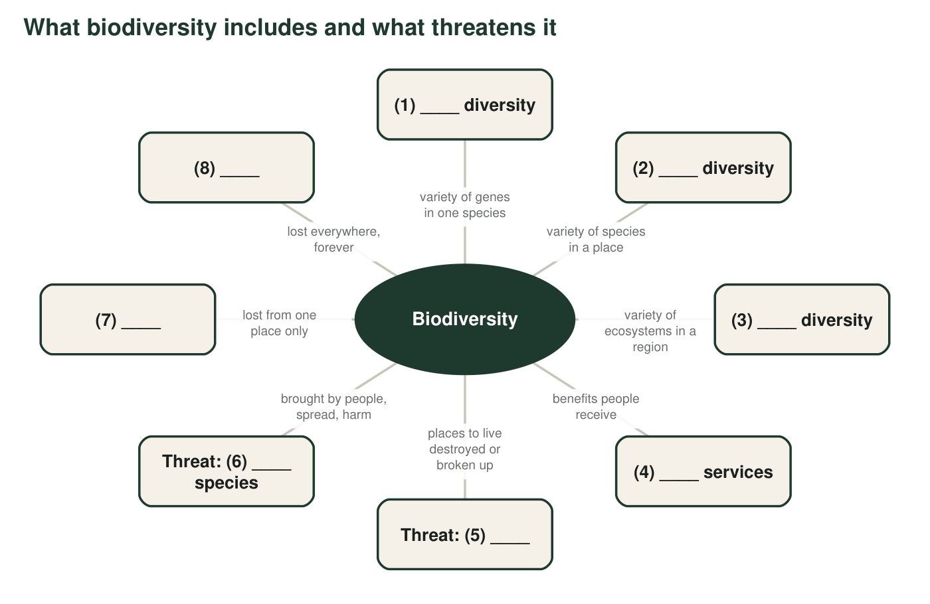
12. Write the missing word for each numbered blank in the concept map.
Missing word
(1)
(2)
(3)
(4)
(5)
(6)
(7)
(8)

Part D: How the terms are related
13. Every endemic species is a native species, but not every native species is endemic. Explain why, using the island fox and the mountain lion, which lives naturally from Canada to South America.
______________________________________________________________________________________
______________________________________________________________________________________
______________________________________________________________________________________
14. Explain how species richness and a biodiversity index are different. Use example 8 from Part A to show why two places with the same richness can have different index values.
______________________________________________________________________________________
______________________________________________________________________________________
______________________________________________________________________________________
15. Is every species that is not native to California an invasive species? Use the definitions to explain, and give an example of a non-native species that is not invasive.
______________________________________________________________________________________
______________________________________________________________________________________
______________________________________________________________________________________
16. A species can be extirpated from many places and still not be extinct. Explain why this matters for bringing a species back to a place, using the sea otters in q2.
______________________________________________________________________________________
______________________________________________________________________________________
______________________________________________________________________________________
17. Write a short paragraph (4 to 6 sentences) about a California salt marsh where a road is planned and a non-native grass is spreading. Use at least six terms from the word bank correctly, and underline each one.
______________________________________________________________________________________
______________________________________________________________________________________
______________________________________________________________________________________
______________________________________________________________________________________
______________________________________________________________________________________
______________________________________________________________________________________

Three questions that sort most examples
Ask: Is the example about differences among individuals of one species? Then it is genetic diversity. Is it about how many kinds of organisms live in one place? Then it is species diversity (or species richness if it only counts kinds). Is it about how many kinds of places a region has? Then it is ecosystem diversity. For extirpation and extinction, ask: does the species still live anywhere on Earth?

Is a lawn an ecosystem?
Your school lawn probably has thousands of grass plants, but how much biodiversity does it have at each of the three levels? Write a short argument that rates the lawn high, medium or low at the genetic, species and ecosystem levels, with a reason for each. Then propose one change to part of the schoolyard that would raise its biodiversity at two levels, and name one ecosystem service the change could provide.

