Angela's Tools · Chapter 27: Biodiversity · Worksheet 4 of 10

Patches and Passages: Modeling Habitat Loss and Fragmentation (Teacher answer key)
Learning target: I can use a grid model of a landscape to tell habitat loss apart from habitat fragmentation, predict which species can survive, and design a wildlife crossing that reconnects habitat.
Diagrams and models · about 45 minutes · individual · Standards: MS-LS2-4 (practice), MS-LS2-5 (practice)

Standards connections
MS-LS2-4 (practice): Students use a model to predict how a physical change to an ecosystem (houses, farms and a freeway replacing habitat) changes which populations can persist, and they separate two causes, habitat loss and fragmentation, with evidence from the model.
MS-LS2-5 (practice): Students design one solution, a wildlife crossing, and test it against each species' needs in the model, practicing the evaluation of design solutions for maintaining biodiversity.

Answers with reasoning

The model
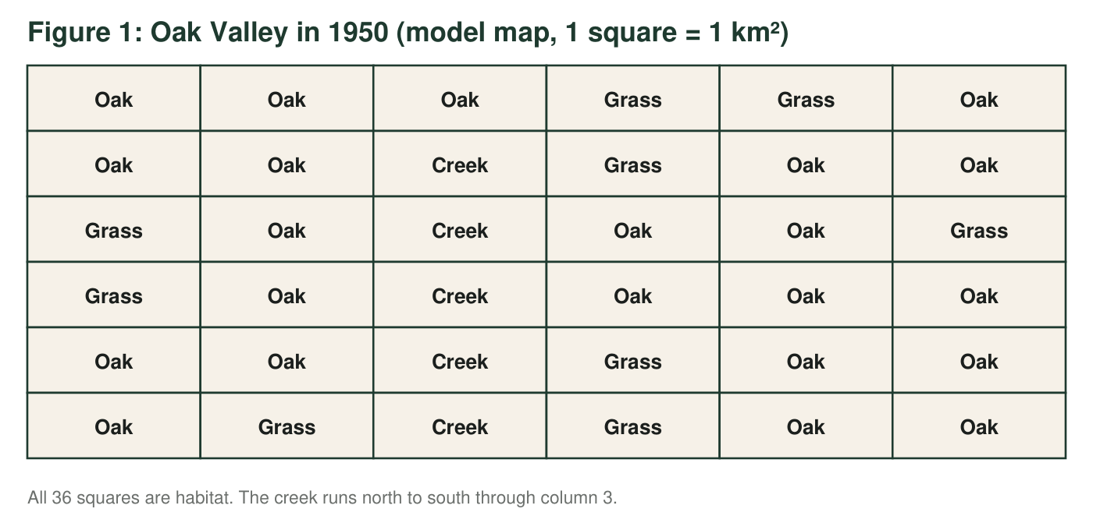
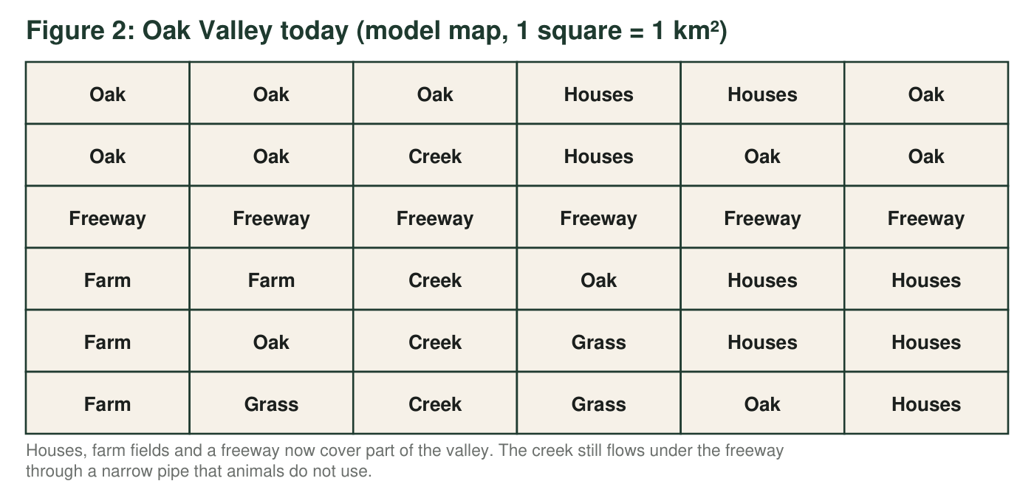
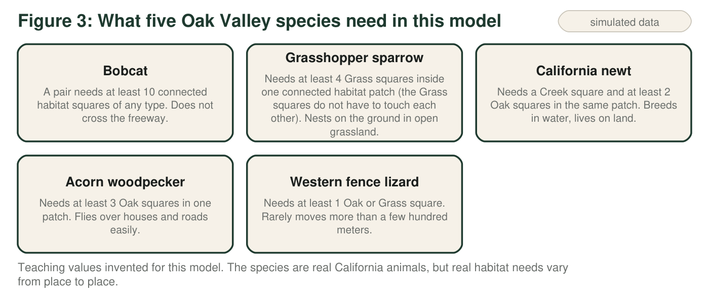
The real version
Freeways surround the Santa Monica Mountains near Los Angeles. Biologists who track mountain lions there found that very few lions cross U.S. Highway 101, and the population has very low genetic diversity. Earlier research found that the same freeway also limited the movement of genes in bobcats and coyotes. A wildlife bridge over Highway 101 at Liberty Canyon in Agoura Hills, planted with native plants, is scheduled to open in late 2026 to connect the mountains with wild land to the north.

Part A: Read the maps
1. Count the habitat squares in Figure 1 and in Figure 2. What percent of Oak Valley's habitat has been lost? Show the calculation.
Answer: 1950: 36 habitat squares. Today: 4 + 5 + 0 + 2 + 3 + 4 = 18 habitat squares (row by row). Lost: 36 − 18 = 18 squares. Percent lost: 18 ÷ 36 × 100 = 50 percent.
Reasoning: Every square is habitat in Figure 1. In Figure 2, rows 1 to 6 hold 4, 5, 0, 2, 3 and 4 Oak, Grass or Creek squares.
Also acceptable: Accept 'half' with the counts shown.
2. How many separate habitat patches does Figure 2 have? Give the size of each patch in km² and describe where each one is (for example, 'northwest corner').
Answer: Three patches. Northwest: 6 km² (row 1, columns 1-3 and row 2, columns 1-3, including the creek square). Northeast: 3 km² (row 1, column 6 and row 2, columns 5-6). South: 9 km² (the creek in rows 4-6 with the Oak, Grass squares beside it: row 4 columns 3-4, row 5 columns 2-4, row 6 columns 2-5). 6 + 3 + 9 = 18.
Reasoning: The freeway separates north from south, and the houses in column 4 separate the northwest from the northeast. Corner contact does not count.
Also acceptable: Accept any clear description of the three locations.
Full credit must include:
• Three patches
• Sizes 6, 3 and 9
• Locations described correctly
3. Use Figure 3 to decide whether each species can live in Oak Valley in 1950 and today. For 'today', name the patch or patches where it can live, or write 'none'.
Answer: Bobcat: 1950 yes; today none (largest patch is 9, below 10). Grasshopper sparrow: 1950 yes (9 Grass squares in one patch); today none (the most Grass in one patch is 3, in the south). California newt: 1950 yes; today northwest (1 Creek, 5 Oak) and south (3 Creek, 3 Oak), not northeast (no creek). Acorn woodpecker: 1950 yes; today northwest (5 Oak), northeast (3 Oak) and south (3 Oak). Western fence lizard: 1950 yes; today all three patches.
Reasoning: Each decision comes from comparing a patch's squares with the need in Figure 3.
Also acceptable: None.
Full credit must include:
• Bobcat and sparrow: none today
• Newt: northwest and south only
• Woodpecker and lizard: all three patches
• All 1950 answers yes
4. Oak Valley still has 18 habitat squares today, and a bobcat pair needs only 10. Explain why bobcats cannot live there anyway. Is their problem caused mainly by habitat loss or by habitat fragmentation? Use numbers from the map.
Answer: A bobcat pair needs 10 connected squares, but the largest patch is only 9 km², and bobcats do not cross the freeway, so the 18 squares cannot be used together. The main problem is fragmentation: there is enough habitat in total (18 is more than 10), but it is broken into patches of 6, 3 and 9.
Reasoning: This is the central distinction of the sheet: total area versus connected area.
Also acceptable: Accept 'both, but fragmentation decides it' with the numbers.
Full credit must include:
• States that no single patch reaches 10
• Uses 18 total versus 9 largest
• Identifies fragmentation as the main cause
5. Is the grasshopper sparrow's problem caused mainly by habitat loss or by fragmentation? Count the Grass squares in 1950 and today to support your answer.
Answer: Mainly habitat loss. In 1950 there were 9 Grass squares in one connected patch; today only 3 Grass squares remain, all in the south patch, and the northern patches have none. Houses, farms and the freeway replaced most of the grassland, so even joining all the patches would leave the sparrow only 3 Grass squares in one patch. Grassland would have to be restored.
Reasoning: Unlike the bobcat, the sparrow's habitat type is mostly gone, not just separated.
Also acceptable: None.
Full credit must include:
• Identifies habitat loss
• Uses 9 versus 3 Grass squares
• Notes that reconnecting alone would not reach 4
6. The fence lizard can still live in every patch. Explain why biologists might still worry about the lizards in the small northeast patch over many generations, even though none are dying from a lack of habitat today.
Answer: The northeast patch is small and cut off by houses and the freeway, and fence lizards rarely move far, so lizards there can only mate with each other. Over many generations they will become more closely related and the patch's genetic diversity will fall, which can lead to inbreeding problems. A small population can also be wiped out by one event, such as a fire, with no lizards able to move back in.
Reasoning: Isolation reduces gene flow; small isolated populations lose genetic variety and cannot be rescued by newcomers.
Also acceptable: Full credit for either the genetic or the disaster argument if clearly explained; both is excellent.
Full credit must include:
• Notes the patch is small and isolated
• Explains loss of genetic diversity or inbreeding over generations
• Or explains that no new lizards can arrive after a disaster

Part B: Build your model
Draw today's map as a 6-by-6 grid (you may abbreviate: O = Oak, G = Grass, C = Creek, H = Houses, F = Farm, W = Freeway). Add ONE wildlife crossing, a bridge over the freeway or a large tunnel under it, in the square where it helps the most. A crossing is not habitat: it only joins the habitat on its two sides. Shade every square that is now part of one connected patch with the crossing, draw arrows to show where animals can move, label the crossing, and write the size of every patch. Then circle any Farm squares the town could restore to grassland, and label them 'restore'.
Expected drawing: The 6-by-6 grid matches Figure 2. The crossing is at row 3, column 3, where the creek meets the freeway. Shaded as one patch: the six northwest squares and the nine south squares (15 squares, not counting the crossing), with arrows through the crossing. The northeast patch (3) is labeled separately. Restore: the four Farm squares (row 4 columns 1-2, row 5 column 1, row 6 column 1) are circled; they touch the south patch.
Reasoning: Only the column 3 crossing has habitat on both sides (Creek at row 2 and row 4); every other row-3 square has Houses or Farm on at least one side.

Part C: Test your design
7. Where did you put your crossing (row and column)? What is the size of the largest connected patch after you add it? Does it meet the bobcat's need? Show how you added the patch sizes.
Answer: Row 3, column 3. Largest connected patch: 6 (northwest) + 9 (south) = 15 km², not counting the crossing. Yes: 15 is at least 10, so a bobcat pair could live there.
Reasoning: The crossing joins the two patches on its sides; the crossing square is not habitat in this model.
Also acceptable: Accept 16 if the student counted the crossing square and says so; the rule in the drawing prompt says not to count it.
8. Which species gain from your crossing, and which do not? For any species the crossing does not help, explain why, and say whether restoring the Farm squares you circled would help it. Give the new number of Grass squares in that patch.
Answer: Bobcats gain (15 connected squares). California newts gain because the northwest and south newt populations are joined into one. Fence lizards in the northwest and south can now mix. Acorn woodpeckers gain little because they already fly between patches. The grasshopper sparrow does not gain: the joined patch still has only 3 Grass squares (all in the south), because the northwest patch has none. Restoring the four circled Farm squares to grassland would give the south patch 3 + 4 = 7 Grass squares, which meets the sparrow's need of 4.
Reasoning: A crossing solves fragmentation, not habitat loss; restoration addresses the lost grassland.
Also acceptable: Accept '4 + 3 = 7' in either order.
Full credit must include:
• Bobcat and newt named as gaining
• Sparrow named as not gaining with the reason
• Restoration adds 4 Grass squares, giving 7
9. Explain why only one square in row 3 makes a useful crossing in this model. What does that tell real engineers about choosing where to build a wildlife bridge?
Answer: A crossing helps only where there is habitat on both sides. In row 3, only column 3 has habitat above (Creek, row 2) and below (Creek, row 4); every other square has Houses or Farm on one side, so a bridge there would lead animals into houses or fields. Real engineers must build crossings where protected wild land meets the road on both sides and where animals already try to travel, such as along a creek or canyon.
Reasoning: Placement depends on what lies on each side, not only on the road.
Also acceptable: Accept 'where animals already travel' as an additional point.
Full credit must include:
• Explains habitat must be on both sides
• Identifies column 3 as the only such square
• Draws a lesson for real crossing placement
10. Name two ways the real Santa Monica Mountains differ from this grid model, and explain how each difference could change the model's predictions.
Answer: Any two, with an effect: real animals sometimes cross freeways and are killed, so the model overstates isolation but understates deaths; real habitat is not made of equal squares, and quality varies (water, food, shelter), so patches of the same size can support different numbers; edges near houses bring noise, lights, pets and poisons that make habitat near the edge worse than the middle; real mountain lions need far more space than one valley (hundreds of km²); populations change over many years, so a patch that works now may lose its genetic diversity later.
Reasoning: Every model simplifies; students should name a difference and say how it would shift the prediction.
Also acceptable: Accept fire, drought or the time it takes plants on a new bridge to grow as valid differences.
Full credit must include:
• Two distinct differences
• Each linked to a change in the model's prediction

Teacher notes
The maps and species needs are a teaching model; the species are real California animals (bobcat, grasshopper sparrow, California newt, acorn woodpecker, western fence lizard), but their needs in Figure 3 are invented round numbers. Patch sizes and crossing results were checked with a short script: today's patches are 6, 3 and 9 squares; a crossing at row 3, column 3 joins the northwest and south patches into 15 squares; no other row-3 square joins two patches. Restoring the four Farm squares and adding the crossing gives one 19-square patch with 7 Grass squares. The real-world callout is accurate as of October 2026: National Park Service researchers report very low genetic diversity and signs of inbreeding (such as kinked tails) in Santa Monica Mountains mountain lions; Riley and colleagues (2006) showed that U.S. 101 is a barrier to gene flow for bobcats and coyotes; the Wallis Annenberg Wildlife Crossing at Liberty Canyon was scheduled to open on 2 December 2026, so after that date check whether it has opened and update the callout. The sparrow rule counts Grass squares anywhere in one habitat patch; in 1950 the 9 Grass squares are scattered but all lie in the single 36-square patch. Common errors: counting corner-touching squares as connected (which would merge patches incorrectly), and counting the crossing square as habitat.

