Angela's Tools · Chapter 27: Biodiversity · Worksheet 4 of 10

Patches and Passages: Modeling Habitat Loss and Fragmentation
Learning target: I can use a grid model of a landscape to tell habitat loss apart from habitat fragmentation, predict which species can survive, and design a wildlife crossing that reconnects habitat.
Diagrams and models · about 45 minutes · individual · Standards: MS-LS2-4 (practice), MS-LS2-5 (practice)
Name: ____________________________ Date: ____________ Period: ______

Directions
Figures 1 and 2 are a model of Oak Valley, an invented valley in California. Each square stands for 1 square kilometer. Rows are numbered 1 to 6 from the top and columns 1 to 6 from the left. Oak, Grass and Creek squares are habitat; Houses, Farm and Freeway squares are not. Squares that touch along an edge are connected; squares that touch only at a corner are not. Figure 3 gives each species' needs in this model. Answer Part A by reading the maps, then build your own model in the drawing box, then answer Part C.

The model
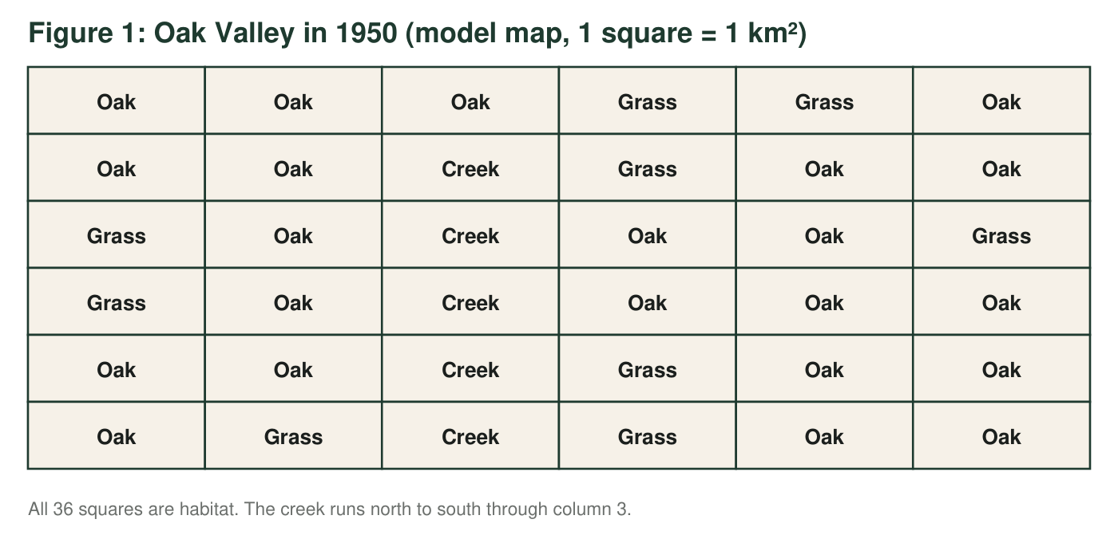
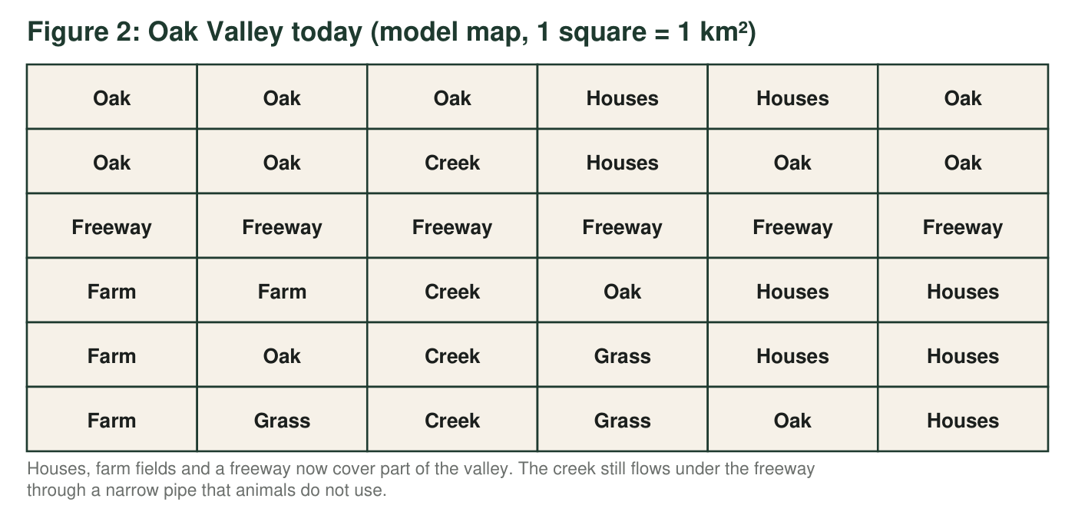
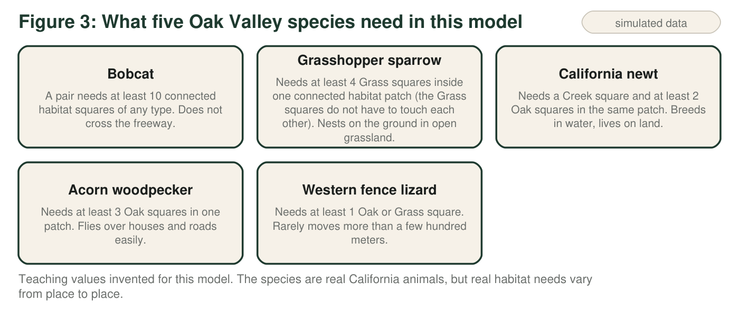
The real version
Freeways surround the Santa Monica Mountains near Los Angeles. Biologists who track mountain lions there found that very few lions cross U.S. Highway 101, and the population has very low genetic diversity. Earlier research found that the same freeway also limited the movement of genes in bobcats and coyotes. A wildlife bridge over Highway 101 at Liberty Canyon in Agoura Hills, planted with native plants, is scheduled to open in late 2026 to connect the mountains with wild land to the north.

Part A: Read the maps
1. Count the habitat squares in Figure 1 and in Figure 2. What percent of Oak Valley's habitat has been lost? Show the calculation.
______________________________________________________________________________________
______________________________________________________________________________________
______________________________________________________________________________________
2. How many separate habitat patches does Figure 2 have? Give the size of each patch in km² and describe where each one is (for example, 'northwest corner').
______________________________________________________________________________________
______________________________________________________________________________________
______________________________________________________________________________________
3. Use Figure 3 to decide whether each species can live in Oak Valley in 1950 and today. For 'today', name the patch or patches where it can live, or write 'none'.
1950: can it live here? (yes/no) | Today: which patch or patches?
Bobcat
Grasshopper sparrow
California newt
Acorn woodpecker
Western fence lizard

4. Oak Valley still has 18 habitat squares today, and a bobcat pair needs only 10. Explain why bobcats cannot live there anyway. Is their problem caused mainly by habitat loss or by habitat fragmentation? Use numbers from the map.
______________________________________________________________________________________
______________________________________________________________________________________
______________________________________________________________________________________
______________________________________________________________________________________
5. Is the grasshopper sparrow's problem caused mainly by habitat loss or by fragmentation? Count the Grass squares in 1950 and today to support your answer.
______________________________________________________________________________________
______________________________________________________________________________________
______________________________________________________________________________________
6. The fence lizard can still live in every patch. Explain why biologists might still worry about the lizards in the small northeast patch over many generations, even though none are dying from a lack of habitat today.
______________________________________________________________________________________
______________________________________________________________________________________
______________________________________________________________________________________

Part B: Build your model
Draw today's map as a 6-by-6 grid (you may abbreviate: O = Oak, G = Grass, C = Creek, H = Houses, F = Farm, W = Freeway). Add ONE wildlife crossing, a bridge over the freeway or a large tunnel under it, in the square where it helps the most. A crossing is not habitat: it only joins the habitat on its two sides. Shade every square that is now part of one connected patch with the crossing, draw arrows to show where animals can move, label the crossing, and write the size of every patch. Then circle any Farm squares the town could restore to grassland, and label them 'restore'.

Part C: Test your design
7. Where did you put your crossing (row and column)? What is the size of the largest connected patch after you add it? Does it meet the bobcat's need? Show how you added the patch sizes.
______________________________________________________________________________________
______________________________________________________________________________________
______________________________________________________________________________________
8. Which species gain from your crossing, and which do not? For any species the crossing does not help, explain why, and say whether restoring the Farm squares you circled would help it. Give the new number of Grass squares in that patch.
______________________________________________________________________________________
______________________________________________________________________________________
______________________________________________________________________________________
______________________________________________________________________________________
9. Explain why only one square in row 3 makes a useful crossing in this model. What does that tell real engineers about choosing where to build a wildlife bridge?
______________________________________________________________________________________
______________________________________________________________________________________
______________________________________________________________________________________
10. Name two ways the real Santa Monica Mountains differ from this grid model, and explain how each difference could change the model's predictions.
______________________________________________________________________________________
______________________________________________________________________________________
______________________________________________________________________________________
______________________________________________________________________________________

Counting patches without getting lost
Put your finger on one habitat square and lightly number it 1. Number every habitat square that touches it along an edge, then every square that touches those, until you cannot go further: that is patch 1. Pick a habitat square that has no number yet and start patch 2. When every Oak, Grass and Creek square has a number, count how many squares share each number. Check that the patch sizes add up to the total from q1.

One crossing or two?
The town can afford a second crossing next year, or it can use the same money to restore four Farm squares to grassland. Using the model and Figure 3, decide which choice protects more species, and explain your reasoning. Then propose a sixth species with a need you invent, such as 'needs 6 Oak squares in one patch', that would change your decision, and explain why.

