Angela's Tools · Chapter 28: The Importance of Healthy Ecosystems · Worksheet 1 of 10

Trucks Full of Bees: The Almond Bloom Puzzle
Learning target: I can describe a pattern in how almond flowers turn into nuts, connect it to the bees that growers truck in each winter, and write a first explanation of what an orchard depends on that it does not own.
Phenomenon exploration · about 30 minutes · individual · Standards: MS-LS2-5 (supports), MS-LS2-2 (supports)
Name: ____________________________ Date: ____________ Period: ______

Directions
Read both observations carefully and study the timeline and the table. The numbers in the table are a teaching dataset, not a real survey. Write what you notice before you write what you wonder. Your answers in Part C are first drafts: it is fine to be unsure, but give a reason for every idea. Keep this sheet, because you will come back to it at the end of the chapter.

Observation 1: An orchard that rents its bees
Each year in late winter, usually starting in mid-February, more than a million acres of almond orchards in California's Central Valley burst into white and pale-pink blossom. California grows most of the world's almonds, and most of its trees flower within the same few weeks. Before the first buds open, trucks start arriving at night, each one stacked with wooden boxes of honey bees from beekeepers in many states. Growers pay a rental fee for each colony and usually set out about two colonies per acre. By recent estimates, the almond bloom uses most of the managed honey bee colonies in the United States. When the petals drop, the boxes go back on the trucks and leave. One more surprise: honey bees are not native to North America. European colonists brought them over in the 1600s.
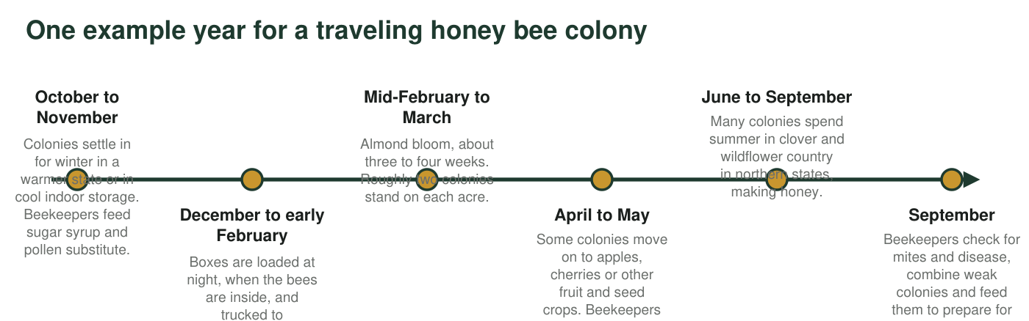
An example of one migratory honey bee colony's year, simplified. Real routes differ from beekeeper to beekeeper and from year to year.

Observation 2: The mesh-bag test
A grower wants to know how much her trees need the bees. Just before bloom, she slips a bag of fine mesh over one branch on each of four trees. Bees cannot reach the flowers inside, but light, air and rain can. She ties a ribbon on a second branch of similar size on each tree and leaves it open. She counts the flowers on every branch at bloom, and in early summer she counts how many of those flowers became almonds.
Flowers and almonds on bagged and open branches (teaching dataset)
Simulated teaching dataset (not real measurements).
Tree | Bagged branch: flowers | Bagged branch: almonds | Open branch: flowers | Open branch: almonds
Tree 1 | 120 | 2 | 115 | 38
Tree 2 | 98 | 0 | 104 | 31
Tree 3 | 132 | 3 | 126 | 44
Tree 4 | 110 | 1 | 118 | 35

Simulated data for teaching. The pattern is realistic for almond varieties that need pollen from a different variety, but these counts were not measured in a real orchard.

Part A: Notice and wonder
1. Write three things you notice in the two observations. At least one must use a number from the table.
______________________________________________________________________________________
______________________________________________________________________________________
______________________________________________________________________________________
2. Write three questions you wonder about. Start each with why, how or what would happen if.
______________________________________________________________________________________
______________________________________________________________________________________
______________________________________________________________________________________
3. Add up the flowers and the almonds for all four bagged branches, then for all four open branches. What percent of flowers became almonds in each group? Show your work and round to one decimal place.
______________________________________________________________________________________
______________________________________________________________________________________
______________________________________________________________________________________

Part B: What you already know
4. From earlier lessons on interactions: what does a bee get from a flower, and what does the plant get from the bee? What kind of interaction is this?
______________________________________________________________________________________
______________________________________________________________________________________
______________________________________________________________________________________

Part C: Your first explanation
5. Explain why so few flowers inside the bags became almonds. Use the words pollen and pollination. Then name one other possible reason for the result that the grower would need to rule out.
______________________________________________________________________________________
______________________________________________________________________________________
______________________________________________________________________________________
______________________________________________________________________________________
______________________________________________________________________________________
______________________________________________________________________________________
6. Most almond varieties cannot make nuts from their own pollen or from pollen of trees of the same variety. Growers plant rows of a second variety between rows of the main one. Explain why this makes insects even more important to the orchard.
______________________________________________________________________________________
______________________________________________________________________________________
______________________________________________________________________________________
______________________________________________________________________________________
7. The bees stay in the orchard for only a few weeks. Where do you think they find food the rest of the year, and what could happen to the orchard's harvest if those places disappeared? Write your best explanation of something the orchard depends on that the grower does not own or control.
______________________________________________________________________________________
______________________________________________________________________________________
______________________________________________________________________________________
______________________________________________________________________________________
______________________________________________________________________________________
______________________________________________________________________________________
8. List three other things the orchard gets from nature without paying for them directly. Think about soil, water, weather and other living things.
______________________________________________________________________________________
______________________________________________________________________________________
______________________________________________________________________________________
9. Write one question you could investigate about the orchard and its bees, and one measurement that would help answer it.
______________________________________________________________________________________
______________________________________________________________________________________
______________________________________________________________________________________
Keep this page
At the end of the chapter you will reread your answers to q5 and q7 and mark what you would keep, change or add. An explanation that changes as you learn is a sign of good thinking, not a mistake.

Sentence starters for Part C
For q5 try: 'Inside the bag, pollen could not ___ because ___. Without pollination, a flower cannot ___.' For q7 try: 'When almonds are not blooming, the bees need ___, which they can find in ___. If those places were plowed or paved, then ___.' For q8 think about what you would have to buy or build if nature stopped doing it.

A tree that can pollinate itself
Plant breeders have developed a few almond varieties that can set nuts with their own pollen, and growers of these varieties often rent fewer colonies per acre. Predict what the mesh-bag test would show on a self-fertile variety, and explain why such growers may still place some bees in the orchard. Then name one advantage and one risk of planting a whole orchard of a single self-fertile variety.

