Angela's Tools · Chapter 28: The Importance of Healthy Ecosystems · Worksheet 2 of 10

Four Kinds of Help: Sorting the Services Ecosystems Provide (Teacher answer key)
Learning target: I can sort ecosystem services into provisioning, regulating, supporting and cultural services, tell an ecosystem service apart from a natural resource, and use the chapter's terms to describe a new situation.
Vocabulary in action · about 30 minutes · individual · Standards: MS-LS2-5 (supports), MS-ETS1-1 (supports)

Standards connections
MS-LS2-5 (supports): Naming and classifying ecosystem services gives students the language they need to say which services a design solution keeps or harms. That is background the PE assumes; this sheet does not evaluate solutions.
MS-ETS1-1 (supports): Two items ask students to tell a criterion from a constraint in a short design rule, the distinction they will use when defining and judging solutions later in the chapter.

Answers with reasoning
ecosystem service: A benefit people get from the natural processes of a healthy ecosystem, such as clean water, pollinated crops, fertile soil or calmer floodwaters.
provisioning service: A service that supplies a product people use, such as food, fresh water, wood, fiber, or the chemicals and genes used to make medicines and new crop varieties.
regulating service: A service that keeps conditions in check, such as filtering water, slowing floods and erosion, pollinating crops, controlling pests or limiting the spread of disease.
supporting service: A basic process that all the other services depend on, such as photosynthesis, soil formation and nutrient cycling.
cultural service: A nonmaterial benefit people get from nature, such as recreation, beauty, spiritual meaning, learning and scientific discovery.
natural resource: Anything from nature that people use for materials or energy. Some are produced by living things (wood, food); others form through geologic processes (stone, metals, oil).
pollination: The transfer of pollen from the part of a flower that makes it to the part that receives it, the first step toward seeds and fruit.
cross-pollination: Pollination with pollen from a different plant. Most almond varieties set nuts only with pollen from a different, compatible variety.
biodiversity: The variety of life in a place: how many species live there, how much individuals of each species differ in their traits, and how many kinds of ecosystems there are.
disease resistance: An inherited trait that makes an organism less likely to be infected by, or badly harmed by, a particular disease.
scavenger: An animal that feeds mostly on animals that are already dead instead of hunting live prey.
watershed: All the land that drains rain and snowmelt into the same stream, river, lake or reservoir.
turbidity: How cloudy water is because of tiny particles floating in it, such as silt, clay or bits of plants. Higher turbidity means murkier water.
replacement cost: What it would cost to do, with machines, chemicals or human labor, a job that an ecosystem now does for free.
criteria: The things a design must achieve to count as a success (one is called a criterion).
constraint: A limit a design must stay within, such as a budget, a deadline, the materials allowed, or its effects on people and the environment.

Part A: Which kind of service is it?
1. 1. Almonds harvested from an orchard
2. 2. Bees carrying pollen between rows of almond trees
3. 3. Fungi and bacteria turning fallen leaves into soil nutrients
4. 4. Forest soil trapping mud before it reaches a reservoir
5. 5. A family hiking and bird-watching in a mountain meadow
6. 6. Vultures eating a dead cow before rats and stray dogs can
7. 7. Lumber cut from a managed forest to build houses
8. 8. Dune grass roots holding sand in place during a winter storm
9. 9. Plants making sugar from sunlight, carbon dioxide and water
10. 10. A wild banana whose genes help breeders make a disease-resistant crop
11. 11. Students studying tide pools on a field trip
12. 12. Rock slowly crumbling and mixing with decayed plants to form new soil
1. Write each example number (1-12) in the row where it fits best. Every number goes in exactly one row.
Answer: Provisioning: 1, 7, 10. Regulating: 2, 4, 6, 8. Supporting: 3, 9, 12. Cultural: 5, 11.
Reasoning: Almonds, lumber and genes are products people take and use. Pollination, water filtering, disease control by scavengers and erosion control keep conditions in check. Nutrient cycling, photosynthesis and soil formation are basic processes behind all the others. Hiking and learning are nonmaterial benefits.
Also acceptable: Accept 2 (pollination) under supporting with a reason, because many school texts place it there. Accept 3 under regulating if the student calls it waste breakdown. Accept 10 under supporting if the student explains it as biodiversity; the framework used here counts genetic material as a product (provisioning).
Full credit must include:
• Products (1, 7, 10) as provisioning
• Pollination, filtering, scavenging and erosion control as regulating
• Nutrient cycling, photosynthesis and soil formation as supporting
• Hiking and field study as cultural

Part B: Which term fits?
Write the one term from the word bank that best fits each situation.
2. A town's planners add up what it would take to build and run a filtration plant to do the job its forested hills now do for nothing.
Answer: replacement cost
Reasoning: The planners are pricing a human-built substitute for a service the hills provide free.
Also acceptable: Accept 'ecosystem service' only if the student also names replacement cost in discussion; otherwise partial credit.
3. Rain that lands anywhere on these hills eventually ends up in Willow Creek and then in Willow Lake.
Answer: watershed
Reasoning: All land draining to the same creek and lake is one watershed.
Also acceptable: None.
4. A turkey vulture circles, lands and feeds on a deer that was hit by a car the day before.
Answer: scavenger
Reasoning: The vulture feeds on an animal that was already dead; it did not hunt it.
Also acceptable: None.
5. In a field trial, a few wild tomato plants stay healthy while a leaf disease kills most of the farm tomatoes beside them. Breeders want the trait those wild plants share.
Answer: disease resistance
Reasoning: The wild plants share an inherited trait that keeps the disease from harming them; breeders want to move that trait into crop tomatoes.
Also acceptable: Accept 'biodiversity' for partial credit if the student explains that the variety of traits is what makes the resistant plants possible.
6. A school team decides its water filter must remove at least 90 percent of the mud from a sample to be called a success.
Answer: criteria (a criterion)
Reasoning: Removing 90 percent of the mud is what the design must achieve to succeed.
Also acceptable: Accept 'criterion'.
7. The same team may spend no more than $10 and may use only materials found in the classroom.
Answer: constraint
Reasoning: The budget and the allowed materials are limits on the design, not goals.
Also acceptable: Accept 'constraints'.
8. A coastal marsh holds about 140 kinds of plants, insects, fish and birds, and the individuals of each kind differ in size, color and behavior.
Answer: biodiversity
Reasoning: The sentence describes both the number of species and the variation among individuals, the two parts of biodiversity named in the word bank.
Also acceptable: None.
9. Copper ore dug from a mine in Arizona and made into electrical wire.
Answer: natural resource
Reasoning: Copper ore forms through geologic processes, not through the activity of a living ecosystem, so it is a natural resource but not an ecosystem service.
Also acceptable: None; 'provisioning service' is incorrect because ecosystems do not make metal ores.
10. An almond grower plants a row of Monterey trees between rows of Nonpareil trees so that bees carry pollen from one variety to the other.
Answer: cross-pollination
Reasoning: Nonpareil cannot set nuts with its own variety's pollen, so the grower plants a compatible variety nearby and relies on bees to carry pollen between them.
Also acceptable: Accept 'pollination' for partial credit; full credit needs the idea of pollen from a different variety.
11. After a storm, a student holds a jar of creek water up to the window and can barely see through it.
Answer: turbidity
Reasoning: Cloudiness caused by suspended particles is turbidity; storms wash silt and clay into creeks and raise it.
Also acceptable: None.

Part C: Complete the concept map
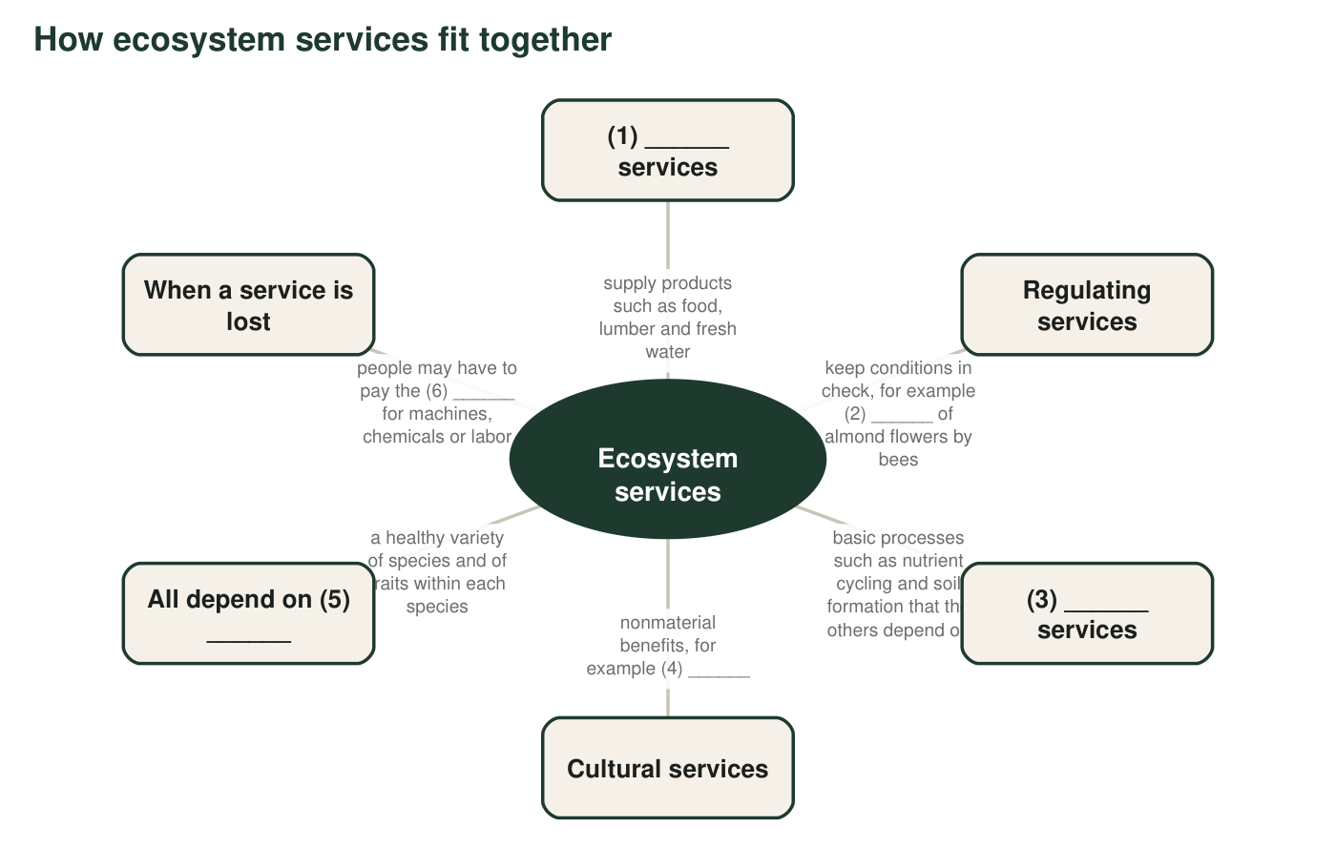
A concept map about ecosystem services with six numbered blanks. Each blank is a term from the word bank or an example from Part A.
12. Fill each numbered blank in the concept map.
Answer: Blank 1: provisioning. Blank 2: pollination. Blank 3: supporting. Blank 4: recreation, hiking, beauty, learning or scientific discovery. Blank 5: biodiversity. Blank 6: replacement cost.
Reasoning: Each blank is defined by the description beside it; blank 4 has several correct answers.
Also acceptable: Blank 4 accepts any cultural example (the field trip or the hike from Part A).
Full credit must include:
• Provisioning and supporting in blanks 1 and 3
• Pollination in blank 2
• Any nonmaterial benefit in blank 4
• Biodiversity and replacement cost in blanks 5 and 6

Part D: How the terms relate
13. A forest gives people lumber, and it also holds soil on a steep hillside. Which of these is a natural resource and which is an ecosystem service? Explain the difference in your own words.
Answer: The lumber is a natural resource: a material taken from the forest and used. Holding soil on the hillside is an ecosystem service: a process the living forest carries out (roots gripping soil, leaves softening rain) that benefits people by preventing erosion and landslides. A resource is a thing you take; a service is work the ecosystem does while it stays in place. Cutting the forest for lumber can end the soil-holding service.
Reasoning: Separates a material from a process, the distinction the chapter uses throughout.
Also acceptable: Accept 'lumber is a provisioning service' if the student still identifies soil holding as a regulating service and explains the difference.
Full credit must include:
• Lumber identified as the natural resource
• Soil holding identified as the ecosystem service
• Explains the difference (material taken vs. process carried out)
14. Pollination can be placed in more than one category. Give one reason to call it a regulating service and one reason someone might call it supporting or provisioning instead.
Answer: Regulating: pollinators keep crop and wild-plant reproduction working by moving pollen, a process that controls how many fruits and seeds form. Supporting: pollination keeps plant populations reproducing, which every other service depends on. Provisioning: pollination leads directly to food people harvest, such as almonds.
Reasoning: The categories overlap; the major international framework from 2005 lists pollination as regulating, while many school texts call it supporting.
Also acceptable: Any well-reasoned pair earns credit.
Full credit must include:
• One sound reason for regulating
• One sound reason for another category
15. A town writes two rules for a flood plan: 'It must keep water off Main Street in a storm as large as the one in 2017' and 'It must cost less than $5 million.' Which rule is a criterion and which is a constraint? How can you tell?
Answer: Keeping water off Main Street in a 2017-sized storm is a criterion, because it describes what success looks like. Costing less than $5 million is a constraint, because it is a limit the plan must stay within.
Reasoning: Criteria describe the goal; constraints describe the limits.
Also acceptable: Accept a student who notes that cost can be written as a criterion ('lower cost is better') if they still identify the $5 million cap as a constraint.
Full credit must include:
• Correctly labels both rules
• Explains goal versus limit
16. Write a paragraph of 4 to 6 sentences about a mountain meadow that sits next to an apple orchard. Use at least five terms from the word bank correctly, and describe at least one service from three different categories.
Answer: Example: The meadow's wildflowers support native bees, which carry out pollination in the orchard next door, a regulating service that helps the trees make apples. When meadow plants die, decomposers recycle their nutrients and build soil, a supporting service. The meadow's biodiversity means many kinds of insects visit the flowers, so the orchard does not rely on one pollinator. Families who hike there enjoy a cultural service. If the meadow were paved, the orchard might face a replacement cost for renting bees.
Reasoning: The paragraph must use terms accurately and describe services from at least three categories.
Also acceptable: Any accurate paragraph meeting the criteria.
Full credit must include:
• Five or more word-bank terms used correctly
• Services from at least three categories
• Accurate science (no reversed definitions)
• 4 to 6 sentences about the meadow and orchard

Teacher notes
The four categories come from the Millennium Ecosystem Assessment (2005). That framework lists pollination, water purification, erosion control and disease regulation as regulating services and counts genetic resources as provisioning; many textbooks place pollination under supporting, so accept either with a reason. Item 6 (vultures) previews W3 and item 10 (wild banana) previews W8. q9 targets a known textbook simplification: the lesson implies stone and metals come from ecosystems, but ores form through geology; they are natural resources, not ecosystem products. Collect the q16 paragraphs to check whether students reverse the meaning of 'ecosystem service' (thinking it is something people do for nature), which W7 addresses directly.

