Angela's Tools · Chapter 28: The Importance of Healthy Ecosystems · Worksheet 2 of 10

Four Kinds of Help: Sorting the Services Ecosystems Provide
Learning target: I can sort ecosystem services into provisioning, regulating, supporting and cultural services, tell an ecosystem service apart from a natural resource, and use the chapter's terms to describe a new situation.
Vocabulary in action · about 30 minutes · individual · Standards: MS-LS2-5 (supports), MS-ETS1-1 (supports)
Name: ____________________________ Date: ____________ Period: ______

Directions
Read the word bank first. In Part A, sort twelve examples into the four kinds of ecosystem services. In Part B, write the one term that best fits each situation. In Part C, fill the blanks in the concept map. In Part D, explain how pairs of terms are related and then use the terms yourself. Some examples could fit more than one group; when that happens, choose the best fit and be ready to give your reason.
ecosystem service: A benefit people get from the natural processes of a healthy ecosystem, such as clean water, pollinated crops, fertile soil or calmer floodwaters.
provisioning service: A service that supplies a product people use, such as food, fresh water, wood, fiber, or the chemicals and genes used to make medicines and new crop varieties.
regulating service: A service that keeps conditions in check, such as filtering water, slowing floods and erosion, pollinating crops, controlling pests or limiting the spread of disease.
supporting service: A basic process that all the other services depend on, such as photosynthesis, soil formation and nutrient cycling.
cultural service: A nonmaterial benefit people get from nature, such as recreation, beauty, spiritual meaning, learning and scientific discovery.
natural resource: Anything from nature that people use for materials or energy. Some are produced by living things (wood, food); others form through geologic processes (stone, metals, oil).
pollination: The transfer of pollen from the part of a flower that makes it to the part that receives it, the first step toward seeds and fruit.
cross-pollination: Pollination with pollen from a different plant. Most almond varieties set nuts only with pollen from a different, compatible variety.
biodiversity: The variety of life in a place: how many species live there, how much individuals of each species differ in their traits, and how many kinds of ecosystems there are.
disease resistance: An inherited trait that makes an organism less likely to be infected by, or badly harmed by, a particular disease.
scavenger: An animal that feeds mostly on animals that are already dead instead of hunting live prey.
watershed: All the land that drains rain and snowmelt into the same stream, river, lake or reservoir.
turbidity: How cloudy water is because of tiny particles floating in it, such as silt, clay or bits of plants. Higher turbidity means murkier water.
replacement cost: What it would cost to do, with machines, chemicals or human labor, a job that an ecosystem now does for free.
criteria: The things a design must achieve to count as a success (one is called a criterion).
constraint: A limit a design must stay within, such as a budget, a deadline, the materials allowed, or its effects on people and the environment.

Part A: Which kind of service is it?
1. 1. Almonds harvested from an orchard
2. 2. Bees carrying pollen between rows of almond trees
3. 3. Fungi and bacteria turning fallen leaves into soil nutrients
4. 4. Forest soil trapping mud before it reaches a reservoir
5. 5. A family hiking and bird-watching in a mountain meadow
6. 6. Vultures eating a dead cow before rats and stray dogs can
7. 7. Lumber cut from a managed forest to build houses
8. 8. Dune grass roots holding sand in place during a winter storm
9. 9. Plants making sugar from sunlight, carbon dioxide and water
10. 10. A wild banana whose genes help breeders make a disease-resistant crop
11. 11. Students studying tide pools on a field trip
12. 12. Rock slowly crumbling and mixing with decayed plants to form new soil
1. Write each example number (1-12) in the row where it fits best. Every number goes in exactly one row.
Example numbers that belong here
Provisioning
Regulating
Supporting
Cultural

Part B: Which term fits?
Write the one term from the word bank that best fits each situation.
2. A town's planners add up what it would take to build and run a filtration plant to do the job its forested hills now do for nothing.
______________________________________________________________________________________
______________________________________________________________________________________
______________________________________________________________________________________
3. Rain that lands anywhere on these hills eventually ends up in Willow Creek and then in Willow Lake.
______________________________________________________________________________________
______________________________________________________________________________________
______________________________________________________________________________________
4. A turkey vulture circles, lands and feeds on a deer that was hit by a car the day before.
______________________________________________________________________________________
______________________________________________________________________________________
______________________________________________________________________________________
5. In a field trial, a few wild tomato plants stay healthy while a leaf disease kills most of the farm tomatoes beside them. Breeders want the trait those wild plants share.
______________________________________________________________________________________
______________________________________________________________________________________
______________________________________________________________________________________
6. A school team decides its water filter must remove at least 90 percent of the mud from a sample to be called a success.
______________________________________________________________________________________
______________________________________________________________________________________
______________________________________________________________________________________
7. The same team may spend no more than $10 and may use only materials found in the classroom.
______________________________________________________________________________________
______________________________________________________________________________________
______________________________________________________________________________________
8. A coastal marsh holds about 140 kinds of plants, insects, fish and birds, and the individuals of each kind differ in size, color and behavior.
______________________________________________________________________________________
______________________________________________________________________________________
______________________________________________________________________________________
9. Copper ore dug from a mine in Arizona and made into electrical wire.
______________________________________________________________________________________
______________________________________________________________________________________
______________________________________________________________________________________
10. An almond grower plants a row of Monterey trees between rows of Nonpareil trees so that bees carry pollen from one variety to the other.
______________________________________________________________________________________
______________________________________________________________________________________
______________________________________________________________________________________
11. After a storm, a student holds a jar of creek water up to the window and can barely see through it.
______________________________________________________________________________________
______________________________________________________________________________________
______________________________________________________________________________________

Part C: Complete the concept map
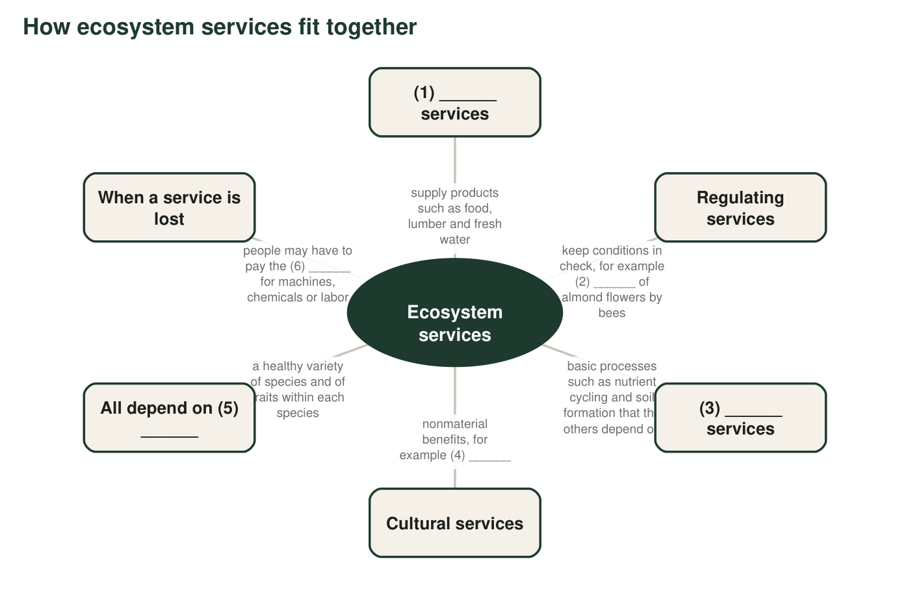
A concept map about ecosystem services with six numbered blanks. Each blank is a term from the word bank or an example from Part A.
12. Fill each numbered blank in the concept map.
Term or example that fills the blank
Blank 1
Blank 2
Blank 3
Blank 4
Blank 5
Blank 6

Part D: How the terms relate
13. A forest gives people lumber, and it also holds soil on a steep hillside. Which of these is a natural resource and which is an ecosystem service? Explain the difference in your own words.
______________________________________________________________________________________
______________________________________________________________________________________
______________________________________________________________________________________
14. Pollination can be placed in more than one category. Give one reason to call it a regulating service and one reason someone might call it supporting or provisioning instead.
______________________________________________________________________________________
______________________________________________________________________________________
______________________________________________________________________________________
15. A town writes two rules for a flood plan: 'It must keep water off Main Street in a storm as large as the one in 2017' and 'It must cost less than $5 million.' Which rule is a criterion and which is a constraint? How can you tell?
______________________________________________________________________________________
______________________________________________________________________________________
______________________________________________________________________________________
16. Write a paragraph of 4 to 6 sentences about a mountain meadow that sits next to an apple orchard. Use at least five terms from the word bank correctly, and describe at least one service from three different categories.
______________________________________________________________________________________
______________________________________________________________________________________
______________________________________________________________________________________
______________________________________________________________________________________
______________________________________________________________________________________
______________________________________________________________________________________

Questions to ask when sorting
For each example in Part A, ask: Is something being harvested and used (provisioning)? Is nature keeping a problem in check, such as mud, floods, pests or disease (regulating)? Is it a slow basic process that keeps the whole system running (supporting)? Is the benefit an experience, a feeling or knowledge rather than a thing (cultural)? If two answers seem right, pick the one that describes the main benefit to people.

Who decides the categories?
Scientists in an international study published in 2005 grouped services into these four categories, and later groups have changed them; some no longer use 'supporting' at all and treat those processes as part of how the other services work. Write a short argument for or against keeping 'supporting services' as its own group. Use two examples from Part A, and explain how counting a process twice (once as supporting and again inside a regulating service) could mislead someone adding up what an ecosystem is worth.

