Angela's Tools · Chapter 28: The Importance of Healthy Ecosystems · Worksheet 4 of 10

Follow the Raindrop: Modeling How a Watershed Cleans Water (Teacher answer key)
Learning target: I can interpret a model of a forested watershed, identify where living and nonliving parts clean the water, and draw a model that predicts what happens to that service when the land is developed.
Diagrams and models · about 45 minutes · individual · Standards: MS-LS2-5 (practice), MS-ESS3-3 (supports)

Standards connections
MS-LS2-5 (practice): Students build the scientific model of how a watershed provides water purification, the knowledge needed to judge competing solutions such as protecting land or building a filtration plant (the lesson's New York City case). Building the model is practice toward evaluating those solutions.
MS-ESS3-3 (supports): This Grade 6 PE in the California sequence asks students to design ways to monitor and minimize a human impact. Part B looks at one land-use impact (replacing forest with pavement) and asks what to monitor, as background only; the Grade 6 design task is not assessed here.

Answers with reasoning

Figure 1: The path of one raindrop
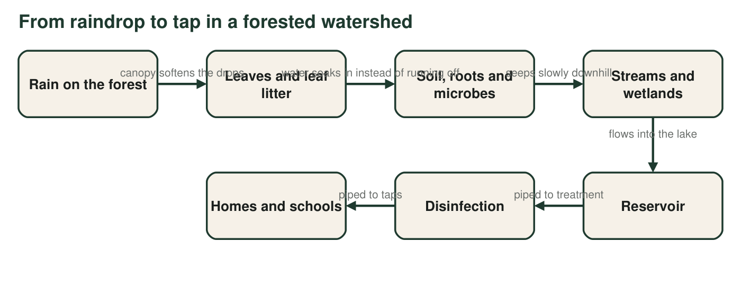
A simplified model of how rain becomes tap water in a forested watershed. Most of the cleaning happens in the first four boxes; the reservoir lets fine particles settle, and disinfection kills the germs that remain.

Figure 2: What each part of the watershed does
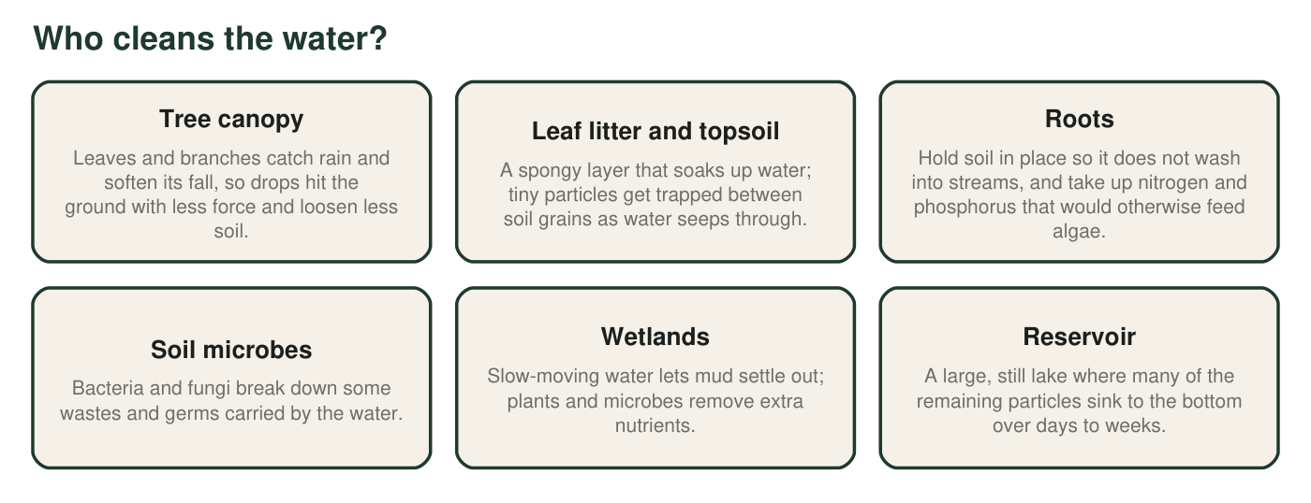
Jobs done by the living and nonliving parts of a healthy forested watershed. Several parts do more than one job.
A real case: New York City
New York City gets most of its drinking water from reservoirs in mostly forested watersheds in the Catskill Mountains and the upper Delaware River area, more than 100 miles north of the city. Since 1993, federal regulators have allowed most of this supply to skip filtration because the city protects the land around its reservoirs: it buys land, pays for better farm and sewage practices, and tests the water constantly. The water is still disinfected before it reaches taps.

Part A: Read and build the model
Draw a side view of a forested hillside that drains into a reservoir. Include trees, leaf litter, soil, roots, a stream, a wetland and the reservoir. Draw solid arrows for rainwater flowing over the surface and dashed arrows for water moving through the soil. Label at least four places where the water gets cleaner, and write what happens there in three to six words.
Expected drawing: A side view with the hilltop, trees, a leaf-litter layer, soil with roots, a stream, a wetland and the reservoir. Solid arrows run over the surface, mostly few and short; dashed arrows run down through the soil toward the stream. At least four labeled cleaning places, for example: canopy (softens rain), leaf litter and soil (traps particles), roots (hold soil, take up nutrients), microbes (break down wastes and some germs), wetland (mud settles, nutrients removed), reservoir (particles sink).
Reasoning: The model must show both the path of water and where cleaning happens along it.
1. Using Figure 2, name two parts of the watershed that mainly remove mud (particles) and one step in Figure 1 that mainly deals with germs. Explain how each one works.
Answer: Mud removers: leaf litter and topsoil (particles get trapped between soil grains as water seeps through) and wetlands (slow water lets mud settle). Roots and the reservoir also count (roots hold soil so it never enters the stream; particles sink in the still reservoir). Germs: disinfection kills the germs that remain; soil microbes also break down some germs and wastes.
Reasoning: Figure 2 assigns particle removal to soil, wetlands, roots and the reservoir; Figure 1 places disinfection at the end of the line.
Also acceptable: Accept soil microbes as the germ answer if explained.
Full credit must include:
• Two correct particle-removing parts with how they work
• Disinfection (or soil microbes) named for germs with how it works
2. Figure 1 shows rain soaking into the soil instead of running over the surface. Describe two things that would happen to the stream if most of the rain ran over the surface instead.
Answer: Surface runoff would carry loose soil, so the stream would turn muddy (more particles). The water would also reach the stream faster and all at once, so the stream would rise quickly and could flood, and it would carry more nutrients and wastes because the water skipped the soil's cleaning.
Reasoning: Soaking in slows water and filters it; running off does neither.
Also acceptable: Accept 'less water seeps into the ground to feed the stream in dry months' as a second change.
Full credit must include:
• Muddier water
• Faster, higher flow or flooding, or more pollutants reaching the stream
3. Roots take up nitrogen and phosphorus. Using what you know about algae, explain why this matters for the reservoir.
Answer: Nitrogen and phosphorus are nutrients that algae need. If roots did not take them up, they would wash into the reservoir and feed fast algae growth. Thick algae can make water smell and taste bad, clog treatment screens, and, when the algae die and decompose, use up oxygen in the water. By taking up the nutrients, roots help keep algae in check.
Reasoning: Connects nutrient uptake to algae growth from earlier lessons on ecosystems and matter cycling.
Also acceptable: Accept 'algae blooms' as the problem without the oxygen detail.
Full credit must include:
• Nitrogen and phosphorus feed algae
• Extra algae cause a problem for the water (taste, odor, low oxygen or treatment trouble)
• Roots reduce that problem
4. Figure 1 is drawn as a one-way line, but real water also evaporates and falls again as rain. What part of the water's journey does the model leave out, and why might the modelers have chosen to leave it out?
Answer: It leaves out evaporation from the land, plants (transpiration) and the reservoir, and the return of that water as rain, as well as water soaking deep into groundwater. The modelers probably left these out because the model's purpose is to show how water gets cleaner on its way to the tap; including the whole water cycle would make the cleaning steps harder to see.
Reasoning: Every model has boundaries chosen for a purpose; recognizing what is left out is part of using models.
Also acceptable: Accept 'the water cycle' named generally with a sensible reason.
Full credit must include:
• Names an omitted part (evaporation, transpiration, groundwater, rain returning)
• Gives a reason linked to the model's purpose

Part B: Change the model
A developer proposes clearing 30 percent of the forest above the reservoir and replacing it with houses, roads, lawns and parking lots. Rain cannot soak through roofs, roads or parking lots, and storm drains carry the runoff straight into the nearest stream.
5. Draw a second side view of the same hillside after development. Show at least two kinds of new surfaces and redraw the water arrows. Circle two places where a cleaning step is now weaker or missing.
Answer: The same hillside with part of the forest replaced by roofs, roads, lawns or parking lots. Long solid arrows run off the hard surfaces into storm drains that empty straight into the stream; few or no dashed soil arrows under the paved areas. Circled weaker steps, for example: soil no longer soaks up or filters water under pavement; fewer roots hold soil or take up nutrients; storm drains bypass the wetland; lawns may add fertilizer.
Reasoning: The drawing must show how development changes the path of water and which cleaning steps are lost.
Also acceptable: A student who shows a construction site with bare soil washing downhill also earns credit.
Full credit must include:
• Two kinds of new hard or altered surfaces
• Runoff arrows longer and more direct
• Two circled weakened or missing steps
• Same hillside outline as the first drawing
6. Predict two changes in the water that reaches the reservoir after development. For each change, name the part from Figure 2 whose job has been lost or weakened.
Answer: Example 1: more mud and sediment in the reservoir, because roots and leaf litter no longer hold soil and the soil no longer filters water where it is paved. Example 2: more nutrients (fertilizer from lawns) and more algae, because fewer roots take up nitrogen and phosphorus and the wetland is bypassed. Other answers: more oil, salt or pet waste from roads and yards, because water skips the soil and microbes; bigger, faster floods after storms because water cannot soak in.
Reasoning: Each predicted change must be tied to the job of a part in Figure 2.
Also acceptable: Any two reasoned changes with a matching part.
Full credit must include:
• Two predicted changes in water quality or quantity
• Each tied to a specific lost or weakened part from Figure 2
7. Name one thing the water managers could measure in the stream every month to find out whether the development is harming the service. Say what result would be a warning sign.
Answer: Examples: cloudiness (turbidity) of the stream water, with a rising trend after storms as a warning sign; nitrate or phosphate levels, with rising values as a warning; counts of fecal bacteria such as E. coli, with higher counts as a warning; numbers of pollution-sensitive stream insects, with a drop as a warning.
Reasoning: Monitoring needs a measurable quantity and a stated threshold or trend that signals harm.
Also acceptable: Accept 'water color or clearness' measured with a clear tube or disk.
Full credit must include:
• A measurable water property
• A stated result that would signal harm
8. Why does New York City still disinfect its water even though the watershed does most of the cleaning?
Answer: The watershed removes most particles and many germs, but not all of them. Wild animals, farms and leaking septic systems can still add germs, so the city disinfects the water as a final safety step to kill anything that is left. Federal rules also require disinfection.
Reasoning: Watershed protection lets the supply skip filtration, not all treatment.
Also acceptable: Accept 'to be safe in case something gets through'.
Full credit must include:
• Watershed does not remove every germ
• Disinfection is a final safety step
9. Use your two drawings to explain why protecting a forest can be a way of building a water treatment system. Include at least one way the forest does a better job than a treatment plant and one way it does a worse job.
Answer: Example: The forest does the same jobs a plant does: it slows water, traps particles, removes nutrients and breaks down some wastes, so protecting it is like building and maintaining the first stages of a treatment plant. Better: it runs on sunlight, rebuilds itself, also gives habitat, recreation and flood control, and has no machinery to replace. Worse: it cannot be adjusted quickly when a new pollutant appears, it can be damaged by fire, storms or development, it does not kill every germ, and its cleaning drops in big storms.
Reasoning: The answer uses both drawings to compare a natural system with an engineered one, a key step toward evaluating competing solutions.
Also acceptable: Accept cost-based advantages ('cheaper to protect than to build') if a scientific advantage is also given.
Full credit must include:
• Links forest processes to treatment steps
• One accurate advantage of the forest
• One accurate disadvantage
• Refers to the drawings (what is lost after development)

Teacher notes
The New York City callout follows the city's own description: most of the supply (the Catskill and Delaware systems) has operated under federal filtration-avoidance determinations since 1993 because of watershed protection, and the water is still disinfected. The textbook implies the water needs little treatment and calls the watershed mostly wetlands; in fact it is mostly forest, with farms, streams, wetlands and reservoirs. Figure 1 is deliberately a line with a boundary at the tap (q4 asks students to notice that). Students often think plants 'drink up' pollution; steer them toward settling, filtering through soil, uptake of nutrients and breakdown by microbes. If time is short, assign the drawing and q5 to q8 and leave q9 for homework.

