Angela's Tools · Chapter 28: The Importance of Healthy Ecosystems · Worksheet 4 of 10

Follow the Raindrop: Modeling How a Watershed Cleans Water
Learning target: I can interpret a model of a forested watershed, identify where living and nonliving parts clean the water, and draw a model that predicts what happens to that service when the land is developed.
Diagrams and models · about 45 minutes · individual · Standards: MS-LS2-5 (practice), MS-ESS3-3 (supports)
Name: ____________________________ Date: ____________ Period: ______

Directions
Study Figure 1 (the path of water) and Figure 2 (what each part does) before you draw anything. Make your drawings large and label them clearly; labels matter more than artistic skill. Use solid arrows for water flowing over the surface and dashed arrows for water moving through soil. Answer the questions using the figures and your own drawings as evidence.

Figure 1: The path of one raindrop
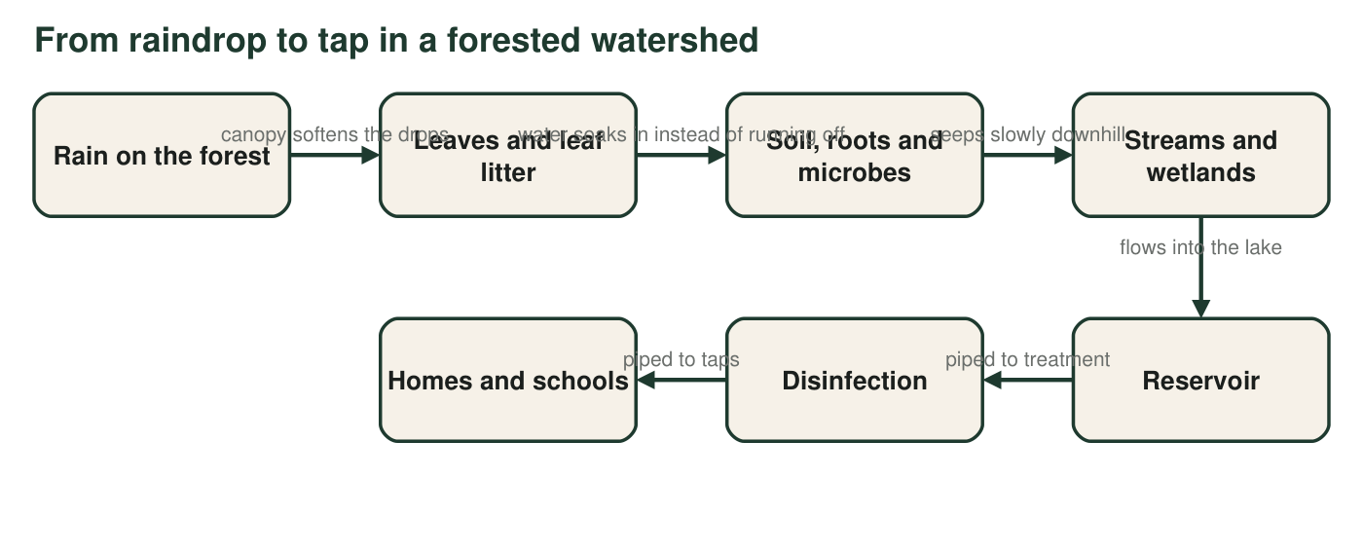
A simplified model of how rain becomes tap water in a forested watershed. Most of the cleaning happens in the first four boxes; the reservoir lets fine particles settle, and disinfection kills the germs that remain.

Figure 2: What each part of the watershed does
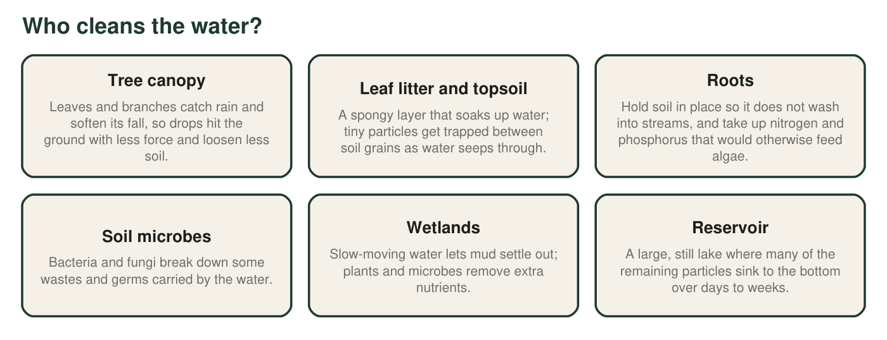
Jobs done by the living and nonliving parts of a healthy forested watershed. Several parts do more than one job.
A real case: New York City
New York City gets most of its drinking water from reservoirs in mostly forested watersheds in the Catskill Mountains and the upper Delaware River area, more than 100 miles north of the city. Since 1993, federal regulators have allowed most of this supply to skip filtration because the city protects the land around its reservoirs: it buys land, pays for better farm and sewage practices, and tests the water constantly. The water is still disinfected before it reaches taps.

Part A: Read and build the model
Draw a side view of a forested hillside that drains into a reservoir. Include trees, leaf litter, soil, roots, a stream, a wetland and the reservoir. Draw solid arrows for rainwater flowing over the surface and dashed arrows for water moving through the soil. Label at least four places where the water gets cleaner, and write what happens there in three to six words.

1. Using Figure 2, name two parts of the watershed that mainly remove mud (particles) and one step in Figure 1 that mainly deals with germs. Explain how each one works.
______________________________________________________________________________________
______________________________________________________________________________________
______________________________________________________________________________________
2. Figure 1 shows rain soaking into the soil instead of running over the surface. Describe two things that would happen to the stream if most of the rain ran over the surface instead.
______________________________________________________________________________________
______________________________________________________________________________________
______________________________________________________________________________________
3. Roots take up nitrogen and phosphorus. Using what you know about algae, explain why this matters for the reservoir.
______________________________________________________________________________________
______________________________________________________________________________________
______________________________________________________________________________________
4. Figure 1 is drawn as a one-way line, but real water also evaporates and falls again as rain. What part of the water's journey does the model leave out, and why might the modelers have chosen to leave it out?
______________________________________________________________________________________
______________________________________________________________________________________
______________________________________________________________________________________

Part B: Change the model
A developer proposes clearing 30 percent of the forest above the reservoir and replacing it with houses, roads, lawns and parking lots. Rain cannot soak through roofs, roads or parking lots, and storm drains carry the runoff straight into the nearest stream.
5. Draw a second side view of the same hillside after development. Show at least two kinds of new surfaces and redraw the water arrows. Circle two places where a cleaning step is now weaker or missing.

6. Predict two changes in the water that reaches the reservoir after development. For each change, name the part from Figure 2 whose job has been lost or weakened.
______________________________________________________________________________________
______________________________________________________________________________________
______________________________________________________________________________________
______________________________________________________________________________________
7. Name one thing the water managers could measure in the stream every month to find out whether the development is harming the service. Say what result would be a warning sign.
______________________________________________________________________________________
______________________________________________________________________________________
______________________________________________________________________________________
8. Why does New York City still disinfect its water even though the watershed does most of the cleaning?
______________________________________________________________________________________
______________________________________________________________________________________
______________________________________________________________________________________
9. Use your two drawings to explain why protecting a forest can be a way of building a water treatment system. Include at least one way the forest does a better job than a treatment plant and one way it does a worse job.
______________________________________________________________________________________
______________________________________________________________________________________
______________________________________________________________________________________
______________________________________________________________________________________
______________________________________________________________________________________
______________________________________________________________________________________

Drawing checklist
Before you start, sketch the shape lightly: hilltop on the left, reservoir on the right, stream and wetland in between. Then add, in order: trees, a brown leaf-litter layer, soil with roots, solid surface arrows, dashed soil arrows, and labels. For the developed hillside, copy the same outline, then replace part of the forest with gray roofs and roads and add storm-drain arrows straight to the stream.

How much forest is enough?
Water managers want to know how much of a watershed can be developed before the water gets noticeably dirtier. Design a study that uses several small streams whose watersheds have different amounts of pavement (for example 0, 10, 20 and 40 percent). Say what you would measure in each stream, how often, and what pattern in your results would suggest a safe limit. Then explain why the answer might be different for a watershed with steep slopes or thin soil.

